Table S1. Landscape, socioeconomic and rain gardens variables definition and expected effects on insect diversity. DSE: Desservices associated species.
Variables | Definition | Source | Unit | Expected effect
 |  |  |  | Insects | Pollinators | DSE
Landscape (buffer r= 200 m)
IDH-M | Municipal Developing Human Index per district (considering income, education and longevity informations) adjusted to the sampled buffer area | Brazilian Institute of Geography and Statistics (IBGE), 2010 Population Census tract data for São Paulo municipality. | Dimensionless index calculated for each 200-m-radius buffer. Each census tract’s population was weighted by the proportion of its area overlapping the buffer, and the resulting population estimates and corresponding census data were aggregated to calculate IDHM. | - | + | -
Vegetation cover | Total vegetation proportion in sampled buffer | Vegetation cover map available on the GeoSampa platform, which was produced by vectorizing 15 categories classified through photointerpretation of orthorectified aerial imagery from 2017–2018. (https://geosampa.prefeitura.sp.gov.br) | % | + | + | +
Arboreal vegetation cover | Vegetation proportion of arboreal coverage | Aboreal vegetation category from the vegetation cover map available on the GeoSampa platform. | % | + | + | +
Herb-shrub vegetation cover | Vegetation proportion of herbaceous and shrubby coverage | Herbaceous and shrubby vegetation category from the vegetation cover map available on the GeoSampa platform. | % | + | - | +
Proportion of built-up areas | Building proportion in the sampled buffer | 2D building footprint map available on the GeoSampa platform. | % | - | - | +
Mean volume of built-up areas | Mean building volume (mean height x mean cover) | Mean building cover derived from the 2D building footprint map and mean building height derived from the LiDAR-based 3D building map, both available on the GeoSampa platform. | m³ | - | - | +
MESH vegetation | Effective Mesh Size (MESH) metric which estimate the fragmentation and patches sizes of total vegetation (0, small patches and fragmented; 1 larges patch connected) | Calculated using the landscapemetrics package in R (lsm_l_mesh()), based on total vegetation cover data obtained from the GeoSampa platform. | Ha | + | + | +
MESH arboreal vegetation | Effective Mesh Size (MESH) metric which estimate the fragmentation and patches sizes of arboreal vegetation | Calculated using the landscapemetrics package in R (lsm_l_mesh()), based on arboreal vegetation cover data obtained from the GeoSampa platform. | Ha | + | + | +
MESH herb-shrub vegetation | Effective Mesh Size (MESH) metric which estimate the fragmentation and patches sizes of herbaceous and shrubby vegetation | Calculated using the landscapemetrics package in R (lsm_l_mesh()), based on herbaceous and shrubbt vegetation cover data obtained from the GeoSampa platform. | ha | + | - | +
Rain garden (gardens units)
Rain garden area | Rain garden area by City Hall of São Paulo | Municipal bioretention structures survey (https://www.prefeitura.sp.gov.br/cidade/secretarias/upload/subprefeituras/SMSUB/Mapeamento%20-%20Jardins%20de%20Chuva%202022_.pdf.) | m² | + | + | +
Management level | Rain garden management level | Field work, details available in Almeida et al. 2024 (see References section) | The score was defined by the sum of parameters: delimitation (1 for well delimited places and 0 for places without clear delimitation), ruderal (1 for absence of ruderal plants and 0 for presence ruderal plants), ornamental (1 for presence of ornamental plants and 0 for absence ornamental plants) and recent management (1 for signs of recent management (e.g. signs of cutting and cleaning patterns) and 0 for no visible signs of management) | - | - | -
Plant species richness in the rain garden | Number of plants recorded in the sampled plots in each rain garden | Field work, details available in Almeida et al. 2024 | Number of different species | + | + | +
Native plant species richness in the rain garden | Number of native plants recorded in the sampled plots in each rain garden | Field work, details available in Almeida et al. 2024 | Number of different species | + | + | +
Exotic plant species richness in the rain garden | Number of exotic plants recorded in the sampled plots in each rain garden | Field work, details available in Almeida et al. 2024 | Number of different species | + | + | +
Invasive plant species richness in the rain garden | Number of invasive plants recorded in the sampled plots in each rain garden | Field work, details available in Almeida et al. 2024 | Number of different species | + | + | +
Presence of anthropogenic litter | Presence (1) or absence (0) of garbage in the sample | Field work, details available in Almeida et al. 2024 | 1 for presence and 0 for absence | + | - | +

Table S2. Statistical families of response variables and packages used in the analyses.
Response Variables | Statistical family | Model strcture | R package
Insects
Alpha diversity rain garden effect zone | Poisson | glmer (response variable ~ landscape explanatory variables + rain garden area + rain garden management level + (fixed = pantrap sampling effort (number of bowls)) + (1|Rain Garden ID), family = poisson) | lme4
Gamma diversity | Poisson |  | lme4
Alpha diversity rain garden no-effect zone | Poisson | glm (response variable ~ landscape explanatory variables + rain garden area + rain garden management level + (fixed = pantrap sampling effort (number of bowls)), family = poisson) | glmmTMB
Beta diversity | Beta | glmmTMB (response variable ~ landscape explanatory variables + rain garden area + rain garden management level + (fixed = pantrap sampling effort (number of bowls)) + (1|Rain Garden ID), family = beta_family(link = "logit")) | glmmTMB
Alpha diversity rain garden effect zone | Conway-Maxwell Poisson distribution | glmmTMB (response variable ~ rain garden explanatory variables + (fixed = pantrap sampling effort (number of bowls)), family = compois(link="log")) | glmmTMB
Pollinator
Alpha diversity rain garden effect zone | Conway-Maxwell Poisson distribution | glmmTMB (response variable ~ landscape explanatory variables + rain garden area + rain garden management level + (fixed = pantrap sampling effort (number of bowls)), family = compois(link = "log")) | glmmTMB
Alpha diversity rain garden no-effect zone | Conway-Maxwell Poisson distribution |  | glmmTMB
Gamma diversity | Poisson | glm (response variable ~ landscape explanatory variables + rain garden area + rain garden management level + (fixed = pantrap sampling effort (number of bowls)), family = poisson)
Beta diversity | Beta | glmmTMB (response variable ~ landscape explanatory variables + rain garden area + rain garden management level + (fixed = pantrap sampling effort (number of bowls)) + (1|Rain Garden ID), family = beta_family("cloglog"), control = glmmTMBControl(optimizer = optim, optArgs = list(method = "BFGS")))
Alpha diversity rain garden effect zone | Poisson | glmer(response variable ~ rain garden explanatory variables + (fixed = pantrap sampling effort (number of bowls)) + (1|Rain Garden ID), family = poisson) | lme4
Desservices-associated species
Alpha diversity rain garden effect zone | Conway-Maxwell Poisson distribution | glmmTMB (response variable ~ landscape explanatory variables + rain garden area + rain garden management level + (fixed = pantrap sampling effort (number of bowls)), family = compois(link = "log")) | glmmTMB
Alpha diversity rain garden no-effect zone | Conway-Maxwell Poisson distribution |  | glmmTMB
Gamma diversity | Conway-Maxwell Poisson distribution |  | glmmTMB
Alpha diversity rain garden effect zone | Poisson | glmer(response variable ~ rain garden explanatory variables + (fixed = pantrap sampling effort (number of bowls)) + (1|Rain Garden ID), family = poisson) | lme4

Table S3. Residual diagnostics of uniformity, dispersion, zero inflation, and spatial autocorrelation for the full models.
Response | p-value
Response | Uniformity | Zero inflation | Dispersion | Spatial autocorrelation
Insect alpha diversity rain garden effect zone | 0.943567857 | 1 | 0.928 | 0.885789937
Insect alpha diversity rain garden no-effect zone | 0.812903737 | 1 | 0.248 | 0.366001983
Pollinator alpha diversity rain garden effect zone | 0.968451531 | 0.474 | 0.832 | 0.783016535
Pollinator alpha diversity rain garden no-effect zone | 0.902014136 | 0.468 | 0.938 | 0.652414859
Disservices associated species alpha diversity rain garden effect zone | 0.431578031 | 1 | 0.922 | 0.762395705
Disservices associated species alpha diversity rain garden no-effect zone | 0.684852605 | 1 | 0.94 | 0.26831426
Insect gamma diversity | 0.729971657 | 1 | 0.88 | 0.834087872
Pollinator gamma diversity | 0.499383723 | 0.666 | 0.69 | 0.163875839
Insect beta diversity | 0.990738704 | NA | 0.926 | 0.675849649
Pollinator beta diversity | 0.096595246 | NA | 0.278 | 0.461878217

Residual diagnostics for the full models are summarized in Table S3. Using 1,000 simulations per model in the DHARMa package, we tested residual uniformity, dispersion, zero inflation, and spatial autocorrelation, the latter using Moran’s I with inverse-distance weights. The table reports p-values for each test: values below 0.05 indicate evidence of deviations from the expected residual distribution, dispersion, number of zeros, or spatial independence, respectively. Values ≥ 0.05 indicate that no significant deviation was detected. Zero-inflation tests were applied only to count models; NA denotes that this test was not applicable to models fitted to beta-distributed responses.

Table S4. Comparison of insect alpha diversity between rain garden effect and no-effect zones using paired t-tests. ZE = effect zone; ZSE = no-effect zone. Comparisons used two-sided paired t-tests. Confidence intervals are unadjusted; p-values were adjusted for three comparisons using the Holm method.
Group | Number of pairs | Mean alpha diversity (ZE) | Mean alpha diversity (ZSE) | Mean difference (ZE − ZSE) | 95% CI | t | df | p | Holmadj. p
Insect community | 30 | 12.10 | 9.33 | 2.77 | 0.036 to 5.498 | 2.07 | 29 | 0.047 | 0.142
Pollinators | 30 | 2.37 | 2.00 | 0.37 | −0.421 to 1.154 | 0.95 | 29 | 0.349 | 0.654
Disservice-associated insects | 16 | 2.94 | 2.38 | 0.56 | −0.621 to 1.746 | 1.01 | 15 | 0.327 | 0.654

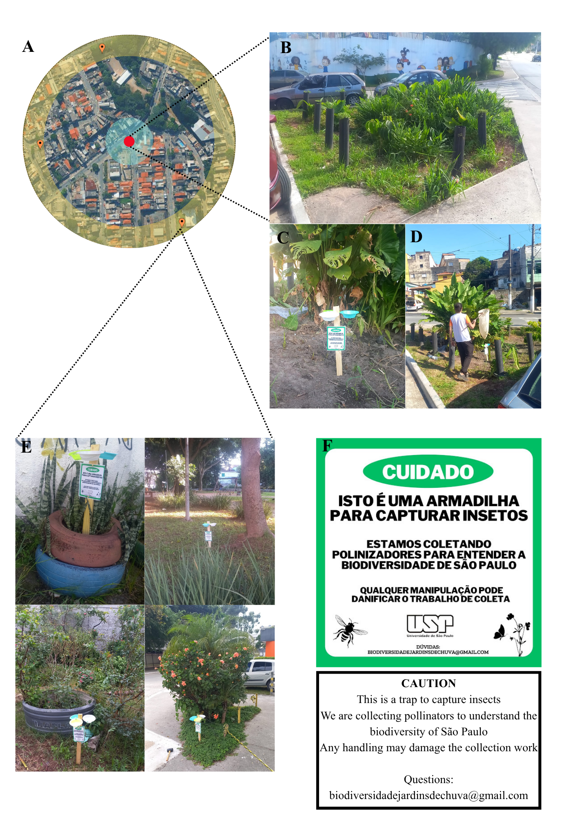
Figure S1. Representation of insect sampling sites. (A) Sampling buffer around the rain garden (r = 200 m), with the no-effect zone in yellow (orange pins indicate pantrap installation sites) and the rain garden effect zone in blue; (B) Example of a sampled rain garden; (C) Pantrap installed in the garden; (D) Active sampling using a hand net in the garden; (E) Examples of pantrap installation sites in the no-effect zone of rain gardens; (F) Signage placed on pantraps during the study and below, translation of the sign’s textual content.

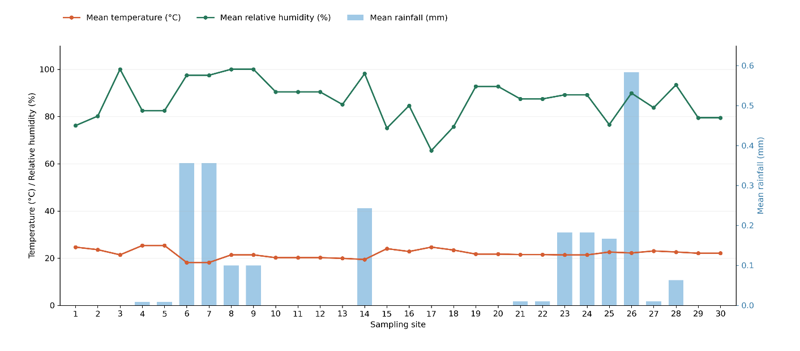
Figure S2. Meteorological conditions at the 30 insect sampling sites during sampling in March–April 2024. Lines represent mean temperature (°C) and mean relative humidity (%) on the left axis, and bars represent mean rainfall (mm) on the right axis. Sites are numbered in the order presented in SM4, as well the meteorological stations sources.
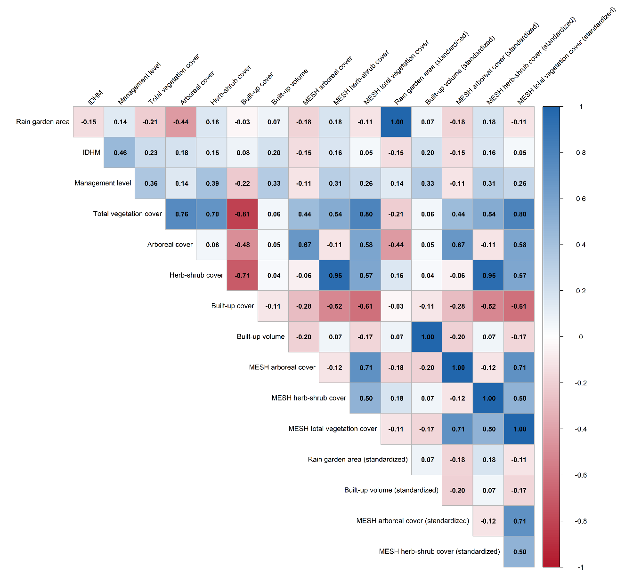
Figure S3. Collinearity matrix of the explanatory variables. Blue gradient indicates positive correlation and red negative correlation.

.

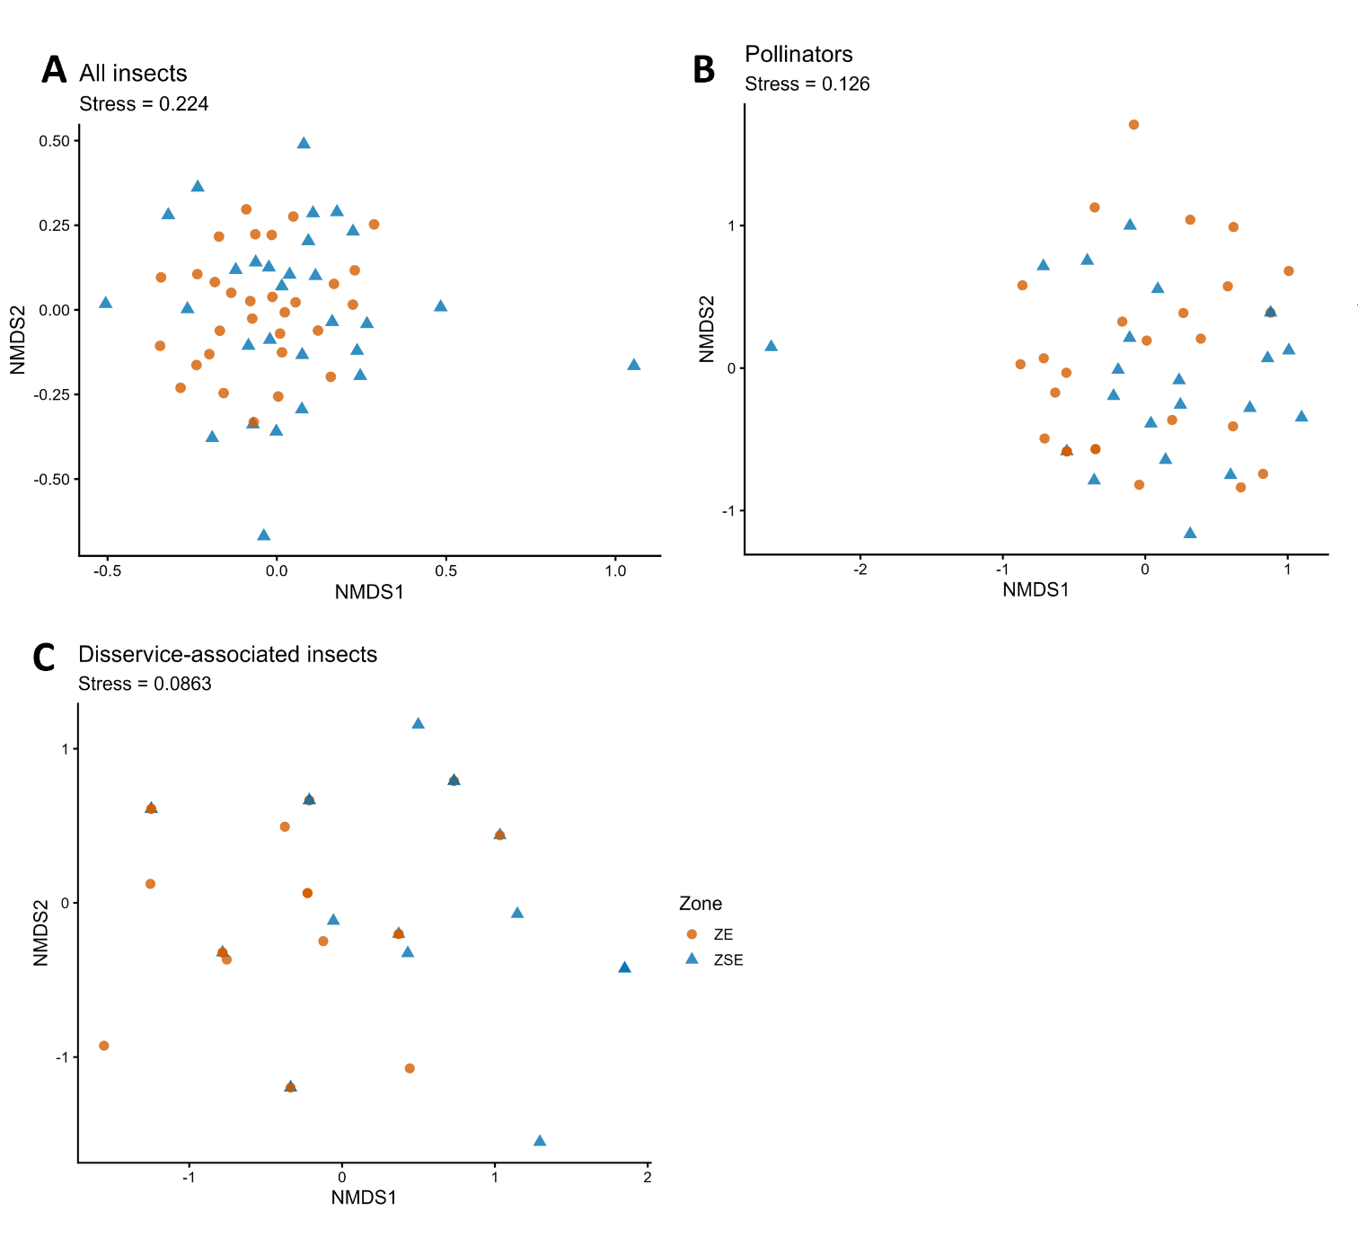
Figure S4. Non-metric multidimensional scaling (NMDS) ordinations based on Jaccard dissimilarities of morphospecies incidence for (A) the entire insect community, (B) pollinators, and (C) disservice-associated insects. Colors and symbols distinguish effect (ZE) and no-effect (ZSE) zones. Each point represents a rain garden–zone combination. Stress values are shown in each panel. To improve visualization, samples sharing no species with any other sample were excluded (one zone from one rain garden in each dataset).

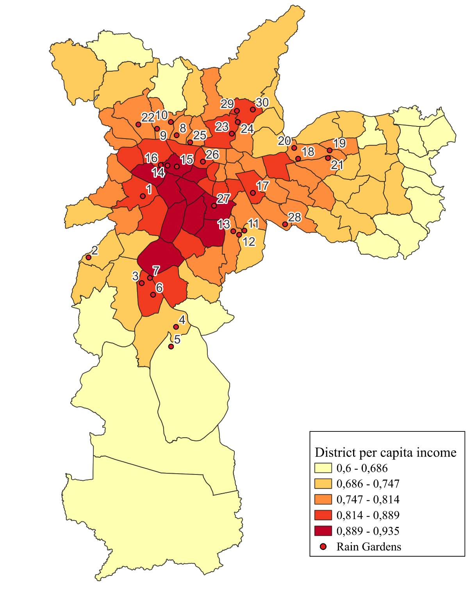
Figure S5. Socio-spatial heterogeneity of São Paulo and its implications for urban insect biodiversity. Presenting all sampled areas to illustrate variation in socioeconomic conditions. Number in the map are related to the next image showing the aerial view of the sampled buffer.

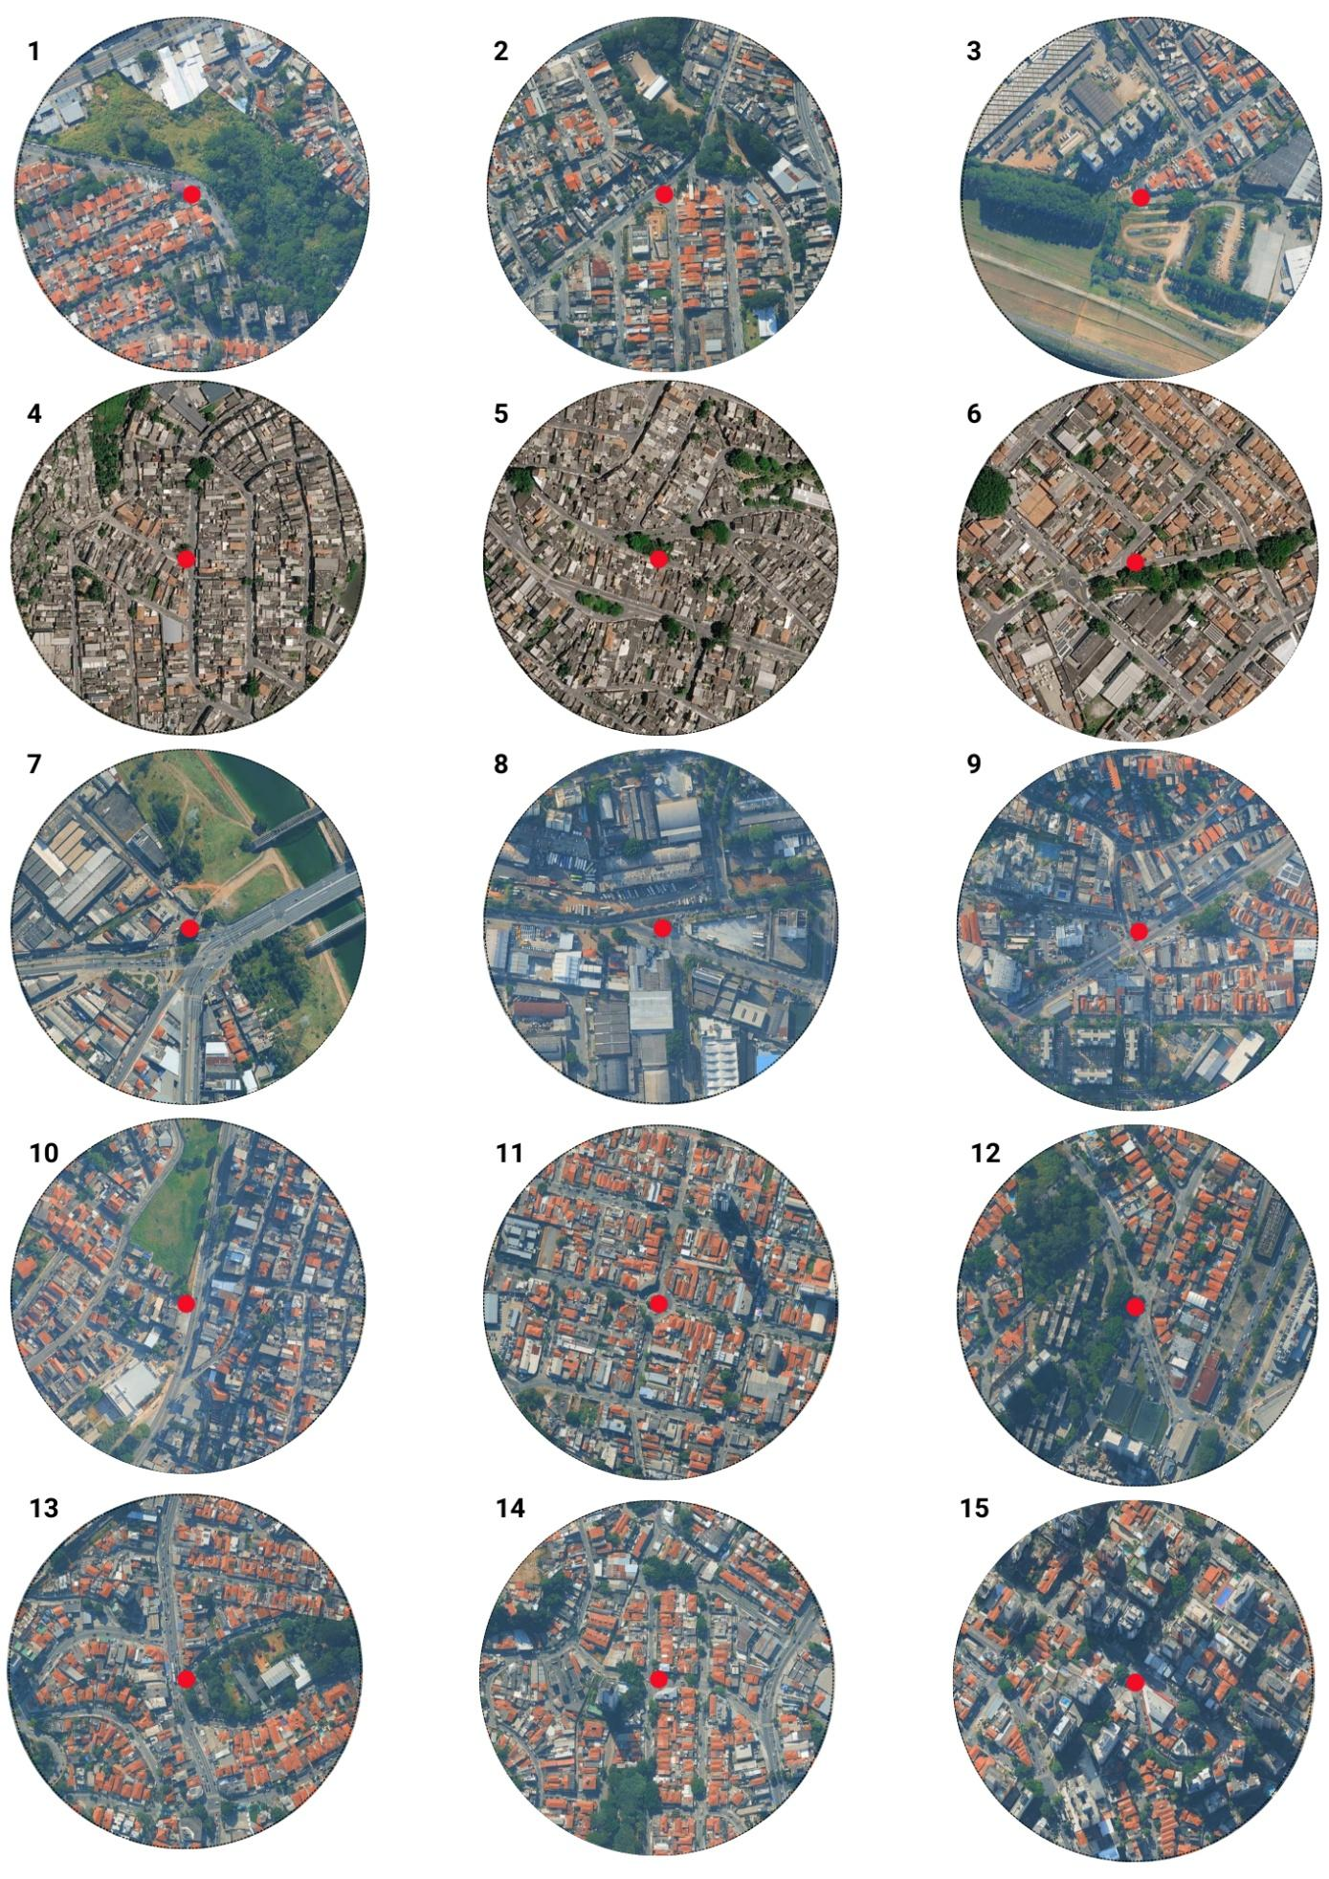
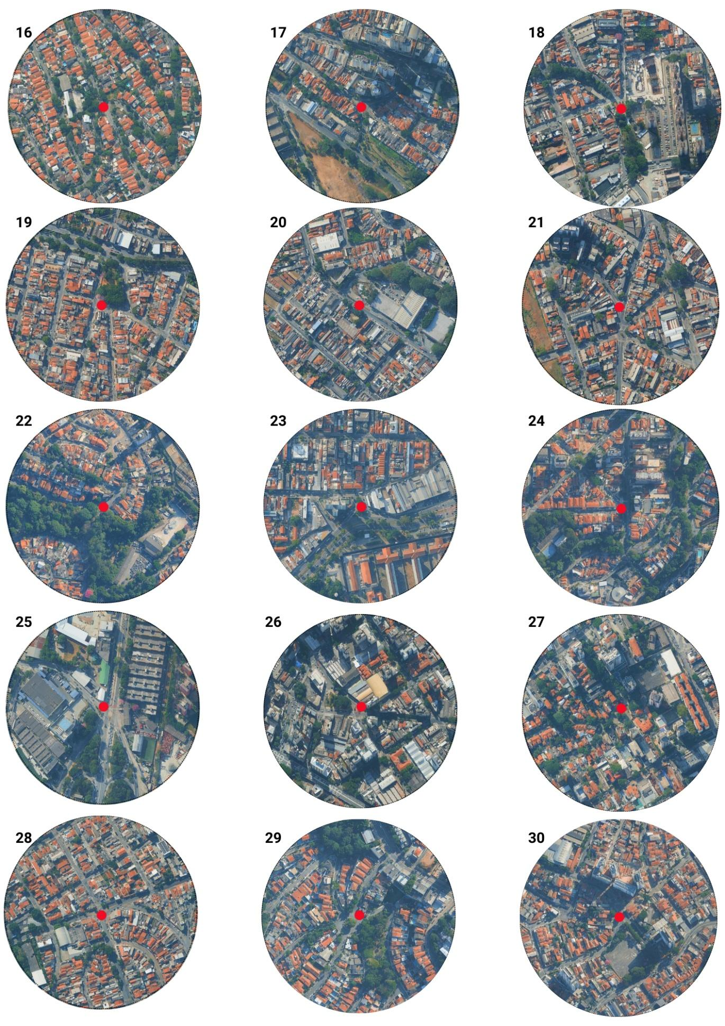
Figure S6. Aerial view of the sampled buffer. Red points represent rain garden locations; numbers refer to rain garden IDs. Imagery: Google Satellite.

