Flow of Control
if/elseif/else / unless
case (series of if, the 1st one to be true get excecuted) (use ===)
While/unless/for
=== (look at clases)

Methods
Not parentesis
not declare type of parameters
return is optional (last line get excecuted)
method? Return boolean values.
Method! Dangerous side-effects
default argument in methods (n = 3)
Splat *
def max (one_param, *numbers, another)
numbers.max
end
=> max (“sm” , 7, 32, 8, 4) =>32

Blocks
Chunk of code that you can pass into methods.
do and ends
When incorporating into your own methods use

Implicit
block_given? To see if block was passed in
yield to call the block
Explicit
Use & in front of the last “paramenter”
Use “call”
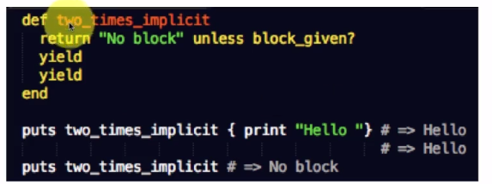
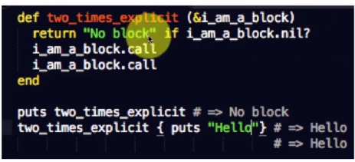

Block example
2.times do |paramenter |
puts index
end
RNGES

# test "the truth" do
# assert true
# end

