Project guideline

Part-I- Contents: - Industrial Project -I-

(Documentation)

1.1.Introduction …………………………………………………………………… 1

1.2.Background (including both Organization and System or Application)……….

1.3.Statement of Problem

1.4.Objective

1.4.1 General Objective

1.4.2 Specific Objective (step by step tasks to achieve the general objective).

1.5.Proposed System

1.6.Literature Review and Related Work

1.7.Scope and Limitation (Limitation should be with detail reason)

1.8.Methods and Tools

1.8.1 Requirements gathering techniques/methods

1.8.2 System Analysis and Design Methods

1.8.3 Requirement validation & verification

1.8.4 System Implementation Methods (How to use Methods)

1.8.5 Development Environment and Programming Tools

1.9.Significance of the Project

1.10. Beneficiaries of the System or Application

1.11. Feasibility Study

1. Technical Feasibility Study

2. Economic Feasibility Study

3. Operational Feasibility Study

4. Legal Feasibility Study

5. Political Feasibility Study

6. Others

1.12. Project Plan

1.12.1 Time Schedule(Time Estimation, pert chart)1.12.2 Budget Plan (Cost estimation techniques e.g, **Algorithmic (parametric)**

model, Expert Judgment, Estimation by analogy, Top down approach, Bottom

up approach )

CHAPTER -2-

DESCRIPTION OF THE EXISTING SYSTEM OR APPLICATION

2.1.Introduction

2.2.Business Rules and Constraints

2.3.Naming Convention and Definition

2.4.Functions or Main Activities of Existing System

2.5.Players of Existing System or Application

2.6.Organization Structure

2.7.Documents used in the Existing System or Application

2.8.Strength and Weakness of the Existing System or Application

2.8.1 Strength of the Existing System or Application

2.8.2 Weakness of the Existing System or Application

2.8.2.1 Alternative Solutions

CHAPTER -3-

REQUIREMENT SPECIFICATION AND ANALYSIS

3.1.Introduction

3.2.Description of the Proposed System or Applications

3.2.1 User Characteristics

3.2.2 Constraints

3.2.3 Assumptions and Dependencies

3.3.Requirement Specifications

3.3.1 Functional Requirement

3.3.2 Non-functional Requirement

3.4.System Modeling

3.5.1 Actor Identification

3.5.2 Use-Case Identification

3.5.3 Use-Case Diagram

3.5.4 Description of Use-Case

3.5. Requirement Analysis

3.5.1. Activity Diagram

3.5.2. Sequence Diagram

3.5.3. Requirement validation & verification

3.5.3.1. Validity checks

3.5.3.2. Consistency checks

3.5.3.3. Completeness checks3.5.3.4. Realism checks

*3.5.3.5.* Verifiability

CHAPTER -4

SYSTEM DESIGN

4.1.Introduction

4.2.Design issues for your system(like reuse, future change, refactoring concept of

components)

4.3.Design patterns

4.4.Class Diagram

4.5.Database Model

4.5.1 Entity Relationship Diagram (ERD)

4.5.2 Persistence Modeling

4.5.3 Mapping with Normalization

4.6.Subsystem Decomposition

4.7.Deployment Diagram

4.8.System Architecture (Layered Architecture of the System)

4.6.1. Overall system architecture.

4.6.2. Detail of your architectural patterns and styles

4.9.User-Interface (UI) Design

4.10. UI Flow Diagramming

# CHAPTER 1: INTRODUCTION

The Bus Reservation System is a comprehensive online platform designed to revolutionize the way bus tickets are booked and managed. It offers a convenient and user-friendly interface for customers to browse bus schedules, select seats, make reservations, and secure their tickets without the need to visit a physical ticket counter. This system automates and streamlines the ticketing process, benefiting both passengers and bus companies alike.

Traditionally, purchasing bus tickets involved long queues, limited availability, and the inconvenience of physically visiting ticket counters. However, with the advent of technology and the rise of online booking systems, the Bus Reservation System has emerged as a game-changer in the transportation industry. It provides passengers with the ease and flexibility to book their desired bus tickets from the comfort of their homes or on the go, using their computers or mobile devices.

The Bus Reservation System offers a range of features and functionalities that enhance the ticket booking experience. Passengers can access real-time information about bus schedules, seat availability, and fares. They can conveniently compare different routes, departure times, and seating options, allowing them to make informed decisions based on their preferences and travel requirements. The system also enables secure online payments, ensuring a hassle-free and secure transaction process.

Overall, the Bus Reservation System revolutionizes the way bus tickets are booked and managed, making the entire process more convenient, efficient, and accessible. It empowers passengers with the freedom to plan their journeys and secure their tickets seamlessly. At the same time, it empowers bus companies with advanced tools to optimize their operations and provide exceptional customer service. With ongoing advancements in technology and the increasing demand for online services, the Bus Reservation System will continue to shape the future of bus ticketing, transforming the way people travel.

* 1. Project Background

This chapter provides an overview of the Bus Ticket Booking System project, which focuses on implementing an online ticketing system for the Modern Coast Bus Company. The company currently faces challenges with their ticketing and scheduling processes, leading to inefficiencies and inconvenience for customers. To address these issues and improve customer service, the project aims to computerize the company's semi-computerized ticketing system.

Electronic tickets, also known as e-tickets, serve as digital proof that holders have permission to access entertainment venues, use transportation services, or utilize certain internet-based services. The Bus Ticket Reservation System will enable customers of the bus company to easily purchase bus tickets online, providing them with the easiest and quickest way to secure their seats.

The implementation of an online ticketing system is relatively new in the bus industry, both globally and in ethiopia . Currently, the company's staff uses an internal system at the ticket counter to sell tickets. However, customers are unable to purchase bus tickets online and must physically visit the counter. This often results in long queues and delays in obtaining tickets or information. Additionally, customers are unable to purchase tickets over the telephone, and the company's telephone line is frequently busy, causing inconvenience for customers.

The Online Bus Ticket Reservation System will address these challenges by allowing customers to purchase bus tickets, make payments, cancel reservations, and access information easily online. It will provide a more streamlined and efficient process for both customers and staff members. Staff members will be able to check ticket availability for customers and issue physical tickets to those who queue up at the counter.

Overall, the project aims to enhance customer convenience, improve the efficiency of ticket sales, and provide a better travel experience for passengers. The Online Bus Ticket Reservation System will revolutionize the way customers interact with the bus company, offering a more accessible and efficient ticketing solution.

1.2 Organizational Background:

Zemen Bus Reservation is a leading and reputable bus transportation company operating in the country. Established in 2005, the company has built a strong presence in the industry by providing reliable and comfortable bus services to a wide range of destinations across the country.

Zemen Bus Reservation is known for its commitment to customer satisfaction and safety. With a fleet of modern and well-maintained buses, the company ensures a comfortable and enjoyable travel experience for passengers. The buses are equipped with amenities such as air conditioning, comfortable seating, onboard entertainment, and restroom facilities, making long-distance journeys convenient and pleasant.

The company operates on various routes, connecting major cities, towns, and popular tourist destinations. Zemen Bus Reservation has established a strong network of routes, enabling passengers to travel conveniently and efficiently to their desired locations. The company takes pride in maintaining a punctual schedule, ensuring that passengers arrive at their destinations on time.

**In addition** to its focus on providing excellent transportation services, Zemen Bus Reservation has embraced technological advancements to enhance the booking and reservation process. The company offers a user-friendly online reservation system, allowing customers to conveniently book their bus tickets from the comfort of their homes or offices. The online system provides real-time information on ticket availability, departure and arrival times, and seating options, enabling customers to make informed decisions.

1.3 PROBLEM STATEMENT:

The current ticketing system used by the staff at the counter is an internal system primarily designed for selling bus tickets in person. Customers are required to physically visit the ticket counter to purchase their bus tickets or inquire about bus schedules. Additionally, customers are limited to making cash payments for their tickets, which can be inconvenient for those who prefer alternative payment methods. This often results in long queues, causing customers to wait for extended periods to obtain their bus tickets. Furthermore, the bus company's telephone line does not support ticket purchases, and customers frequently encounter a consistently busy signal when attempting to contact the company via phone.

1.4 Objective

1.4.1 General Objective:

The general objective of the Bus Reservation System project is to implement an efficient and user-friendly online ticketing system that improves customer experience and streamlines the ticketing process for the Modern Coast Bus Company.

1.4.2 Specific Objectives:

1. Develop an Online Bus Reservation System:

- Design and develop a web-based platform that allows customers to browse bus schedules, select seats, and make reservations online.

2. Enable Online Ticket Purchasing:

- Integrate a secure online payment gateway to facilitate convenient and safe transactions.

3. Automate Seat Availability and Reservation Management:

- Develop a real-time seat availability tracking system to enable customers to view and select available seats.

- Enable customers to receive instant confirmation of their reservations and electronic tickets via email or SMS

4. Provide Bus Schedule Information:

- Integrate a comprehensive database of bus schedules, routes, and fares into the system.

- Enable customers to search and filter bus schedules based on their preferred dates, destinations, and other criteria.

5. Enhance Customer Service and Communication:

- Implement a customer support feature, such as a live chat or ticketing system, to address customer inquiries and issues promptly.

6. Generate Reports and Analytics:

- Develop a reporting module to generate insights and analytics on ticket sales, revenue, and customer preferences.

7. Improve Operational Efficiency:

- Streamline the ticketing process to reduce manual work for staff and minimize errors.

1.6 Literature Review and Related Work

The tourism sector has witnessed significant success in leveraging mobile applications to enhance the travel experience. According to Buell, Campbell, & Frei (2010), approximately 50% of existing tourism recommender systems are designed specifically for mobile devices. In the tourism industry, mobile travel applications are typically grouped into four main categories: "Online Booking," "Information Resource," "Location-Based Services," and "Trip Journals." The "Online Booking" category, as highlighted by Smirnov, Kashevnik, Shilov, Teslya, & Shabaev (2014), enables tourists to make online reservations for various services, including bus travel, car rental, hotel bookings, and airplane ticket purchases. Such applications are in high demand among tourists, particularly prior to their trips.

Research by Gunduz & Pathan (2013) reveals that online purchases of flight tickets accounted for 32% of overall online sales, while hotel and tour bookings represented 26%, and event ticket sales accounted for 20% of global online purchases. In the United States, approximately 79% of mobile phone users rely on their devices for online shopping and various other conveniences. This underscores the importance for airlines, bus operators, and travel agents, as service providers, to expand their ticketing services through mobile platforms.

Self-service technology (SST) plays a pivotal role in enhancing service delivery. Wang, Harris, & Patterson (2012) define SST as technology that allows customers to independently access and utilize services without direct interaction with employees. SSTs serve multiple purposes, including simplifying service delivery, enabling transactions without human interaction, and providing self-help options. By leveraging SSTs, customers can fulfill their needs without visiting physical offices, such as inquiring about banking transactions, ticket information, and bill payments, leading to savings in time, effort, and money. Additionally, SSTs facilitate transactions, allowing customers to make purchases, payments, and orders directly through the internet without the need for direct employee interaction. Furthermore, SSTs empower customers to learn, receive information, train themselves, and even provide their own services. Self-service technologies bring benefits to both companies and consumers, as they are cost-effective, enhance accessibility, provide pervasive availability, result in time and money savings, and reduce customer anxiety.

In today's global travel landscape, electronic ticketing systems (e-ticket systems) have gained immense popularity among travelers. E-ticketing systems have transformed traditional ticketing methods by offering numerous advantages to customers, such as the ability to avoid queues at ticket counters. These systems emerged in tandem with the development of the internet, replacing paper-based or smart card-based ticketing systems. Various ticketing systems have their own advantages and disadvantages, which have been extensively studied and classified (Jakubauskas, 2010).

It's worth noting that the information provided in this literature review is based on past research and may require an update to reflect the current state of mobile applications and electronic ticketing systems in the tourism industry. To illustrate, let's consider the example of Ethiopian Airlines, which has successfully implemented mobile booking applications and e-ticketing systems to streamline its ticketing processes and offer enhanced convenience to its customers.

1.7 PROJECT SCOPE:

The system is web based application. The users will gain access to the available buses per certain route and available seats by logging in through the customer’s portal.

The staff will access the system by logging in via the staff portal where they can compare bus performance and monitor other related business performance issues.

1.71 PROJECT LIMITATIONS:

**User acceptance** is a significant consideration when introducing new technologies or systems in an organization. In the case of an online counter system, some staff members may be skeptical or resistant to the idea due to concerns about potential job loss. They may fear that automating the ticketing process could render their roles obsolete. Addressing these concerns and ensuring that staff members understand the benefits of the system, such as improved efficiency and customer service, is crucial for successful implementation.

The computer literacy level of the intended customers is another important factor to consider. If the customer base lacks the necessary ICT skills to benefit from the proposed online counter system, the company may need to invest in training programs to bring customers up to speed. This could incur additional costs for the company, but it is essential to ensure that customers can effectively use the system and derive the intended benefits.

Proper system testing is vital to ensure the smooth functioning and usability of the online counter system. If there are inadequate unit and system testing procedures in place, it may lead to usability issues and delays in certain modules of the system. This can negatively impact the customer experience and undermine the efficiency of the ticketing process. Therefore, it is crucial to conduct thorough testing and address any identified issues before implementing the system.

1.8 Methods and Tools for Bus Reservation System

1.8.1 Requirements Gathering Techniques/Methods

Interviews: Conduct interviews with stakeholders like bus operators, passengers, and travel agents to understand their needs and expectations.

Surveys: Use online or paper-based surveys to gather feedback from a larger group of potential users.

Focus groups: Organize focus groups with representative users to discuss specific aspects of the system.

Document analysis: Review existing documentation related to bus reservation systems, regulations, and industry standards.

Observation: Observe how passengers currently book bus tickets and identify pain points and areas for improvement.

1.8.2 System Analysis and Design Methods

Use case analysis: Identify and document the different use cases for the system, such as booking a ticket, canceling a reservation, or managing passenger information.

Data flow diagrams:Create data flow diagrams to visualize the flow of data through the system.

Entity-relationship diagrams: Develop entity-relationship diagrams to represent the relationships between different entities in the system, such as passengers, buses, and routes.

Prototyping: Build prototypes of the user interface to gather feedback and refine the design before full development.

1.8.3 Requirement Validation & Verification

Review meetings: Conduct regular review meetings with stakeholders to ensure that the requirements are complete, consistent, and achievable.

Inspections: Perform inspections of the system design and code to identify any potential defects or deviations from the requirements.

Testing: Conduct thorough testing of the system to ensure it meets all functional and non-functional requirements.

1.8.4 System Implementation Methods (How to use Methods)

* Agile development: Use an agile development methodology to break down the project into smaller, manageable iterations and deliver working software incrementally.
* Waterfall model: Follow a traditional waterfall model for projects with well-defined requirements and a stable environment.
* Rapid application development (RAD): Employ RAD techniques to quickly develop a prototype and gather user feedback for iterative refinement.

1.8.5 Development Environment and Programming Tools

* Programming languages: Choose appropriate programming languages like Java, Python, or C# based on project requirements and developer expertise.
* Databases: Select a suitable database management system like MySQL, PostgreSQL, or Oracle to store and manage reservation data.
* Development tools: Utilize integrated development environments (IDEs) like Eclipse, IntelliJ IDEA, or Visual Studio to streamline the development process.
* Testing frameworks: Implement automated testing frameworks like JUnit or Selenium to ensure code quality and functionality.

Additional Considerations:

* Security: Implement robust security measures to protect sensitive user information and prevent unauthorized access.
* Scalability: Design the system to handle increasing demand and future growth in passenger volume.
* Integration: Integrate the reservation system with other relevant systems, such as payment gateways and customer relationship management (CRM) software.

1.9 Significance of the Bus Reservation System

The bus reservation system holds significant value for both passengers and bus operators, offering numerous benefits that enhance the overall travel experience.

For Passengers:

* Convenience: Passengers can book tickets online or through a mobile app, eliminating the need to visit bus stations or stand in queues.
* Time-saving: The online booking process saves passengers valuable time, allowing them to book tickets quickly and easily.
* Flexibility: Passengers can choose from a wider range of routes, timings, and bus types, ensuring a more convenient travel experience.
* Real-time information: Passengers can access real-time information about bus schedules, availability, and fares, enabling informed decision-making.
* Transparency: The system provides transparent pricing and ticketing information, ensuring fair and reliable transactions.
* Payment options: Passengers can choose from various payment options, including credit cards, debit cards, and e-wallets, offering greater convenience and flexibility.
* Ticket management:Passengers can easily manage their bookings, cancel or reschedule tickets, and track their travel history.

1.10 Beneficiaries of the Bus Reservation System

The primary beneficiaries of the bus reservation system include:

* Passengers:Individuals who use the system to book bus tickets for their travel needs.
* Bus Operators:Transportation companies that provide bus services and manage ticket bookings through the system.
* Travel Agencies: Agencies that sell bus tickets and use the system to access real-time availability and booking information.
* Government Agencies: Regulatory bodies that oversee the transportation industry and benefit from improved data collection and analysis.
* The Economy: The system contributes to economic growth by facilitating travel and tourism, creating job opportunities, and generating revenue for the transportation sector.

Additional Beneficiaries:

* People with disabilities: The system can be designed to be accessible to people with disabilities, providing them with equal access to transportation services.
* Students and low-income individuals: The system can offer discounts or special fares to make bus travel more affordable for these groups.
* Environmental organizations: The system can promote sustainable transportation by encouraging the use of buses, which have a lower carbon footprint than other modes of transport.

By providing benefits to a wide range of stakeholders, the bus reservation system plays a significant role in improving the overall transportation ecosystem and contributing to the social and economic well-being of the community.

1.11 Feasibility Study for Bus Reservation System

The feasibility study for the bus reservation system aimed to assess its viability across various aspects: legal, operational, economic, technical, and schedule.

1. Social Operational Feasibility

This assessment evaluated how well the proposed system addressed identified problems and opportunities, and how it satisfied user requirements. It focused on the impact of the system on the company's social and operational environment.

The operational feasibility assessment ensured the alignment of the project with existing business objectives and constraints, including development schedule, delivery date, corporate culture, and business processes. It considered design-dependent parameters like reliability, maintainability, supportability, usability, and affordability to ensure desired operational outcomes.

The Modern Coast bus ticket booking system was found to be reliable and adaptable, making it operationally feasible.

2. Legal Feasibility

This study determined whether the proposed system complied with legal requirements, particularly data protection regulations. Any legal concerns were addressed to protect client interests. The Modern Coast bus ticket booking system successfully passed this stage and was deemed legally compliant.

3 Economic Feasibility

The economic feasibility assessment evaluated the potential financial benefits of the system for the organization. It involved identifying and quantifying all expected benefits and conducting a cost-benefit analysis. The Modern Coast online bus booking system was found to be economically viable with no foreseeable obsolescence in the near future.

4. Technical Feasibility

This assessment evaluated the adequacy of existing technical resources, including hardware and software, for the new system. It determined whether current facilities were sufficient for implementation. The Modern Coast bus ticket booking system passed this stage, demonstrating that the necessary technical resources were available.

5. Schedule Feasibility

This assessment evaluated the project timeline's reasonableness. It considered the estimated development time and ensured that the system could be completed within a given timeframe. Based on the project schedule, the system was deemed feasible, with an estimated development period of approximately 3 months.

6. Political Feasibility Study

A political feasibility study assesses the level of support or opposition that a proposed project might receive from key stakeholders, including government agencies, regulatory bodies, and political groups. This study aims to identify potential political risks and opportunities associated with the project and develop strategies to mitigate risks and maximize opportunities.

## **1.12 PROJECT SCHEDULE**

This project will comprise all the activities involved in SDLC (see Fig 1). All these activities have been summarized in a Gantt chart below.

|  |  |  |  |  |  |  |  |  |
| --- | --- | --- | --- | --- | --- | --- | --- | --- |
| Weeks activity | 1 | 2 | 3 | 4 | 5 | 6 | 7 | 8 |
| Problem  Definition |  |  |  |  |  |  |  |  |
| Requirement  Identification |  |  |  |  |  |  |  |  |
| Analysis |  |  |  |  |  |  |  |  |
| Design |  |  |  |  |  |  |  |  |
| Implementation testing documenting |  |  |  |  |  |  |  |  |

1.12.2 Budget Plan (Cost estimation techniques e.g, **Algorithmic (parametric)**

model, Expert Judgment, Estimation by analogy, Top down approach, Bottom

up approach )

1.12.2 Budget Plan (Cost estimation techniques e.g, **Algorithmic (parametric)**

model, Expert Judgment, Estimation by analogy, Top down approach, Bottom

up approach )

|  |  |
| --- | --- |
| Resource | Cost (Ksh.) |
| Flash Disk (8GB) | 1,500 |
| Web browser software | 2,500 |
| Text editor software | 2,000 |
| Travelling | 1,000 |
| Printing | 1,500 |
| Binding | 500 |
| Total amount | 9000 |

**CHAPTER 2: DESCRIPTION OF THE EXISTING SYSTEM OR APPLICATION**

2.1 Introduction:

The existing system is a bus reservation system that allows users to book bus tickets online. It provides a convenient way for passengers to search for available buses, select seats, and make reservations. The system automates the process of ticket booking, making it efficient and user-friendly.

2.2 Business Rules and Constraints:

- Users must have an internet connection and a compatible device to access the system.

- Users need to create an account to make reservations and access additional features.

- The system has a limited number of seats available for each bus, and availability is subject to change.

- Users can only book tickets for a specific date and time.

- Payment must be made at the time of reservation to confirm the booking.

- Cancellation and refund policies apply, depending on the terms and conditions set by the bus operators.

2.3 Naming Convention and Definition:

The system follows a standard naming convention for its components, variables, and functions to ensure consistency and readability. For example:

- Classes and objects: CamelCase naming convention (e.g., BusReservation, UserAccount)

- Variables and functions: camelCase naming convention (e.g., searchBus, makeReservation)

- Constants: UPPERCASE naming convention (e.g., MAX_SEATS, CURRENCY)

2.4 Functions or Main Activities of the Existing System:

**a) User Registration and Login:** Users can create an account by providing their personal information and login credentials. This allows them to access their profile and make reservations.

**b) Bus Search and Selection:** Users can search for available buses based on various parameters such as source, destination, date, and time. The system retrieves and displays relevant bus options. Users can select a preferred bus based on their requirements.

**c) Seat Selection:** Once a bus is selected, users can view the seating layout and choose their preferred seats. The system provides a visual representation of the bus layout, indicating available and booked seats.

**d) Reservation and Payment:** Users can confirm their seat selection and proceed to the reservation process. They are prompted to provide passenger details and make the payment using a secure payment gateway. The system generates a unique reservation ID upon successful completion.

**e) Booking Management:** Users can view and manage their bookings through their account. They can access their reservation details, cancel or modify bookings (if permitted), and view booking history.

**f) Ticket Generation:** After successful payment, the system generates an e-ticket or a booking confirmation with relevant details such as passenger names, seat numbers, boarding point, and journey information. The ticket can be downloaded, printed, or displayed digitally.

**g) Notifications and Alerts:** The system sends notifications and alerts to users regarding booking confirmation, payment status, cancellation updates, and any other relevant information.

**h) Administrative Functions:** The system includes administrative functions for managing bus routes, schedules, fares, and seat availability. Administrators can also handle customer support and address any issues or disputes.

**2.5 Players of Existing System or Application:**

The bus reservation system involves several key players who interact with the system to facilitate its operation and use. These players include:

**a) Customers:** Customers are the primary users of the bus reservation system. They access the system to search for buses, book tickets, make payments, and manage their reservations. Customers can be individual passengers, travel agencies, or corporate clients.

**b) Bus Operators:** Bus operators are the service providers who offer bus services through the system. They provide information about their bus routes, schedules, seat availability, and fares. Bus operators collaborate with the system to make their services accessible for online booking.

**c) System Administrators:** System administrators are responsible for managing and maintaining the bus reservation system. They oversee the system's overall operation, including user management, bus operator management, system configuration, updates, and resolving technical issues.

**d) Payment Gateway Providers:** Payment gateway providers are third-party services integrated into the system to handle secure online transactions. They facilitate the payment process, ensuring that customers can make payments using various methods such as credit cards, debit cards, or digital wallets.

**2.6 Organization Structure:**

The organization structure of the bus reservation system may vary depending on the specific implementation and the organization operating it. However, a typical organization structure may include the following roles:

**a) Management:** The management team sets strategic objectives for the bus reservation system. They make decisions related to system features, partnerships with bus operators and payment gateway providers, and overall business development.

**b) Development Team:** The development team consists of software engineers, designers, and testers who are responsible for developing, maintaining, and enhancing the bus reservation system. They work on the frontend and backend aspects, ensuring the system's functionality, performance, and user experience.

**c) Operations Team:** The operations team manages the day-to-day activities of the bus reservation system. They monitor the system's performance, handle technical issues, coordinate with bus operators for data updates, and ensure the system operates smoothly.

**d) Customer Support:** The customer support team assists customers with their inquiries, provides guidance on using the system, resolves issues related to reservations, cancellations, refunds, and handles any complaints or disputes. They play a crucial role in ensuring customer satisfaction and maintaining a positive user experience.

**2.7 Documents used in the Existing System or Application:**

The bus reservation system relies on various documents to support its operations and ensure effective management. These documents include:

**a) Bus Operator Agreements:** These agreements outline the terms and conditions between the system provider and bus operators. They cover aspects such as data sharing, commission rates, service level agreements, and other business-related terms.

**b) Terms of Service and Privacy Policy:** These documents detail the terms and conditions that customers must agree to while using the bus reservation system. They cover aspects such as user responsibilities, payment terms, cancellation policies, data privacy, and security.

**c) Bus Schedules and Route Information:** These documents provide comprehensive information about bus schedules, routes, departure points, arrival points, intermediate stops, and estimated travel times. They ensure accurate and up-to-date bus information for customers.

**d) Fare Structure:** The fare structure document outlines the pricing information for different bus routes, seat categories, and any additional charges or discounts that may apply. It helps customers understand the cost associated with their travel and assists in making informed decisions.

**e) Payment Gateway Integration Documents:** These documents include technical specifications and guidelines provided by the payment gateway providers. They assist in integrating the payment gateway into the bus reservation system, ensuring secure and seamless payment processing.

**f) User Guides and FAQs:** User guides and frequently asked questions (FAQs) provide instructions, tips, and solutions to common queries related to system usage, ticket booking, payment processes, and managing reservations. They serve as a reference for customers to navigate and utilize the system effectively.

**2.8. Strengths and Weaknesses of the Existing Bus Reservation System**

2.8.1 Strengths of the Existing Bus Reservation System

* **Convenience:** The online bus reservation system offers a convenient way for passengers to book their tickets from anywhere with an internet connection. This eliminates the need to physically visit a bus station or travel agency.
* **24/7 Availability:** The system is available 24/7, allowing passengers to book tickets at any time of day or night.
* **Real-time Information:** The system provides real-time information on bus schedules, availability, and fares. This allows passengers to make informed decisions about their travel plans.

**Variety of Payment Options:** The system typically offers a variety of payment options, including credit cards, debit cards, and online wallets. This provides passengers with flexibility and convenience.

**Confirmation and E-tickets:** The system sends confirmation emails and e-tickets to passengers, eliminating the need to print physical tickets.

**Customer Support:** The system usually provides customer support through email, phone, or chat. This allows passengers to get assistance with any issues they may encounter.

**2.8.2 Weaknesses of the Existing Bus Reservation System**

**Technical Issues:** The system may experience technical issues such as website crashes, server outages, or payment processing errors. These issues can disrupt the booking process and cause inconvenience to passengers.

**Limited Accessibility:** Not everyone has access to a computer or the internet, which can limit their ability to use the online bus reservation system.

**Security Concerns:**There are always security concerns associated with online transactions. Passengers may be hesitant to provide their personal and financial information online.

**Lack of Flexibility:** The system may not offer enough flexibility for passengers who need to make changes to their bookings. For example, it may be difficult to change the date or time of a reservation, or to cancel a reservation altogether.

**Limited Information:** The system may not provide all the information that passengers need to make informed decisions. For example, it may not provide information on the bus amenities, the bus operator, or the cancellation policy.

**2.8.2.1 Alternative Solutions for Bus Reservation System**

**Mobile App:** Develop a mobile app that provides the same functionality as the online bus reservation system. This would make it easier for passengers to book tickets on their smartphones.

**Call Center:** Set up a call center where passengers can book tickets over the phone. This would provide an alternative for passengers who do not have access to the internet.

**Travel Agencies:** Partner with travel agencies to offer bus ticket booking services. This would expand the reach of the bus reservation system and make it more accessible to passengers.

**Kiosks:** Install self-service kiosks at bus stations and other public places. These kiosks would allow passengers to book tickets without needing a computer or smartphone.

**Improve System Features:** Focus on improving the existing system by addressing its weaknesses. This could include improving the website's performance, enhancing security measures, and providing more flexibility for passengers.

**Additional Considerations:**

**User Interface:** The user interface of the bus reservation system should be user-friendly and intuitive. It should be easy for passengers to navigate and find the information they **Customer Support:** Provide excellent customer support to address any issues that passengers may encounter.

**Marketing:** Market the bus reservation system to potential passengers through various channels such as online advertising, social media, and partnerships with travel agencies.

CHAPTER 3 - REQUIREMENT SPECIFICATION AND ANALYSIS

3.1 Introduction

This chapter outlines the requirements for the proposed bus reservation system. It describes the system's functionality, user characteristics, constraints, assumptions, and dependencies. The goal of this chapter is to provide a clear and concise understanding of what the system is expected to do and how it will be used.

**3.2 Description of the Proposed System or Application**

The proposed bus reservation system is a web-based application that allows passengers to book bus tickets online. The system will provide users with the following functionalities:

**Search for bus routes:**Users can search for bus routes based on their origin, destination, and travel date.

**View bus schedules and availability:** Users can view the available bus schedules for their selected route, including departure and arrival times, bus type, and fare information.

**Select and book seats: U**sers can select their preferred seats on the bus and book their tickets online.

**Make payments:** Users can make payments for their tickets using various payment methods, such as credit cards, debit cards, or online wallets.

**Receive e-tickets:** Users will receive e-tickets via email after their booking is confirmed.

**Manage bookings:** Users can view, modify, or cancel their bookings through their online account.

**Track bus location:**  Users can track the real-time location of their bus on a map.

**Receive notifications:** Users can receive notifications about their bookings, such as booking confirmations, cancellations, and bus arrival updates.

**3.2.1 User Characteristics**

The proposed bus reservation system will be used by a variety of users, including:

**Individual travelers:** Individuals who are looking to book bus tickets for personal travel.

**Groups:** Groups of people who are traveling together and need to book multiple tickets.

**Travel agents:** Travel agents who book bus tickets on behalf of their clients.

**Bus operators:** Bus operators who use the system to manage their bookings and track their buses.

**3.2.2 Constraints**

The following constraints will be considered during the development of the bus reservation system:

**Technical constraints:** The system must be compatible with different browsers and operating systems. It should also be able to handle a high volume of traffic.

**Security constraints:** The system must be secure and protect user data from unauthorized access.

**Legal constraints:** The system must comply with all applicable laws and regulations.

**Budget constraints:** The system must be developed within a reasonable budget.

**3.2.3 Assumptions and Dependencies**

The following assumptions and dependencies will be made during the development of the bus reservation system:

Assumptions:

* Users have access to the internet and a web browser.

* Users are familiar with using online applications.

* Bus operators provide accurate and up-to-date information about their schedules and availability.

Dependencies:

* The system will require a database to store user data, booking information, and bus schedules.

* The system will need to integrate with payment gateways to process online payments.

* The system may need to integrate with GPS tracking systems to provide real-time bus location information.

**3.3 SYSTEM REQUIREMENT**

To automate the manual system and enhance online booking for the Modern Coast Bus ticket booking system, specific system requirements need to be fulfilled. The requirements can be categorized into functional, non-functional, and domain requirements.

**3.3.1 Functional Requirements**

Functional requirements define the system's expected behavior and functionalities. Key functional requirements for the new automated system include:

2.1 User Registration and Authentication

- Users should be able to register for an account.

- Users should be able to log in using their credentials.

- User roles (e.g., customer, administrator) should be defined.

2.2 Bus Route Management

- Administrators should be able to manage bus routes (e.g., add, edit, delete).

- Each bus route should have information such as origin, destination, distance, and duration.

2.3 Bus Schedule Management

- Administrators should be able to manage bus schedules (e.g., add, edit, delete).

- Each bus schedule should include the bus route, departure time, arrival time, and available seats.

2.4 Ticket Booking

- Customers should be able to search for available bus routes and schedules.

- Customers should be able to select a preferred schedule and book tickets.

- The system should validate seat availability and prevent overbooking.

2.5 Payment Processing

- Customers should be able to make secure online payments for their booked tickets.

- Integration with a payment gateway or third-party payment processor is required.

2.6 Ticket Management

- Customers should be able to view and manage their booked tickets.

- Customers should be able to cancel or reschedule their tickets, subject to applicable rules and restrictions.

2.7 Reporting and Analytics

- Administrators should have access to reports and analytics on ticket sales, revenue, popular routes, ect

3.3.2 Non-functional Requirements

Non-functional requirements describe the system's qualities, constraints, and limitations. Non-functional requirements for the new system include:

**- Scalability:** The system should be capable of handling an unlimited number of concurrent users without performance degradation.

**- Documentation:** The system should be thoroughly documented, and PDF manuals should be provided to users for reference when the system goes live.

**- Recoverability**: Regular backups should be performed to ensure data can be recovered in case of accidental loss or system failures.

**- Design Constraints:** The software should be developed using a MySQL database backend, which will serve as the repository for storing and retrieving data.

**- Internet Dependency:** The system will require a stable internet connection to function properly.

**- User Authentication:** Only registered users should be allowed to log in and access the system's features and functionalities.

**- Data Modification:** Only super administrators should have permission to modify data in the database; regular users will have read-only access.

3.4 system modelling

Use case diagram components.

3.5.1. Actors identification :

**a. Customer:** Represents the passengers or users of the system who interact with it to book tickets, manage reservations, and access other passenger-related functionalities.

**b. Administrator**: Represents the system administrator or staff members responsible for managing and maintaining the bus transport management system. They have elevated privileges and can perform administrative tasks such as route management, fleet management, and user management.

**c. Driver:** Represents the bus drivers who operate the buses and interact with the system for tasks like viewing assigned routes, updating bus status, and communicating with the administrator.

**d. Payment Gateway:** Represents the external service that handles the secure processing of payments made by customers for booking tickets.

**3.5.2. Use Cases:**

**a. Register Account:** Allows a customer to create a new account in the system, providing necessary details for registration.

**b. Login:** Enables customers, administrators, drivers, and staff members to log into the system using their respective credentials.

**c. comment:** Allows customers to give their feedback on the accessible service freely. And the administrator manages their feedback.

**d. Book Ticket:** Enables customers to select a bus, choose seats, provide passenger details, and make payment to book tickets through the integrated payment gateway.

**e. Cancel Ticket**: Allows customers to cancel their booked tickets and initiate the refund process.

**f. Manage Routes:** Allows the administrator to create, modify, and delete bus routes, specifying source, destination, intermediate stops, and schedules.

**g. Manage Fleet:** Allows the administrator to add, update, and retire buses, as well as track their availability and maintenance status.

**h. Assign Driver:** Enables the administrator to assign drivers to specific routes and trips, managing their schedules and breaks.

**i. Manage Tickets:** Handles ticket-related operations such as ticket verification, ticket cancellation, and refund processing.

**j. Track Bus:** Allows the administrator and staff members to track the real-time location and status of buses, ensuring efficient management and communication with drivers and passengers.

**k. Manage Passengers:** Provides functionalities for passenger management, including registration, profile management, and tracking passenger occupancy.

**l. Communicate with Passengers:** Facilitates communication between the system and passengers by sending notifications, updates, and alerts regarding ticket status, delays, cancellations, and other relevant information.

m**. Manage Payments:** Handles the integration and communication with the payment gateway for secure payment processing during ticket booking.

Their relationships

***Passenger Registration (UC1****)* includes Passenger Verification (UC6). UC2, in turn, can extend to Forgot Password (UC14) for password recovery. Booking Tickets (UC3) includes extends to Payment Processing (UC13) for secure online payments.

**Bus Route Management (UC7**) extends to Schedule Management (UC10) for defining bus schedules and Bus Availability Tracking (UC11) for checking seat availability. Bus Route Management (UC7) also extends to Bus Fleet Management (UC8) and Driver Management (UC9) for managing the bus fleet .

Passengers can provide feedback through Providing Feedback (UC12), and banks process online payments through Payment Processing (UC13).

These relationships highlight the dependencies and extensions between the various use cases, ensuring a smooth functioning of the Online Bus Ticket System for both passengers and administrators.

3.5.3 Example of use case diagram

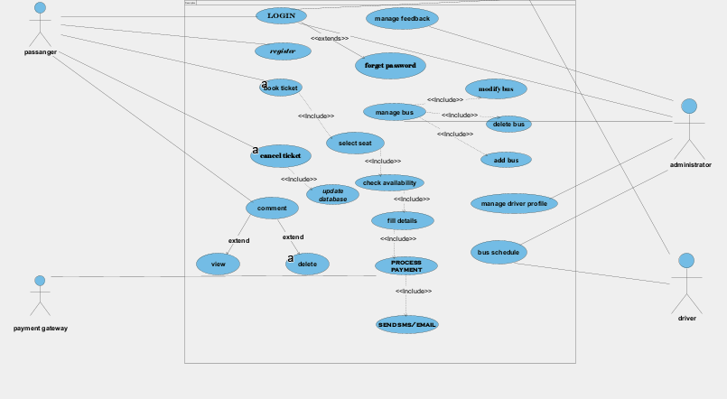

**3.5.4 Use case Description/template**

|  |  |
| --- | --- |
| Use Case | Bus Route Management |
| Participating Instance Actor: | Administrator |
| Precondition: | The administrator is logged into the system with valid credentials and has the necessary privileges to manage bus routes. |
| Flow of Events: | To add a new bus  1. The administrator selects the option to create a new bus route.  2. The system prompts the administrator to enter the source, destination, and intermediate stops for the new route.  3. The administrator provides the necessary details.  4. The system validates the route details and checks for any conflicts or inconsistencies.  5. If the route details are valid, the system generates a unique identifier for the new route and stores the route in the system.  6. The system confirms the successful creation of the new bus route. |
| Alternative Flow: | - If the route details are not valid in step 4:  1. The system displays an error message indicating the validation failure.  2. The administrator corrects the invalid details and proceeds with the creation of the route from step 2. |
| Post condition | A new bus route is successfully created and stored in the system. |

|  |  |
| --- | --- |
| Use Case | Bus Route Management |
| Participating Instance Actor: | Administrator |
| Precondition: | The administrator is logged into the system with valid credentials and has the necessary privileges to manage bus routes. |
| Flow of Events: | Modify an Existing Bus Route:  1. The administrator selects the option to modify an existing bus route.  2. The system presents a list of available bus routes for the administrator to choose from.  3. The administrator selects the desired route to be modified.  4. The system retrieves the current details of the selected route, including the stops and timings.  5. The administrator makes the necessary changes to the stops, timings, or other details of the route.  6. The system validates the modified details and checks for any conflicts or inconsistencies.  7. If the modifications are valid, the system updates the route with the new details.  8. The system confirms the successful modification of the bus route |
| Alternative Flow: | -Alternative Flow (Invalid Modifications):  1. If the modified details of the bus route are not valid or contain conflicts/inconsistencies:  2. The system displays an error message indicating the validation failure.  3. The administrator can choose to:  a. Correct the invalid modifications, making necessary corrections to the details.  b. Cancel the modification operation.  4. If the modifications are corrected and valid, the system updates the route with the corrected details.  5. If the modification operation is canceled, the original details of the bus route are retained. |
| Post condition | he selected bus route is successfully modified with the updated details. |

|  |  |
| --- | --- |
| Use Case | Bus Route Management |
| Participating Instance Actor: | Administrator |
| Precondition: | The administrator is logged into the system with valid credentials and has the necessary privileges to manage bus routes. |
| Flow of Events: | To remove the existing bus  1. The administrator selects the option to remove a bus route.  2. he system presents a list of available bus routes for the administrator to choose from.  3. The administrator selects the bus route to be removed.  4. The system validates the route removal request and checks if the selected route exists in the system.  5. If the route exists, the system deletes the route from the system and updates any associated data or references.  6. The system confirms the successful removal of the bus route. |
| Alternative Flow: | If the route removal request is invalid in step 4:  1.The system displays an error message indicating that the selected route does not exist or cannot be removed.  2.The administrator selects a different bus route to be removed or cancels the removal operation |
| Postcondition: | The selected bus route is successfully removed from the system. |

|  |  |
| --- | --- |
| Use Case | Online Ticket Booking |
| Participating Instance Actor: | Passenger |
| Precondition: | The administrator is logged into the system with valid credentials and has the necessary privileges to manage bus routes. |
| Flow of Events: | 1. Passenger Access: The passenger visits the online ticket booking website or mobile application.  2. Route and Date Selection: The system presents a user interface for selecting the desired bus route, travel date, and other relevant details.  3. Route Search: The passenger enters the required information and selects or searches for the required route with a specific time option.  4. Seat Availability Check: The system retrieves the current seat availability for the selected bus and travel date.  5. Seat Selection: If seats are available, the system displays the available seats to the passenger, highlighting the already booked seats. The passenger selects seats from the available options.  6. Fare Calculation: The system calculates the fare based on factors such as the distance of the selected route, the type of bus chosen, and any applicable discounts.  7. Payment Method Selection: The passenger selects the preferred payment method (e.g., credit card, digital wallet).  8. Payment Processing: The system redirects the passenger to the payment gateway's interface. The passenger enters the necessary payment details securely. The payment gateway processes the payment transaction securely.  9. Booking Confirmation: If the payment is successful, the system updates the seat availability status in real-time to prevent double bookings. The system confirms the successful booking and generates a unique ticket reference number.  10. Ticket Generation: The system displays the ticket details to the passenger, including the route, travel date, seat numbers, fare, and ticket reference number. |
| Alternative Flow: | If the route removal request is invalid in step 4:  - If seat availability changes between seat selection and payment, the system notifies the passenger and prompts them to select alternative seats.  - If the payment transaction fails, the system provides an error message and allows the passenger to retry or choose another payment method. |
| Postcondition | The online ticket booking use case is completed, and the passenger receives a booking confirmation or cancellation confirmation. |

|  |  |
| --- | --- |
| Use Case | Ticket Cancellation |
| Participating Instance Actor: | Administrator |
| Precondition: | The passenger has a valid ticket and intends to cancel it. |
| Flow of Events: | 1. Passenger Initiates Cancellation: The passenger accesses the ticket cancellation feature through the system, website, or app.  2. Ticket Identification: The passenger provides the necessary information, such as ticket number or booking reference, to identify the ticket to be canceled.  3. Ticket Verification and Eligibility Check: The system verifies the provided information and determines if the ticket is valid and eligible for cancellation. If eligible, the system proceeds to step 4. If not, the passenger receives an error message and cancellation is not possible.  4. Refund Calculation: The system calculates the refund amount based on the cancellation policy and any applicable fees or deductions.  5. Cancellation Confirmation: The passenger confirms the cancellation, acknowledging the refund amount and any applicable terms and conditions.  6. Ticket Cancellation and Refund Processing: The system updates the ticket status as canceled, initiates the refund process, and updates the passenger's account with the refund amount. The passenger receives a notification confirming the cancellation and providing details of the refund process. |
| Alternative Flow: | If the route removal request is invalid in step 4:  1.- If the ticket is not eligible for cancellation based on the cancellation policy or other restrictions, the system displays an error message and informs the passenger accordingly.  2- In cases where the refund amount is subject to review or manual processing, the system may display a message indicating that the refund will be processed separately, and the passenger will be notified of any updates. |
| Post condition | The ticket cancellation process is completed, and the passenger receives confirmation of the cancellation and any applicable refund. |

|  |  |
| --- | --- |
| Use Case | User Registration |
| Participating Instance Actor: | passenger |
| Precondition: | 1. The user has access to a web browser or mobile application with internet connectivity.  2. The user has a valid email address and a mobile phone number (optional). |
| Flow of Events: | 1. User opens the transport booking system in their web browser or mobile application.  2. User clicks on the "Register" or "Sign Up" option.  3. User fills in the registration form with their personal information:  - Name  - Email address  - Password  - Contact number (optional)  - Other necessary details (optional)  4. User submits the registration form.  5. System performs validation checks on the entered information:  - Email address uniqueness  - Password complexity  - Contact information formatting  6. If validation checks pass:  - System creates a new user account with a unique identifier.  - User account is stored in the system's database.  - Confirmation email or notification is sent to the registered email address.  7. If validation checks fail:  - System displays error messages indicating the specific issues.  - User corrects the errors and resubmits the form.  8. If a duplicate account exists:  - System notifies the user and prompts them to recover their existing account or use a different email address. |
| Alternative Flow: | If the route removal request is invalid in step 4:  1.- If the ticket is not eligible for cancellation based on the cancellation policy or other restrictions, the system displays an error message and informs the passenger accordingly.  2- In cases where the refund amount is subject to review or manual processing, the system may display a message indicating that the refund will be processed separately, and the passenger will be notified of any updates. |
| Post condition | The user registration process is completed, and the user receives a confirmation email or notification to verify their account. |

|  |  |
| --- | --- |
| Use Case | Feedback Submission |
| Participating Instance Actor: | Passenger |
| Precondition: | The passenger wants to provide feedback on their travel experience or the services provided. |
| Flow of Events: | 1. Initiate feedback submission:  - The passenger accesses the feedback submission feature through the system, website, or app.  - The system presents the feedback submission form to the passenger.  2. Provide feedback details:  - The passenger fills out the feedback submission form, providing details such as their name, contact information, date of travel, and the nature of their feedback.  - The passenger may also provide additional comments or suggestions related to their experience.  3. Submit feedback:  - After completing the feedback form, the passenger submits their feedback to the system.  - The system records the feedback submission and assigns a unique identifier to the feedback.  4. Acknowledge feedback submission:  - The system displays a confirmation message to the passenger, acknowledging the successful submission of their feedback.  - The system may provide an estimated time frame for a response, if applicable. |
| Alternative Flow: | If the route removal request is invalid in step 4:  1.- If the ticket is not eligible for cancellation based on the cancellation policy or other restrictions, the system displays an error message and informs the passenger accordingly.  2- In cases where the refund amount is subject to review or manual processing, the system may display a message indicating that the refund will be processed separately, and the passenger will be notified of any updates. |
| Post condition | The feedback submission process is completed, and the passenger receives confirmation of their feedback submission. |

3.5 Requirement Analysis

3.5.1 Activity Diagram

The activity diagram for the bus reservation system is a visual representation of the system's functionality from the user's perspective. It shows the different steps involved in booking a bus ticket, starting from the user's initial search for a bus to the final confirmation of their booking.

Detailed Explanation of the Activity Diagram:

**1. Start:** The user opens the bus reservation system and starts the booking process.

**2. Search for Bus:** The user enters their travel details, including origin, destination, and travel date. The system searches for available buses based on these criteria.

**3. Select Bus:** The system displays a list of available buses with details such as departure time, arrival time, bus type, and fare. The user selects the desired bus and continues.

**4. Select Seats:** The system displays the available seats on the selected bus. The user selects their preferred seats and proceeds to the next step.

**5. Passenger Details:** The user enters their personal information, including name, contact details, and email address. This information is required for booking confirmation and e-ticket delivery.

**6. Payment:** The user chooses their preferred payment method and provides the necessary payment information. The system processes the payment and confirms the booking.

The system displays a confirmation message with the booking details, including the e-ticket. The user receives an email with the e-ticket attached.

**8. Track Bus:** The user can track the real-time location of the bus on a map using the booking reference number.

**9. Notifications:** The user receives notifications about their booking, such as booking confirmations, cancellations, and bus arrival updates.

**10. End:** The booking process is completed, and the user can access their booking details and manage their trip through their online account.

Activity Diagram for Admin

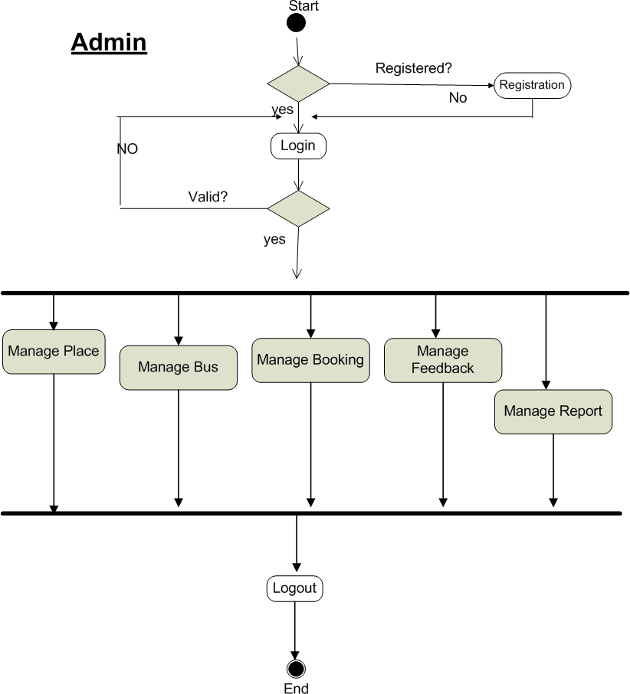

Activity Diagram for User

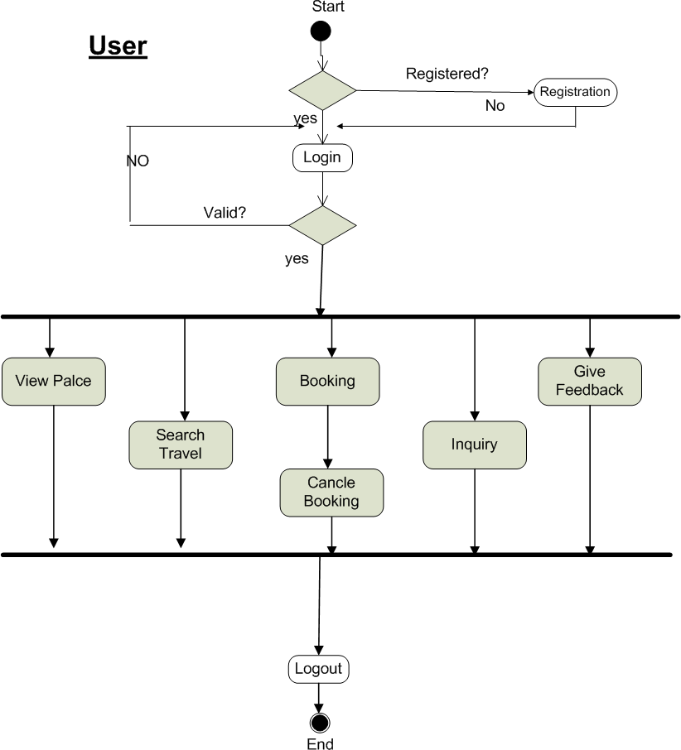

3.5.2 Sequence Diagram

The sequence diagram for the bus reservation system is a visual representation of the interactions between the user, the system, the database, and the payment gateway. It shows the sequence of messages exchanged between these components during the booking process.

1. Booking bus

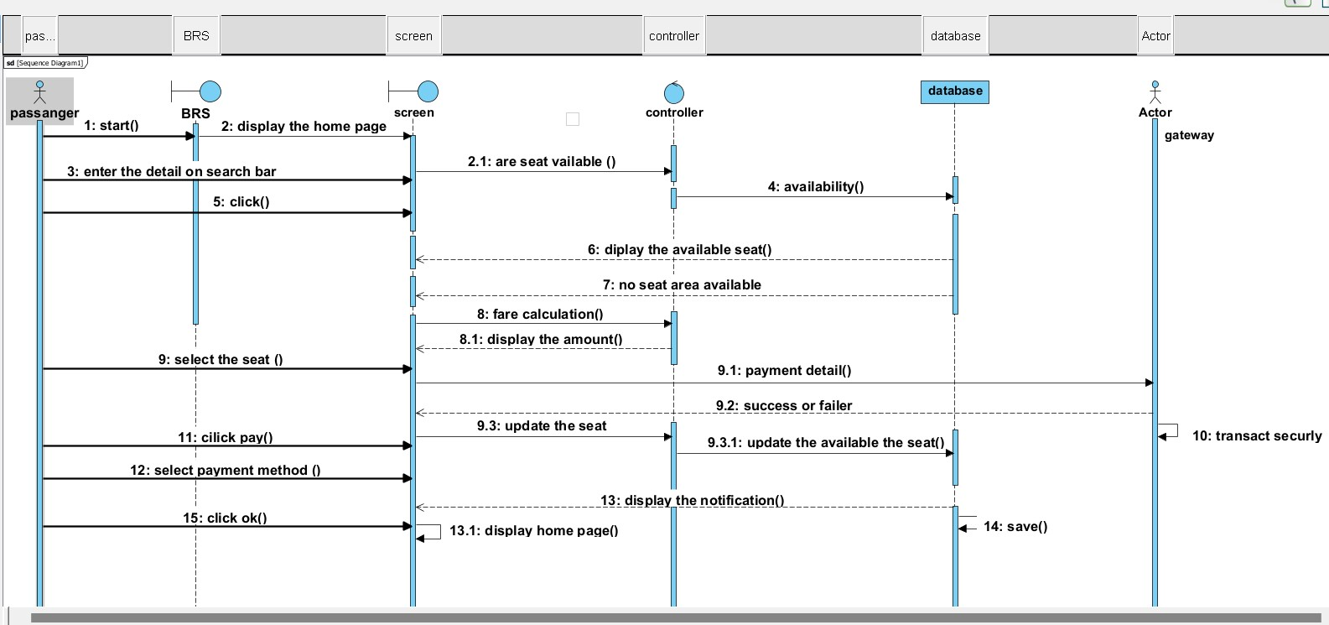

2.remove bus route

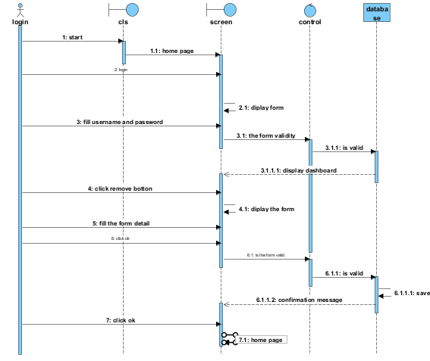

3.add bus route

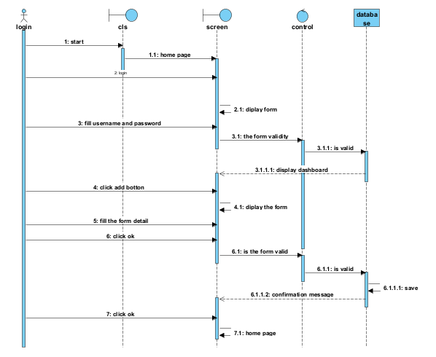

4.registration

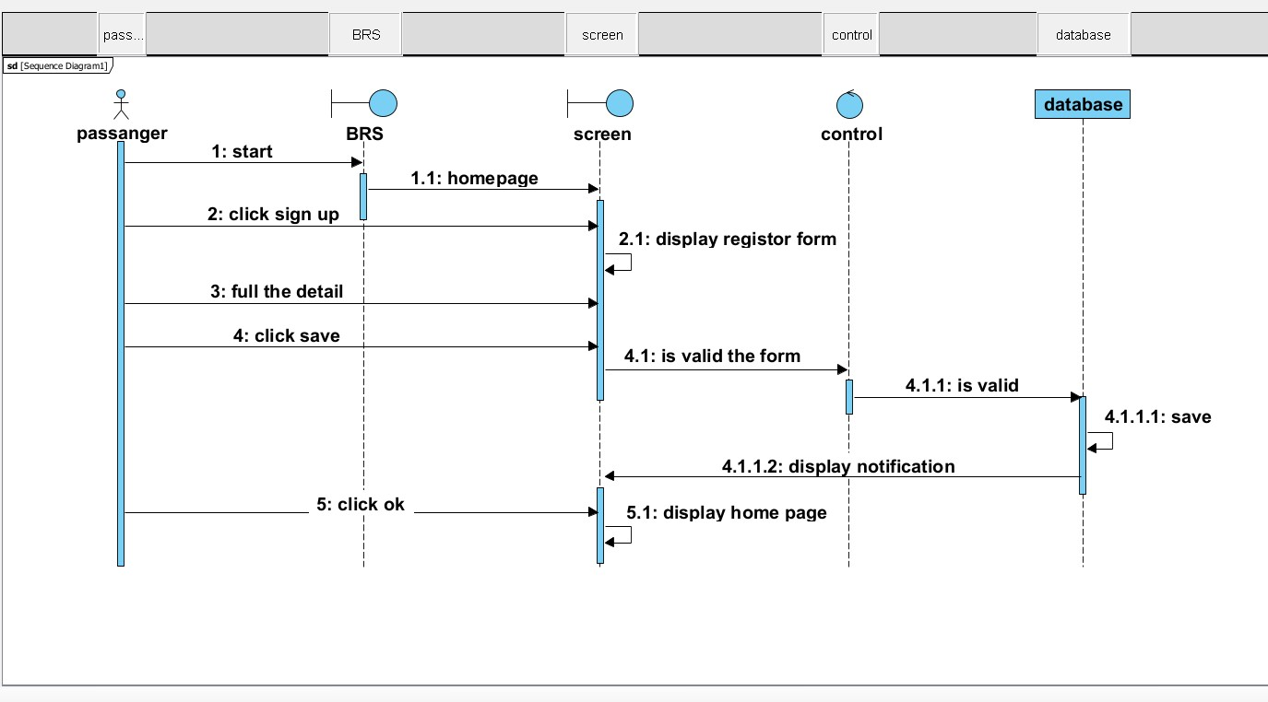

**5.update bus route**

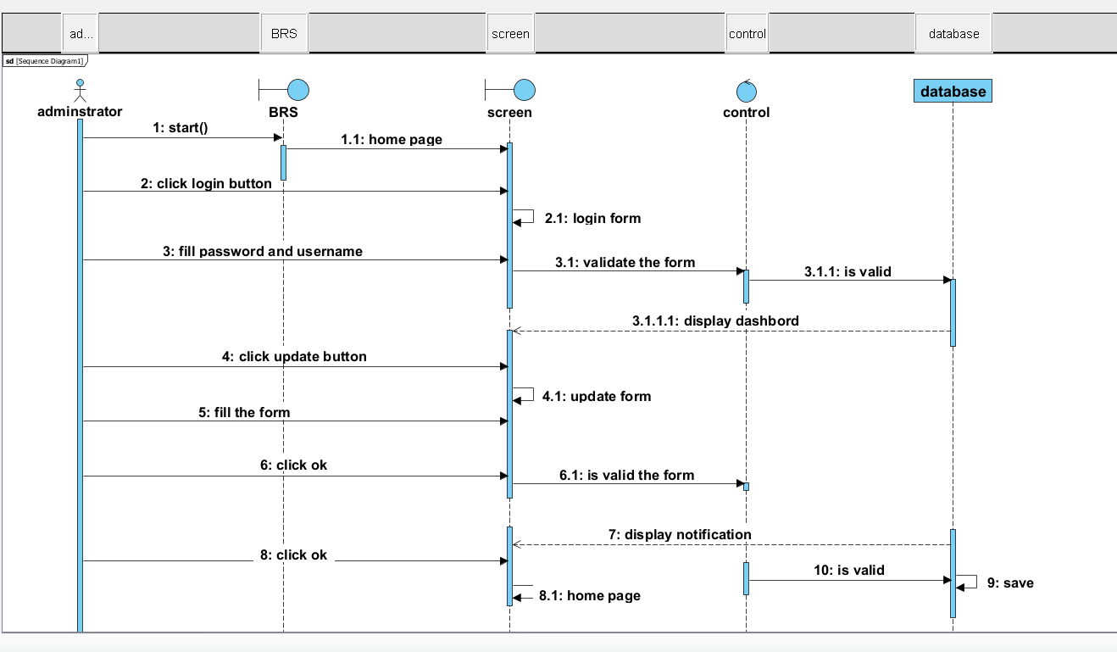

Detailed Explanation of the Sequence Diagram:

**1. User:** The user enters their search criteria into the system.

**2. System**: The system sends a request to the database to search for available buses.

**3. Database:** The database returns the results to the system.

**4. System:** The system displays the available buses to the user.

**5. User:**The user selects a bus and seats.

**6. System:** The system sends a request to the payment gateway to process the payment.

**7. Payment Gateway:** The payment gateway processes the payment and sends a confirmation to the system.

**8. System:** The system confirms the booking and sends an e-ticket to the user.

9. User: The user can track the bus location in real-time.

**10. System:** The system sends notifications to the user about their booking.

3.5.3 Requirement Validation & Verification

3.5.3.1 Validity Checks

Validity checks ensure that the system meets the basic requirements and specifications. This includes verifying that:

**User inputs are valid:** Check that user-entered data, such as names, email addresses, and dates, are in the correct format and within acceptable ranges.

**Bus schedules are accurate**: Verify that the bus schedules are up-to-date and reflect the actual departure and arrival times.

**Fare calculations are correct:** Ensure that the fare calculations are accurate and consistent with the published fares.

**Payment processing is secure:** Verify that the payment gateway is secure and protects user payment information.

3.5.3.2 Consistency Checks

Consistency checks ensure that the system's data is consistent and free from contradictions. This includes verifying that:

Bus availability is consistent across different search results: Ensure that the availability of buses displayed in different search results is consistent and reflects the actual availability.

Seat selections are consistent with the bus layout: Verify that the seat selections made by users are consistent with the actual layout of the bus.

Booking confirmations match the original booking details: Ensure that the booking confirmations sent to users accurately reflect the details of their original booking.

3.5.3.3 Completeness Checks

Completeness checks ensure that all necessary information is captured and stored in the system. This includes verifying that:

**User profiles are complete**: Ensure that user profiles contain all the necessary information, such as name, contact details, and email address.

**Booking records are complete**: Verify that booking records include all the necessary details, such as passenger information, bus details, and payment information.

**System logs are complete:** Ensure that system logs capture all relevant events, such as user actions, system errors, and successful transactions.

3.5.3.4 Realism Checks

Realism checks ensure that the system's functionality is realistic and meets the actual needs of users. This includes verifying that:

Search results are relevant: Ensure that the search results displayed to users are relevant to their search criteria and provide accurate information.

Booking process is user-friendly: Verify that the booking process is easy to understand and follow for users with varying levels of technical expertise.

System performance is acceptable: Ensure that the system responds quickly and efficiently to user requests, even during peak usage times.

3.5.3.5 Verifiability

Verifiability checks ensure that the system's requirements can be objectively verified through testing and other methods. This includes:

Defining clear acceptance criteria: Establish clear and measurable criteria for each requirement to determine whether it has been met.

Developing test cases: Create test cases that cover all aspects of the system's functionality and verify that it meets the defined acceptance criteria.

Documenting test results: Record the results of testing and other verification activities to provide evidence that the system meets the requirements.

CHAPTER 4 - SYSTEM DESIGN

4.1 Introduction

This chapter describes the design of the bus reservation system. It covers the design issues, design patterns, and system architecture. The goal of this chapter is to provide a clear and detailed understanding of how the system will be designed and implemented.

4.2 Design Issues

Several design issues need to be considered when developing the bus reservation system. These include:

Reuse:The system should be designed to reuse existing components and libraries whenever possible. This will save time and effort during development and ensure consistency across different parts of the system.

Future change:The system should be designed to be flexible and adaptable to future changes. This includes changes in user requirements, technology, and business needs.

Refactoring:The system should be designed to allow for easy refactoring. Refactoring is the process of improving the design of existing code without changing its functionality. This can help to improve the system's maintainability and performance.

Components: The system should be designed using a component-based architecture. This means that the system will be divided into smaller, independent components that can be developed and tested independently. This will make the system easier to maintain and extend.

4.3 Design Patterns

Several design patterns can be used to improve the design of the bus reservation system. These include:

Model-View-Controller (MVC): The MVC pattern is a popular design pattern for web applications. It separates the application into three parts: the model, the view, and the controller. The model represents the data, the view represents the user interface, and the controller handles the interactions between the model and the view. This pattern helps to improve the separation of concerns and make the application more maintainable.

Service Layer: The service layer pattern is used to encapsulate business logic and data access. This pattern helps to improve the modularity of the application and make it easier to test and reuse business logic.

Repository Pattern: The repository pattern is used to abstract data access from the rest of the application. This pattern helps to improve the separation of concerns and make the application more independent of the underlying data store.

**4.4 Class digram**

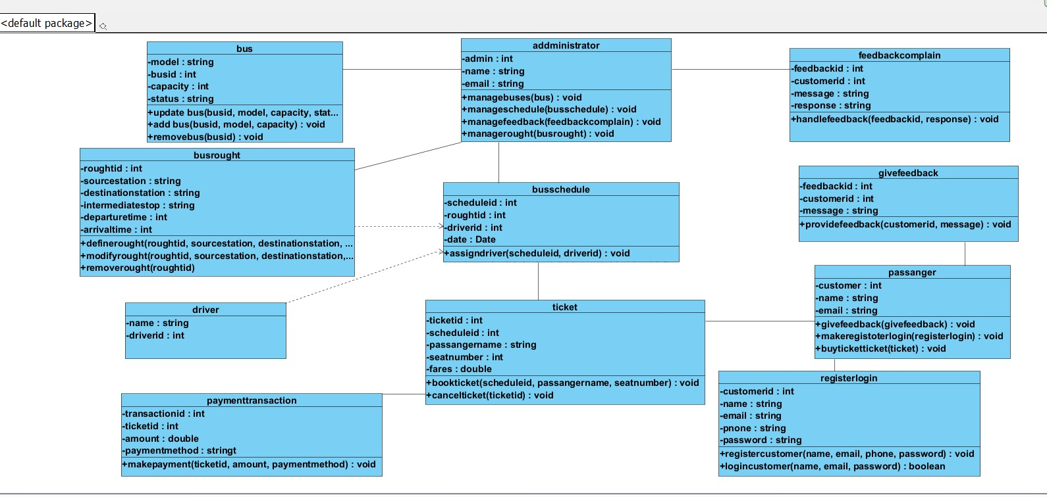

Observer Pattern: The observer pattern is used to notify interested parties about changes in the system. This pattern can be used to implement features such as real-time bus tracking and booking notifications.

4.5 Database Model

4.5.1 Entity Relationship Diagram (ERD)

The Entity Relationship Diagram (ERD) for the bus reservation system is shown below:

![Bus Reservation System ERD][image_0]

Explanation:

* The ERD shows the entities involved in the system and the relationships between them.

* The entities include:

* User: Represents a registered user of the system.

* Bus: Represents a bus operated by a bus company.

* Route: Represents a route that a bus travels on.

* Schedule: Represents a specific schedule for a bus on a route.

* Seat: Represents a seat on a bus.

* Booking: Represents a booking made by a user for a specific seat on a specific schedule.

* The relationships between the entities are:

* A user can make multiple bookings.

* A bus can have multiple schedules.

* A schedule can have multiple seats.

* A booking is for a specific seat on a specific schedule.

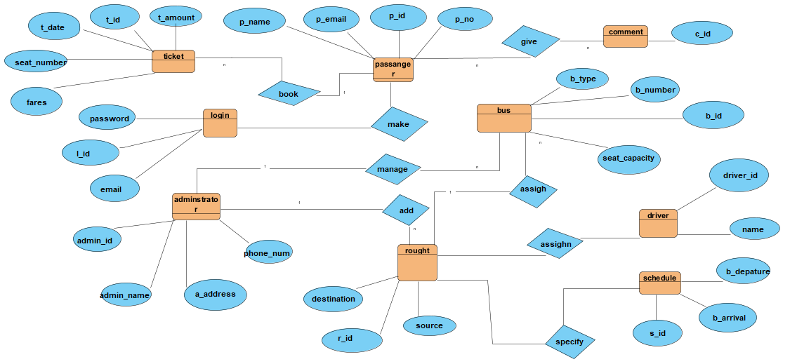

4.5.2 Persistence Modeling

The persistence model for the bus reservation system will be implemented using a relational database management system (RDBMS). The following tables will be created to store the system's data:

Users: This table will store information about registered users, including their name, email address, password, and contact details.

Buses: This table will store information about buses, including their bus ID, bus type, capacity, and amenities.

Routes: This table will store information about routes, including their route ID, origin, destination, and distance.

Schedules: This table will store information about bus schedules, including their schedule ID, bus ID, route ID, departure time, arrival time, and fare.

Seats: This table will store information about seats on buses, including their seat ID, bus ID, seat number, and type (e.g., window, aisle).

Bookings: This table will store information about bookings made by users, including their booking ID, user ID, schedule ID, seat ID, and payment details.

4.5.3 Mapping with Normalization

The database model will be normalized to reduce data redundancy and improve data integrity. The following normalization rules will be applied:

1NF (First Normal Form): Each column in a table will contain atomic values (indivisible units of data).

2NF (Second Normal Form): All non-key attributes will be fully dependent on the primary key.

3NF (Third Normal Form): All non-key attributes will be non-transitively dependent on the primary key.

**4.6 Subsystem Decomposition**

The bus reservation system can be decomposed into the following subsystems:

1. User Management Subsystem:

* Responsible for managing user accounts, including registration, login, and profile updates.

* Handles user authentication and authorization.

* Provides functionalities for users to view their booking history and manage their profile information.

2. Bus Management Subsystem:

* Responsible for managing information about buses, including bus types, capacities, and amenities.

* Handles the addition, modification, and deletion of bus information.

* Provides functionalities for bus operators to update bus availability and manage their fleet.

3. Route Management Subsystem:

* Responsible for managing information about routes, including origin, destination, distance, and stops.

* Handles the addition, modification, and deletion of route information.

* Provides functionalities for route planners to create and manage routes.

4. Schedule Management Subsystem:

* Responsible for managing bus schedules, including departure times, arrival times, fares, and availability.

* Handles the creation, modification, and deletion of schedules.

* Provides functionalities for bus operators to create and manage their schedules.

5. Seat Management Subsystem:

* Responsible for managing seat availability on buses.

* Handles the allocation and release of seats.

* Provides functionalities for users to select and book seats.

6. Booking Management Subsystem:

* Responsible for managing user bookings, including booking confirmation, cancellation, and payment processing.

* Handles the generation of e-tickets and booking confirmations.

* Provides functionalities for users to view and manage their bookings.

7. Payment Processing Subsystem:

* Responsible for processing payments for bus tickets.

* Integrates with payment gateways to securely handle online transactions.

* Provides functionalities for users to pay for their bookings using various payment methods.

8. Notification Subsystem:

* Responsible for sending notifications to users about their bookings, such as booking confirmations, cancellations, and bus arrival updates.

* Integrates with email and SMS services to deliver notifications.

* Provides functionalities for users to manage their notification preferences.

9. Reporting Subsystem:

* Responsible for generating reports on bus bookings, revenue, and other system metrics.

* Provides functionalities for administrators to analyze system usage and performance.

* Generates reports in various formats, such as PDF, CSV, and Excel.

10. Administration Subsystem:

* Provides functionalities for administrators to manage the system, including user management, bus management, route management, and system configuration.

* Allows administrators to monitor system activity, view logs, and troubleshoot issues

**4.7 Deployment diagram**

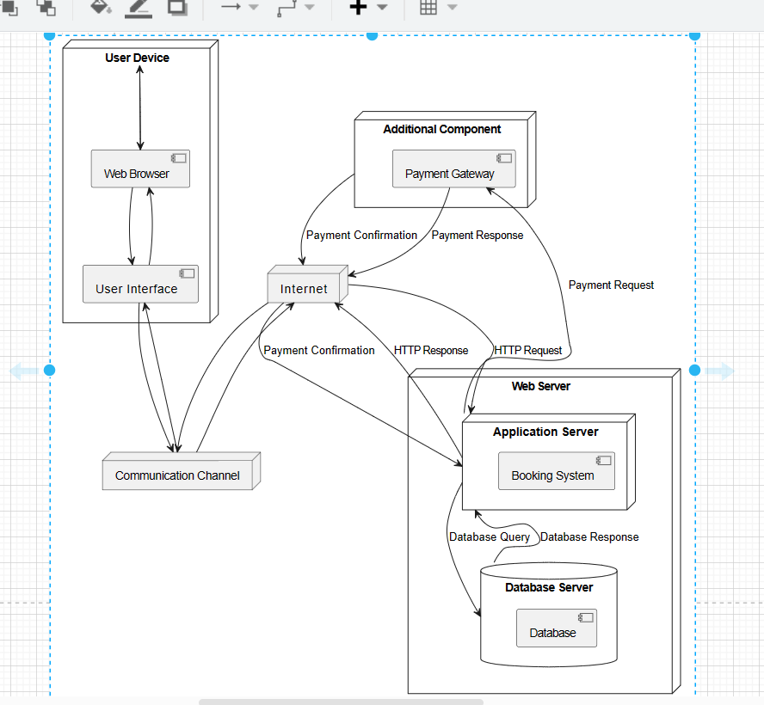

4.8 System Architecture (Layered Architecture of the System)

4.8.1 Overall System Architecture

The bus reservation system will be designed using a layered architecture, as shown below:

![Bus Reservation System Layered Architecture][image_0]

Explanation:

Presentation Layer: This layer is responsible for handling user interactions and displaying information to the user. It includes the user interface (UI), which can be a web application, mobile app, or desktop application.

Business Logic Layer: This layer contains the core business logic of the system, such as booking management, payment processing, and notification handling. It interacts with the presentation layer to receive user requests and send responses.

Data Access Layer: This layer is responsible for accessing and managing data stored in the database. It provides an abstraction layer between the business logic layer and the database, allowing the business logic to be independent of the specific database technology used.

Database Layer: This layer stores the system's data, such as user information, bus schedules, bookings, and payments. It can be implemented using a relational database management system (RDBMS), a NoSQL database, or a cloud-based database service.

**4.8.2 Detail of Architectural Patterns and Styles**

The following architectural patterns and styles will be used in the design of the bus reservation system:

Model-View-Controller (MVC): The MVC pattern will be used to structure the presentation layer. The model will represent the data, the view will represent the user interface, and the controller will handle the interactions between the model and the view.

Service Layer: The service layer pattern will be used to encapsulate business logic and data access. This will improve the modularity of the application and make it easier to test and reuse business logic.

Repository pattern: The repository pattern will be used to abstract data access from the rest of the application. This will improve the separation of concerns and make the application more independent of the underlying data store.

RESTful API: The system will expose a RESTful API to allow external applications to interact with it. This will enable integration with other systems and provide flexibility for future development.

**4.9 User-Interface (UI) Design**

The UI design of the bus reservation system will be user-friendly, intuitive, and responsive. It will provide a seamless experience for users to search for buses, book tickets, and manage their bookings. The UI will be desiged with the following principles in mind:

Clarity: The UI will be clear and easy to understand, with intuitive navigation and clear instructions.

Consistency: The UI will be consistent across different pages and devices, providing a familiar and predictable experience for users.

Accessibility: The UI will be accessible to users with disabilities, following accessibility guidelines and best practices.

Responsiveness: The UI will be responsive and adapt to different screen sizes and devices, ensuring a good user experience on all platforms.

1. The user interface for system home page

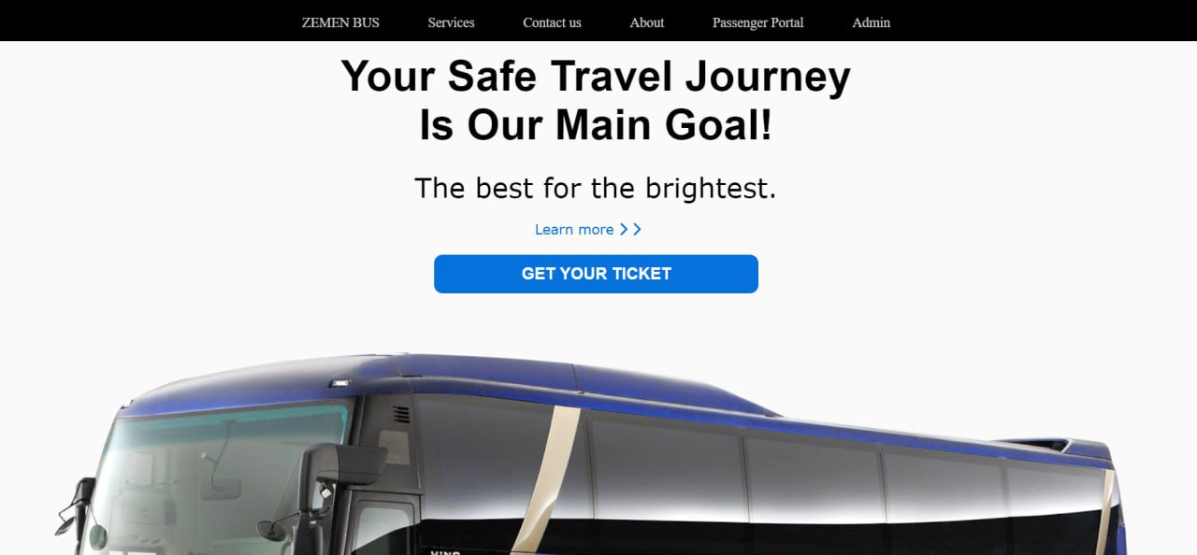

2. The login page form for admin

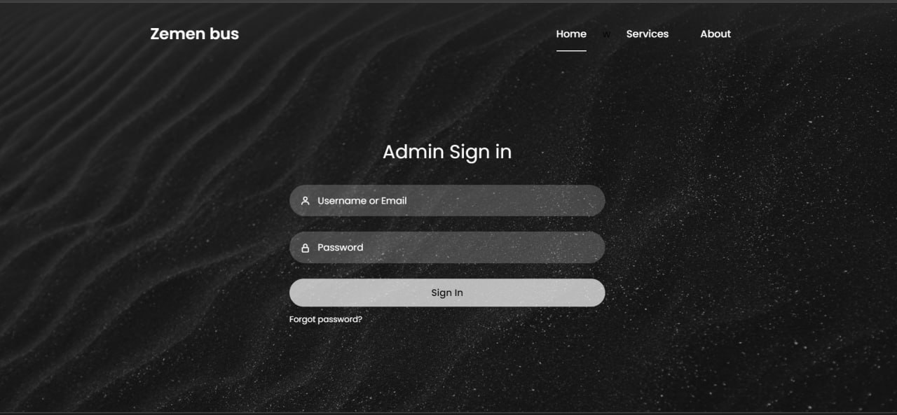

1. The admin dashboard

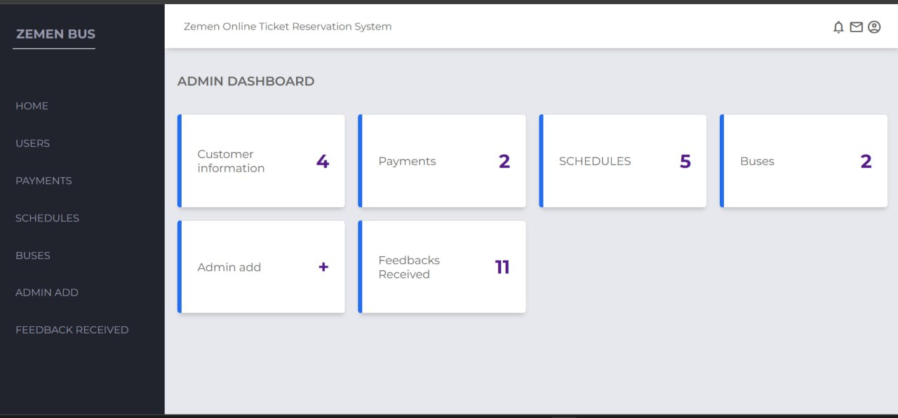

1. the customer registration

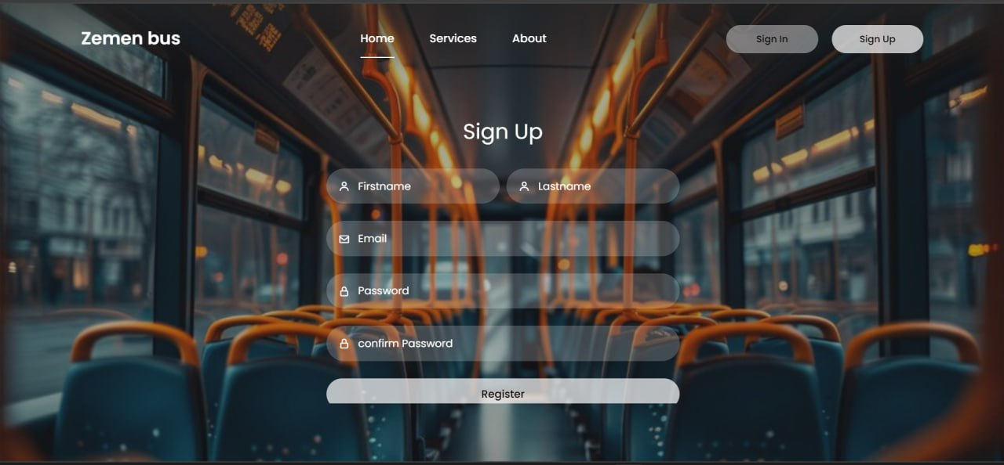

1. the customer dashboard

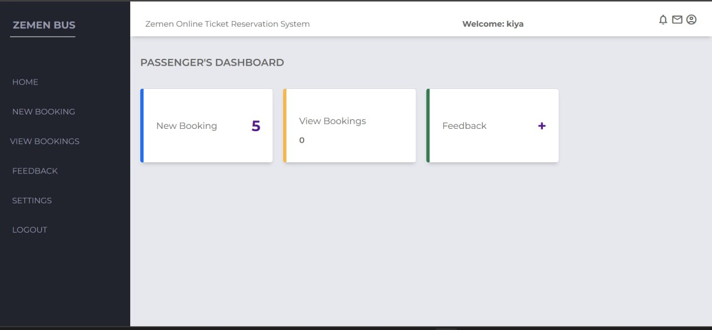

1. The passanger login page

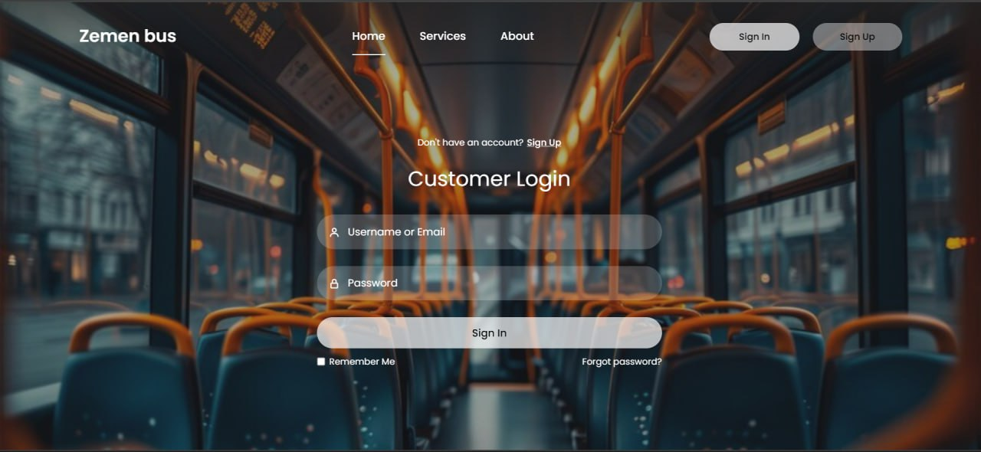

4.10 UI Flow Diagramming

The UI flow diagrams for the bus reservation system will illustrate the different user journeys and interactions with the system. These diagrams will show the steps involved in searching for buses, booking tickets, managing bookings, and other system functionalities. The UI flow diagrams will help to ensure that the UI is designed to meet the needs of users and provide a smooth and efficient experience.