Topic – SQL Task-1

TABLE: - Employee

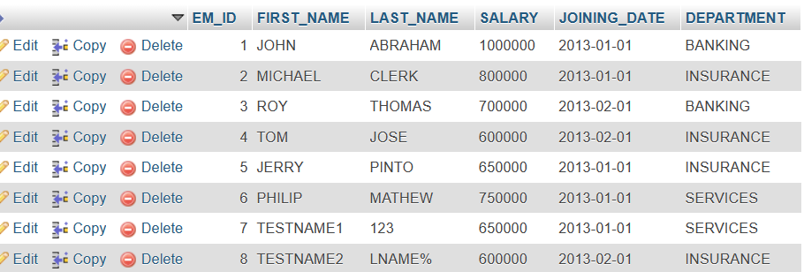
TABLE: - Incentives
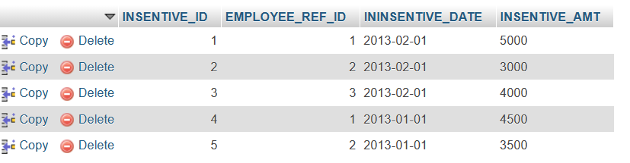
a) Get First_Name from employee table using alias name “Employee Name”.

=> select FIRST_NAME as Employee_Name from employee;

b) Get FIRST_NAME, Joining year, Joining Month and Joining Date from employee table.

=>SELECT FIRST_NAME,JOINING_DATE FROM employee;

c) Get all employee details from the employee table order by First Name Ascending And Salary descending?

=>SELECT* from employee order by FIRST_NAME ASC,SALARY DESC;

d) Get employee details from employee table whose first name contains „o‟.

=>SELECT * FROM employee WHERE FIRST_NAME like 'o%';

e) Get employee details from employee table whose joining month is “January”.

=>SELECT * FROM employee WHERE JOINING_DATE like '2013-01-01%';

f) Get department, total salary with respect to a department from employee table Order By total salary descending.

=> SELECT all SALARY FROM employee ORDER BY SALARY DESC;

g) Get department wise maximum salary from employee table order by salary ascending?

=>SELECT MAX(SALARY),SALARY FROM employee ORDER BY SALARY ASC;

h) Select first_name, incentive amount from employee and incentives table for those Employees who have incentives and incentive amount greater than 3000

=> select EMPLOYEE_REF_ID,INSENTIVE_AMT from incentives where 3000 < INSENTIVE_AMT;

i) Select 2nd Highest salary from employee table.

=> SELECT * FROM employee ORDER BY SALARY DESC LIMIT 1,1;

j) Select first_name, incentive amount from employee and incentives table for all Employees who got incentives using left join.
=> SELECT FIRST_NAME,INCENTIVE_AMT
FROM employee A LEFT JOIN incentives B
ON A.EM_ID=B.EMPLOYEE_REF_ID;

k) Create View OF Employee table in which store first name, last name and salary only.
=>SELECT FIRST_NAME,LAST_NAME,SALARY FROM employee;
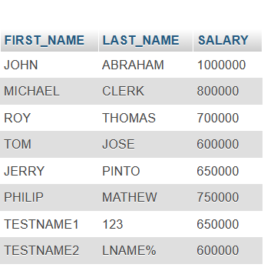

l) Create Procedure to find out department wise highest salary.
=> SELECT DEPARTMENT,MAX(SALARY) FROM employee GROUP BY DEPARTMENT;

m) Create after Insert trigger on Employee table which insert records in view table.
=> SELECT EM_ID, FIRST_NAME LAST_NAME, SALARY, JOINING_DATE,DEPARTMENT FROM employee WHERE ('TRIGGER ACTION');

Task-2:

TABLE – SALES PERSON

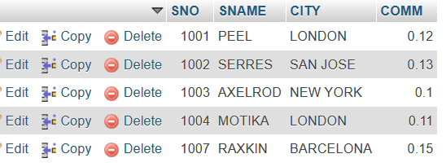

TABLE – CUSTOMER

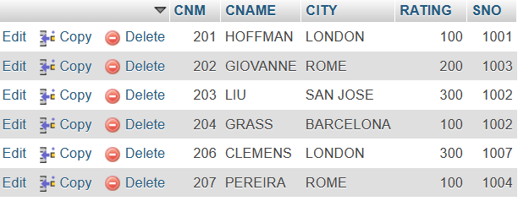
TABLE – ORDER

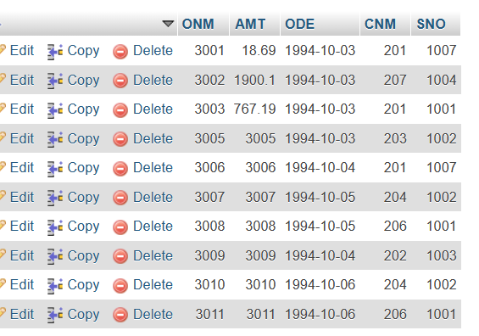

a) All orders for more than $1000.
=> SELECT * FROM `orders` WHERE AMT >1000;

b) Names and cities of all salespeople in London with commission above 0.10.
=> SELECT SNAME,CITY FROM salesperson WHERE COMM > 0.10 AND CITY ='LONDON';

c) All salespeople either in Barcelona or in London.
=> SELECT SNAME,CITY FROM salesperson WHERE CITY IN ('BARCELONA','LONDON');

d) All salespeople with commission between 0.10 and 0.12. (Boundary values should be excluded).
=> SELECT SNAME,COMM FROM salesperson WHERE COMM > 0.10 AND COMM <0.12 ;

e) All customers with NULL values in city column.
=>SELECT CNAME FROM `customer` WHERE CITY IS NULL;

f) All orders taken on Oct 3Rd and Oct 4th 1994.
=> SELECT * FROM `orders` WHERE ODE IN ('1994-10-03','1994-10-04');

g) All customers serviced by peel or Motika.
=>SELECT CNAME FROM customer, orders WHERE orders.CNM= customer.CNM AND orders.SNO IN (SELECT SNO FROM salesperson WHERE SNAME IN 'PEEL','MOTIKA');

h) All customers whose names begin with a letter from A to B
=> SELECT CNAME FROM `customer` WHERE CNAME LIKE 'A%' OR CNAME LIKE 'B%' ORDER BY CNAME;

i) All customers excluding those with rating <= 100 unless they are located in Rome.
=>SELECT CNAME FROM customer WHERE RATING <=100 OR CITY = 'ROME';

j) All orders except those with 0 or NULL value in amt field.
=> SELECT ONM FROM `orders` WHERE AMT!=0 OR AMT IS NOT NULL;

k) Count the number of salespeople currently listing orders in the order table.
=> SELECT COUNT(DISTINCT SNO) FROM orders;

