Project Name: DIAMOND DREAMS

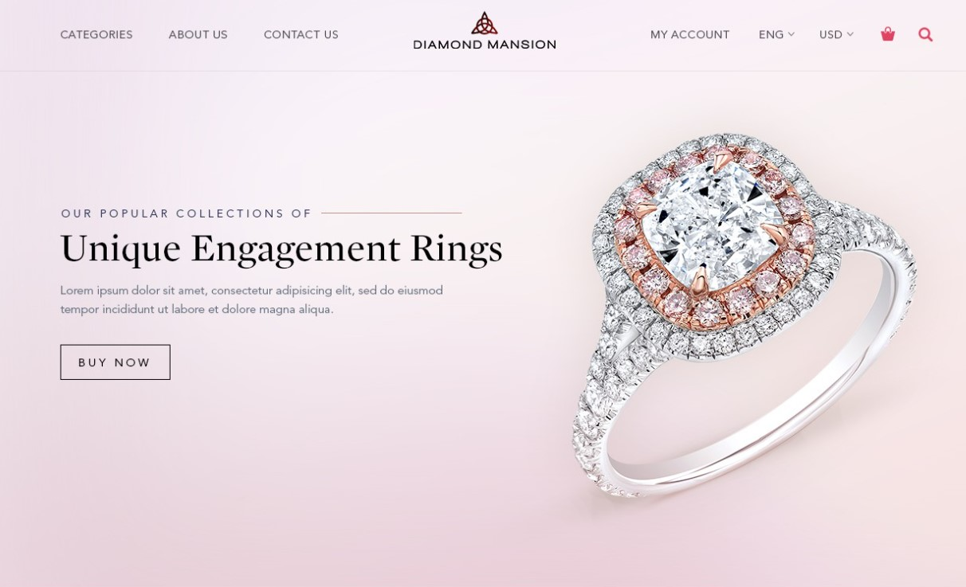

Jalpa Sarvaliya

Edureka Presents

Overview:

It’s an e-commerce website for all type jewellery for every occasion for women.

1. HOME PAGE:

* Logo
* Searchbar
* Icons(account,wishlist,add to cart)
* Slider with arrows(images)
* Shop by category
* Feature
* Trends product(images)
* Connect with us
* Footer(information/contact no./social media icons/link or download to mobile app/brief description about company/payment method/icon to show payment structure)

1. Account/Sign up:

* Name
* Contact no.
* Email
* Password
* Re-enter password

1. Main page:

* Images of the chosen product with details (product name,price,discount%(if any))
* On clicking the image – (multiple images of product will appear from different angles,zoom in, zoom out)
* Product Description – product name , price , discount% (if any), size chart , delivery options,product details, size , specification , rating, reviews with images(if any)

1. Payment page:

* Name for customer
* Contact no.
* Email
* Address
* Payment method

1. Technologies used in :

* Frontend:
* Html
* Css
* Bootstrap
* Code compilers:
  + - Visual studio code
    - Git Bash
    - Git Hub