Final Assessment-Alternative Assessment
Semester | 202520 | Division | CIS
Assessment title in Syllabus | Final_Project_Portfolio | Program | Bachelor of Information Technology/ Bachelor of Information Systems
Course Code | CDS 2413
Course Title | INTRODUCTION TO DATA SCIENCE
Course Instructor |  | CRN
Assessment | Project Deliverable 1 – Data Analysis Report | Submission Date | Week 6
Student Declaration:
Academic Integrity Statement
In accordance with the HCT Academic Integrity Policy
• Students are required to refrain from all forms of academic integrity breaches as defined and explained by HCT.
• A student found guilty of having committed acts of academic integrity breach(es) will be subject to the relevant sanctions as outlined by HCT.
إفادة النزاهة الأكاديمية
وفقًا لسياسة كليات التقنية العليا للنزاهة الأكاديمية
• على الطلبة الإلتزام بلوائح وقواعد النزاهة الأكاديمية، كما هو مبيّن وموضح في السياسات والإجراءات الخاصة بكليات التقنية العليا.
• في حالة ارتكاب الطالب أي شكل من أشكال الإخلال بالنزاهة الأكاديمية، سيتعرض الى العقوبات الموضحة في السياسات ذات الصلة.
This assignment is entirely my/our own work except where I have duly acknowledged other sources in the text and listed those sources at the end of the assignment. I have not previously submitted this work to the HCT, or any other entity. I understand that I may be orally examined on my submission.

Student HCT ID(s): | H00497493 | H00478342 | H00 | H00
Student Name(s): | Jawaher Adel | Sara Ahmad
Student Signature
Chatbot (e.g. ChatGPT) statement
This submission allows you to use AI generated tools, but the prompt used must be stated and the response must be in red font. Include References to ChatGPT.

Instructions

Remove instructions and hints from the template before submitting the final report to BBLearn.

CLO1: Introduction and Data Wrangling

Purpose of Data Analysis

The purpose of analyzing the student’s social media and relationships dataset is to understand how students’ social media usage affects their academic performance, mental health, sleep habits, and relationships. The dataset contains anonymized survey responses from students across different countries and academic levels, including variables such as daily usage hours, addiction score, relationship conflicts, and sleep time.

Through data analysis, we aim to identify patterns, relationships, and trends ( for example, whether higher social media usage leads to lower academic performance or more relationship conflicts). This helps in making data-driven decisions for educators, students, and researchers.

Type of Programming

The type of programming used is Data Analysis Programming using Python
Justification:
- Python (with libraries such as pandas, NumPy, Matplotlib, and Scikit-learn) is widely used for data cleaning, visualization, and machine learning.
- The dataset is structured (CSV format with multiple variables), which makes it suitable for data-analysis programming.
- Python supports both descriptive analysis and machine learning modelling, which are required for this project.

Type and Purpose of ML algorithm

The most suitable ML type for this dataset is:
Supervised learning:
Type of algorithms:
- Classification (predicting whether social media affects academic performance : YES /NO)
- OR
- Regression (predicting addiction score or mental health score)
Purpose:

To build a predictive model that can:
- Predict whether social media usage negatively affects academic performance
- Predict addiction level or mental health score based on usage patterns
This dataset si appropriate for ML because it includes labelled variables such as affects academic performance and addiction score.

Identify the Varaibles
Independent variables (input features ) :
- Age
- Gender
- Academic level
- Country
- Average daily usage hours
- Most used platform
- Sleep hours per night
- Mental health score
These variables represent factors that may influence outcomes.

Dependent variables (Target variables):
You can choose one to depend on your model goal:
- Affect academic performance (YES/NO) →for classification
Or
- Addicted Score / mental health score → for regression

Justification:
The dependent variable is the outcome we want to predict, while the independent variable are the factors that may influence it.

Sampling
Yes, sampling can be applied if the dataset is large or to reduce processing time.

Type of sampling:
Random sampling
Justification:
- The dataset contains responses from many students across countries and academic level
- Random sampling ensures every student has equal chance of being selected.
- It reduces bias and maintains a representative subset of the population.

CLO2: Descriptive, Exploratory and Statistical Analysis

Purpose of Descriptive Analysis
Descriptive analysis is used to summarize and understand the main characteristics of the dataset before applying machine learning.

Why we perform descriptive analysis:
- To understand data distribution (mean , median , standard deviation)
- To identify missing values and outliers
- To observe patterns such as:
- Average daily social media usage
- Most used platforms
- Distribution of addiction scores

- To identify relationships between variables (usage hours vs sleep hours)
Descriptive statistics help in preparing the dataset for further analysis and modelling and ensure data quality before applying ML techniques.

Script for Descriptive Analysis (1 point)
import pandas as pd
import numpy as np
import matplotlib.pyplot as plt
import seaborn as sns

from scipy.stats import pearsonr, spearmanr, chi2_contingency, ttest_1samp

df = pd.read_csv("student_social_media.csv")

print(df.columns)

def descriptive_stats(sample, column):
data = sample[column].dropna()
return pd.Series({
"count": data.count(),
"mean": data.mean(),
"median": data.median(),
"std": data.std(),
"min": data.min(),
"max": data.max(),
"25%": data.quantile(0.25),
"75%": data.quantile(0.75)
})

Describtion:
- This function calculates descrptive stattisc for any selected column in the dataset. It returns key measures such as mean, median, standard deviation, min , max, and quartile. These values help summarize the distribution and central tendency of the dependent variable before performing further analysis.

Random Sampling (1 point)
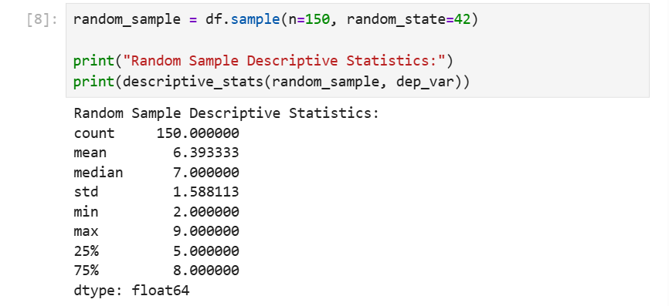

random_sample = df.sample(n=150, random_state=42)

print("Random Sample Descriptive Statistics:")
print(descriptive_stats(random_sample, dep_var))

Description:
- This program selects a random sample of 150 students from the dataset, giving each student an equal chance of being chosen. The descriptive statistics function is then applied to the dependent variable ( Addicted_Score) to summarize its mean , median , spread, and overall distribution within the sample.

Systematic Sampling (1 point)
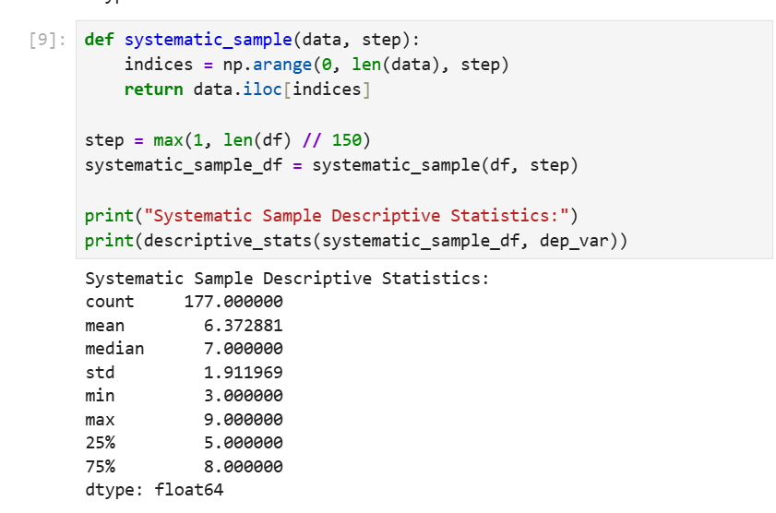

def systematic_sample(data, step):
indices = np.arange(0, len(data), step)
return data.iloc[indices]

step = max(1, len(df) // 150)
systematic_sample_df = systematic_sample(df, step)

print("Systematic Sample Descriptive Statistics:")
print(descriptive_stats(systematic_sample_df, dep_var))

Description:
- This script perforoms systematic sampling by selecting every k-th row from the dataset, ensuring the sample is evenly spread across all students. The step value is calculated so the sample size is close to 150. After creating the systematic sample, the descriptive statistics function is applied to the dependent variable ( Addicted_Score) to summarize its distribution within this structured sample.

Descriptive Statistical Report (1 point)
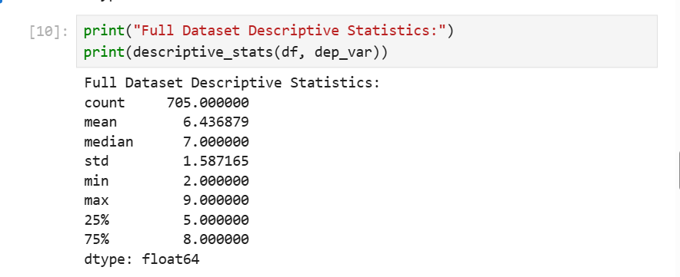

print("Full Dataset Descriptive Statistics:")
print(descriptive_stats(df, dep_var))

Describtion:
- This section denerates a full descriptive statistics report for the dependent variable ( Addicted_Score) using the entire dataset. It summarizes key measures such as mean, median, standard deviation, min , max , and quartiles. These statistics provide a cleare understanding of the overall distribution, central tendency, and variability of the dependent variable across all students.

Visualisation through Various Charts (2 points)

- Scatter plot:

plt.figure(figsize=(6,4))
sns.scatterplot(data=df, x="Avg_Daily_Usage_Hours", y=dep_var)
plt.title("Daily Usage Hours vs Addiction Score")
plt.show()

Describtion:
- The scatter plot shows how daily social media usage relates to addiction score.

: 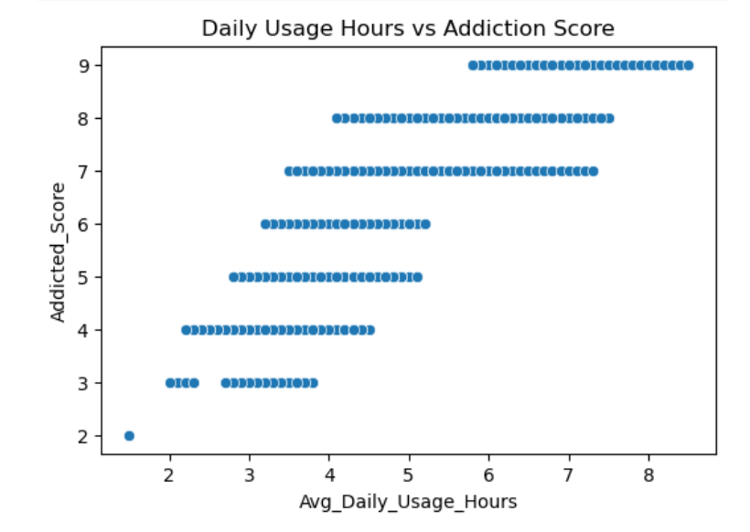

- Box plot:

plt.figure(figsize=(4,6))
sns.boxplot(y=df[dep_var])
plt.title("Box Plot of Addiction Score")
plt.show()
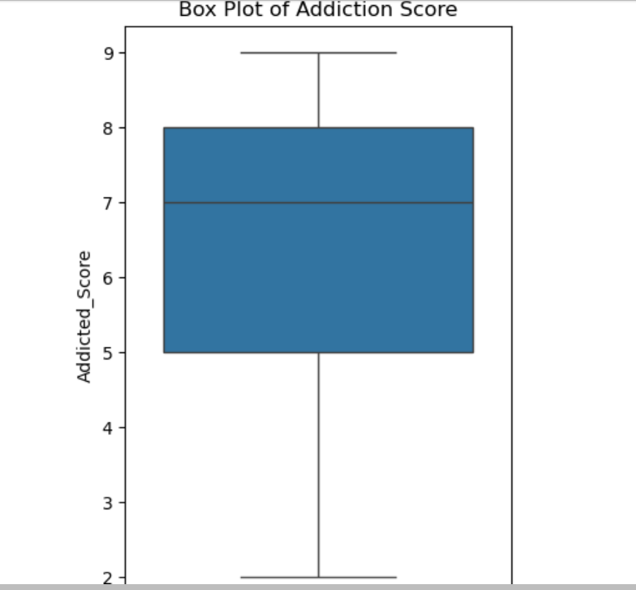

Description:
- The box plot highlights the spread of addtiction score and identifies any outlier.

- Histogram:

plt.figure(figsize=(6,4))
sns.histplot(df[dep_var], bins=20, kde=True)
plt.title("Histogram of Addiction Score")
plt.show()

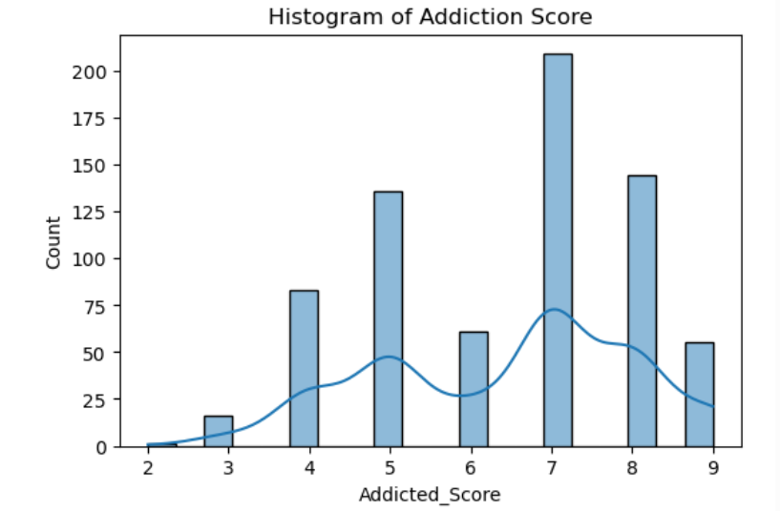

Description:

- This histogram displays the frequency distribution of addiction levels among students.

- Heatmap:

numeric_df = df.select_dtypes(include=[np.number])
plt.figure(figsize=(10,8))
sns.heatmap(numeric_df.corr(), cmap="coolwarm")
plt.title("Correlation Heatmap")
plt.show()

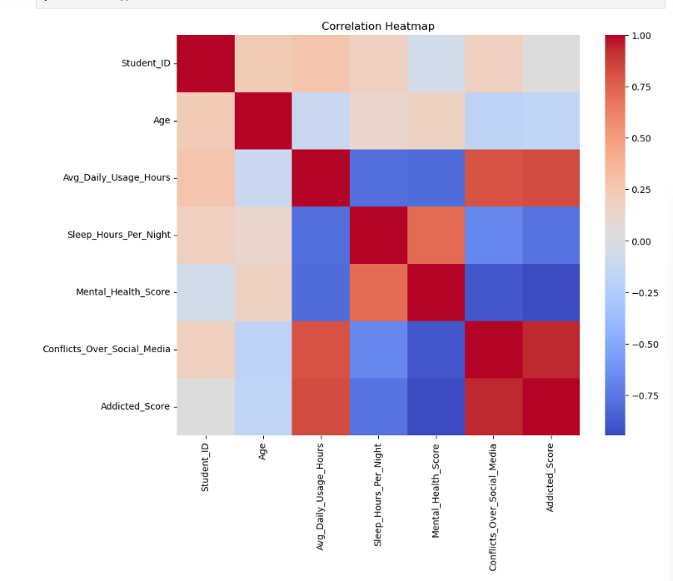

Description:
- The heatmap shows correlations between all numerical variables, helping identify which factors may influence addiction score.

Hypothesis Test (1 point)
ind_num = "Avg_Daily_Usage_Hours"

clean = df[[ind_num, dep_var]].dropna()

pearson_corr, pearson_p = pearsonr(clean[ind_num], clean[dep_var])
spearman_corr, spearman_p = spearmanr(clean[ind_num], clean[dep_var])

print("Pearson correlation:", pearson_corr, "p-value:", pearson_p)
print("Spearman correlation:", spearman_corr, "p-value:", spearman_p)

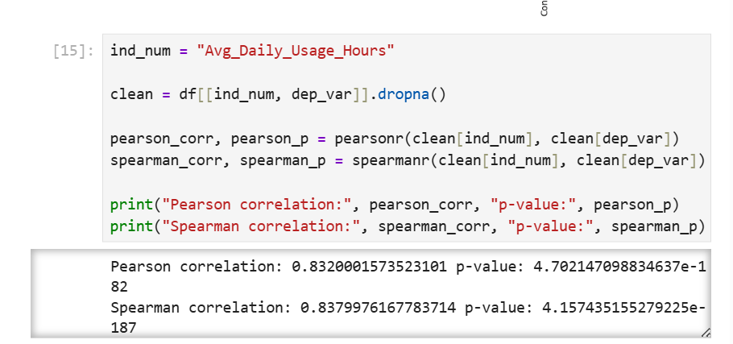

cat_ind = "Gender"
cat_dep = "Affects_Academic_Performance"

table = pd.crosstab(df[cat_ind], df[cat_dep])
chi2, p, dof, expected = chi2_contingency(table)

print("Chi-square statistic:", chi2)
print("p-value:", p)
print("Degrees of freedom:", dof)
print(table)

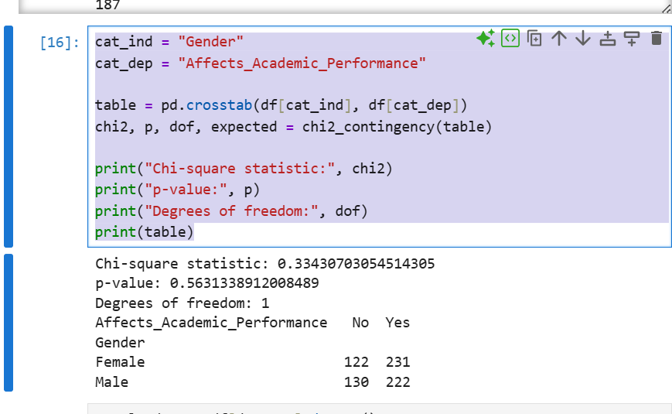

Description:
- This section performs hypothesis testing to measure the relationship between the independent and depentend variables. Person and spearman correlation tests are used for numerical variables to check whether daily social media usage is related to addiction score. Pearson measures linear correlation, while spearman measures rank-based correlation. A chi-square test is also performed for categorical variables, such as Gender and Affects Academic performance, to determine whether there is significant association between the two categories.

One Sample T-test (2 points)

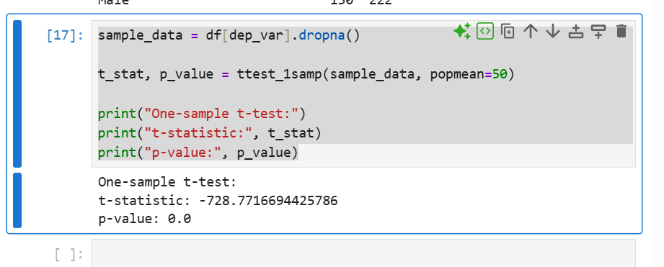

Description:
- This tets evaluates whether the mean of the dependent variable (Addicted_Score) is significantly different from a chosen population mean. The midpoint value of 50 is used as the expected normal population average. The one-sample t-test compares the samples addiction score against this benchmark to determine whether students in the dataset shoe higher or lower addiction level than expected. The results t-statistic and p-value indicate whether the difference is statistically significant.

