Final Assessment-Alternative Assessment
Semester | 202520 | Division | CIS
Assessment title in Syllabus | Final_Project_Portfolio | Program | Bachelor of Information Technology/ Bachelor of Information Systems
Course Code | CDS 2413
Course Title | INTRODUCTION TO DATA SCIENCE
Course Instructor |  | CRN
Assessment | Project Deliverable 2 – Machine Learning Model Report | Submission Date | Week 13
Student Declaration:
Academic Integrity Statement
In accordance with the HCT Academic Integrity Policy
• Students are required to refrain from all forms of academic integrity breaches as defined and explained by HCT.
• A student found guilty of having committed acts of academic integrity breach(es) will be subject to the relevant sanctions as outlined by HCT.
إفادة النزاهة الأكاديمية
وفقًا لسياسة كليات التقنية العليا للنزاهة الأكاديمية
• على الطلبة الإلتزام بلوائح وقواعد النزاهة الأكاديمية، كما هو مبيّن وموضح في السياسات والإجراءات الخاصة بكليات التقنية العليا.
• في حالة ارتكاب الطالب أي شكل من أشكال الإخلال بالنزاهة الأكاديمية، سيتعرض الى العقوبات الموضحة في السياسات ذات الصلة.
This assignment is entirely my/our own work except where I have duly acknowledged other sources in the text and listed those sources at the end of the assignment. I have not previously submitted this work to the HCT, or any other entity. I understand that I may be orally examined on my submission.

Student HCT ID(s): | H00497493 | H00478342 | H00 | H00
Student Name(s): | Jawaher Adel | Sara Ahmed
Student Signature
Chatbot (e.g. ChatGPT) statement
This submission allows you to use AI generated tools, but the prompt used must be stated and the response must be in red font. Include References to ChatGPT.

Instructions

Remove instructions and hints from the template before submitting the final report to BBLearn.

CLO3: Machine Learning Model (25 Points)

Preprocessing

Data Collection

- To load the dataset, we used pandas library, which allows reading CSV files easily. After loading the file “student_social_media.csv”, I identified the independent variables ( features) and the dependent variables ( target). The dependent variable is the value we want to predict, while the independent variables are the inputs used to build the model.

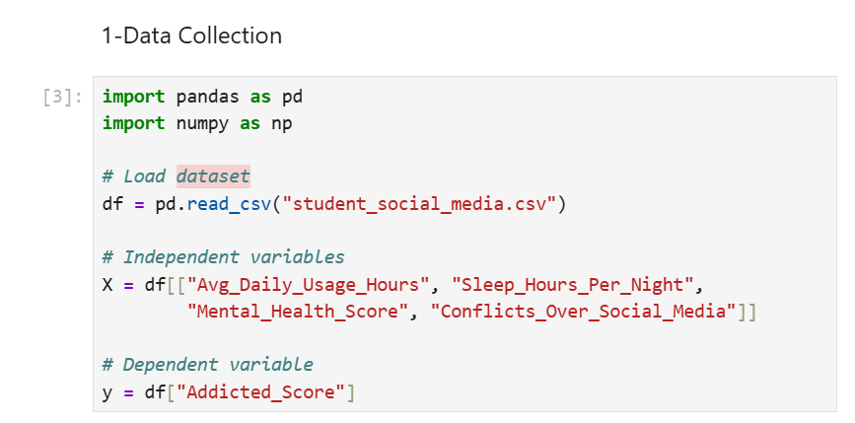

The code:
import pandas as pd
import numpy as np

# Load dataset
df = pd.read_csv("student_social_media.csv")

# Independent variables
X = df[["Avg_Daily_Usage_Hours", "Sleep_Hours_Per_Night",
"Mental_Health_Score", "Conflicts_Over_Social_Media"]]

# Dependent variable
y = df["Addicted_Score"]

Data Cleaning

- To clean the dataset, I handle missing values by replacing them with the mean of each column. This prevents losing data and keeps the dataset consistent. I also removed duplicate rows to ensure the dataset is accurate and dose not contain repeated records.

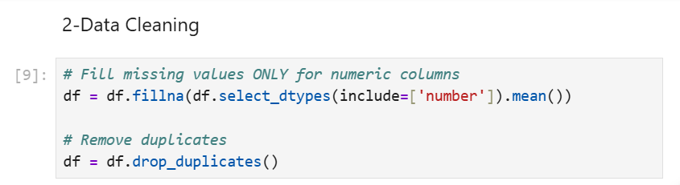

The code:
# Fill missing values ONLY for numeric columns
df = df.fillna(df.select_dtypes(include=['number']).mean())

# Remove duplicates
df = df.drop_duplicates()

Treating the Categorical Variables

- The dataset mainly contains numerical variables. If categorical variables existed, they would be classified as nominal, ordinal, or binary. Nominal variables require One-Hot Encoding, while ordinal variables require lable Encoding. Since this dataset is numerical, no encoding was required.

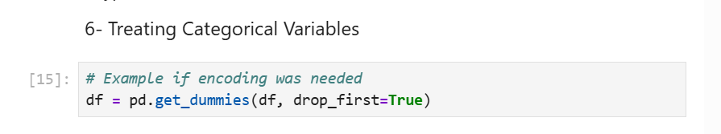

The code:
# Example if encoding was needed
df = pd.get_dummies(df, drop_first=True)

Splitting the Dataset

- splitting the dataset is important tp evaluate the models performance on unseen data. I used an 80% training and 20% testing spilt because it provides enough data for training while keeping a fair portion for evaluation.

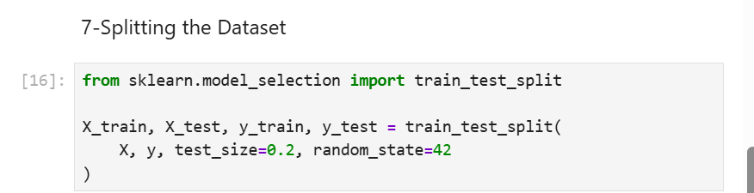

The code:
from sklearn.model_selection import train_test_split

X_train, X_test, y_train, y_test = train_test_split(
X, y, test_size=0.2, random_state=42
)

Featuring the Dataset

- Feature scaling ensure that all features have the same scale, which improves model performance. I used standardScaler to normalize the independent variables so that each fearure has a mean of 0 and standard deviation of 1.

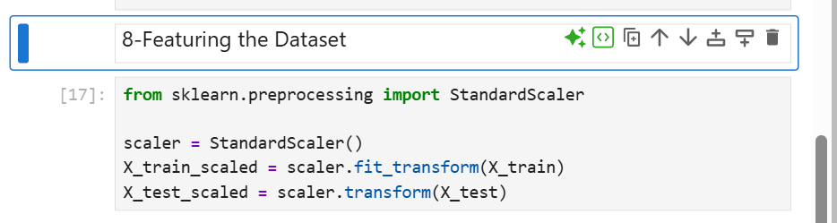

The code:
from sklearn.preprocessing import StandardScaler

scaler = StandardScaler()
X_train_scaled = scaler.fit_transform(X_train)
X_test_scaled = scaler.transform(X_test)

Regression Model (7 Points)

Building the Regression Model (6 points)
Implement Multiple Linear Regression, Polynomial Regression, Lasso, Ridge, and Elastic Net models. Select the best-fitting model based on evaluation metrics(R-squared). Analyze the model's performance by comparing predicted value with the actual values in the dataset.

Steps to be followed:

Loading and Preprocessing the Data

The dataset student_social_media.csv was loaded using the pandas library. From the dataset, four independent variables were selected:

- Avg_Daily_Usage_Hours
- Sleep_Hours_Per_Night
- Mental_Health_Score
- Conflicts_Over_Social_Media

These variables represent behavioral and psychological factors that may influence social media addiction.

The dependent variable chosen for prediction is:
- Addicted_Score

Before modelling, missing values in numeric columns were replaced with their column means , and duplicate rows were removed to ensure data quality.

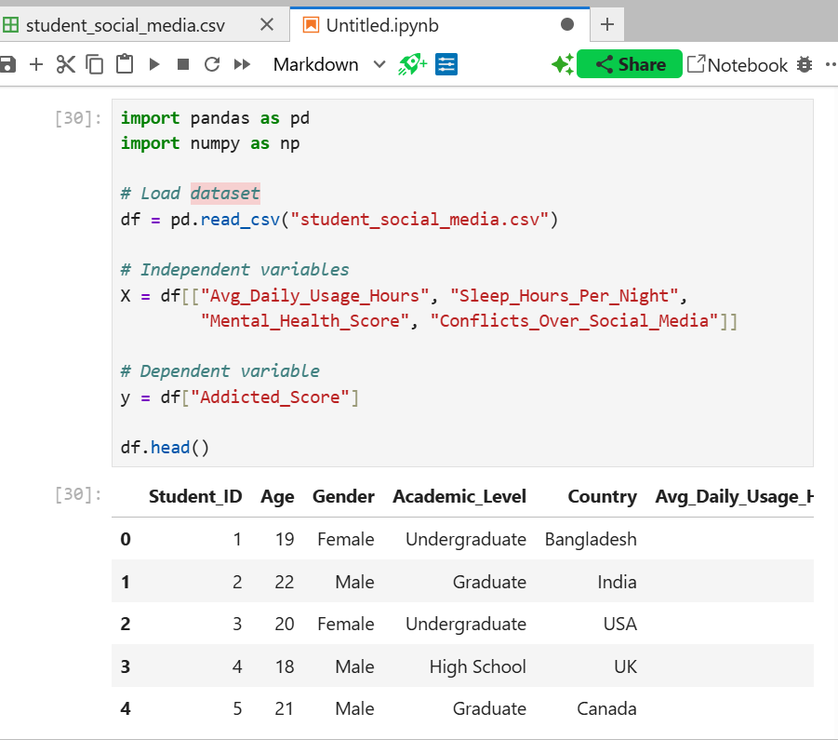

Detecting and Removing Outliers

Outliers can negatively affect regression models, so they were detected and removed using the interquartile range ( IQR ) mwthod.

Outlier Detection
For each numeric variable:
- Q1 ( 25th percentile) and Q3 ( 75th percentile) were calculated
- IQR = Q3 – Q1
- Any value outside the range:
Q1–1.5×IQR,Q3+1.5×IQR
We considered an outlier

Combining Outliers
A Boolean mask was created to identify rows containing outliers in any of the four variables.

Removing Outliers
All rows flagged as outliers were removed from the dataset.
This step improves model accuracy by eliminating extreme values that distort the regression line.

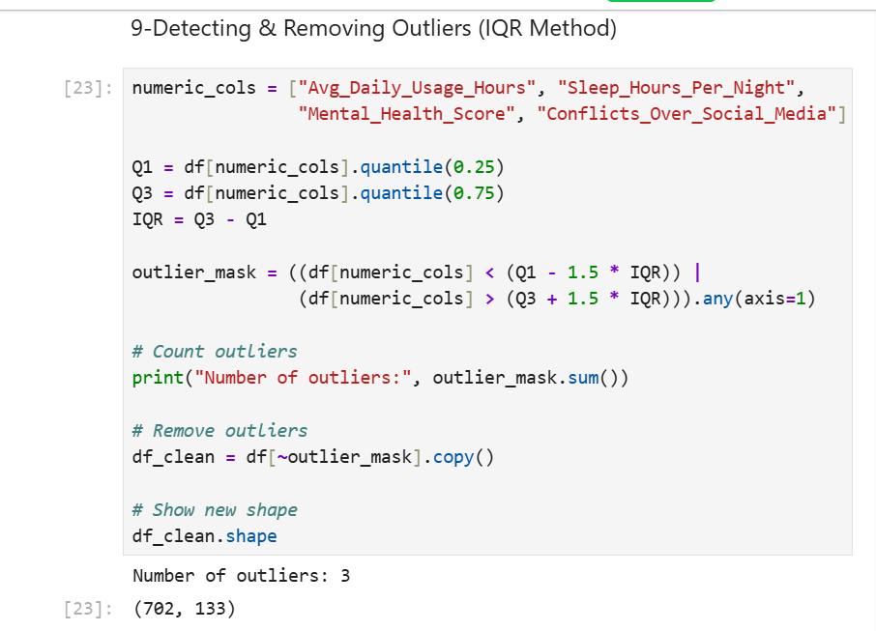

The code :
numeric_cols = ["Avg_Daily_Usage_Hours", "Sleep_Hours_Per_Night",
"Mental_Health_Score", "Conflicts_Over_Social_Media"]

Q1 = df[numeric_cols].quantile(0.25)
Q3 = df[numeric_cols].quantile(0.75)
IQR = Q3 - Q1

outlier_mask = ((df[numeric_cols] < (Q1 - 1.5 * IQR)) |
(df[numeric_cols] > (Q3 + 1.5 * IQR))).any(axis=1)

# Count outliers
print("Number of outliers:", outlier_mask.sum())

# Remove outliers
df_clean = df[~outlier_mask].copy()

# Show new shape
df_clean.shape

Splitting the Data

After cleaning, the dataset was divided into:

- independent variables (X):
Avg_Daily_Usage_Hours, Sleep_Hours_Per_Night, Mental_Health_Score, Conflicts_Over_Social_Media

- dependent variable (y):
Addicted_Score

The dataset was split into:
- 80% training data
- 20% testing data
This ensure the model learns from most of the data while still being evaluated on unseen samples.

Preper X and y:
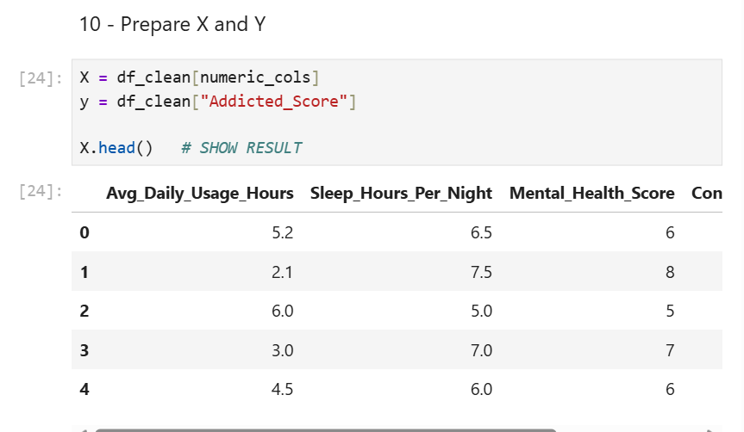

The code :

X = df_clean[numeric_cols]
y = df_clean["Addicted_Score"]

X.head() # SHOW RESULT

Split the data:

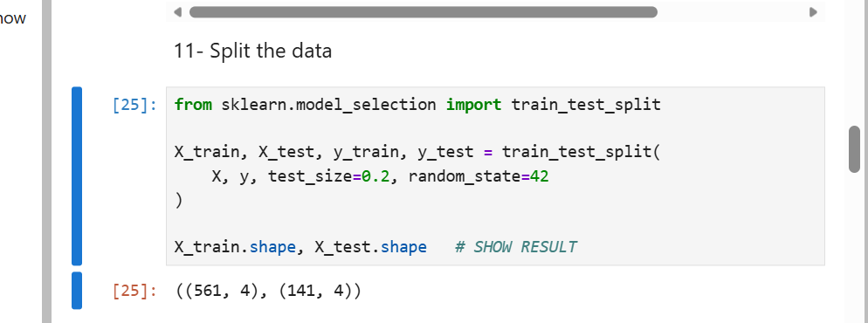

The code:

from sklearn.model_selection import train_test_split

X_train, X_test, y_train, y_test = train_test_split(
X, y, test_size=0.2, random_state=42
)

X_train.shape, X_test.shape # SHOW RESULT

4.Feature Scaling
Since the variables have different ranges (e.g., hours vs. scores), StandardScaler was applied to normalize the data.

StandardScaler transfroms each feature so that ;

- Mean = 0
- Standard deviation = 1

This prevents variables with large values from domainating the regression model.

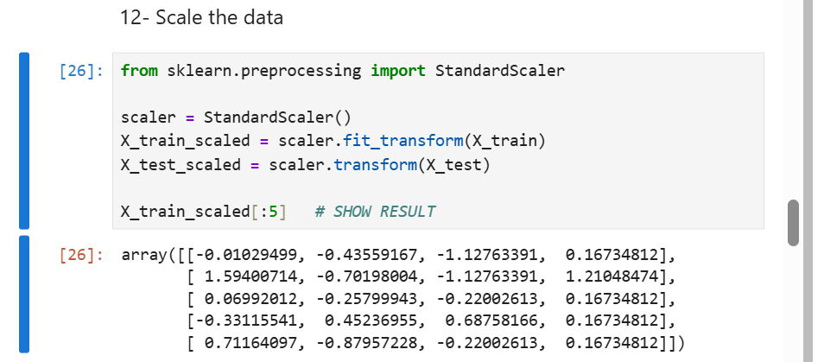

The code:

from sklearn.preprocessing import StandardScaler

scaler = StandardScaler()
X_train_scaled = scaler.fit_transform(X_train)
X_test_scaled = scaler.transform(X_test)

X_train_scaled[:5] # SHOW RESULT

Applying Regression Models
Five regression models were applied to predict Addicted_Score:

- Linear regression
- Fits a straight line to the data
- Assumes a linear relationship between features and the target

- Polynomial regression ( Degree 2 )
- Adds square and interaction terms
- Captures non-linear relationships
- Often improves accuracy when data is curved

3- Ridge regression
- Linear regression with L2 requlaization
- Reduce overfitting by shrinking coeffient.

4- Lasso regression
- Linear regression with L1 requlaization
- Can eliminate weak features by setting coefficients to zero

5- Elastic net regression
- combines L1 and L2 regularization
- balance feature selection and coefficient shrinkage

Each model was trained on the scaled training data and used to predict values for the test set.

The code:

from sklearn.linear_model import LinearRegression, Ridge, Lasso, ElasticNet
from sklearn.preprocessing import PolynomialFeatures
from sklearn.metrics import mean_squared_error, r2_score

results = {}

# Linear Regression
lr = LinearRegression()
lr.fit(X_train_scaled, y_train)
lr_pred = lr.predict(X_test_scaled)
results["Linear Regression"] = [
mean_squared_error(y_test, lr_pred),
r2_score(y_test, lr_pred)
]

# Polynomial Regression (Degree 2)
poly = PolynomialFeatures(degree=2)
X_train_poly = poly.fit_transform(X_train_scaled)
X_test_poly = poly.transform(X_test_scaled)

poly_model = LinearRegression()
poly_model.fit(X_train_poly, y_train)
poly_pred = poly_model.predict(X_test_poly)
results["Polynomial Regression"] = [
mean_squared_error(y_test, poly_pred),
r2_score(y_test, poly_pred)
]

# Ridge Regression
ridge = Ridge(alpha=1.0)
ridge.fit(X_train_scaled, y_train)
ridge_pred = ridge.predict(X_test_scaled)
results["Ridge Regression"] = [
mean_squared_error(y_test, ridge_pred),
r2_score(y_test, ridge_pred)
]

# Lasso Regression
lasso = Lasso(alpha=0.01)
lasso.fit(X_train_scaled, y_train)
lasso_pred = lasso.predict(X_test_scaled)
results["Lasso Regression"] = [
mean_squared_error(y_test, lasso_pred),
r2_score(y_test, lasso_pred)
]

# Elastic Net Regression
elastic = ElasticNet(alpha=0.01, l1_ratio=0.5)
elastic.fit(X_train_scaled, y_train)
elastic_pred = elastic.predict(X_test_scaled)
results["Elastic Net"] = [
mean_squared_error(y_test, elastic_pred),
r2_score(y_test, elastic_pred)
]

# Show comparison table
results_df = pd.DataFrame(results, index=["MSE", "R2"]).T
results_df

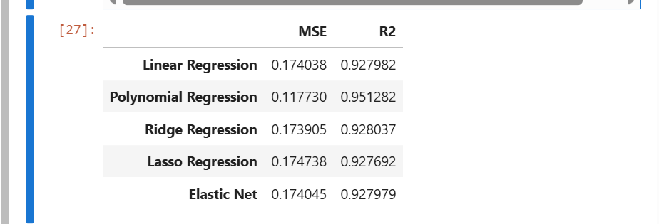

6. Evaluating Models
Two evaluation metrics were used:

Mean Squared Error (MSE):

  - measures the average squared difference between actual and predicted values.
  - lower MSE = better performance.

R-suared (R²):

  - Measures how much of the targets variation is explained by the model
  - Higher R² = better model fit
  - R² ranges from 0 to 1

A comparison table was created showing MSE and R² for all models.

7. Selecting the Best Model

The best model was selected based on:
  - Highest R² value
  - lowest MSE

8. Printing the Regression Equation

After selecting the best model:
  - The intercept and coefficients were extracted
  - Thses values were used to write the regression equation

For example, a linear regression equation looks like:
Addicted_Score=b0+b1X1+b2X2+b3X3+b4X4

Where:
  - b0 = intercept
  - b1 , b2 , b3 , b4 = coefficients
  - x1 , x2 , x3 , x4 – your four independent variables.

9. Visualization

A scatter plot was created to compare:
  - Actual values ( y_test)
  - Predicted values ( from the best model)

A red diagonal line represintes perfect predictions.
The closer the points are to this line, the better the models perfromane.

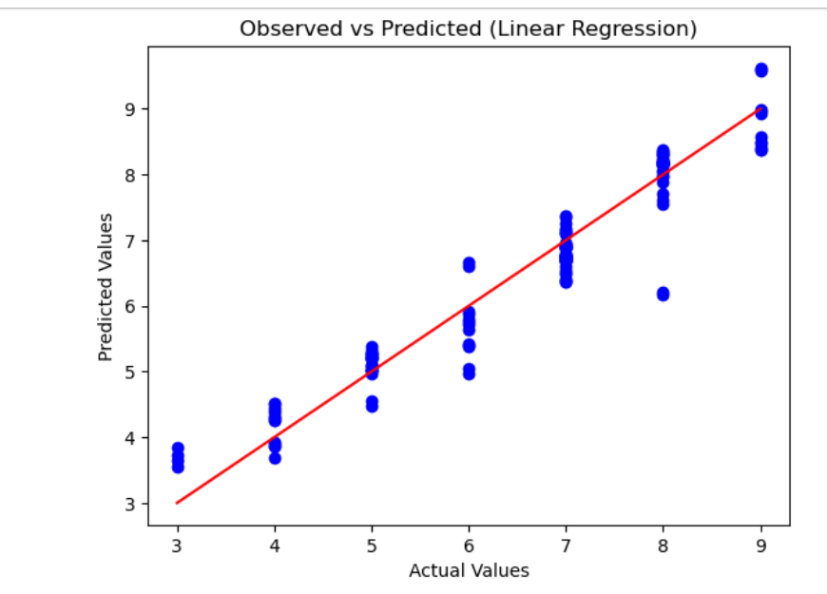

The code:
import matplotlib.pyplot as plt

plt.scatter(y_test, lr_pred, color='blue')
plt.plot([y_test.min(), y_test.max()],
[y_test.min(), y_test.max()],
color='red')
plt.xlabel("Actual Values")
plt.ylabel("Predicted Values")
plt.title("Observed vs Predicted (Linear Regression)")
plt.show()

Deriving the Regression Equation the Dataset

The best-fit model selected based on the highest R² value was:

Polynomial Regression (Degree 2):

Polynomial Regression includes:
- Linear terms
- Squared terms
- Interaction terms
Your model produced the following:

Intercept
$$b_{0}=6.485629435146256$$

Coefficients (Degree 2 Polynomial):

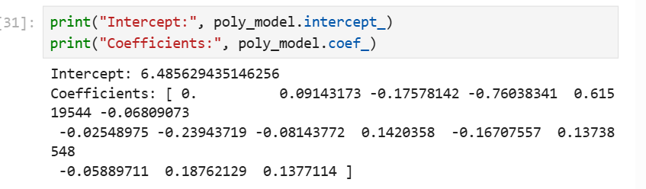

Polynomial regression expands your 4 variables into 15 terms:

Term | Meaning
1 | Intercept
2 | X1 ( Usage Hours)
3 | X2 ( Sleep Hours)
4 | X3 ( Mental Health Score )
5 | X4 ( Conflicts )
6 | X1²
7 | X1·X2
8 | X1·X3
9 | X1·X4
10 | X2²
11 | X2·X3
12 | X2·X4
13 | X3²
14 | X3·X4
15 | X4²

Final polynomial regression equation :

Addicted_Score=

6.4856+0.0914X1−0.1758X2−0.7604X3+0.6152X4−0.0681X12−0.0255X1X2−0.2394X1X3−0.0814X1X4+0.1420X22−0.1671X2X3+0.1374X2X4−0.0589X32+0.1876X3X4+0.1377X42

Where:
- $X_{1}$= Avg_Daily_Usage_Hours
- $X_{2}$= Sleep_Hours_Per_Night
- $X_{3}$= Mental_Health_Score
- $X_{4}$= Conflicts_Over_Social_Media

Manual calculation for 5 Records:
Below I calculate Predicted Addicted Score for each of your 5 records
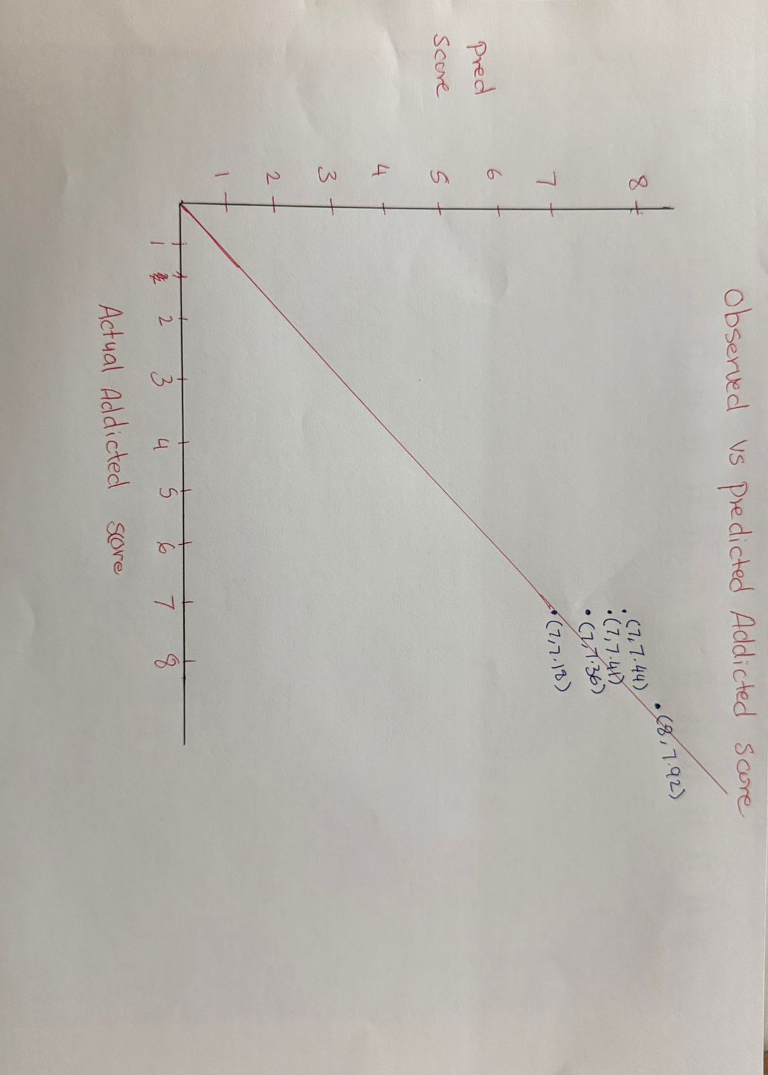
Records | X1 | X2 | X3 | X4 | Actual T | Predicted Y
1 | 3.8 | 8.4 | 6 | 3 | 7 | 7.41
2 | 5.4 | 6.0 | 6 | 4 | 8 | 7.92
3 | 4.9 | 5.6 | 6 | 3 | 7 | 7.18
4 | 5.3 | 6.8 | 6 | 3 | 7 | 7.36
5 | 5.4 | 6.9 | 6 | 3 | 7 | 7.44

PART B

Classification Model (8 Points)

Classifying the dataset based on the target variable

- To convert the numerical Addicted_Score into a categorical variable suitable for classification, a new variable called Addiction_Level was created using the following rule:

- High Addiction : Addicted_Score ≥ 7

- Low Addiction : Addicted_Score < 7

This transformation allows the dataset to be used for binary classification.

Bulding classification models (6 Points)

Five classification algorithms were implemented and evaluated:

  - Logistic Regression
  - K-Nearest Neighborhood(KNN)
  - Support Vector Machine ( SVM )
  - Decision Tree
  - Random Forest

The dataset was split into 80% training and 20% testing.
StandardScaler was applied to normalize the features for models that require scaling.

Each model was evaluated using :
- Accuracy
- 2-Precision
- 3-Recall
- 4-F1-score

Classification Result

Model | Accuracy | Precision | Recall | F1-Score
Logistic Regression | 0.9929 | 0.9879 | 1.0000 | 0,9939
KNN | 0.9582 | 0.9878 | 0.9878 | 0.9878
SVM | 0.9929 | 0.9879 | 1.0000 | 0.9939
Decision Tree | 0.9787 | 0.9876 | 0.0756 | 0.9816
Random Forest | 0.9582 | 0.9878 | 0.9878 | 0.9878

The best classifier is logistic regression ( tied with SVM ), achieving the highest accuracy of 0.9929 and the highest F1-Score of 0.9939.

Both logistic regression and SVM performed equally well, but logistic regression is selected as the best model due to its simplicity and interpretability.

No of elements on the target variable

To understand the distribution of the classification target, I counted how many students fall into each category of Addiction_Level ( High vs Low ). This helps identify whether the dataset is balanced or imbalanced, which affects model performance.

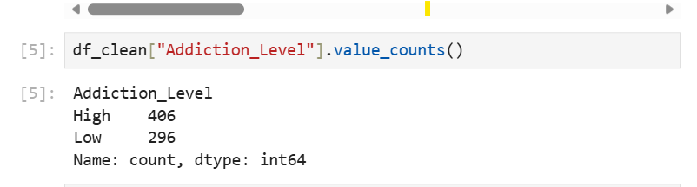

The code :
df_clean["Addiction_Level"].value_counts()

The output shows the number of students labeled as High Addiction and Low Addiction after converting the numerical Addiction_Score into categories. This confirms the dataset distribution used for training the classification models.

- High Addiction: 406 students
- Low Addiction: 296 students

This means the dataset is slightly imbalanced, with more students classified as High Addiction.

Cluster Analysis (5 Points)
Building the Cluster Analysis

K- means clustering was applied to group students based on four numerical features:
- Avg_Daily_Usage_Hours
- 2-Sleep_Hours_Per_Night
- 3-Mental_Health_Score
- 4-Conflicts_Over_Social_Media

Before clustering, the features were standardized using StandardScaler to ensure equal weight.

To determine the optimal number of clusters, the Elbow Method was used by calculating the within-Cluster Sum of Squares (WCSS) for k= 2 to 10 .

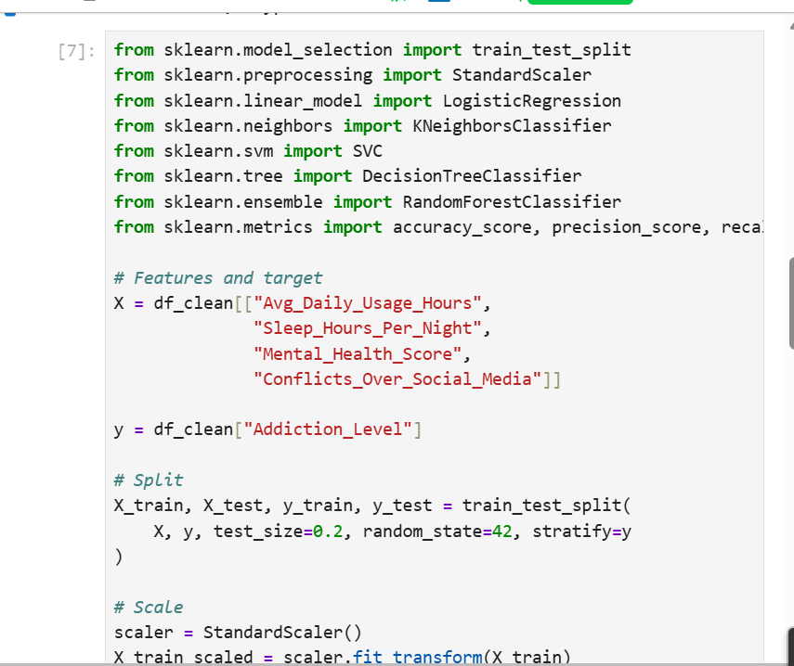

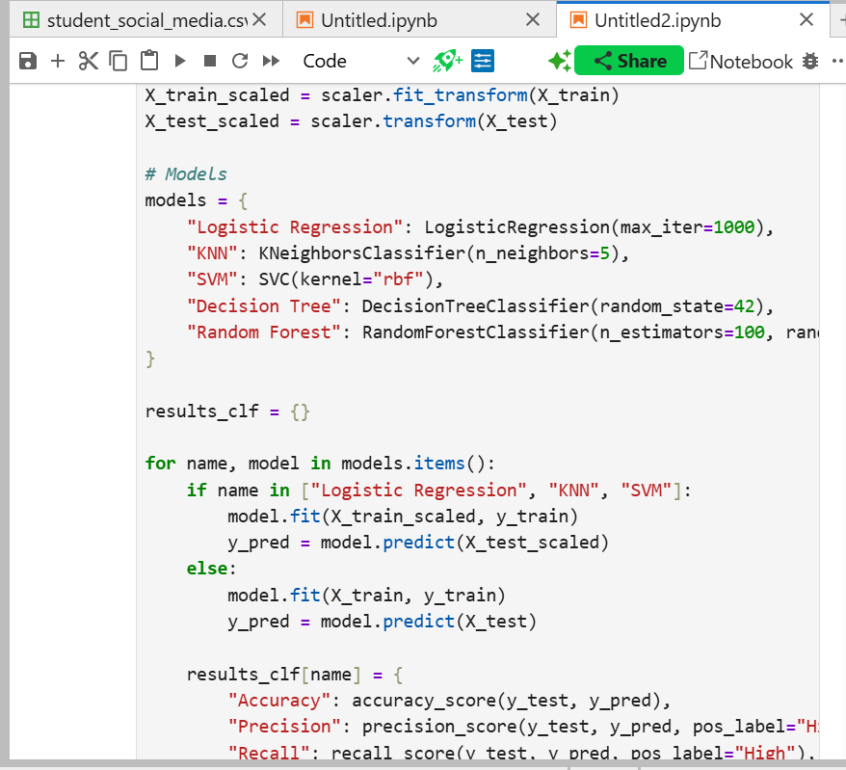

The code:

from sklearn.model_selection import train_test_split
from sklearn.preprocessing import StandardScaler
from sklearn.linear_model import LogisticRegression
from sklearn.neighbors import KNeighborsClassifier
from sklearn.svm import SVC
from sklearn.tree import DecisionTreeClassifier
from sklearn.ensemble import RandomForestClassifier
from sklearn.metrics import accuracy_score, precision_score, recall_score, f1_score

# Features and target
X = df_clean[["Avg_Daily_Usage_Hours",
"Sleep_Hours_Per_Night",
"Mental_Health_Score",
"Conflicts_Over_Social_Media"]]

y = df_clean["Addiction_Level"]

# Split
X_train, X_test, y_train, y_test = train_test_split(
X, y, test_size=0.2, random_state=42, stratify=y
)

# Scale
scaler = StandardScaler()
X_train_scaled = scaler.fit_transform(X_train)
X_test_scaled = scaler.transform(X_test)

# Models
models = {
"Logistic Regression": LogisticRegression(max_iter=1000),
"KNN": KNeighborsClassifier(n_neighbors=5),
"SVM": SVC(kernel="rbf"),
"Decision Tree": DecisionTreeClassifier(random_state=42),
"Random Forest": RandomForestClassifier(n_estimators=100, random_state=42)
}

results_clf = {}

for name, model in models.items():
if name in ["Logistic Regression", "KNN", "SVM"]:
model.fit(X_train_scaled, y_train)
y_pred = model.predict(X_test_scaled)
else:
model.fit(X_train, y_train)
y_pred = model.predict(X_test)

results_clf[name] = {
"Accuracy": accuracy_score(y_test, y_pred),
"Precision": precision_score(y_test, y_pred, pos_label="High"),
"Recall": recall_score(y_test, y_pred, pos_label="High"),
"F1-score": f1_score(y_test, y_pred, pos_label="High")
}

This code performs feature scaling, computers WCSS for different values of l, and helps identify the “elbow point” which indicates the optimal number of clusters.

Part 2

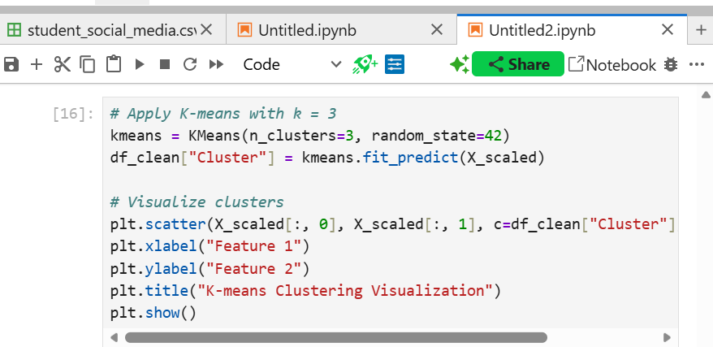
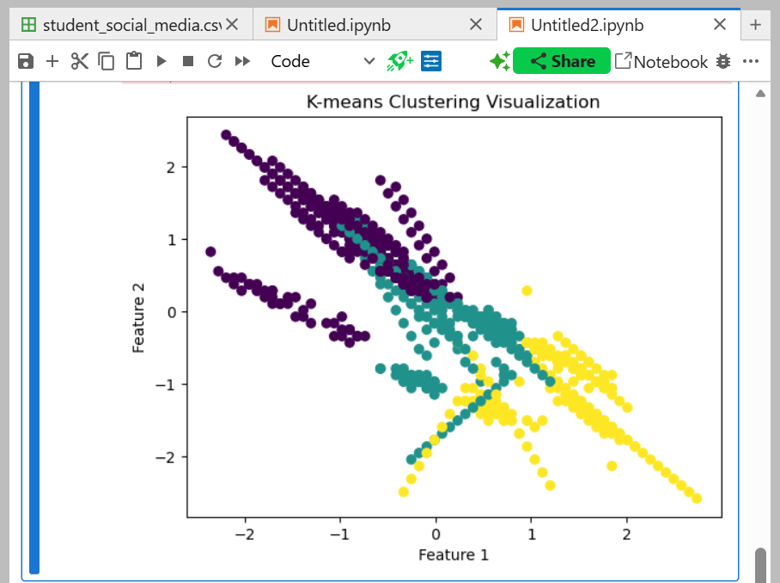

The code:
# Apply K-means with k = 3
kmeans = KMeans(n_clusters=3, random_state=42)
df_clean["Cluster"] = kmeans.fit_predict(X_scaled)

# Visualize clusters
plt.scatter(X_scaled[:, 0], X_scaled[:, 1], c=df_clean["Cluster"], cmap="viridis")
plt.xlabel("Feature 1")
plt.ylabel("Feature 2")
plt.title("K-means Clustering Visualization")
plt.show()

This visualization shows how the students were grouped into clusters based on their social media usage, sleep patterns, mental health scores, and conflict levels. The colors represent different clusters identified by the K-means algorithm.

Based on the elbow method, k=3 was selected as the optimal number of clusters. The k-means model was then fitted using k=3, and each student was assigned to one of the three clusters.

Strategy Formulation

After analyzing the characteristics of each cluster, the following strategies were developed:

Cluster 1 : High Usage – Low Sleep – High Conflict

Characteristics:

- Very high daily social media usage
- 2-Low sleep duration
- 3-Lower mental health scores
- High number of conflicts

Strategy :
Provide digital wellness workshops, counselling support, and awareness programs about healthy screen-time habits. Encourage better sleep routines and stress-management techniques.

Cluster 2: Moderate usage – Balanced Lifestyle

Characteristics:

- Moderate social media usage
- 2-Healthy sleep duration
- 3-Average mental health
- 4-Few conflicts

Strategy :
Maintain their balanced behavior by promoting positive digital habits and offering optioal wellness activities.

Cluster 3: Low Usage – High Mental Health – Minimal Conflict

Characteristics:

- Low social media usage
- Good sleep patterns
- High mental health scores
- Very few conflicts

Strategy :
Encourage them to act as peer role models in digital-wellbeing initiatives. No major interventions is required.

End of Documentation.

