# Deliverable 4: Wireframes & Feature Plan

CSC425 Fall 2025

Student Name: Ty Mcmullen

Date Submitted: 9/21/25

GitHub REPO URL: https://github.com/jalsobrook2/team-rep

Branch Name: TM-branch

## 1. Low-Fidelity Wireframes (Mobile-First)

Insert/export images of your sketches or digital mockups. Each wireframe should be clearly labeled.

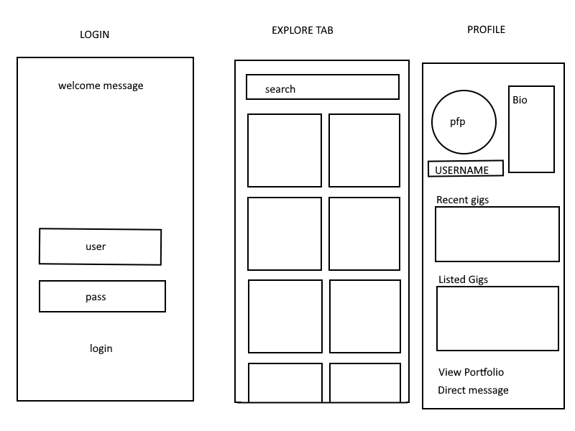

## 2. Functional Requirements

Provide a bullet-point list of core app features. Be concise but detailed enough to show scope.

• Login using Google SSO  
 • Data maintained:

Users, job listings, payment processing, etc.  
 • Follows a flow similar to online market places:

login-explore-listing-user accounts-portfolios  
 • Server provides app features:

listings, users, portfolios, online encrypted messaging

## 3. User Stories

Provide 3–5 detailed user stories following the required format.

1. As a freelancer, I want to program apps for people, so that I can make money and add to my portfolio.

2. As a busy professional, I want to have someone else do things for me, so that I can remained focused on work.

3. As an employer, I want to find workers with previous experience, so that I can be sure I’m hiring the right person.

## 4. User Journey Flow

Choose one format: flow diagram (preferred) or a step-by-step written description.

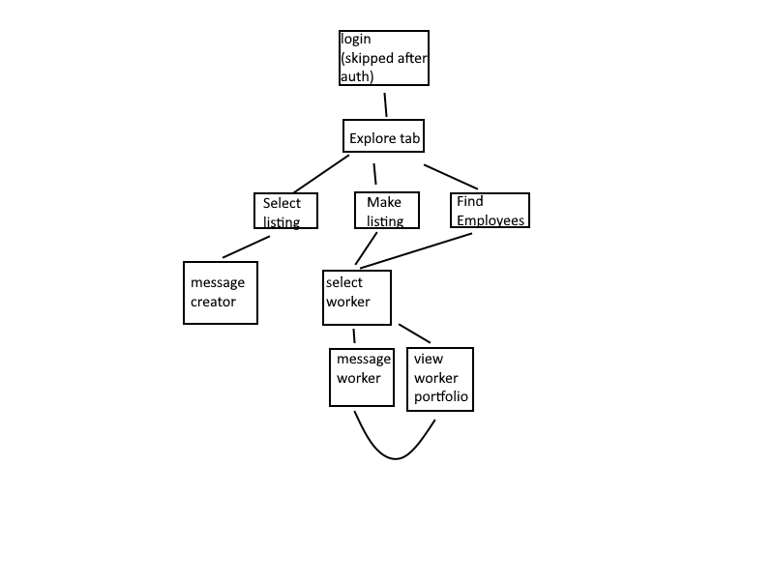

## 5. Document Layout Professional

Document must be organized, clean, professional, and ready for a developer to pick it up and begin coding.