# Deliverable 4: Wireframes & Feature Plan

CSC425 Fall 2025

Student Name: Koen Tanner

Date Submitted: September 20, 2025

GitHub REPO URL: https://github.com/jalsobrook2/team-rep

Branch Name: d4-koen-tanner

## 1. Low-Fidelity Wireframes (Mobile-First)

The app interface is inspired by a hybrid of Facebook Marketplace and eBay (images made with AI):

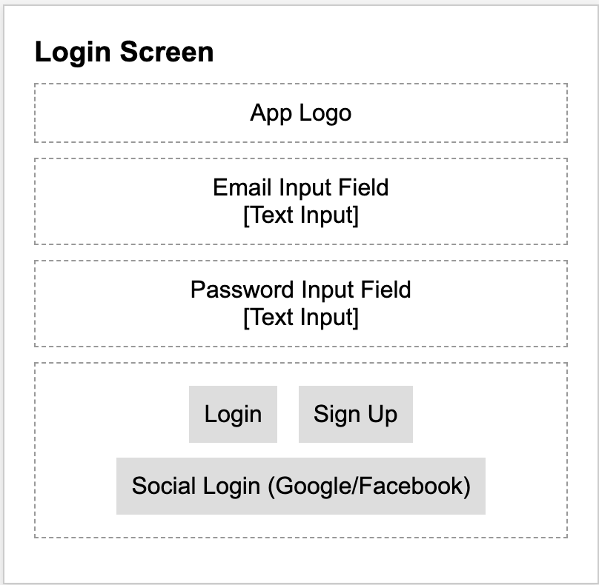

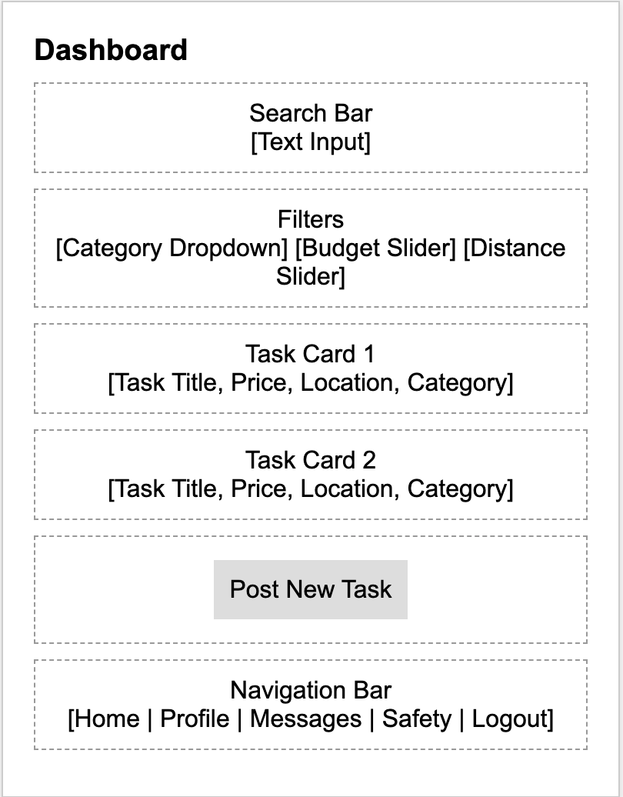

## 2. Functional Requirements

* **Marketplace Task Feed –** dynamic dashboard showing local tasks in card/grid format, with filters for category, budget, and distance.
* **User Profiles & Verification** – every user must create a profile; workers require optional background checks and ID verification.
* **Escrow Payments** – all transactions flow through an in-app escrow system that only releases funds when the task is confirmed complete.
* **Task Lifecycle Management** – posting, accepting, tracking, and completing tasks with real-time updates.
* **Safety Features** – panic button, emergency contact notifications, in-app reporting tools.
* **Accessibility Support** – voice navigation, screen-reader compatibility, large-text toggle.
* **Notifications & Messaging** – push notifications for booking requests, secure in-app chat for coordination.
* **Ratings & Reviews** – mutual rating system to build a trusted local community.

## 3. User Stories

As a new user, I want to sign up with my email or social account, so that I can start using the app quickly.

As a task requester, I want to post a new job with clear details and price, so that I can find someone reliable nearby.

As a gig worker, I want to browse available tasks on the dashboard, so that I can select jobs that match my skills.

As a worker, I want payments to be held securely in escrow, so that I am confident I will get paid after completing a task.

As a client, I want to review and rate workers after a task, so that future users can trust my feedback.

## 4. User Journey Flow

1. User opens the app and sees the Login Screen.

2. User signs up/logs in securely and lands on the Dashboard.

3. Dashboard shows local tasks in a marketplace layout with filters (category, price, location).

4. Client posts a task → fills in details, price, and uploads optional images.

5. Worker browses and selects a task → 'Book Now' sends confirmation.

6. Payment is placed in escrow until task completion.

7. Task is completed → client confirms → payment released.

8. Both client and worker leave ratings/reviews.

9. User logs out or closes the app.