DC Motor Speed Control Design
Jamaan Mohammed Alsultan
Automatic Control, King Khalid University
Instructor: Dr. Abdullah Alharthi

Abstract
This project presents the design and simulation of a speed control system for a DC motor. The objective was to regulate the motor speed to 100 rad/s with a rise time under 2 seconds and a maximum overshoot of 15%. A second-order transfer function was derived from first principles. Proportional (P), Proportional-Integral (PI) and Proportional-Integral-Derivative (PID) controllers were designed and compared. The PID controller met every transient requirement, with zero steady-state error and fast recovery from a disturbance applied at t = 20 s. Simulation also showed that the specified ±24 V supply cannot drive this motor to 100 rad/s: about 410 V is needed at steady state.
- Objective: design a PID controller that holds a DC motor at 100 rad/s.
- Methodology: first-principles modeling and simulation in MATLAB/Simulink.
- Key finding: the PID controller met all transient requirements (under 15% overshoot, under 2 s rise time) with zero steady-state error.
- Constraint: the ±24 V limit makes the target physically unreachable for this motor.

Introduction
DC motors are central to modern automation and need precise speed control under changing loads. The motor in this project has the following parameters:
- Electrical: resistance R = 2 Ω, inductance L = 0.5 H
- Mechanical: inertia J = 0.02 kg·m², viscous friction b = 0.2 N·m·s/rad
- Electromechanical: motor constant K = 0.1 V·s/rad
The goal is a controller that stays stable and meets the performance targets under a setpoint step, a disturbance, and a physical input limit of ±24 V.

Results

1. Mathematical model
Kirchhoff's voltage law for the armature circuit and Newton's second law for the rotor give:
V(t) = R·i(t) + L·di/dt + K·ω(t)
J·dω/dt + b·ω(t) = K·i(t)
Taking the Laplace transform and solving for G(s) = Ω(s)/V(s):
G(s) = K / [(Ls + R)(Js + b) + K²] = 0.1 / (0.01s² + 0.14s + 0.41)
Stability: the characteristic polynomial 0.01s² + 0.14s + 0.41 has all positive coefficients. For a second-order system this places both poles in the left half-plane (s = −4.17 and s = −9.83), so the open-loop motor is stable. The Routh-Hurwitz array shows no sign changes, confirming that the output stays bounded for any bounded input.

2. Controller design and comparison
To compare the controllers on their tuning alone, the input saturation was removed for this comparison. With a voltage limit in place, all three controllers drive the actuator into saturation at start-up, which hides the differences between them (see Section 3).
Controller | Kp | Ki | Kd | Rise time 10–90% (s) | Overshoot (%) | Steady-state error
P | 50 | 0 | 0 | 0.06 | 37 | 7.6%
PI | 50 | 100 | 0 | 0.06 | 38 | 0%
PID | 15 | 40 | 1.5 | 0.26 | 0.1 | 0%

The P controller (Kp = 50) responds fast but leaves a 7.6% steady-state error, as expected for a type-0 plant. The PI controller (Kp = 50, Ki = 100) removes the error, but its overshoot of 38% exceeds the 15% limit. The PID controller (Kp = 15, Ki = 40, Kd = 1.5, derivative filter N = 100) meets every requirement: 0.26 s rise time, 0.1% overshoot and zero steady-state error.
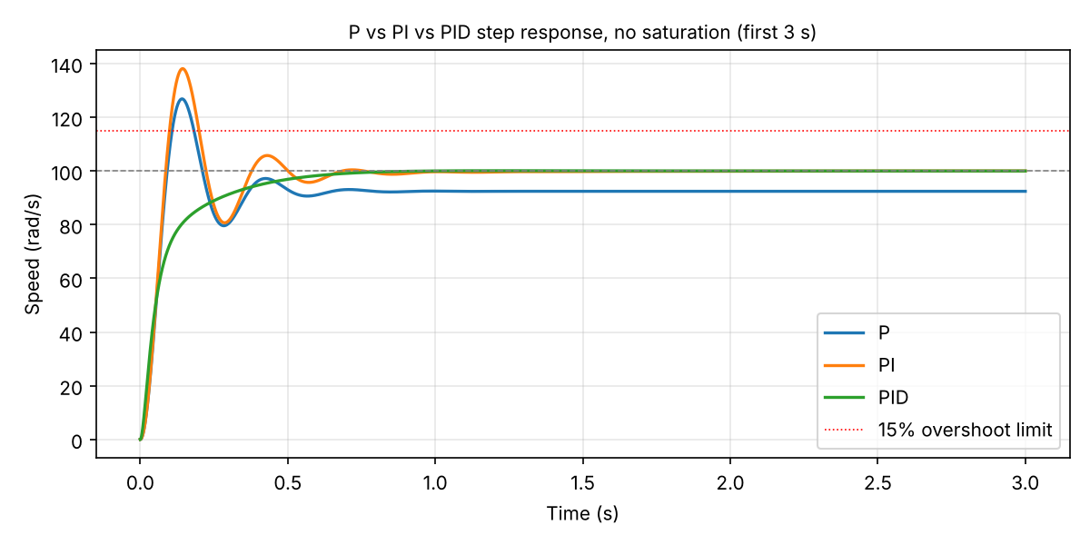
Figure 1: Step response of the P, PI and PID controllers with saturation removed.
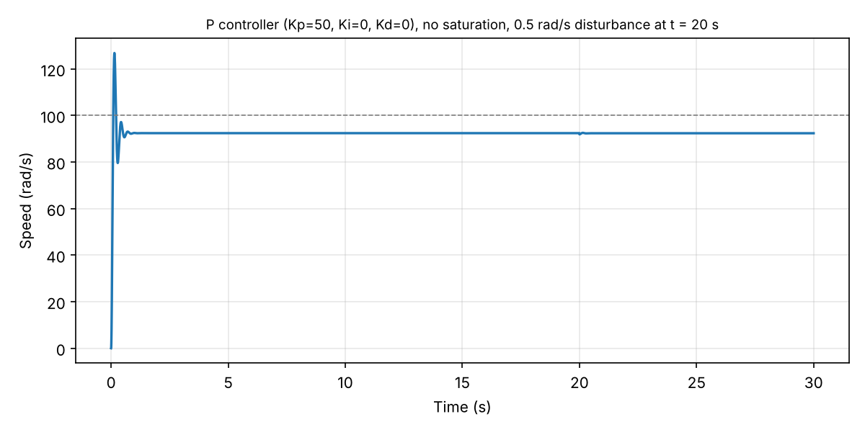
Figure 2: P controller, full run including the disturbance at t = 20 s.
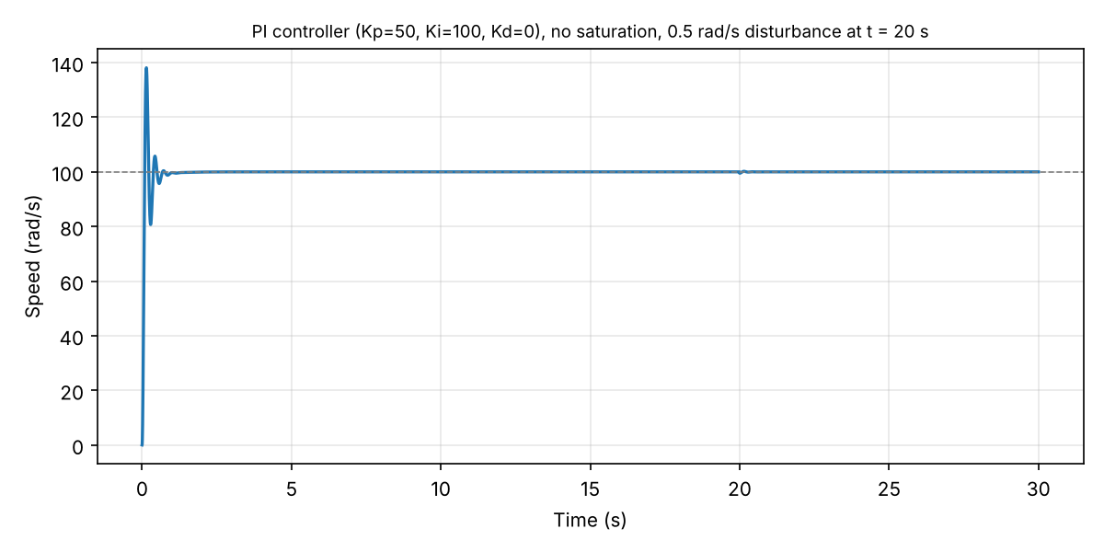
Figure 3: PI controller, full run including the disturbance at t = 20 s.
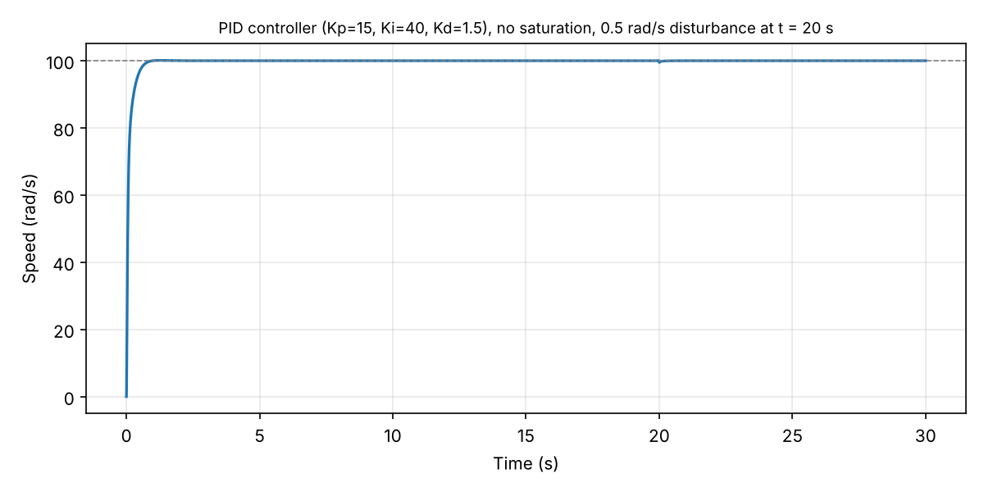
Figure 4: PID controller, full run including the disturbance at t = 20 s.

3. Simulink implementation and input saturation
The closed loop was built in Simulink with a saturation block on the controller output. A 100 rad/s reference step is applied at t = 0, and a 0.5 rad/s step disturbance is subtracted from the measured speed at t = 20 s.
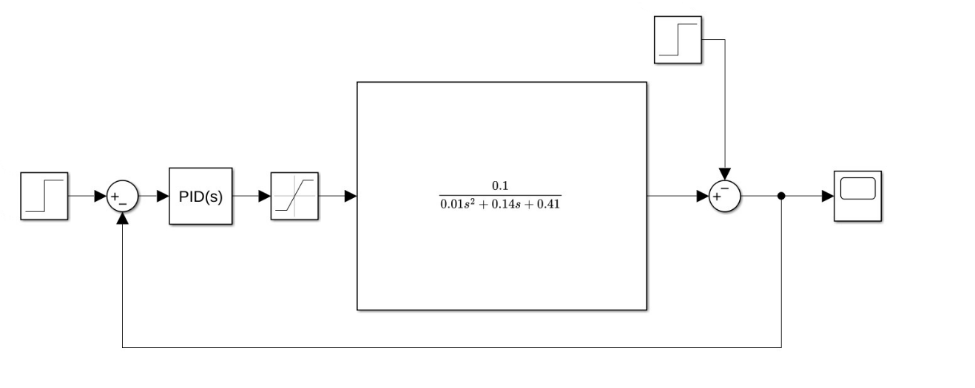
Figure 5: Simulink model with PID controller, saturation and disturbance.
With the specified ±24 V limit, the motor only reaches 5.85 rad/s. The required steady-state voltage is:
V_ss = ω_ss·(R·b + K²) / K = 100·(2·0.2 + 0.1²) / 0.1 = 410 V
To study the controller behaviour at the target speed, the limit was raised to ±450 V, giving headroom above the 410 V steady-state requirement during the transient. Even so, the PID controller initially asks for about 16,500 V, so the actuator stays saturated during start-up. While it is saturated, the integrator keeps accumulating error (integrator windup). This produces a flat overshoot of about 10% before the speed settles. At this limit the PI and PID controllers behave almost the same, because the saturation, not the controller, sets the response.
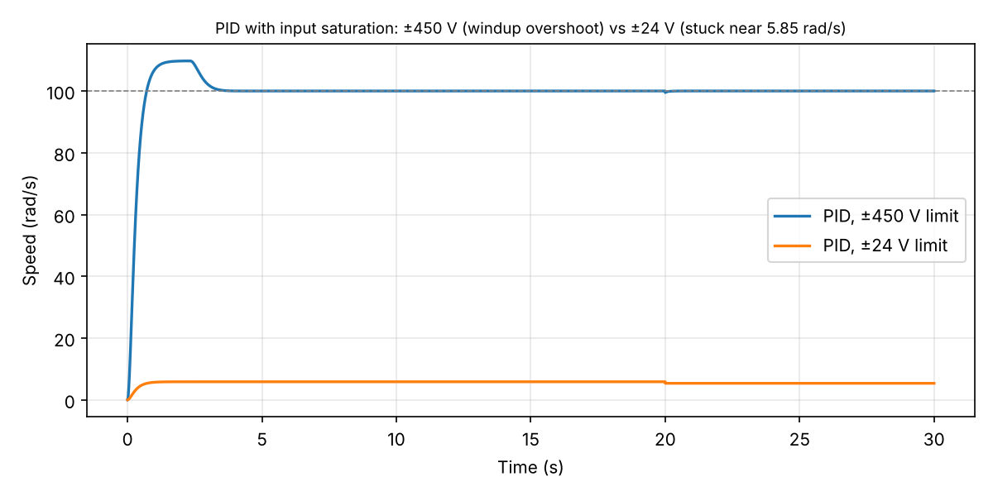
Figure 6: PID controller with a ±450 V limit (windup overshoot) and a ±24 V limit (speed limited to about 5.85 rad/s).

Conclusion
The PID controller was the most effective design, meeting all transient requirements with zero steady-state error and fast disturbance rejection. Simulation also showed a critical physical limitation: this motor needs about 410 V to reach 100 rad/s because of its high friction (b = 0.2), far above the 24 V supply. A real 24 V design would need a motor with a higher torque constant or a gearbox to reduce the required torque. Because the controller output saturates during start-up, a practical implementation should also include anti-windup on the integrator.

References
- G. F. Franklin, J. D. Powell and A. Emami-Naeini, Feedback Control of Dynamic Systems, 8th ed. Pearson, 2019.
- R. C. Dorf and R. H. Bishop, Modern Control Systems, 14th ed. (Global ed.). Pearson, 2021.
- MathWorks, "PID Controller," Simulink documentation, 2026.
- 441-EE-3 Course Notes: Automatic Control Systems, King Khalid University.

