Jacob Luke
Course: ECE 601
Instructor: Marco Duarte
Project Phase 3

Section I: Baseline Model Reverse Ablation

Parameter Count: Since part of my goal is minimizing the model size I performed an ablation study on the parameter count to see how performance was affected by changes. The baseline LLM generated model had 4,349,240 trainable parameters with fine and coarse accuracies of 47% and 64% respectively. When I changed that to 17,275,384 trainable parameters with a chunk of them added to the convolutional layers and a chunk added to the FC layers the fine and coarse accuracies were 49% and 67% respectively. This was an improvement but only marginal when compared against the cost of increasing the trainable parameter count by a factor of four. To see if the improvement was hidden in either the convolutional layers or the FC layer I decided to test them individually boosted. I changed the model again by reverting the FC layers back to the baseline and increased the convolutional layers bringing the model total to 10,926,840 parameters. This hurt the model and dropped the test statistics to 28% (fine) and 55% (coarse) accuracies. However, when I reversed the setup and had a total of 7,552,056 trainable parameters the test statistics increased to 53% (fine) and 67% (coarse) indicating to me that the number of trainable parameters in the FC layers are more impactful for test performance.

Batch Normalization: When I removed batchnorm from the baseline model the test statistics dropped by .28% on the fine label task and 3% on the coarse label task. This indicated that batchnorm was not super impactful for the baseline model.

Dropout: Dropout on the baseline model was set to .4, however, when I tested a handful of values .6, .2, .1, and 0 I found that removing dropout on the model performed the best. Without dropout the test accuracies increased by 9% and 4% on the fine and coarse tasks respectively.

Learning Rate Initialization: Another thing worth testing on the baseline model was the learning rate initialization. During this test I found that the baseline model was very sensitive to the learning rate initialization. Each different value I tested dropped the model test performance statistics quite drastically.

Weight Decay: The weight decay value did not show much significance when non drastic changes were made to it.

Section Notes: After using this information and tweaking the model I settled on a version of the baseline model with 7,552,056 parameters, batchnorm, no dropout, base learning rate initialization, and a decreased weight decay. This model achieved test statistics of 57% and 69% on the fine and coarse tasks respectively. This was 10% better on the fine task and 5% better on the coarse task. I will say importantly that looking at the training curves for this model it was clear that it was overfitting. It was also clear that the tweaks I was making were allowing the model to overfit the data more aggressively which ended up helping the test performance.

Section II: Model Changes:

Change 1, Adding Batchnorm to the FC Layers: While analyzing the baseline model I realized that the FC layers did not have batchnorm, in this section I first decided to add it. After many model adjustments I was able to push the model to 59% and 71% accuracies with the batchnorm on the FC layers. This same model without batchnorm on the FC layers had test statistics of 44% and 60% accuracies. This drop from removing the batchnorm on the FC layers showed that it was a beneficial change for the model.

Change 2, Trainable Parameter Count: While working on change 1 I found that the dropout it performed best with was dropout = .7. This indicated to me that the trainable parameter count was too high since the regularization needed was so intense. After much testing on the model architecture I was able to adjust it down to 2,748,600 parameters from the 4,350,776 parameters that worked best with the model from change 1 with less than a 1% decrease on both test accuracies.

Change 3, Label Smoothing: At the bottom of the generated notebook it was recommended by the LLM to add label smoothing for improvement. Label smoothing is a hyperparameter for cross-entropy loss that allocates a percentage of probability in the label space for the labels that aren't the target label for the sample. That is for a 3 class problem the label distribution for a sample i would be [0, 1, 0] where all of the probability is assigned to the target class. If you were to set label smoothing to .2 then the label distribution would change to [.1, .8, .1] for the same sample i. After trying multiple values of the label smoothing I found that a value of .4 for the label smoothing performed the strongest pushing the accuracies to 61% and 71% for the fine and coarse tasks. This is an increase by 2% for the fine labels and an equal performance on the coarse labels.

Change 4, Skip Connections: Skip connections was another recommendation from the LLM. Skip connections work by adding the input to a layer to the output of the layer allowing the true data to flow into the next layer. This allows gradients to still pass backwards even if they start to get very small; more details can be found at [1]. After implementing it and running 1 run it dropped the test statistics quite a bit and I was unsure about the need for it. That is because as I read more about it I started to see that it is more useful in very deep networks to avoid vanishing gradients and I was not suspecting my model had a vanishing gradient problem.

Change 5, Data Augmentation: Data augmentation was another recommendation from the LLM. For the dataset of images, data augmentation consists of random cropping, rotating, or brightness adjustments during training to artificially inflate the diversity of the training set. This helps prevent overfitting during training by blocking the model from memorizing the images. Implementing this initially improved the model test statistics by 4% and 5% on the fine and course labels. However, due to how data augmentation interacts with training I figured it would be beneficial to decrease the dropout rate that was settled on during the other model changes. Once dropout was decreased the model with data augmentation settled at 68% fine accuracy and 77% coarse accuracy. These are both 6% increases from the pre data augmentation model.

Best Model: Model details, 2,748,600 trainable parameters, batchnorm, dropout=.25, label smoothing = .25, and has data augmentation. This model achieved 68% fine accuracy and 77% coarse accuracy. This is 21% higher accuracy on the fine labels and 13% higher accuracy on the coarse labels than the baseline LLM generated model.

Section III: Final Ablation Study:

For this section I took the top model from the previous section and removed various components so I could then evaluate their effects on the model. I will past the results here;
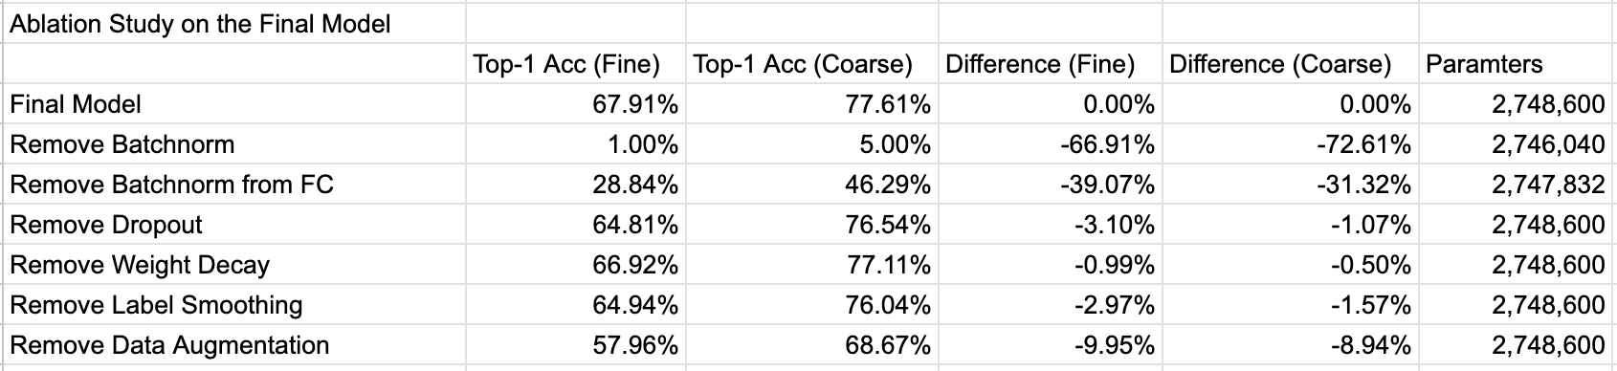

Looking at the results here it is clear that batchnorm on both the convolutional and FC layers is critical because when removed it dropped the model performance by over 30% at least on both accuracy statistics. Removing dropout hurt the model by a modest amount. Removing weight decay did not hurt the model by much at all indicating it might not be too important. Label smoothing had a similar effect on the model as dropout when removed. Removing the data augmentation was the second most detrimental removal, hurting test statistics by 10% and 9% on the fine and coarse accuracies respectively.

References:
[1] “What are skip connections or residual connections?,” Milvus, 2026. [Online]. Available: https://milvus.io/ai-quick-reference/what-are-skip-connections-or-residual-connections. [Accessed: Apr. 2026].

