OYAKHILOME JESSICA ESEOSA

18/0920

COMPUTER SCIENCE GROUP B

INSY 405

INTORDUCTION TO THE FUNDAMENTALS OF SOFTWARE ENGINEERING

ASSIGNMENT QUESTION

There is only one automated lecture hall in New Horizon Building. Each of the three-computer practical’s COSC 444, INSY 455 and ELECT 499 takes place in this hall, in line with the time table. These courses are handled by different lecturers, and each lecturer signs the key from Dean's office, and returns it immediately after lecture, so the next person group can use the hall. On a typical Wednesday, the lectures take place as follows: COSC 400 by 8-9am, INSY 477 by 10-11am and ELECT 488 by 2-3pm. Write a User Story on how to manage the resource, to ensure the three lectures take place in the hall. Transform the resulting user story to a Use Case Diagram.

SOLUTION

Because there is only one automated lecture hall in which these practical lectures can be held, and the key to this lecture hall is placed in the dean's office when the lecture hall is in use (locked), the lecturers taking the practical courses COSC444, INSY455, and ELECT499 are looking for a way to manage their resource. The department is urged to introduce a third party who would fetch and replace the key before and after each lecture in order to maximize time on the lecturer's schedule. By doing so, the department helps lecturers gain speedier entry to the hall by giving them the key before class and shutting the doors before the end of the lectures. It will also assist the lecturer free up some space if they have another class right before or after this practical class.

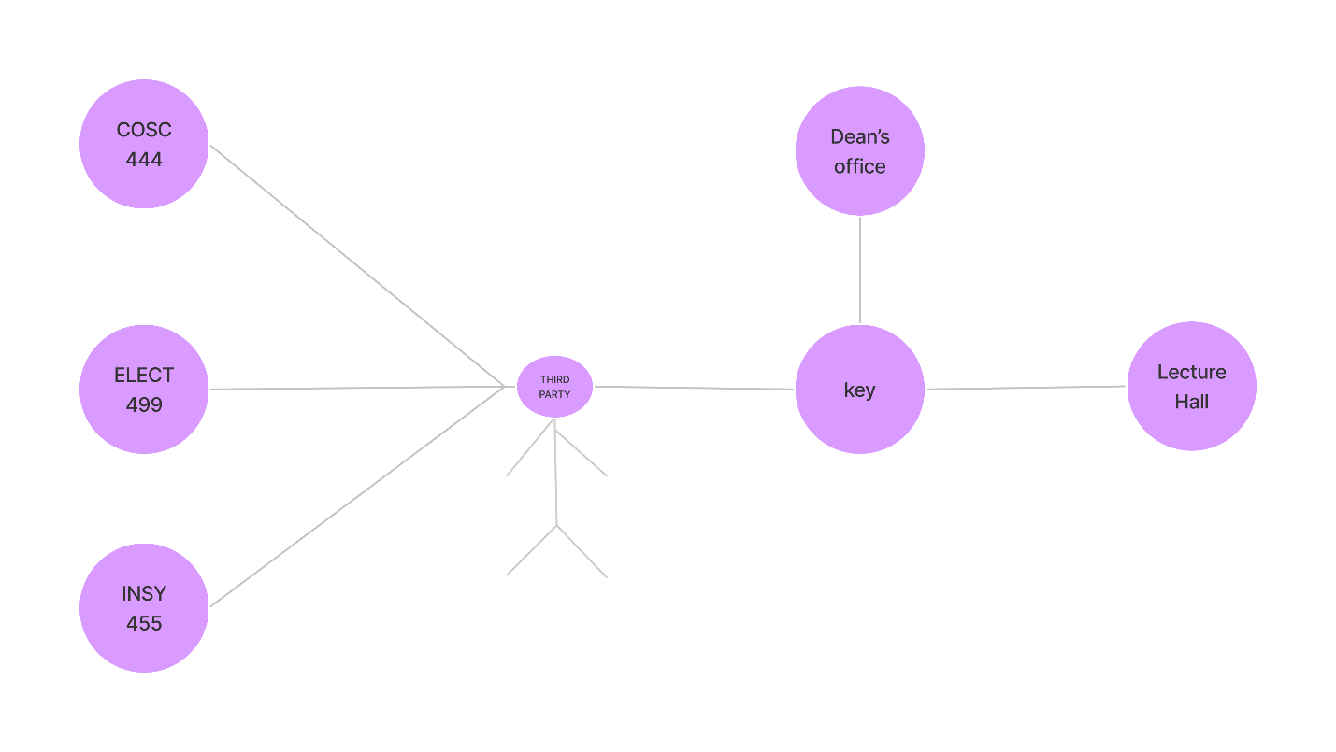

**Use Case Diagram**

