JAMAL MAMMADZADA
STUDENT RESEARCHER / MACHINE LEARNING SYSTEMS / SECURITY
Allen, Texas | (945) 274-4297 | Jamalmamamdzada13@gmail.com Portfolio | GitHub

Research Profile
High school researcher and engineer building auditable systems from noisy, real-world data. Develops competition-deployed computer-vision tools, security automation, robotics education systems, and independent mathematics research with an emphasis on reviewable evidence and reproducible evaluation.
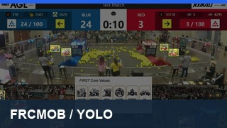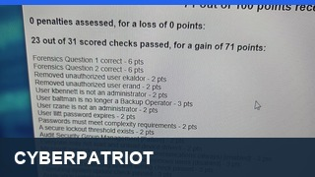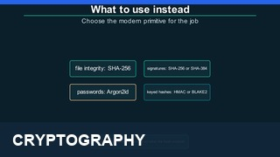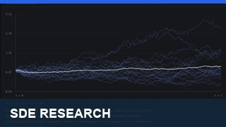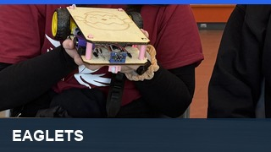

Selected Technical Work
FRCMOB - Sole Developer source ↗ February 2026-Present
- Built and deployed an open-source, full-stack scouting and match-analysis platform used by FRC Team 5417 at a real competition; supports multi-scout data collection, offline submissions, strategy analysis, and mobile-first workflows.
- Developing a computer-vision auto-scouting pipeline that detects and tracks robots in match video, maps observations into field coordinates, and retains confidence and human review before model outputs become accepted data.
Windows Hardening Framework - Sole Developer case study ↗ 2025-Present
- Engineered an approximately 11,900-line PowerShell framework for Windows and Windows Server auditing, hardening, compliance validation, and remediation across authentication, privileges, services, Defender, firewalls, and audit policy.
- Made changes evidence-first and reversible: simulate mode reports findings before modification, while backups and generated revert scripts protect destructive operations.
Practical Cryptography - Course Author case study ↗ 2026
- Authored a 43-lecture course across 16 sections with 16 exercises and a deliberately vulnerable capstone assessed through hidden and mutation-based tests; students preserve evidence and make a defensible release decision.

Research
Analytical Solvability of One-Dimensional SDEs - Independent Research research ↗ 2025-Present
- Compared analytical solution methods across geometric Brownian motion, Ornstein-Uhlenbeck, Cox-Ingersoll-Ross, and stochastic logistic models, varying one structural feature at a time.
Temperature Dependence of Capacitor Discharge - IB Physics Investigation 2026
- Measured RC discharge from 10-50 °C and wrote the Python analysis with gradient-bounded uncertainty; observed a 21% decrease in the time constant and tested it against the predicted Arrhenius trend.

Leadership & Technical Education
Eaglets: Robot Kits for Kids - President; Former Camp Coordinator case study ↗ 2024-Present
- Lead a student-run robotics program providing free camps for grades 3–8; rebuilding the 2026-27 leadership team, training new officers, and preparing Kit V6 for testing and summer 2027 production while it remains under active development.
Programming & AI Instructor - iCode experience ↗ March 2026-Present
- Teach programming fundamentals and practical machine learning through hands-on exercises, guiding younger students as they design and debug their own projects.

Education & Distinctions
Allen High School - International Baccalaureate Diploma Candidate Expected June 2027
Coursework: IB Mathematics HL II, AP Physics C: Electricity & Magnetism; prior AP Calculus BC and IB Physics SL
Honors: CyberPatriot XVIII Open Division National Semifinalist; picoCTF 2026 #68 worldwide on a two-person team that solved all 70 challenges for 14,500/14,500 points (personally solved 60); member of FRC Team 5417 for its 2025 Fort Worth FIRST Impact Award and Tomball District Event win

Technical Toolkit
Languages: Python, Java, C++, C, C#, JavaScript, TypeScript, PHP, PowerShell
ML & vision: YOLO, ByteTrack, OpenCV, OCR, optical flow, feature engineering, calibration, shadow deployment
Systems & data: FastAPI, React, PostgreSQL, Redis, MongoDB, Docker, Git, Windows Server, Raspberry Pi Pico, Arduino
Mathematics: Stochastic calculus, SDEs, numerical simulation, probabilistic modeling

