**MOHAMED YUSUF JAMAL N**

Case Study Report

Data Analytics with Power BI

**“Analysis of Cryptocurrency Growth in last 5 years”**

|  |  |
| --- | --- |
| **NM ID** | **NAME** |
| bru3q2122k0723 | MOHAMED YUSUF JAMAL N |

**“BISHOP AMBROSE COLLEGE”**

TRAINER NAME : R UMAMAHESHARI.,

MASTER TRAINER : R UMAMAHESHWARI.,

**ABSTRACT**

Cryptocurrency, a digital or virtual form of currency secured by cryptography, has revolutionized the financial landscape since the emergence of Bit coin in 2009. This abstract delves into the multifaceted world of Cryptocurrency, examining its underlying technology, economic implications, regulatory challenges, and societal impacts.

At its core, Cryptocurrency operates on decentralized ledger technology, most notably block chain, enabling peer-to-peer transactions without the need for intermediaries. This decentralized nature offers transparency, security, and immutability, reshaping traditional financial systems and fostering financial inclusion.

However, the meteoric rise of Cryptocurrency also brings forth various economic considerations. Its volatility poses both opportunities and risks for investors and businesses alike, with fluctuating values impacting investment strategies and market stability. Moreover, the proliferation of crypto currencies has sparked debates surrounding their legitimacy as a medium of exchange and store of value, with ongoing discussions regarding their classification and regulation.

**TABLE OF CONTENT**

|  |  |  |
| --- | --- | --- |
| **Sr. No.** | **Table of Contents** | **Page No.** |
| 1 | Section 1: Introduction | 4 |
| 2 | Section 2: Services and Tools Required | 6 |
| 3 | Section 3: Project Architecture | 10 |
| 4 | Section 4: Modeling and Result | 12 |
| 5 | Conclusion | 24 |
| 6 | Future Scope | 25 |

**INTRODUCTION**

The case study of cryptocurrency offers a compelling lens through which to explore the disruptive potential and intricate dynamics of digital currencies in today's financial landscape. Since the inception of Bitcoin in 2009, cryptocurrencies have rapidly gained prominence, captivating the attention of investors, policymakers, and technologists worldwide. This introduction sets the stage for delving into a detailed analysis of a specific case study within the realm of cryptocurrency, shedding light on its underlying technology, economic ramifications, regulatory challenges, and broader societal implications.

Cryptocurrency represents a groundbreaking innovation in the realm of finance, underpinned by blockchain technology—a decentralized ledger system that ensures transparency, security, and immutability in transactions. The decentralized nature of cryptocurrencies enables peer-to-peer transactions without the need for intermediaries, disrupting traditional financial systems and offering new avenues for financial inclusion. As such, examining a case study within this domain provides invaluable insights into the transformative potential of decentralized finance and its implications for traditional banking systems and global economies.

* 1. **PROBLEM STATEMENT**

The burgeoning popularity of cryptocurrency has brought to light a myriad of challenges that span technological, economic, regulatory, and societal domains. At the forefront of these challenges lies the issue of scalability, as existing blockchain networks struggle to accommodate growing transaction volumes efficiently. The scalability bottleneck not only hampers the usability of cryptocurrencies as a medium of exchange but also exacerbates concerns regarding transaction fees and confirmation times. Furthermore, the volatility inherent in cryptocurrency markets presents a significant barrier to widespread adoption, hindering its potential as a stable store of value and medium for everyday transactions.

Additionally, the regulatory landscape surrounding cryptocurrencies remains fragmented and uncertain, with divergent approaches adopted by different jurisdictions. This regulatory ambiguity not only undermines investor confidence but also poses challenges for businesses seeking to integrate cryptocurrency into their operations. Moreover, the pseudonymous nature of cryptocurrency transactions raises concerns regarding illicit activities such as money laundering, terrorism financing, and cybercrime, necessitating robust regulatory frameworks to mitigate risks without stifling innovation.

* 1. **PROPOSED SYSTEM**

The growth of cryptocurrency from speculative investment to a new asset class has prompted governments around the world to explore ways to regulate it. As of January 2024, some governments have created frameworks to provide protection for users, while others bide their time. India remains on the fence regarding crypto regulation, neither legalizing nor penalizing its use. There is a bill in circulation that prohibits all private cryptocurrencies in India, but it has yet to be voted on .There is a 30% tax levied on all crypto investments and a 1% tax deduction at source (TDS) on crypto trades .Overall, India continues to hesitate to ban crypto outright or to regulate it. The country's Finance Bill of 2022 defined virtual digital assets as property and outlined tax requirements for collecting taxes on income from them. This research is relevant to achieve a deeper understanding of the impact of digital currencies on investor decision making. Production and economy playing a key role in today's financial investment, helping to increase digital capital, It affects economic growth. Meet the current needs of the digital age and influence investor decisions. Analysis of strengths and weaknesses of digital currencies in India. Analyze the current position of digital currencies and their investors. Provide information on post-implementation economic conditions Digital currency. Study the changes that digital currencies have brought to investors and the economy.

**1.3 FEATURES**

**Stability:** Leveraging stablecoins pegged to fiat currencies or other stable assets to mitigate the volatility inherent in traditional cryptocurrencies.

**Decentralization:** Built on blockchain technology to ensure transparency, security, and immutability of transactions, while eliminating the need for intermediaries.

**Scalability**: Implementing scalable solutions such as layer 2 protocols or sharding to address the scalability challenges faced by existing cryptocurrency networks.

**Interoperability:** Facilitating seamless interoperability with other blockchain platforms and traditional financial systems to promote broader adoption and utility.

**User-friendly Interface:** Designing an intuitive user interface and experience to enhance accessibility for both experienced traders and newcomers to the cryptocurrency space.

**Regulatory Compliance:** Implementing robust KYC/AML procedures and adhering to regulatory guidelines to foster trust and compliance within the cryptocurrency ecosystem.

**Community Governance:** Empowering users through decentralized governance mechanisms to participate in decision-making processes and ensure the platform's sustainability and integrity.

**1.4 ADVANTAGES**

**Stability:** Provides a reliable medium of exchange and store of value, encouraging mainstream adoption and facilitating everyday transactions.

**Security:** Enhances security and transparency through blockchain technology, reducing the risk of fraud and unauthorized access.

**Scalability:** Addresses scalability concerns, enabling the platform to accommodate a growing user base and transaction volume without compromising performance.

**Interoperability:** Promotes interoperability with existing financial systems, facilitating seamless integration and fostering innovation in cross-border payments and remittances.

**Accessibility:** Offers a user-friendly interface and experience, lowering entry barriers and empowering individuals to participate in the cryptocurrency economy.

**Compliance:** Ensures regulatory compliance, mitigating regulatory risks and fostering trust among users, investors, and regulatory authorities.

Community Empowerment: Engages users in governance processes, promoting decentralization, transparency, and inclusive within the cryptocurrency community.

**1.5 SCOPE**

Cryptocurrency encompasses a broad spectrum of applications, including but not limited to digital payments, decentralized finance (DeFi), tokenization of assets, supply chain management, voting systems, and digital identity verification. Its scope extends across various industries, revolutionizing traditional financial systems, enhancing security and transparency in transactions, fostering financial inclusion, and driving innovation in blockchain technology. As the cryptocurrency ecosystem continues to evolve, its scope will likely expand further, influencing diverse sectors and reshaping the global economy.

**SECTION: 2**

**SERVICES AND TOOLS REQUIRED**

**2.1 SERVICES USED**

**Decentralised digital currency** The first and foremost use case of cryptocurrencies is that it has provided the world with a decentralised digital currency. It means that this currency has no government or other third-party interference, and banks or other financial organisations cannot exercise any control over this digital coin.

**Crypto banking** Banking barons like Barclays, JP Morgan, Goldman Sachs, and others have tailored their banking services to manage cryptocurrencies. This has led to the emergence of a system called crypto banking. These banks have begun offering crypto interest accounts and savings accounts. Traditional banks hold cash, stocks and other financial assets for their users. Similarly, crypto banks hold their clients' crypto assets and traditional fiat currencies. Do note that India has to do a lot of catching up in this regard.

**Crypto staking** Crypto staking is one of the best ways to earn passive income from crypto assets. Proof-of-Stake (PoS) blockchains allow you to stake your cryptocurrency and participate in its consensus mechanism. In exchange, you can validate a block on that chain and earn rewards. The cryptocurrencies you can stake are:

Ethereum (ETH)

Solana (SOL)

Cardano (ADA)

Avalanche (AVAX)

Luna (LUNA)

Polkadot (DOT)

You can safely rely on PoS blockchains for investing in your crypto. As the network forces its participants to lock away a certain portion of its local tokens, it safeguards against any malicious activity on that blockchain.

**Asset tokenisation** Cryptocurrencies allow you to tokenise physical assets and link them to digital tokens. Thus, you can tokenise commodities, real estate, art, stocks, copyrights, etc. This process of asset digitisation improves the market liquidity of various real-world assets. Asset tokenisation would allow increased participation of investors who would have otherwise been unable to invest due to inadequate cash. Furthermore, by dividing the ownership of items into several pieces, investors can gain a proportion of the value of assets they hold. Asset tokenisation would be a popular use case in our country, especially in Tier-2 and Tier-3 cities.

**On-chain governance** Cryptocurrencies offer a more refined way to implement new policies on a network. Blockchains have DAOs (Decentralised Autonomous Organisations) allowing you to stake crypto coins in exchange for voting rights. Blockchain developers call it Governance Token. On a blockchain, the community can distribute governing power among its stakeholder via these tokens. This is called On-Chain Governance. By owning governance tokens, you get the authority to alter a network’s protocol.

**Crypto gaming** The crypto gaming industry has seen a boom in recent years. Gamers worldwide are earning in game items in the form of NFTs and trading and selling them based on their demand. These P2E games can be an excellent way to utilise your crypto assets and gain endless hours of fun and NFTs in the form of rewards. Furthermore, you can earn crypto as a reward by playing these games. There are a lot of gamers in the Philippines who earn a daily wage from playing Axie Infinity, a popular NFT game.

**Smart contracts** Smart contracts are lines of code that execute a transaction if a given set of terms and conditions are met among the concerned parties. You can automate various actions and functionalities using smart contracts. The best part about them is that there are no interruptions in the execution of a process when the underlying terms are met. Furthermore, no third parties will have the authority to change or modify the decision or agreement. As smart contracts are blockchain-based, all the data it generates is immutable, and no entity can update or alter it in any way.Smart contracts have an increasing number of use cases in the fields of Governance, Finance, Health Care, Insurance etc.

**Store of value** You may have heard crypto investors call Bitcoin “digital gold”. This is because cryptocurrencies can store and transfer value over time. They work on a supply mechanism that restricts inflation. As the value of crypto increases with a rise in demand, it can serve as an excellent investment opportunity over time. Some experts even predict that Bitcoin will take the market share away from gold in the coming time.

**2.2 TOOLS AND SOFTWARE USED**

**Tools:**

**POWER BI:**

The main tool for this project is PowerBI, which will be used to create interactive dashboards for real-time data visualization.It helps to analyse the overall data about crypto currency for last 5 years using flowchart of different country analysis.

**Software Requirements:**

**PowerBI Desktop:**

This is a Windows application that you can use to create reports and publish them to Power BI. This is an online SaaS (Software as a Service) service that you use to publish reports, create new dashboards, and share insights. This is a mobile application that you can use to access your reports and dashboards on the go.

**CRYPTO SOFTWARE:**

Cryptocurrency mining software handles the processing and machine management related to cryptocurrency mining. Crypto mining software can purely serve individual miners, or facilitate pooled mining operations. They are also often connected to cryptocurrency exchanges. Cryptocurrency mining serves a crucial role in the blockchain ecosystem, in addition to being individually profitable.Cryptocurrency mining is, in simplified terms, the process of verifying transactions made on the blockchain. The miner is eligible to receive coins as a reward once a given block or portion of the blockchain has been verified. These processes most heavily depend on graphical processing units (GPUs) or application-specific integrated circuits (ASICs) to handle the necessary computations. mining pools share hardware’s computing power across multiple machines into a single pool. This helps the overall pool more efficiently earn the cryptocurrency, which is then divided among the participants based on the amount of work that each machine did. Mining software will always support individual miners, but some will also enable mining pools natively on the platform.

These products will likely be more scalable for B2B users in particular.The mining software varies dramatically in sophistication. There are a range of entry-level programs that primarily mine cryptocurrency while the machine is idle. B2B miners will be more focused on the advanced platforms, which assume dedicated machines to mining cryptocurrency. These products offer more advanced customization and configurability for peak efficiency at scale. They will also provide more support for mine pooling and management.

**SECTION 3**

**CRYPTOCURRENCY ARCHITECTURE**

**Blockchain Technology:** Utilizes distributed ledger technology to record and verify transactions across a decentralized network, ensuring transparency, security, and immutability.

**Decentralization:** Operates without a central authority, relying on a network of nodes to validate transactions and maintain the integrity of the blockchain, enhancing resilience and reducing the risk of censorship or control.

**Cryptography:** Employs cryptographic techniques such as hashing, digital signatures, and public-private key pairs to secure transactions, authenticate users, and maintain privacy.

**Consensus Mechanisms:** Implements consensus algorithms like Proof of Work (PoW), Proof of Stake (PoS), or variations thereof to achieve agreement among network participants on the validity of transactions, ensuring the integrity of the ledger.

**Wallets and Addresses:** Enables users to store, send, and receive cryptocurrencies through digital wallets that manage public-private key pairs. Each user has a unique cryptographic address, allowing for secure and pseudonymous transactions.

**CRYPTO EXCHANGE**

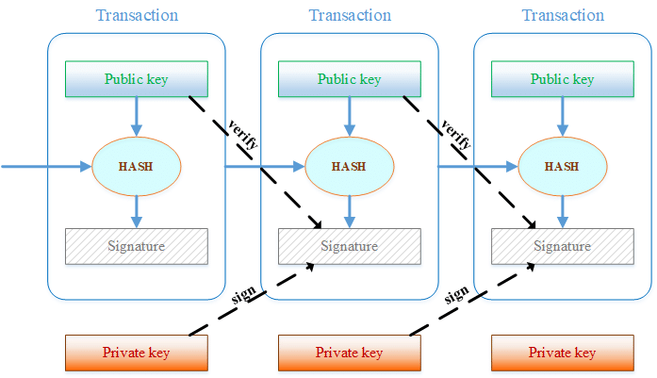

**BLOCK CHAIN ARCHITECTURE**

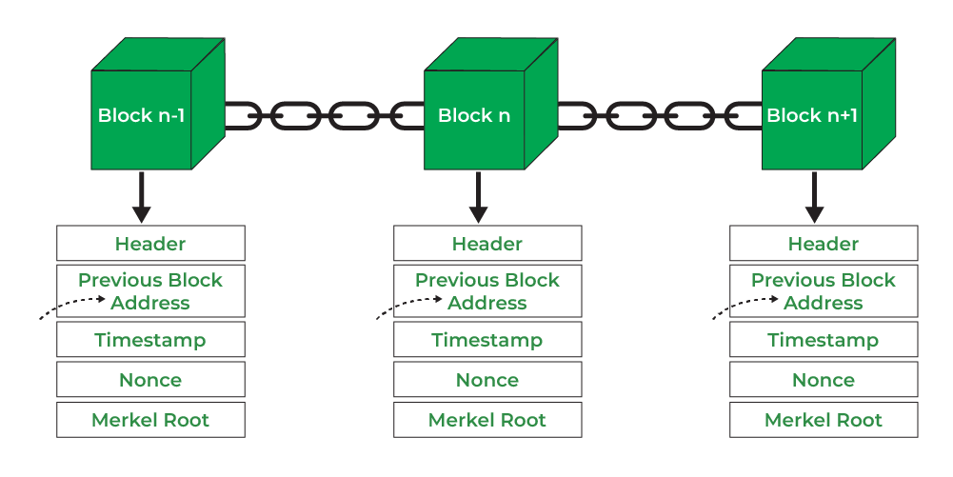

**BLOCKCHAIN VS DATABASES ARCHITECTURE**

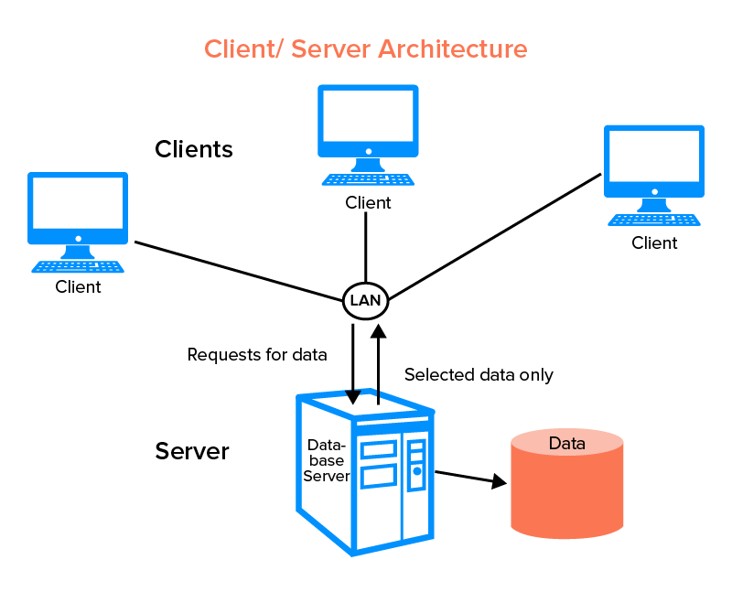

**SECTION: 4**

**MODELING AND RESULT**

**Modeling Cryptocurrency:**

1. **Market Dynamics Modeling:** This involves analyzing the supply and demand dynamics of cryptocurrencies within the market. It includes factors such as trading volume, liquidity, price trends, and market sentiment. Various mathematical models, including econometric models and time series analysis, can be employed to understand and predict market behavior.
2. **Blockchain Network Modeling:** Modeling the structure and behavior of blockchain networks is crucial for understanding their scalability, security, and performance. This includes simulating transactions, consensus mechanisms, network propagation, and validation processes. Agent-based modeling and network simulations are commonly used techniques for studying blockchain networks

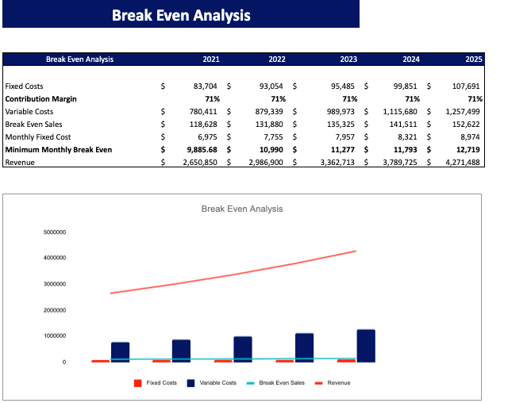

**3. Cryptocurrency Valuation Modeling:** Determining the intrinsic value of cryptocurrencies involves modeling various fundamental factors such as adoption rate, utility, network effects, and tokenomics. Valuation models such as discounted cash flow (DCF), Metcalfe's Law, and network value-to-transaction ratio (NVT) can be utilized to assess the value proposition of cryptocurrencies.

1. **Risk Modeling:** Assessing and quantifying the risks associated with cryptocurrency investments and transactions is essential for informed decision-making. Risk modeling involves analyzing factors such as volatility, liquidity risk, regulatory risk, and cybersecurity threats. Monte Carlo simulations, stress testing, and scenario analysis are common techniques used for risk modeling in the cryptocurrency space.

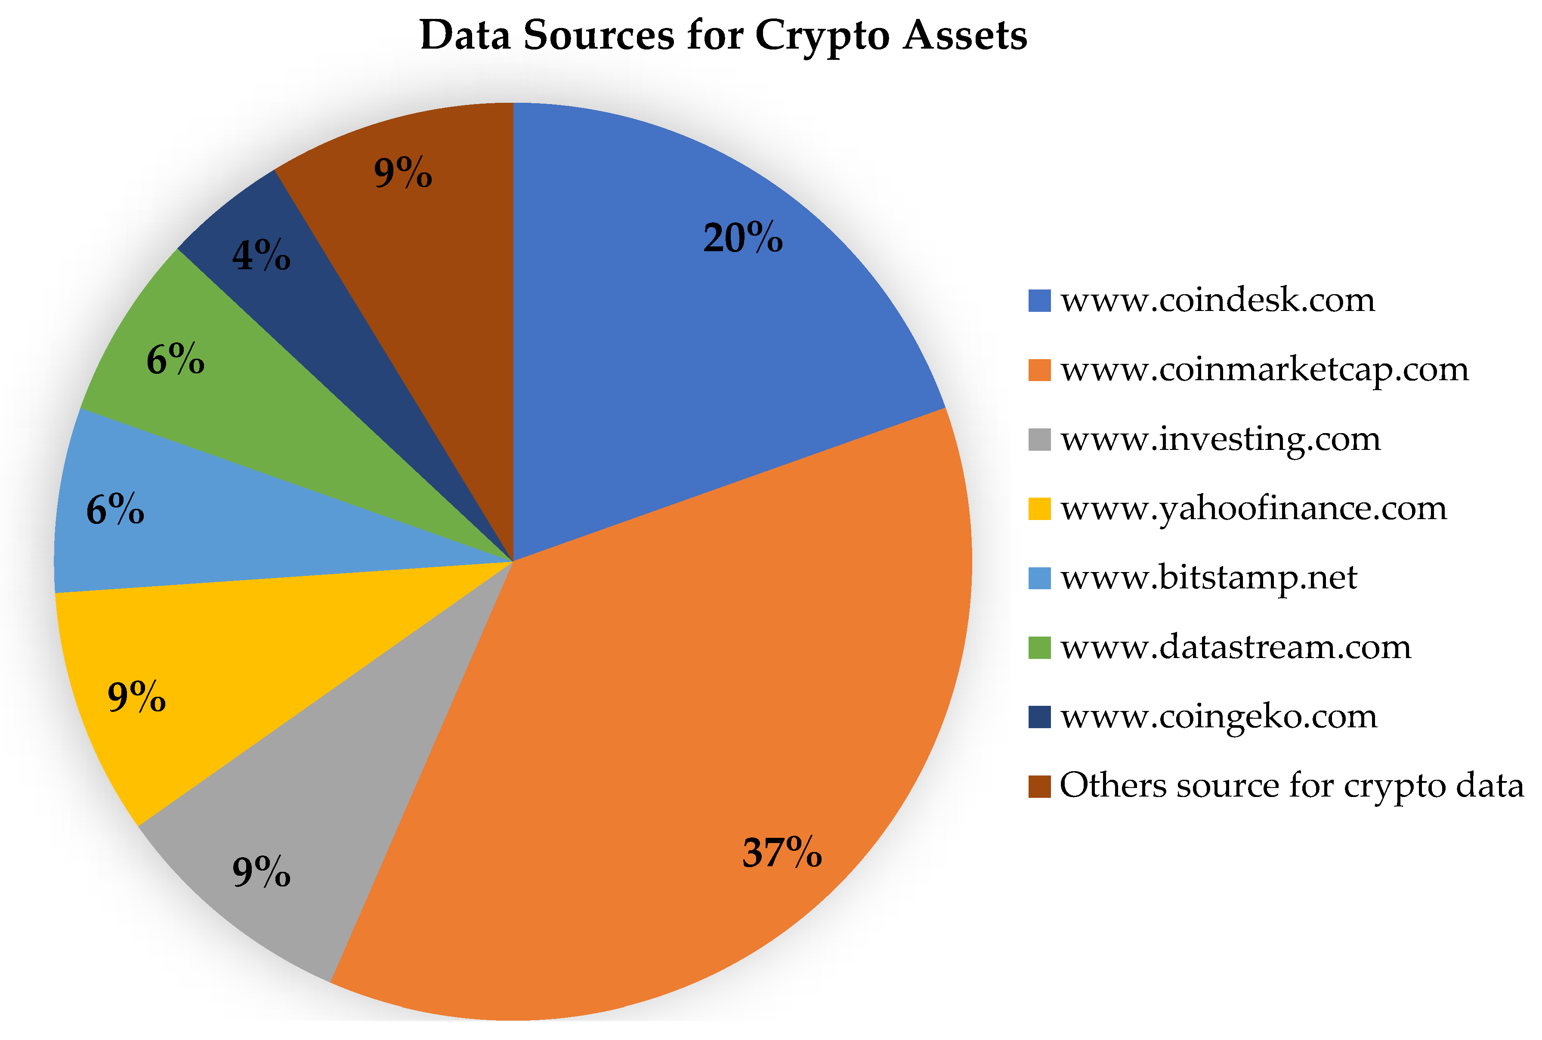

**5. Adoption and Growth Modeling:** Predicting the adoption and growth trajectory of cryptocurrencies involves modeling factors such as user adoption rates, network effects, technological advancements, and regulatory developments. Agent-based modeling, logistic growth models, and diffusion models can be employed to forecast the future adoption and diffusion of cryptocurrencies within the market.

**Blockchain Hashing**

Logically, the first block does not contain the pointer since this one is the first in a chain. At the same time, there is potentially going to be a final block within the blockchain database that has a pointer with no value. Basically, the following blockchain sequence diagram is a connected list of records.

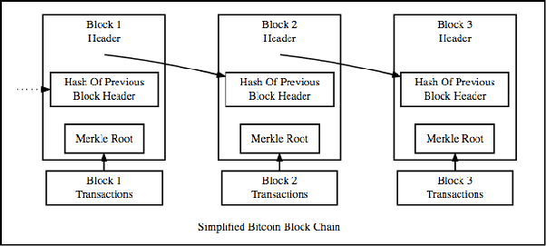

**Blockchain Architecture**

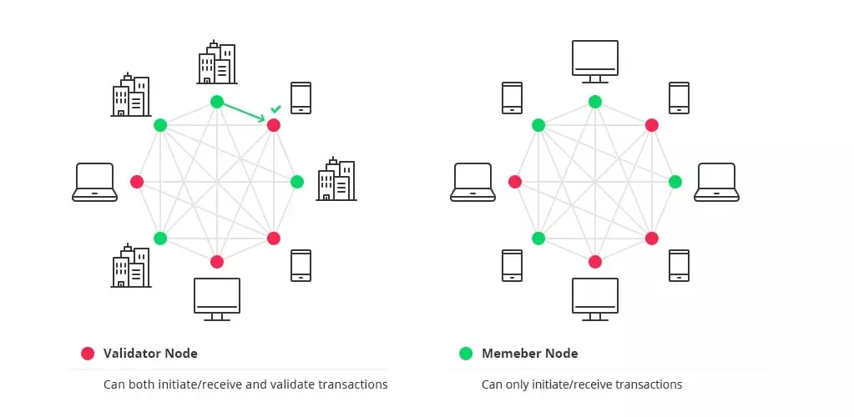

**Public blockchain architecture**

A public blockchain architecture means that the data and access to the system is available to anyone who is willing to participate (e.g. Bitcoin, Ethereum, and Litecoin blockchain systems are public).

**Private blockchain architecture**

As opposed to public blockchain architecture, the private system is controlled only by users from a specific organization or authorized users who have an invitation for participation.

**Consortium blockchain architecture**

This blockchain structure can consist of a few organizations. In a consortium, procedures are set up and controlled by the preliminary assigned users.

**REPORT COVERAGE**

This market report provides an in-depth analysis of the market. It focuses on key aspects such as leading companies, product Industry, and leading mining software and hardware solutions.Besides this, the report offers insights into the cryptocurrency market trends and highlights key industry developments. In addition to the aforementioned factors, the report encompasses several key factors contributing to the market&#39;s growth over recent years.

**ANALYSIS OPINION**

Analysis Opinion on Cryptocurrency:

Cryptocurrency represents a groundbreaking innovation with the potential to reshape the financial landscape and empower individuals worldwide. However, its volatile nature, regulatory uncertainties, and security risks warrant careful consideration and analysis.

From an economic perspective, cryptocurrency offers several advantages, including decentralization, borderless transactions, and financial inclusion. It provides an alternative to traditional banking systems, particularly in regions with limited access to financial services, empowering individuals to participate in global markets and transact securely without intermediaries.

Moreover, cryptocurrency has spurred technological innovation, particularly in blockchain technology, which has applications beyond finance in areas such as supply chain management, identity verification, and decentralized governance.

Despite these benefits, cryptocurrency markets are susceptible to extreme volatility, driven by speculative trading, market sentiment, and external factors. Price fluctuations can pose risks for investors and businesses, impacting investment strategies and market stability. Additionally, concerns regarding regulatory compliance, security breaches, and illicit activities remain significant challenges for the cryptocurrency industry.

Regulatory uncertainty also hampers mainstream adoption and investment in cryptocurrencies. Governments and regulatory bodies worldwide are grappling with the classification and regulation of digital assets, leading to fragmented regulatory frameworks and enforcement actions that vary across jurisdictions.

In conclusion, while cryptocurrency holds immense promise as a disruptive force in finance and technology, its widespread adoption and integration into mainstream systems depend on addressing regulatory challenges, enhancing security measures, and fostering greater transparency and trust within the ecosystem. As the industry continues to evolve, a balanced approach that harnesses the transformative potential of cryptocurrency while mitigating associated risks is essential for realizing its full benefits.

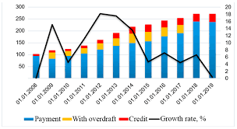

**DASHBOARD**

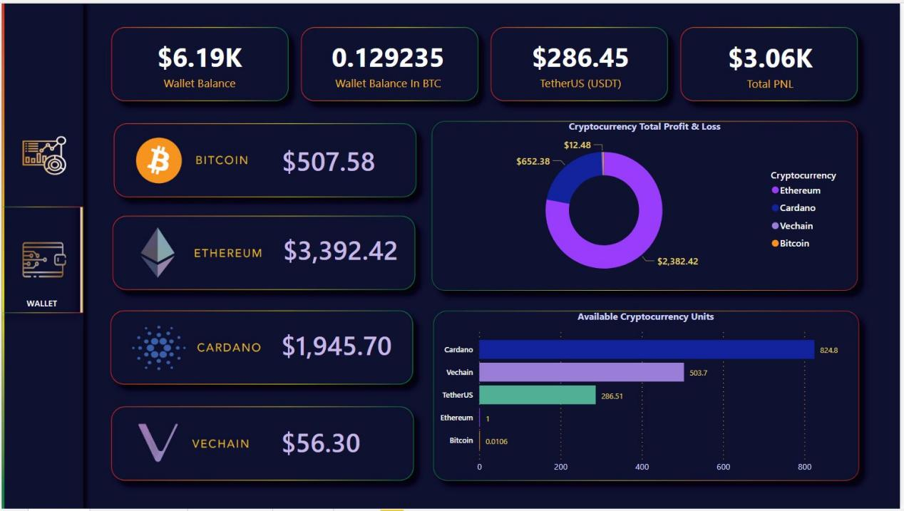

Dive into the digital currency realm with our Crypto Dashboard UI. As the technology it represents, with intuitive navigation and comprehensive overviews of your investments. Track your portfolio growth through vivid charts and stay updated with the latest market moves, all within a striking dark theme that echoes the cutting edge of crypto. Elevate your trading with a dashboard that a step ahead. A cryptocurrency dashboard that lives on a website or an app (either desktop or mobile). Its primary function is to track your cryptocurrency accounts and coins and monitor their historical prices and current values so that you can manage both your crypto assets and related financial plans accordingly. The dashboard

integrates with cryptocurrency exchanges or trackers like CoinMarketCap through an API or other tool to update your crypto assets in real-time.

**Cryptocurrency Awareness**

According to a Forbes Advisor survey conducted in the UK, 90% of respondents had heard of

Bitcoin making it the most well-known cryptocurrency. Other familiar coins included:

Bitcoin – 90%

Ethereum – 50%

Dogecoin – 45%

Binance Coin – 36%

USD Coin – 27%

Tether – 26%

Solana – 21%

Cardano – 18%

CONCLUSION

The emergence of Bitcoin has sparked a debate about its future and that of other cryptocurrencies. Despite Bitcoin’s recent issues, its success since its 2009 launch has inspired the creation of alternative cryptocurrencies such as Etherium, Litecoin, and Ripple. A cryptocurrency that aspires to become part of the mainstream financial system would have to satisfy very divergent criteria. While that possibility looks remote, there is little doubt that Bitcoin’s success or failure in dealing with the challenges it faces may determine the fortunes

of other cryptocurrencies in the years ahead. Crypto-currency is such an invention which has become a global phenomenon. Earlier RBI warned the Indians from using cryptocurrency that to be associated with money laundering and terrorist financing. However, cryptocurrency is a modern technology and a tool which needs to look forward for. Even though there has been no regulatory response from the Indian government, the number of investors in cryptocurrency is increasing rather swiftly over the last few years. Indian government should take responsible steps now to regulate such currency as its user in India is rapidly growing. Future of

cryptocurrency in India looks promising and there is ray of hope. Crypto currencies could provide a significant benefit by overcoming the lack of social trust and by increasing the access to financial services (Nakamoto, 2008) as they can be considered as a medium to support the growth process in developing countries by increasing financial inclusion, providing a better traceability of funds and to help people to escape poverty .

**FUTURE SCOPE**

The future scope of this project is vast. The use of Bitcoin and Ethereum could help strengthen India’s monetary policy and bridge the gap areas that exist in the current fintech landscape. Crypto’s distributed ledger technology permits faster, direct transactions by the users and also

helps keep track of every digital transaction, which is far more advanced and effective than existing protocols such as SWIFT. Secondly, Bitcoin can be used as an asset that sovereigns use to complement their national digital currencies. We can avoid instances such as mortgage fraud and other fraudulent activities. In other words, the evolution of Bitcoin and

cryptocurrencies holds economic importance similar to the internet in the 90s. The second unique crypto called Ethereum, which enabled smart contracts, gave birth to an entire sector called decentralized finance (DeFi). DeFi is to build a multi-faceted financial system that boosts the functionality and helps improve the legacy or the traditional financial system. DeFi alone has created disruptions in the fintech space and, in the future, DeFi neo banks will play a pivotal role to successfully bridge the gap between fintech and DeFi to attract new customers.

**LINK**

<https://github.com/jam92444/NMCASESTUDY.git>