|  |
| --- |
| **TEST CODE : TCS17-04T(R)**  Total number of question : 10  Test duration (min) : 20 min  Correct attempt (mark) : 1  Wrong attempt (mark) : Nil |



**TECHNICAL**

*Certain questions are self-explanatory. Thus detailed solutions are provided only wherever required.*

**1**. What is the purpose of ftell?

a. To get the current file name

b. To get the current file status

c. To get the current file attributes

d. To get the current file position

**Answer:** D

**Explanation:**

ftell() is used to find out the position of file pointer in the file with respect to starting of the file.

**2**. What will be the output of the below code?

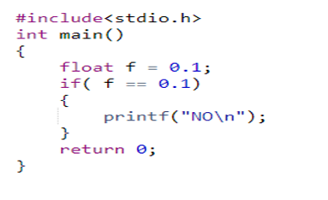

a. NO output b. NO

c. Successfully complied but no output d. ERROR

**Answer:** C

**Explanation:**

No error and if condition fails so there is no output

**3**. What is the output of the below-mentioned programme?

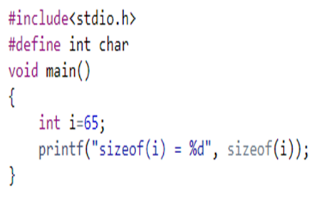

a. sizeof(i) = 2 b. sizeof(i) = 1

c. compile Error d. None of these

**Answer:** B

**Explanation:**

int size is 2bytes or 4 bytes. Char size is 1 byte. Int is defined as Char. Sizeof(i) = 1

**4**. For passing command line argument the main function should be like

a. int main(int argc, char *argv[])

b. int main(int argc)

c. int main(char *argv[])

d. int main(char *argv[], int argc)

**Answer:** A

**Explanation:**

Command Line Arguments Syntax

**5**. Where the local variables are stored?

a. Disk b. Stack c. Heap d. OS

**Answer:** B

**Explanation:**

Local Variable is stored in stack

**6**. Which of the below functions is NOT declared in string.h?

a. strptr () b. strcpy ()

c. strlen() d. strupr()

**Answer:** A

**Explanation:**

strptr() is not declared

7. What is the output of the below-mentioned programme?

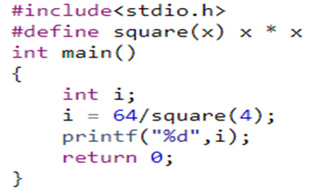

a. 16 b. Compilation Error

c. 64 d. 4

**Answer:** C

**Explanation:**

It executes based on the operator precedence. 64 / 4 * 4. 16*4 = 64

**8**. What is the format of conditional operator?

a. Condition? true value: false value

b. Condition! true value: false value

c. Condition? false value: true value

d. Condition? true value: :false value

**Answer:** A

**Explanation:**

Syntax

**9**. What is recursion?

a. Looping

b. A function calls another function repeatedly

c. A function calls repeatedly

d. A function calls itself repeatedly

**Answer:** D

**Explanation:**

In recursion, function calls itself repeatedly

**10**. A memory leak happens when?

a. A program allocates memory in heap but forget to delete it.

b. A program allocates memory in stack.

c. When an unsigned pointer is freed using free function.

d. When realloc() is called on a pointer that is not allocated

**Answer:** A

**Explanation:**

Memory leak occurs when programmers create a memory in heap and forget to delete it.