17) Performance of a company in terms of sales and profits. Overall profit was Rs 500 crore on a turnover of Rs 7,500 crore(2001 figure)

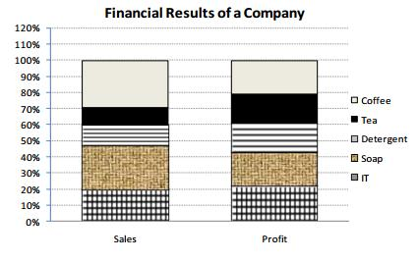

The products category with the highest profitability(i. e. profit /sales × 100) is :

a. IT b. Detergent c. Coffee d. Soap

18) Ghosh Babu has recently acquire four companies namely Arc-Net Technologies (ANT), Babu Anta Transport (BAT), Charles Anter Tailors (CAT) and Daud Akba Transistor (DAT). When the results of the companies for the year 1992-93 were placed before him, he found a few interesting things about them. While the profits of CAT and DAT were the same, the sales of CAT were the same as those of BAT. Profits of ANT were 10% of its sales, where as the profits of BAT were 20% of its sales. While the total expenses of CAT were 5 times of its profits, sales of DAT were 3 times its profits. The total expenses of CAT were Rs.10 lakhs and of ANT were 10% less than those of BAT. Profits are defined between sales and total expenses.

Which company had the highest total expenses?

a. ANT b. BAT c. CAT d. DAT

19) The following pie-chart shows the amount of subscriptions generated for India Bonds from different categories of investors.

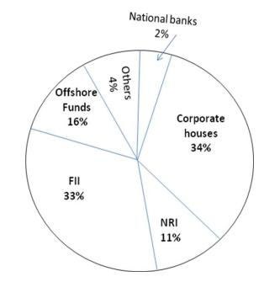

What is the approximate ratio of investment flows into India Bonds from NRIs to corporate houses?

a. 1:4 b. 1:3 c. 3:1 d. Cannot be determined

20) Study the following figure carefully and answer the questions. The triangle represents doctors. The circle represents players and the rectangle represents artists.

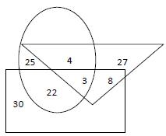

How many doctors are both players and artists?

a. 4 b. 8 c. 3 d. 11

21) Study the following table and answer the questions

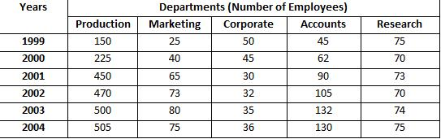

In which department did the number of employees (approximately) remain the same during the years 1999 and 2004?

a. Production b. Corporate c. Research d. None of these

22) In a certain coded language each english alphabet denotes the letter that comes two positions earlier than it i.e. C = A, D= B, J = H, L =J, W = U, B = Z, A = Y etc. on the basis of this code find what would the following groups of letters indicate?

CKTDWU

a. BROKER b. AIRBUS c. DEVISE d. DEVOTE

23) In each of the following questions the terms follow a definite pattern.

However, one term is wrong. Find the wrong term out of given options:

3, 2, 8, 9, 13, 22, 18, 32, 23, 42

a. 8 b. 9 c. 3 d. 22

24) In a certain coded language each english alphabet denotes the letter that comes two positions earlier than it i.e. C = A, D= B, J = H, L =J, W = U, B = Z, A = Y etc. on the basis of this code find what would the following groups of letters indicate?

RCKPVKPI

a. DRESSAGE b. PAINTING c. PROPOUND d. PROPERTY

25) In the following questions one term is missing from the series. Tick the option that you think fits in the blank space to complete the series.

AGM, BHN, (……..) DSP, EKQ, FLR

a. OIC b. CIO c. IOU d. LXR.

In each of the following questions, the letters are coded as some other letters. Trace the code for the given groups of letters.

26) If in a certain language CHENNAI is coded as DIFOOBJ. How is MUMBAI coded in that code?

a. CPNCBX b. NVNCBJ c. CPOCBZ d. CQOCBZ

27) In a certain coded language each english alphabet denotes the letter that comes two positions earlier than it i.e. C = A, D= B, J = H, L =J, W = U, B = Z, A = Y etc. on the basis of this code find what would the following groups of letters indicate?

RTQVTCEV

a. PALADIN b. PAGEBOY c. PROTRACT d. MACHINE

28) In the following questions one term is missing from the series. Tick the option that you think fits in the blank space to complete the series.

BL4, CM9, DN16, (….) FP36, GQ49

a. BF64 b. EO49 c. EO25 d. OE52

29) The sides of a cube show the colours of rainbow. Two positions of the cube of shown below. Which of the colours of rainbow is left out?

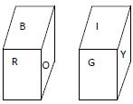

a. Indigo b. Green c. violet d. yellow

30. The terms given in each of the following questions follow a definite pattern and thus make a series. Find the missing number from the series out of the given options:

19, 2, 38, 3, 114, 4, (……..)

a. 228 b. 256 c. 352 d. 456

Answer: 4

ANSWERS

1. B
2. C
3. B
4. C
5. C
6. B
7. B
8. B
9. B
10. B
11. C
12. C
13. C
14. D