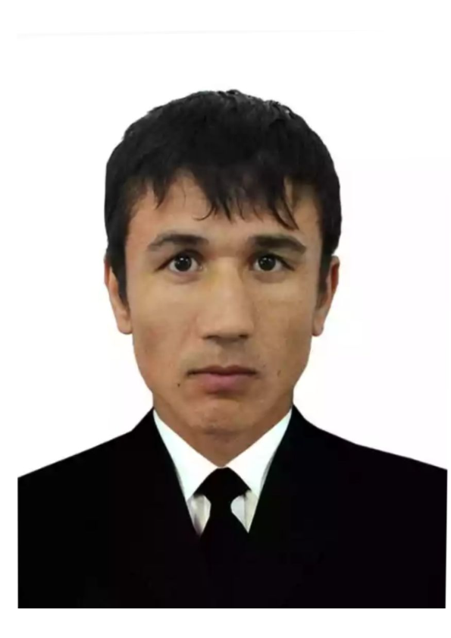  Jamshiddin Babajonov Maqsud o‘g‘li  Telefon: +998 95 799 00 34  Email: jbm050690@gmail.com  Manzil: Toshkent shahri, Uchtepa tumani, 26-daha, 22-uy | [Rasmingizni bu joyga qo‘ying]

Kasbiy maqsad
Web dasturlash sohasida innovatsion yechimlar yaratish, zamonaviy texnologiyalar orqali samarali va foydalanuvchi uchun qulay veb-ilovalarni ishlab chiqish, shuningdek, doimiy o‘rganish va amaliyot orqali malaka va tajribani oshirib, professional web dasturchiga aylanish.

Ta’lim
Najot Ta`lim o’quv markazi
• Web Praktikum kursi — 2025.08 – 2026.04
Toshkent Davlat Pedagogika Universiteti
• Tarix o‘qitish metodikasi (Magistr) — 2013 – 2015

Texnik bilim va ko’nikmalar
• Dasturlash tillar: HTML, CSS, JavaScript
• Texnologiyalar: SCSS, Figma, Git, GitHub
• OS: Windows

Chet tillarini bilish darajasi
O’zbek tili (ona tili), Rus tili (o’rtacha), Ingliz tili (o’rtacha)

Boshqalar
• Haydovchilik guvohnomasi: B
• Rossiya Federatsiyasida ishlash tajribasi (2021–2025)
  Jamshiddin Babajonov Maqsudovich  Phone: +998 95 799 00 34  Email: Jbm050690@gmail.com  Address: House 22, Block 26, Uchtepa District, Tashkent, Uzbekistan |   [Place your photo here]

Professional Summary
To create innovative solutions in the field of web development, build efficient and user-friendly web applications using modern technologies, and continuously enhance skills and experience through ongoing learning and practice in order to become a professional web developer.

Education
Najot Talim education center
• Web Practicum bootcamp — 2025.08-2026.04
Tashkent State Pedagogical University
• M.A. in History Teaching Methodology — 2013–2015

Technical skills and competencies
• Technologies: SCSS, Figma, Git, GitHub
• Languages: HTML, CSS, JavaScript
• Technologies: SCSS, Figma, Git, GitHub
• OS: Windows

Language skills
Uzbek (native), Russian (intermediate), English (Intermediate)

Others
• Driving licence: B
• Work experience in the Russian Federation (2021–2025)

