-Step voltages with random duration to observe roller temperature response.

-Pyrometer cannot read anything below 50C and so until the temp. crosses that limit the temperature is read constant (3 mins at 1.5V).

-Actuation/Input: TOP PS : MAGNAPOWER TSD 10-6000

-State/Observation: Temp in C (Pyrometer)

- Max temp: 300C

- Max V: 5V

- RPM: 0.02

- Brush contact: 180 Phase

- Worked on single roller

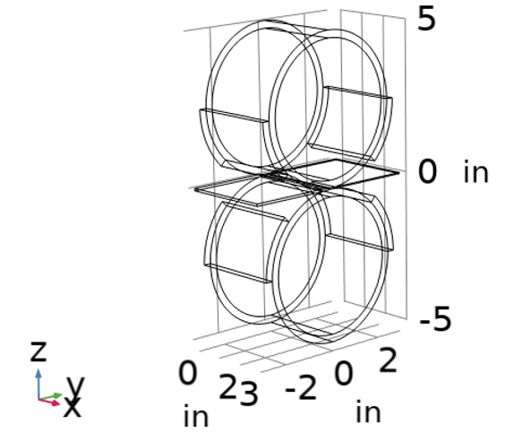

**Settings**

* 1. Materials
     1. Rollers = Graphite
     2. Brushes = Graphite
     3. Sample = Aluminum
  2. Setup
     1. Graphite ring thickness = 0.25 in
     2. Brush arc = 45°
     3. θ = 180° (closest angle between brush)
     4. Electrical Configuration = Positive and negative terminals on each roller
  3. Variables
     1. RPM = 0.02
     2. Voltage = 0~10 V
  4. Sampling @ ~ 1sec

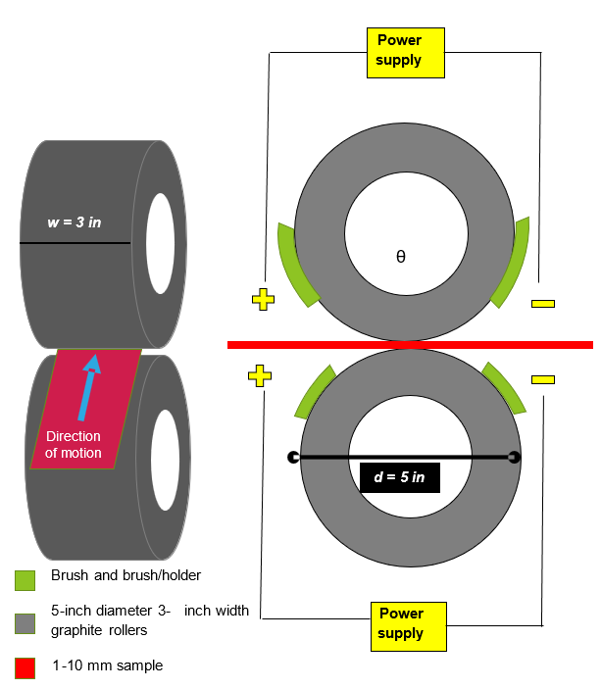

<https://www.engineersedge.com/heat_transfer/convective_heat_transfer_coefficients__13378.htm>