**Choosing and Preparing Example Data for Analysis**

This example uses the hair dryer data, also used by iddemo1 ("Estimating Simple Models from Real Laboratory Process Data"). The process consists of air being fanned through a tube. The air is heated at the inlet of the tube, and the input is the voltage applied to the heater. The output is the temperature at the outlet of the tube.

Let us begin by loading the measurement data and doing some basic preprocessing:

load dry2

Form a data set for estimation of the first half, and a reference set for validation purposes of the second half:

ze = dry2(1:500);

zr = dry2(501:1000);

Detrend each of the sets:

ze = detrend(ze);

zr = detrend(zr);

Let us look at a portion of the estimation data:

plot(ze(200:350))

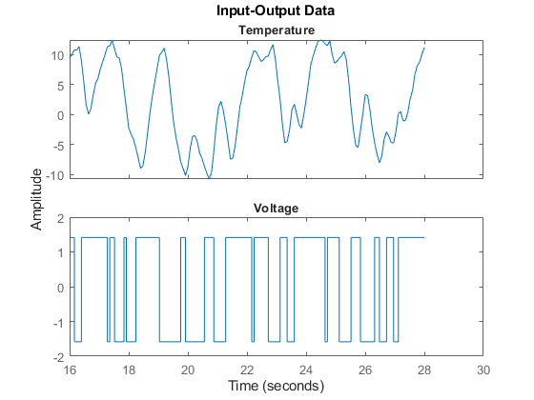

**Using n4sid based state-space evaluation**

We may also estimate a family of parametric models to find the delay corresponding to the "best" model. In case of state-space models, a range of orders may be evaluated simultaneously and the best order picked from a Hankel Singular Value plot. Execute the following command to invoke n4sid in an interactive mode:

m = n4sid(ze,1:15); % All orders between 1 and 15.

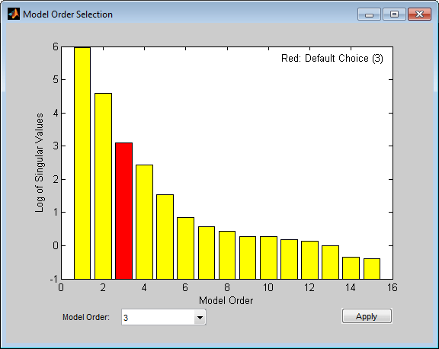

The plot indicates an order of 3 as the best value. For this choice, let us compute the impulse response of the model m:

m = n4sid(ze, 3);

showConfidence(impulseplot(m),3)

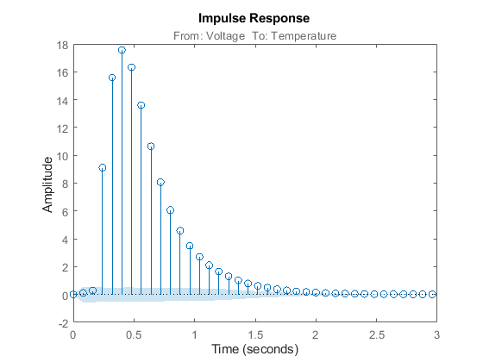

As with non-parametric impulse response, there is a clear indication that the delay from input to output is of three samples.

**20230802 GGJ**

**- Test for primary system identification**

- Step voltages with random duration to observe roller temperature response.

- Pyrometer cannot read anything below 50C and so until the temp. crosses that limit the temperature is read constant (3 mins at 1.5V).

- Actuation/Input: TOP PS : MAGNAPOWER TSD 10-6000

- State/Observation: Temp in C (Pyrometer)

- Max temp: 300C

- Max V: 5V

- RPM: 0.02

- Brush contact: 180 Phase

- Worked on single roller

**Additional Note:**

-Step voltages with random duration to observe roller temperature response.

-Pyrometer cannot read anything below 50C and so until the temp. crosses that limit the temperature is read constant (3 mins at 1.5V).

-Actuation/Input: TOP PS : MAGNAPOWER TSD 10-6000

-State/Observation: Temp in C (Pyrometer)

- Max temp: 300C

- Max V: 5V

- RPM: 0.02

- Brush contact: 180 Phase

- Worked on single roller

- Sampling rate : ~1Hz