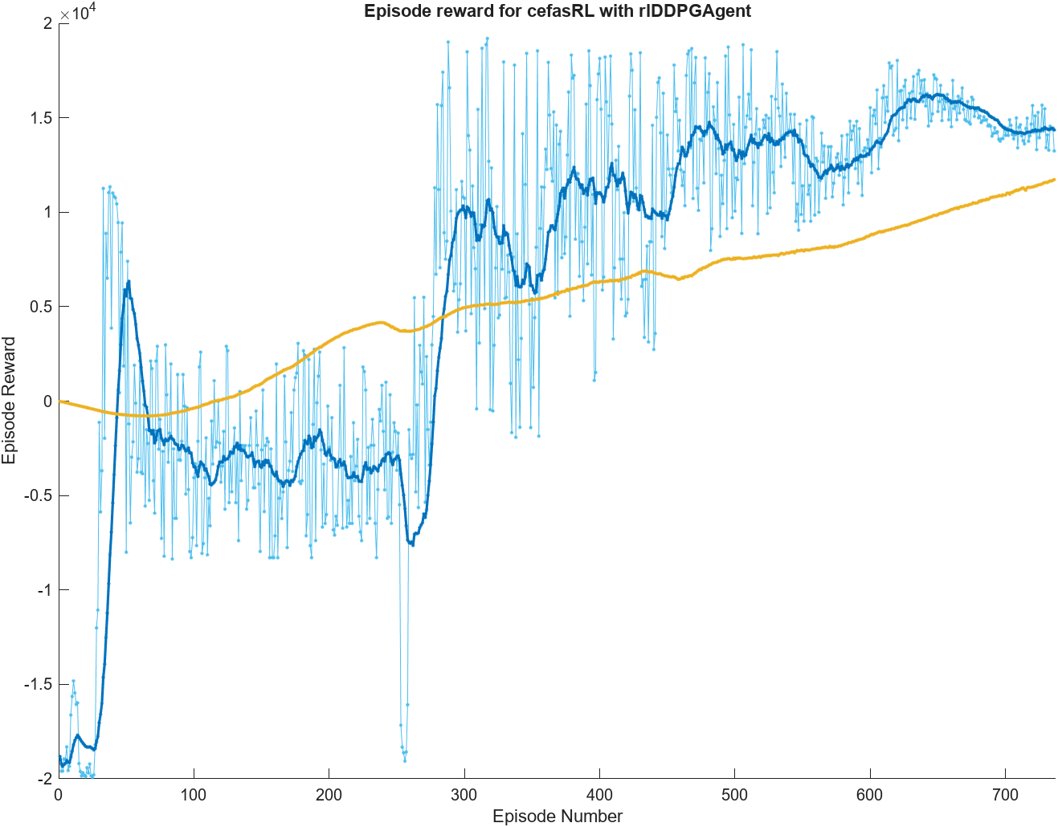

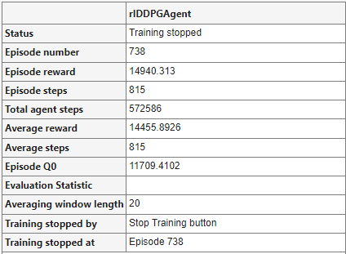

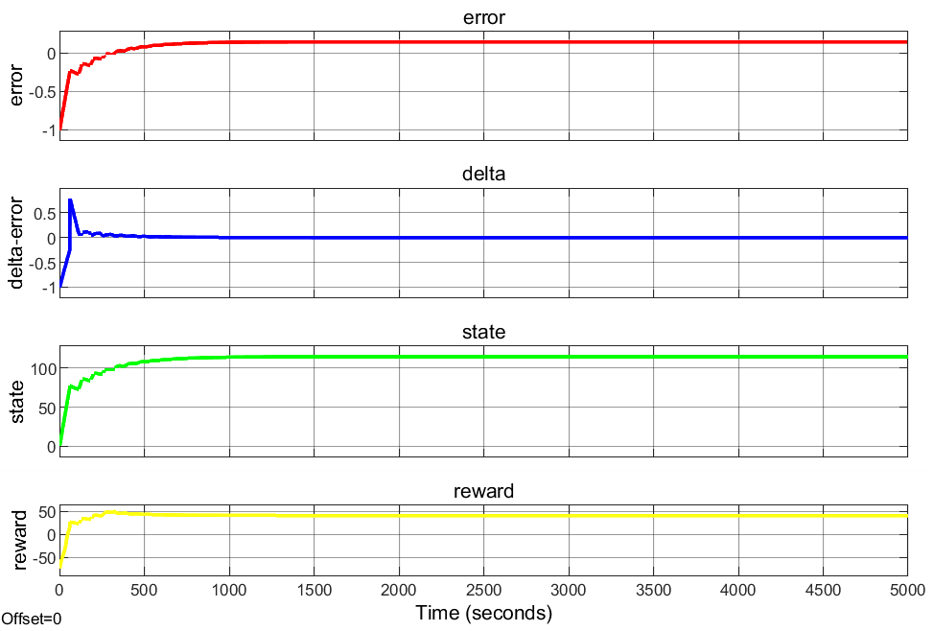

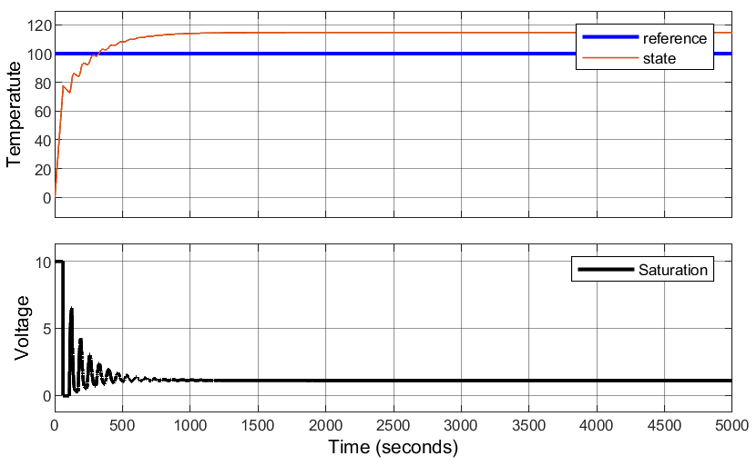

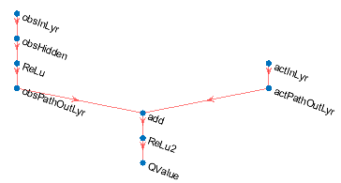

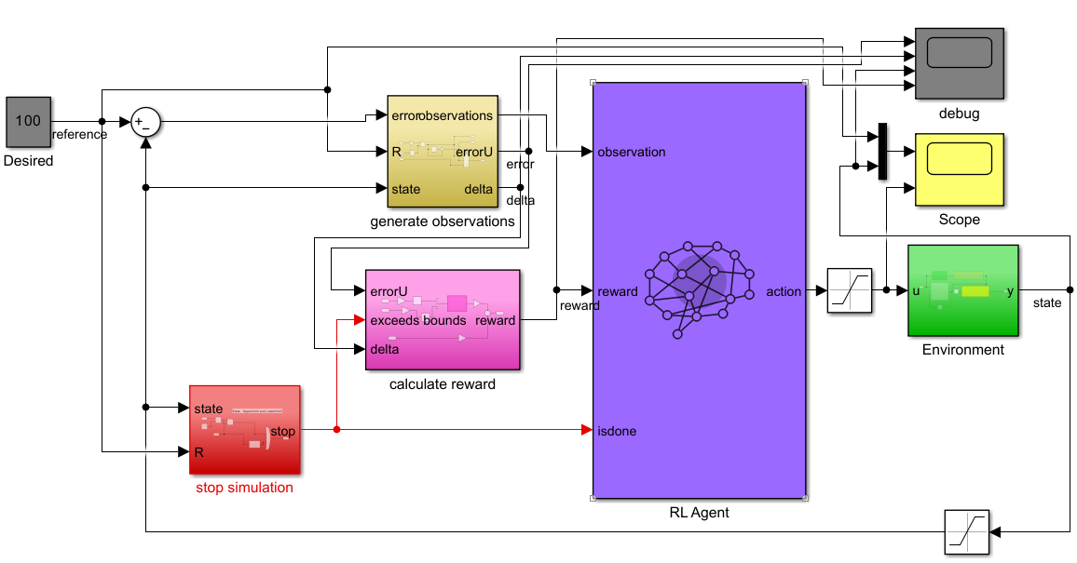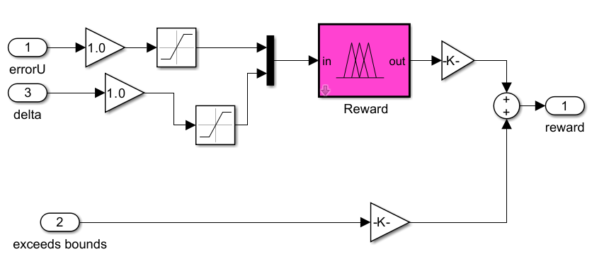

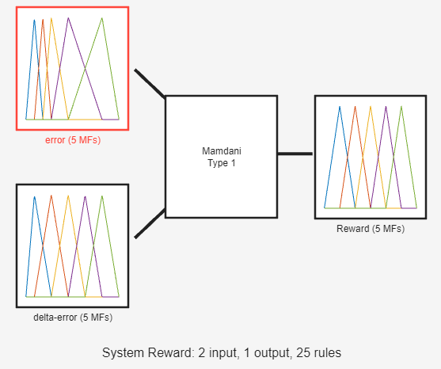

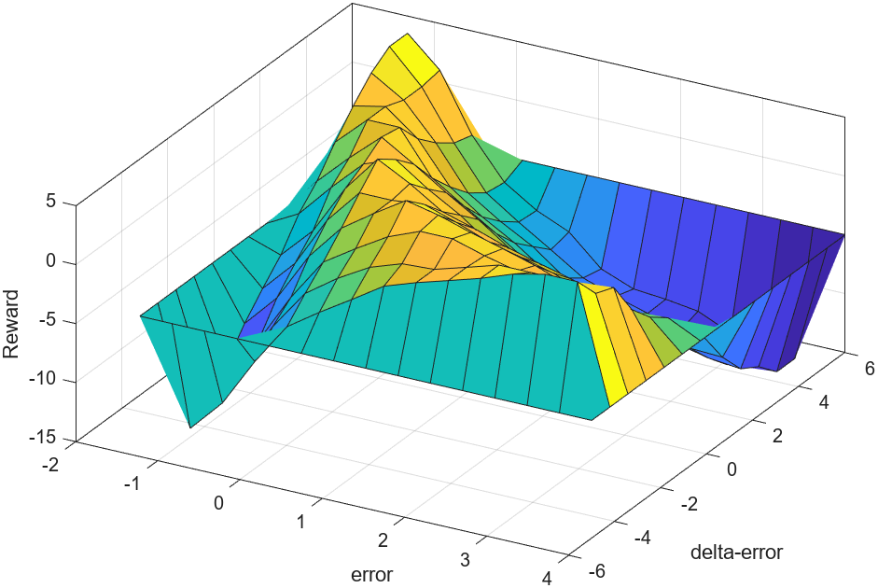

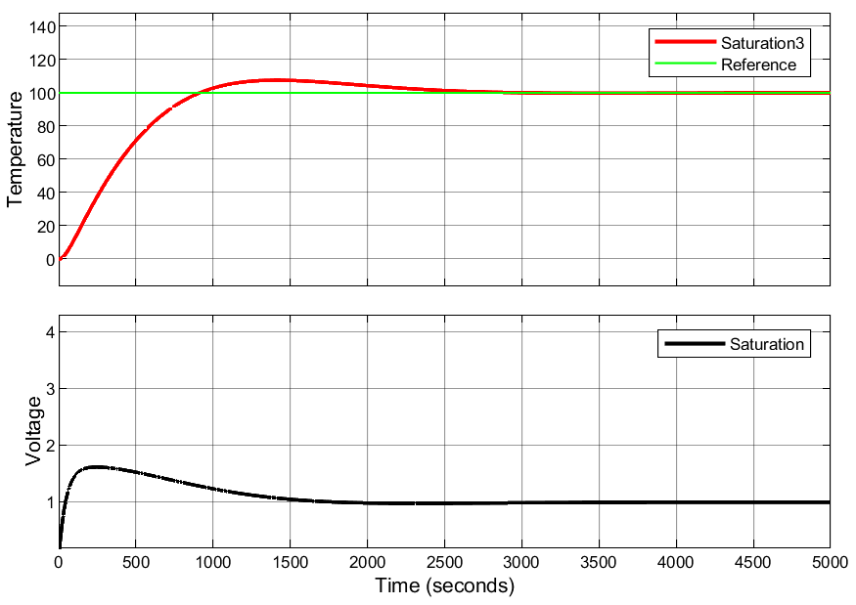

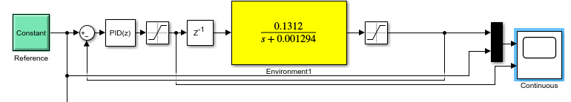

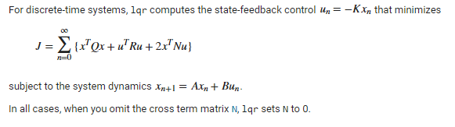

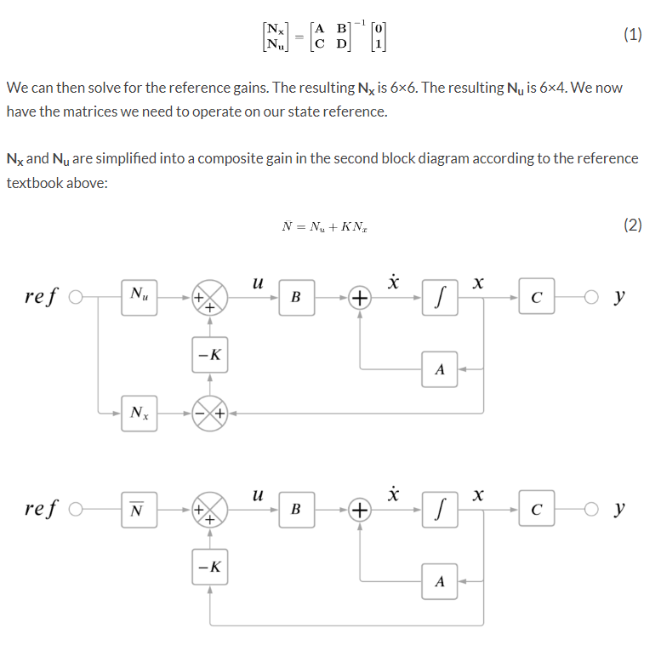

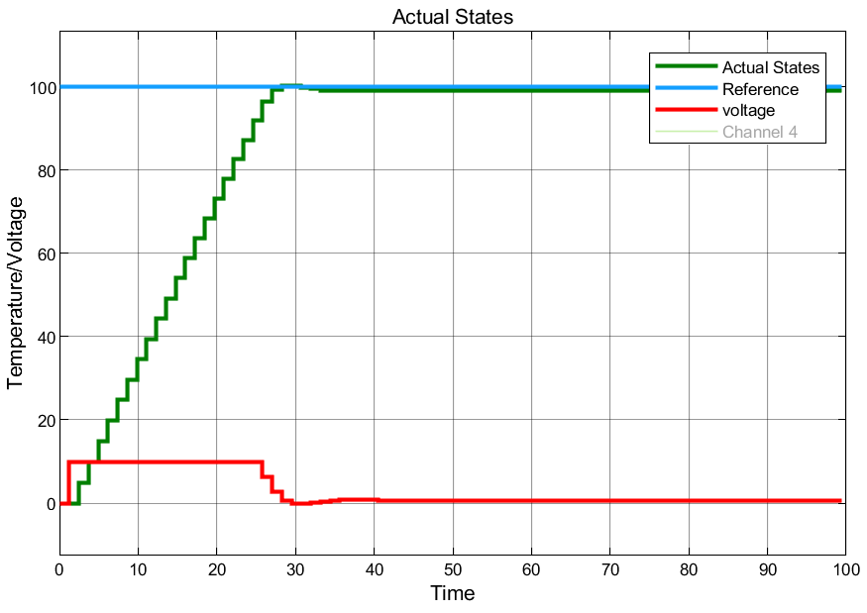

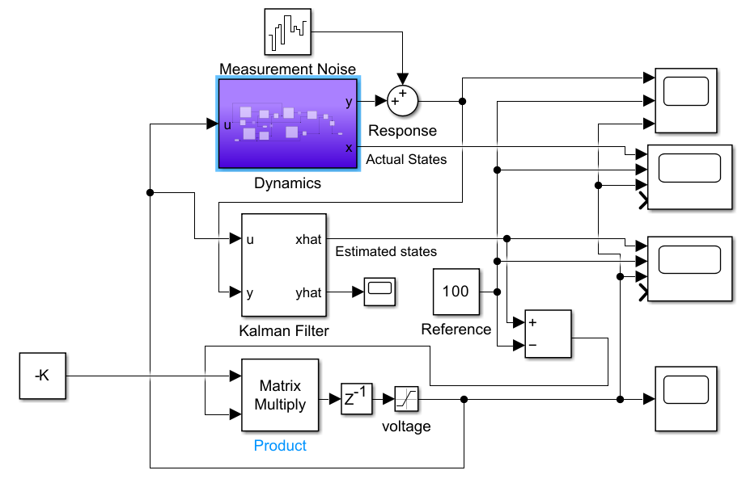

model0 =

0.305

------------

s + 0.002991

Continuous-time transfer function.

Model Properties

model1 =

From input "u1" to output "y1":

0.1312

------------

s + 0.001294

Continuous-time identified transfer function.

Parameterization:

Number of poles: 1 Number of zeros: 0

Number of free coefficients: 2

Use "tfdata", "getpvec", "getcov" for parameters and their uncertainties.

Status:

Estimated using TFEST on time domain data "data_".

Fit to estimation data: 39.67%

FPE: 545.3, MSE: 544.4

Model Properties

model2 =

0.3738

----------

z - 0.9963

Sample time: 1.2279 seconds

Discrete-time transfer function.

Model Properties

model3 =

From input "u1" to output "y1":

0.3171 s^3 + 0.0005216 s^2 + 0.0001898 s + 3.939e-07

------------------------------------------------------------

s^4 + 0.009076 s^3 + 0.0006072 s^2 + 5.461e-06 s + 3.331e-09

Continuous-time identified transfer function.

Parameterization:

Number of poles: 4 Number of zeros: 3

Number of free coefficients: 8

Use "tfdata", "getpvec", "getcov" for parameters and their uncertainties.

Status:

Estimated using TFEST on time domain data "data_".

Fit to estimation data: 56.37%

FPE: 286.7, MSE: 284.7

Model Properties

model4 =

From input "u1" to output "y1":

0.3876 z^-1 - 1.162 z^-2 + 1.161 z^-3 - 0.3868 z^-4

------------------------------------------------------

1 - 3.988 z^-1 + 5.965 z^-2 - 3.966 z^-3 + 0.9889 z^-4

Sample time: 1.2279 seconds

Discrete-time identified transfer function.

Parameterization:

Number of poles: 4 Number of zeros: 4

Number of free coefficients: 8

Use "tfdata", "getpvec", "getcov" for parameters and their uncertainties.

Status:

Created by direct construction or transformation. Not estimated.

**MODEL 3 is considered best linear model**

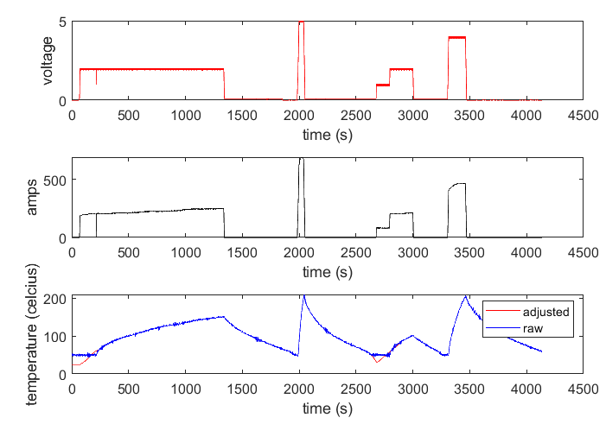

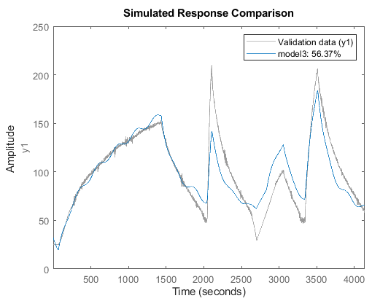

Model 3

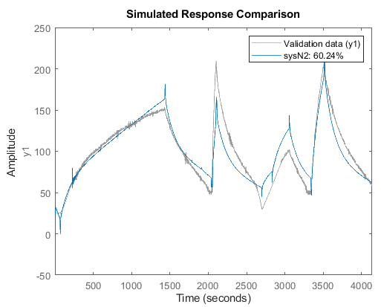

OE model

Model 3 Stuff

