**Task:** Looking at existing correlation (if any) among the strength(Scalar) data and apply **ML** to predict stress, strain and initial slope one at a time from other two.

Printing generic statistics:

|  |  |
| --- | --- |
|  | slope strain stress |
| count | 41.000000 41.000000 41.000000 |
| mean | 0.494024 12089.634146 1589.390244 |
| std | 0.123926 2579.730943 394.177427 |
| min | 0.225000 7724.000000 822.000000 |
| 25% | 20.415000 9710.000000 1324.000000 |
| 50% | 0.490000 12738.000000 1647.000000 |
| 75% | 0.590000 13978.000000 1875.000000 |
| max | 0.705000 17363.000000 2302.000000 |

Correlation coefficients:

slope strain stress

slope 1.000000 -0.617616 0.811004

strain -0.617616 1.000000 -0.162001

stress 0.811004 -0.162001 1.000000

**Scatter matrix:**

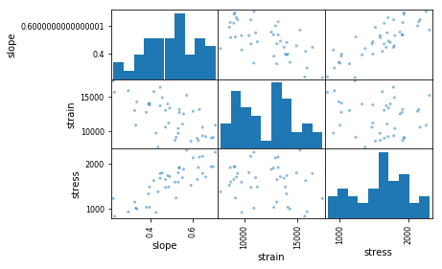

**There were clear indication of linear relation between (strain,slope) and (stress, slope) pairs.**

Linear regression (LR) applied along with Random Forest (RF), as some linear relations were spotted from the scatter matrix. Following tables and plot explore prediction performances for stress, strain and slope across LR and RF along with some error indices.

**Table: RF on SEM**

**Error index: Random Forest**

**Table: LR on SEM**

**Error index: Linear Regression**

|  |  |  |  |
| --- | --- | --- | --- |
|  | Stress | Slope | Strain |
| MAPE | 10.11 | 7.38 | 9.49 |
| RMSE | 169.82 | 0.04 | 1440.31 |
| NRMSE | 0.11 | 0.09 | 0.12 |

|  |  |  |  |
| --- | --- | --- | --- |
|  | Stress | Slope | Strain |
| MAPE | 13.32 | 9.69 | 13.36 |
| RMSE | 236.4 | 0.05 | 1936.1 |
| NRMSE | 0.15 | 0.11 | 0.16 |

GBR_stress.py 🡪 Gradient Boost Regressor on strength parameters alone

LG_stress.py 🡪 Linear Regression on strength parameters alone

svr_stress.py 🡪 Support vector regression on strength parameters

scalarRF_stress.py 🡪 RF on scalar data

relative_stress.py 🡪 Compare SVR/GBR/LR/RF on stress prediction

Note: All of above files predict stress but can be changed to any other strength parameters

scatter.py 🡪 Correlation table of performance parameter

**Error plot between RF and LR**

**Stress regression:**

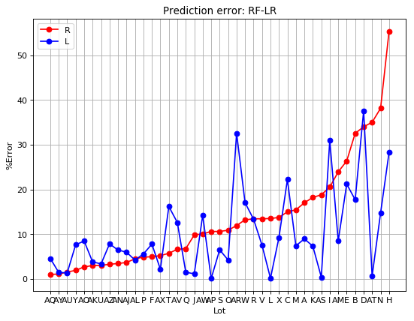

**Slope regression:**

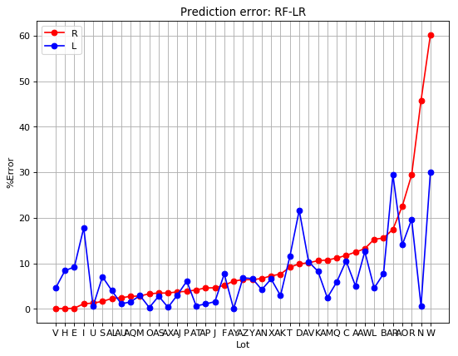

**Strain regression:**

