>>one.py

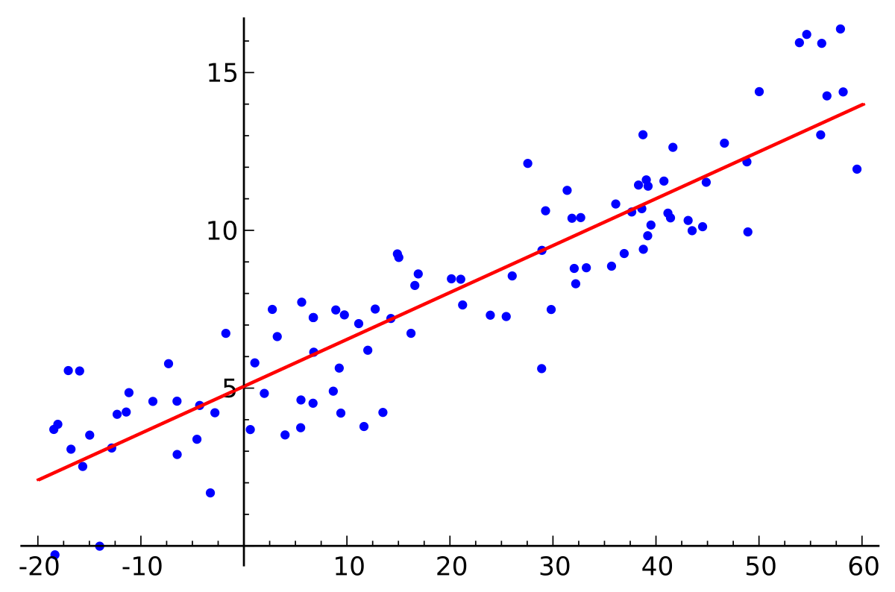

LR



LR

BSIF

Image Feature

Human Assessed Data

Predicted Parameters

Final predicted parameter(s)

Fusion Model Architecture