# Homework: CSS Layout

Please submit as homework a single zip / 7z archive holding the source code of all below described problems.

## Website Header

Create a Web page header like the picture below (**100% accuracy is not required**). Use list for the menu. Use text input field and button for the search. Link the Antra logo with <https://antra.net>. The menu buttons must work (open some URL). The menu must have dropdown functionality on mouse hover.



## Website Footer

Create a Web page footer like the picture below (**100% accuracy is not required**). Use sections for each footer area. Use lists for the menus. The menu buttons must work (open some URL). Embed the Facebook like box using the official FB developer's site.

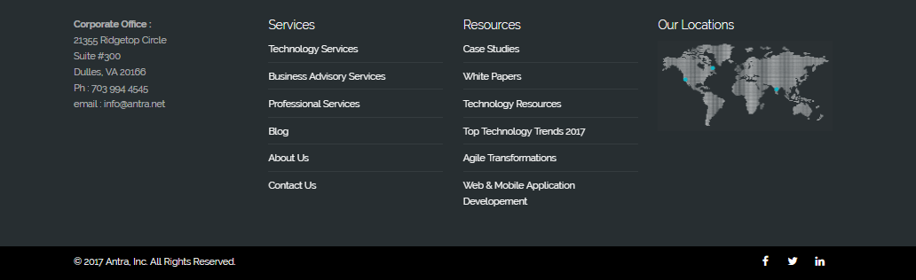

## The Antra News

Create a HTML page like the image below. **100% accuracy is not required.** Use **external CSS** file for the styles. Use floating articles for the news and list for the paging bar.

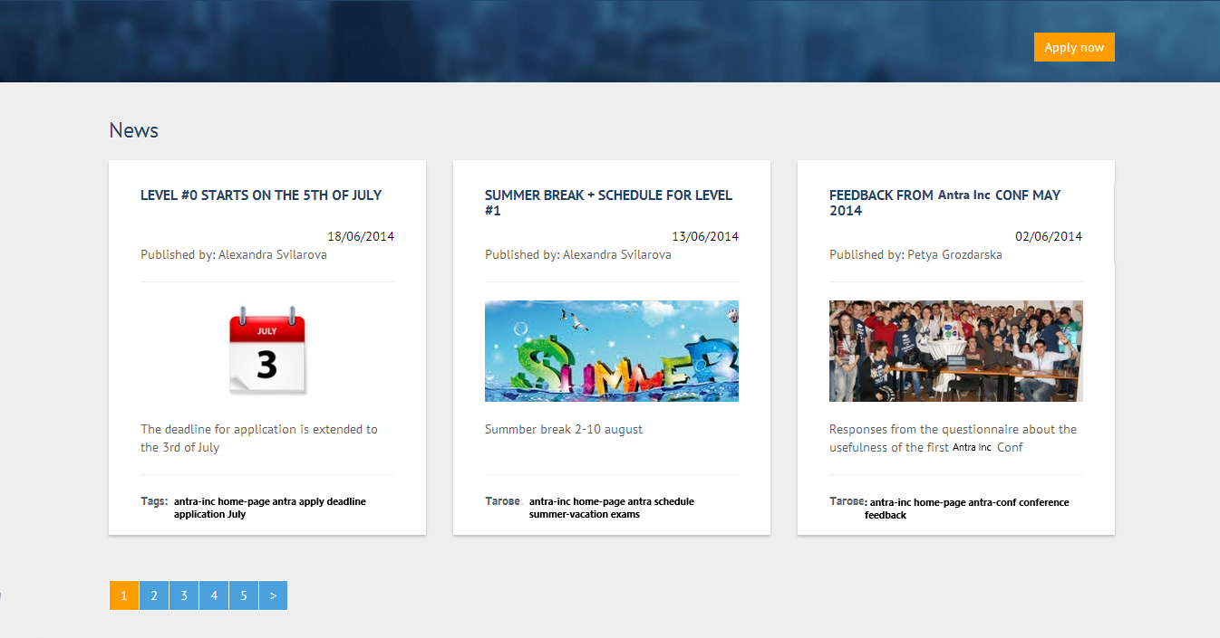

## Pretty Website

Create a HTML page like the image below.Use **external CSS file** for the styles. You are given all the images. The font of the page is "Arial".

