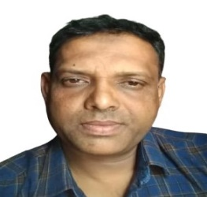**MOHAMMAD SHAMSHUL HUSSAIN**

**Mob :- +974 30798397**

**Doha, Qatar**

**POST APPLIED FOR : STEEL FIXER**

**OBJECTIVE**

A purposeful individual willing to accept a challenging position in a progressive, Growth oriented and dynamic organization, where I can utilize enhance my talent, Knowledge and skill for significant contribution to the organization.

**PERSONAL DETAILS**

Full Name : Mohammad Shamshul Hussain

Date of Birth : 05/12/1973

Gender : Male

Marital Status : Married

Nationality : India

Language : English ,Hindi & Arabic

**PASSPORT & QID DETAILS**

* Passport No : R6698733

Date of Expiry : 24/05/2027

* QID No : 27335641360

Date of Expiry : 08/10/2023

**EDUCATIONAL QUALIFICATION**

* 10Th Passed

**WORKING EXPERIENCE**

* **SAKHRAH ( Contracting & Electrical ) , Saudi Arabia**

Designation : Steel Fixer

Period : 10 Years

* **ACT (BAHADIR Construction) , Qatar**

Designation : Steel Fixer

Period : From 2019 Till Now

* Setting out the work area , following engineering plans.
* Using hand and power tools to cut and bend bars or mesh .
* Tying steel reinforcement bars to build cages.
* Fitting spacers and chairs ( supports )
* Using rebar to build special casts to keep setting concrete in place.

**PERSONAL PROFILE**

* Extremely hard working self-motivated and able to work independently.
* Keep excellent interpersonal relations with colleagues and ready to help .
* Very energetic result oriented and organised.
* Efficient and well-behaved person.

**DECLARATION**

I hereby declare that all the details written in this CV are true , complete and correct to the best of my knowledge and belief.

**MOHAMAD SHAMSHUL HUSSAIN**