Database 2 Endterm test 2020.12.08 16.15 Name: Jamala Khaligova
Neptun code: A0JCKR

Solutions should be written into this file and sent to the following email address: nikovits@inf.elte.hu

Exercise 1 (5 + 5 points)
a) The following is a sequence of REDO-log records written by transactions T, U and V:
<start T> <T,A,10> <start U> <U,B,20> <T,A,30> <start V> <U,D,80> <T,C,50>
<U,B,40> <V,E,50> <U,D,50> <COMMIT V> <COMMIT U> <T,A,50> <END V> <T,C,60> (<COMMIT T> is not yet on disk)
Describe the action of the recovery manager, including changes to both disk and the log, if there is a crash and the last log record to appear on disk is: <T, C, 60>. You should give write(), output(), <log record>, FLUSH LOG actions in the appropriate order.
Write the solution here:

Write(B,20) Output(B) Write(D,80) Output(D) Write(B,40) Output(B) Write(D,50) Output(D) <End U> FLUSH LOG

b) The following is a sequence of UNDO-log records written by transactions T, U and V:
<start T> <T,A,10> <start U> <U,B,20> <T,A,30> <start V> <U,D,80> <T,C,50>
<U,B,40> <V,E,50> <U,D,50> <COMMIT U> <abort V> <T,A,50> <T,C,70> (<COMMIT T> is not yet on disk)
Describe the actions of the recovery manager, including changes to both disk and the log, if there is a crash and the last log record to appear on disk is: <T, C, 70>. You should give write(), output(), <log record>, FLUSH LOG actions in the appropriate order.
Write the solution here:

Write(C,70) Output(C) Write(A,50) Output(A)Write(C,50) Output(C) Write(A,30) Output(A) Write(A,10) Output(A) <ABORT T> FLUSH LOG

Exercise 2 (10 points)
Give the number of conflict-serializable schedules for the following pairs of transactions:
(Give some justification in several words too.)
a) T1: R1(A); W1(A); W1(C); R1(B); T2: R2(A); W2(B); W2(A);
b) T1: R1(A); W1(A); R1(B); W1(B); T2: R2(C); W2(C); W2(D);
c) T1: W1(A); R1(B); W1(B); R1(C); T2: R2(B); W2(B); R2(A);
Write the solution here:

a) 3!/2! * 3
b) 7!/ (4!*3!) I used formula here: total ! / (each!* each!...)
c) 4!/3! + 1 = 5 same as (a)

Exercise 3 (8 points)
What is the precedence graph for the following schedule? Draw the graph with the following program: https://app.diagrams.net/ . You can use graph_draw.svg file on my homepage.
Is the schedule conflict-serializable? If so, what are all the conflict-equivalent serial schedules?

a) R1(B); R3(C); R4(D); R1(C); R2(B); W2(B); W2(C); W3(D); R4(B); W4(A);
b) R1(A); W2(B); R1(C); R2(A); R4(B); W2(A); R3(B); W1(C); R3(C); W4(D);
Write the solution here:

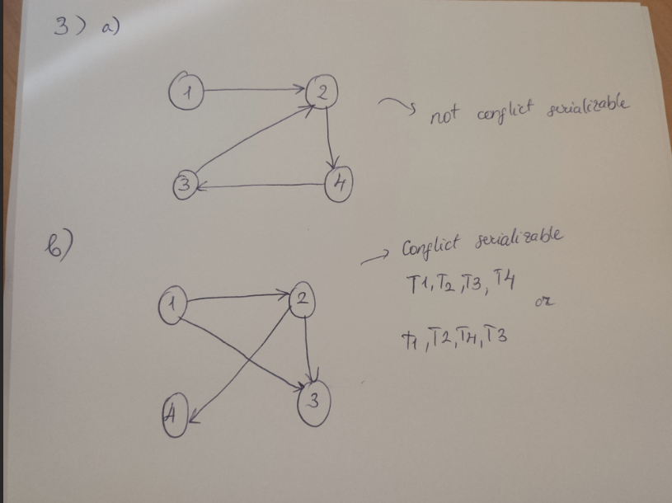

Exercise 4 (8 points)
Here is a schedule with one action missing:
R1(B); W2(C); R2(A); ???; W1(D); R3(C); W2(B); W3(A)
Figure out which READ actions could replace the ??? and make the schedule not conflict-serializable. Find all possible solutions.
Write the solution here:

R3(D), R2(D), R3(B)

Computer Exercises

Exercise 5 (8 points)
Send in a separate text file the source code of print_histogram procedure specified in test2_compulsory.txt file, run your procedure with the following parameters and send the output as well: CALL print_histogram('nikovits','test2','yr');

The owner of the following tables is NIKOVITS.

PRODUCT(prod_id, name, color, weight)
SUPPLIER(supl_id, name, status, address)
PROJECT(proj_id, name, address)
SUPPLY(supl_id,prod_id,proj_id,amount,sDate)

Exercise 6 (2 x 4 points)
Give the sum amount of products where the color of the product is 'fekete' (color = 'fekete') and the address of the project is 'Szeged'. Give hints in order to get the following execution plans:

- In the execution plan all joins should be SORT-MERGE join, and no index should be used for any table.
- In the execution plan all joins should be NESTED LOOP join, and one index should be used for the project table.
Send the SQL queries, the result of the query, and the execution plans.
Copy the solution here:

a)
select /*+ use_merge(s p pr) no_index(s) no_index(p) no_index(pr)*/ sum(s.amount)
from nikovits.supply s, nikovits.product p, nikovits.project pr
where s.prod_id = p.prod_id and s.proj_id = pr.proj_id and p.color = 'fekete' and pr.address = 'Szeged';

b)

Exercise 7 (8 points)
Give a SELECT statement which has the following execution plan (owner of tables is NIKOVITS)

SELECT STATEMENT + +
SORT + ORDER BY +
FILTER + +
HASH + GROUP BY +
MERGE JOIN + +
TABLE ACCESS + BY INDEX ROWID + NIKOVITS.PROJECT
INDEX + FULL SCAN + NIKOVITS.PROJ_ID_IDX
SORT + JOIN +
TABLE ACCESS + FULL + NIKOVITS.SUPPLY
Send the SQL query and execution plan. If your solution is similar to the above, you get subpoints.
Copy the solution here:

EXPLAIN PLAN SET statement_id='st_7' FOR
SELECT /*+ FULL(s) INDEX(p proj_id_idx) USE_MERGE(s,p) */ SUM(s.amount)
FROM NIKOVITS.SUPPLY s, NIKOVITS.PROJECT p
WHERE s.proj_id = p.proj_id AND p.address = 'Szeged'
GROUP BY s.prod_id HAVING s.prod_id > 5
ORDER BY 1 DESC;

