**RAID 0 (block level striping, no parity bits, no mirroring)**

[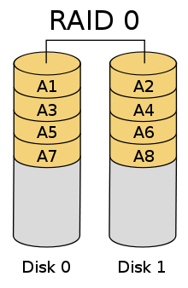](http://hu.wikipedia.org/w/index.php?title=F%C3%A1jl:RAID_0.svg&filetimestamp=20061231060918)

**RAID 1 (mirroring, no parity bits, no striping)**

[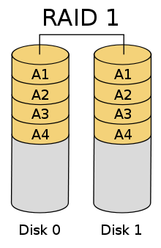](http://hu.wikipedia.org/w/index.php?title=F%C3%A1jl:RAID_1.svg&filetimestamp=20061231061443)

**RAID 2 (bit level striping, error correcting parity bits)**

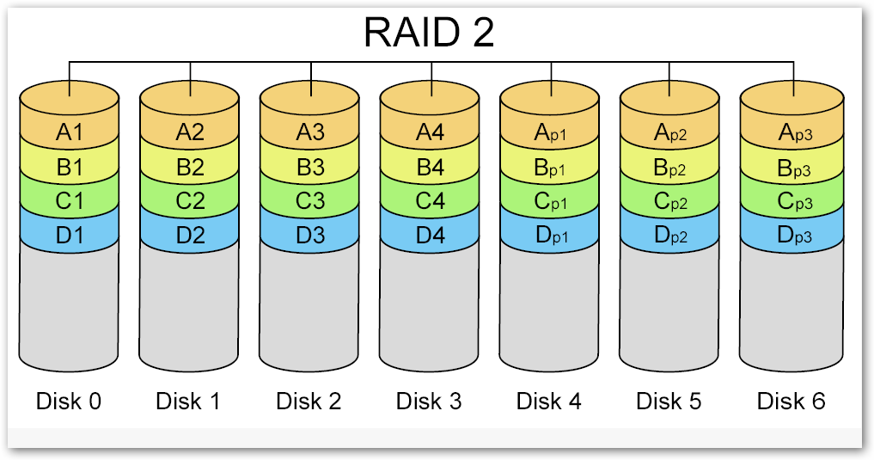

**RAID 3 (byte level striping, dedicated parity disk)**

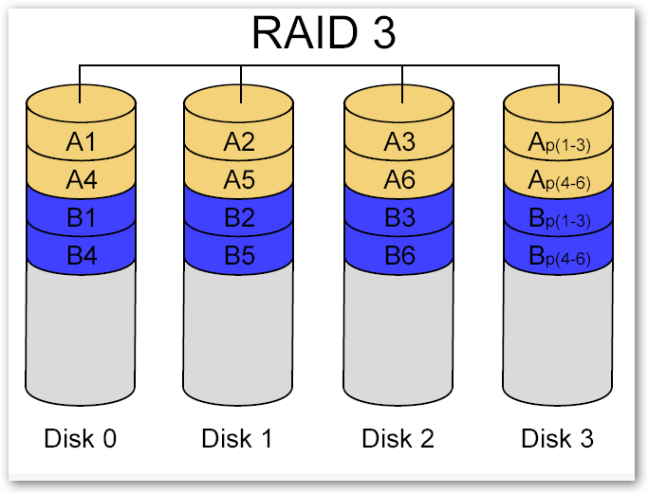

**RAID 4 (block level striping, dedicated parity disk)**

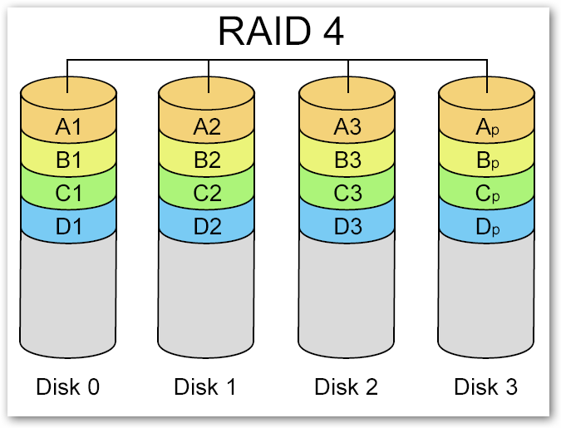

**RAID 5 (block level striping, distributed parity)**

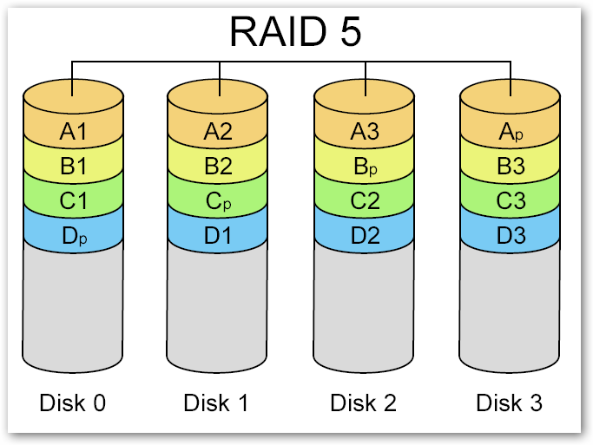

**RAID 6 (block level striping, double parity bits, distributed parity disks)**

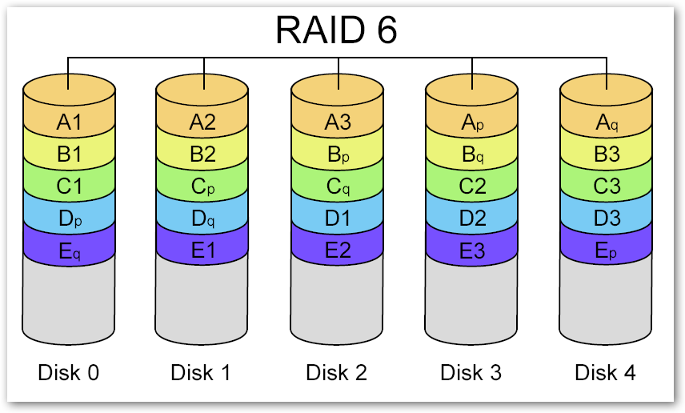

**RAID 0+1 or RAID 01**

[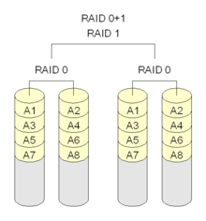](http://hu.wikipedia.org/w/index.php?title=F%C3%A1jl:RAID_0+1.png&filetimestamp=20060223173403)

**RAID 1+0 or RAID 10**

[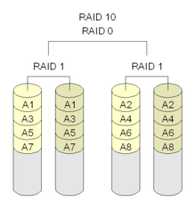](http://hu.wikipedia.org/w/index.php?title=F%C3%A1jl:RAID_10.png&filetimestamp=20060223184147)