TECHNICAL REFERENCE GUIDE

Code Architecture and
Extension Guide
  - Leakage-Safe Multiscale Cortical Brain-Age Prediction
GitHub release 1.0.0 | 27 September 2026
Aligned to brain_age_multiscale.py and the manuscript analysis
Purpose: Enable audit, maintenance, and safe extension of the analysis without changing its inferential meaning.

Primary rule: the outer-validation partition is never used to fit a data-dependent operation.

1. Architecture summary
The repository implements a single repeated nested-cross-validation pipeline for cortical brain-age prediction. It benchmarks five anatomical representations, compares five morphometric phenotype families at ROI resolution, and directly tests whether fractal dimension (FD) improves prediction beyond conventional morphometry. The pipeline is designed for methodological comparison and auditability rather than record-low prediction error.
Design element | Release 1.0.0 contract
Prediction target | Chronological age
Primary accuracy | Mean and SD across five complete raw OOF repeats
Validation | 5 outer folds x 5 repeats; 5-fold inner CV
Inference unit | Participant; repeated paired differences are averaged within participant
Primary explainability | Permutation importance on untouched outer-validation data
Secondary analysis | Training-only age-bias correction, corrected BAG, calibration, and participant-averaged OOF summaries
Descriptive only | Final full-data coefficients and SHAP

Critical correction from the previous guide Primary performance is not computed from participant-averaged predictions, and the paired sign-flip tests are two-sided, not one-sided.

2. Repository map
BrainAge_Multiscale_GitHub/
|-- src/brain_age_multiscale.py
|-- data/README.md + expected_columns.csv
|-- docs/CODE_ARCHITECTURE.docx + .pdf
|-- docs/WORKFLOW.md + OUTPUT_FILES.md
|-- scripts/run_windows.bat + run_linux_mac.sh
|-- tests/smoke_test.py
|-- requirements.txt, .env.example, .gitignore
|-- LICENSE, CITATION.cff, CHANGELOG.md
`-- results/.gitkeep
Participant-level data and generated outputs are deliberately excluded from the release. The repository contains the data contract, not the data.

3. Data contract and feature naming
The default input is an Excel workbook with worksheet ModelingData. ID and Age are required for the primary analysis. Sex and eTIV are required only for the corresponding sensitivity and audit modules. Education, handedness, cognition, normative Z scores, centiles, derivatives, and turning points are excluded by design.
Representation | Naming pattern | All5 count | NoFD count
Whole brain | wholebrain_<measure> | 5 | 4
Hemisphere | <lh|rh>_hemisphere_<measure> | 10 | 8
Bilateral lobe | bilateral_<Lobe>_<measure> | 30 | 24
DK-68 ROI | <lh|rh>_<region>_<measure> | 340 | 272
Multiscale | Deterministic union of all four levels | 385 | 308

3.1 Measures and aggregation
- Measures: volume, area, thickness, curvature, and FD. The internal name curvature denotes FreeSurfer mean curvature.
- Whole-brain, hemisphere, and bilateral-lobe variables are deterministic aggregates supplied in the modelling workbook.
- Volume and surface area are summed; thickness, mean curvature, and FD are surface-area-weighted means.
- Aggregated FD is a weighted composite of regional FD, not a newly estimated FD of a merged surface.
- The multiscale representation adds no new measurement source; it concatenates global and regional summaries derived from the same cortical data.

3.2 Fifteen prespecified feature sets
Family | Feature sets | Scientific purpose
Scale benchmark | WholeBrain_All5 through Multiscale_All5 | Compare anatomical resolution
FD incremental | WholeBrain_NoFD through Multiscale_NoFD | Direct All5 versus NoFD comparison
ROI phenotype | ROI_volume, ROI_area, ROI_thickness, ROI_curvature, ROI_FD | Compare each phenotype alone

4. Runtime configuration
The GitHub distribution preserves all analytical settings and changes only path configuration. The following environment variables are optional:
Variable | Default | Meaning
BRAINAGE_DATA_PATH | data/BrainNormR_grouped_structural_dataset.xlsx | Authorised input workbook
BRAINAGE_SHEET_NAME | ModelingData | Worksheet name
BRAINAGE_OUTPUT_DIR | results | Local analysis output directory

python src/brain_age_multiscale.py

4.1 Reproducibility settings
Setting | Value | Role
SEED | 1234 | Root random seed
OUTER_FOLDS | 5 | Generalisation evaluation
N_REPEATS | 5 | Partition variability
INNER_FOLDS | 5 | Model and hyperparameter selection
N_BOOTSTRAP | 2,000 | Participant-level confidence intervals
N_PAIRED_PERM | 5,000 | Two-sided paired sign-flip tests
Permutation repeats | 5 | Outer-validation feature permutation

Derived random seeds use deterministic arithmetic based on SEED, repeat, fold, feature-set label, or analysis-family label. Do not change seed derivation when attempting to reproduce manuscript tables.

5. End-to-end execution path
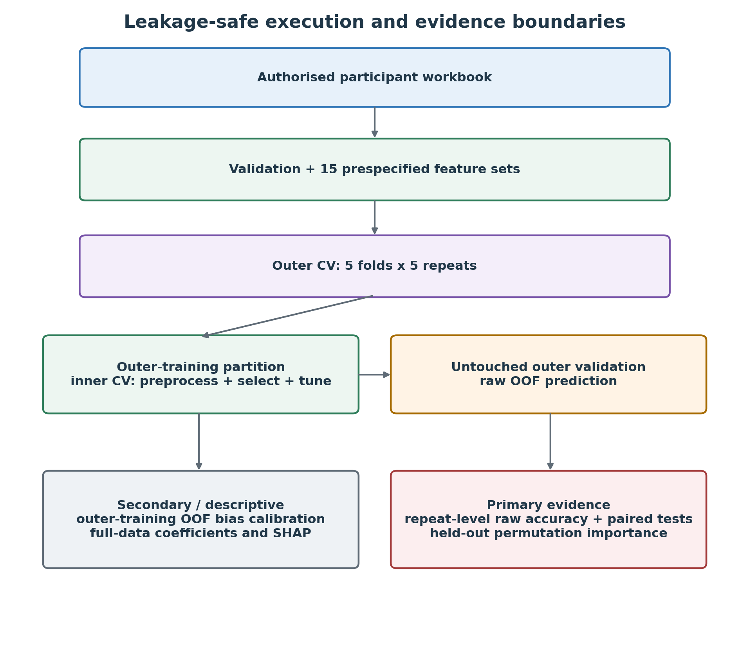
Figure 1. Architectural boundaries between model development, outer evaluation, primary evidence, and secondary or descriptive outputs.
1. Load the workbook, coerce Age and intended predictors to numeric, reject duplicate IDs, and validate the prespecified manifest.
2. Construct the 15 feature sets without consulting prediction outcomes.
3. Generate identical age-stratified outer splits for every feature set.
4. Within each outer-training partition, select preprocessing, k, algorithm, and hyperparameters by inner CV using MAE.
5. Refit the selected pipeline to the complete outer-training partition and predict the untouched outer-validation fold once.
6. Generate correction parameters from OOF predictions inside outer training and apply them to outer-validation predictions only as a secondary analysis.
7. Aggregate evidence, perform participant-level paired inference, calculate OOF importance, and export audit records.
8. After all performance evaluation, fit one full-data descriptive model and generate coefficients or SHAP.

6. Nested cross-validation and leakage boundary
Nested CV is the central architectural boundary. The outer loop estimates generalisation; the inner loop chooses the modelling pipeline. The same outer splits are reused across feature sets so model differences remain participant-paired.
Operation | Where fitted | Outer validation allowed?
Median imputation | Inner-training / outer-training | No
Zero-variance filtering | Inner-training / outer-training | No
Standardisation | Inner-training / outer-training | No
SelectKBest f_regression | Inner-training / outer-training | No
Algorithm and hyperparameters | Five-fold inner CV | No
Raw prediction | Selected pipeline refitted on outer training | Yes, once
Bias-correction parameters | OOF predictions within outer training | No
Permutation importance | Already fitted pipeline evaluated on outer validation | Yes

Invariant Any future transformation that learns a value from the sample must be fitted inside the relevant training partition. Deterministic renaming and prespecified aggregation may occur before CV because they do not learn from outcomes or sample distributions.

6.1 Age stratification
Age is divided into quantile-based strata for fold allocation. Outer folds contain 58 or 59 participants in the manuscript sample. Each participant is in outer validation exactly once per repeat, producing five raw OOF predictions per feature set.

7. Model-search architecture
All candidate algorithms share the same preprocessing pipeline. Standardisation is retained for consistency even though tree-based estimators do not require it.
Component | Search space in release 1.0.0
SelectKBest k | p<=8: all; p<=15: 5/all; p<=40: 10/20/all; larger p: 20/40/80, plus 120 when p>=120, and all
Elastic Net | alpha: 0.05, 0.1, 0.3, 1, 3, 10; l1_ratio: 0.1, 0.3, 0.5, 0.7, 0.9; max_iter=100000; tol=1e-3
Random Forest | 300 trees; max_features=sqrt or 0.5; max_depth=None, 8, 16; min_samples_leaf=1 or 3
XGBoost | n_estimators=200 or 500; max_depth=2 or 4; learning_rate=0.03 or 0.08; subsample=0.8; colsample_bytree=0.8; lambda=1
Selection metric | Negative MAE in GridSearchCV; refit the winning complete pipeline

7.1 Why algorithm selection belongs inside the inner loop
Algorithm choice is itself a model-selection decision. Selecting the best algorithm from outer-validation results and then reporting the same outer results would reuse the evaluation data. New algorithms must therefore be added to make_param_grid and compete inside every inner loop.
Dependency gate The final run stops if XGBoost or required SHAP support is unavailable; the release does not silently substitute another algorithm or omit planned outputs.

8. Performance estimation and statistical inference

8.1 Primary performance
For each feature set and repeat, MAE, RMSE, and R2 are calculated from the complete set of 293 raw OOF predictions. The five complete-repeat estimates are summarised by mean, standard deviation, minimum, and maximum. This is the primary performance estimate.

8.2 Secondary participant-averaged summary
The five OOF predictions for each participant are averaged to create an ensemble-style summary. Metrics from these averaged predictions may appear more favourable and must remain secondary. They are useful for calibration, BAG plots, Bland-Altman analysis, sex audit, and conditional bootstrap figures, but must not replace repeat-level accuracy.

8.3 Paired comparisons
Family | Prespecified contrasts | FDR family
Adjacent scale | Hemisphere vs WholeBrain; Lobe vs Hemisphere; ROI vs Lobe; Multiscale vs ROI | 4 tests
ROI phenotype | ROI_All5 versus each of five single-phenotype ROI models | 5 tests
FD incremental | All5 versus NoFD at five anatomical scales | 5 tests

For each comparison, absolute-error differences are computed within participant and repeat, then averaged across repeats within participant. Positive DeltaMAE means Model A has lower MAE than Model B. Confidence intervals use 2,000 paired participant bootstrap resamples. P values use 5,000 two-sided participant-level sign flips with a finite-sample correction. BH-FDR is applied separately within each family.

9. Age-bias correction and BAG
BAG equals predicted age minus chronological age. Raw BAG commonly correlates negatively with age because predictions regress toward the sample mean. Correction is fitted separately inside each outer fold:
raw_predicted_age = intercept + slope * chronological_age
corrected_age = (raw_predicted_age - intercept) / slope
- The slope and intercept are estimated from cross-validated predictions generated only within outer training.
- No outer-validation age or prediction is used to fit the correction.
- Correction is evaluated on outer validation, but corrected MAE is not the primary accuracy endpoint.
- Inverse calibration can improve the BAG-age correlation while worsening MAE and RMSE; this is expected and not a contradiction.
- Cross-sectional BAG is a deviation from the learned age-related pattern, not a longitudinal rate of ageing or a direct biological-age measurement.
Do not change Never estimate bias-correction parameters on the complete dataset before cross-validation and never replace raw OOF accuracy with corrected accuracy in the main performance claim.

10. Explainability architecture
Output | Evidence status | Interpretation
Outer-validation permutation importance | Primary explainability | Dependence of held-out MAE on each input feature
Selection frequency | Stability diagnostic | How often SelectKBest retains a feature across 25 outer fits
Final Elastic Net coefficients | Descriptive | Standardised coefficients of the final full-data fit
Final SHAP | Descriptive | Global and individual explanations of the final full-data fit
Phenotype x scale heatmap | Descriptive decomposition | Summed importance; affected by unequal feature counts and correlation

Correlated morphometric predictors can share or mask importance. Feature-level rankings are predictive diagnostics, not causal anatomical effects. Individual waterfall examples are selected using OOF BAG profiles but explained by the final full-data model; they are illustrative only.

11. Robustness and diagnostic modules
Module | Implementation | Interpretive boundary
Fixed Elastic Net FD | Reruns All5-NoFD comparisons with algorithm family fixed | Separates feature-set effects from algorithm-family switching
Nuisance sensitivity | Morphology + sex; morphology + sex + eTIV | Predictive sensitivity, not classical residualisation
Nested learning curves | 30%, 45%, 60%, 75%, 90%, 100% nested subsets | Descriptive data-efficiency diagnostic; not proof of adequacy
Sex-bias audit | ROI_All5 and Multiscale_All5; group metrics and HC3 Age x Sex models | Model-behaviour audit, not a biological sex-effect study
Calibration / Bland-Altman | Participant-averaged OOF summaries | Secondary agreement and residual diagnostics

11.1 Learning-curve plateau rule
An approximate plateau is flagged only when the absolute slope across the final three points is below 0.25 MAE years per 100 additional participants and the absolute final-step MAE change is below 0.10 years. The flag is descriptive and cannot replace external validation.

11.2 Sex-related inference
The age-adjusted audit fits each outcome as Age-centered + Female + Age-by-Female with HC3 standard errors. BH-FDR covers all Female and Age-by-Female terms across the audited outcomes and both feature sets. Similar subgroup MAE does not imply equivalent BAG or calibration.

12. Outputs and audit trail
The consolidated workbook is the authoritative analysis index. Primary and secondary sheets must not be interchanged.
Output | Contents | Use
RepeatPerf_Summary | Mean/SD/min/max across complete OOF repeats | Primary manuscript accuracy
Performance | Metrics from participant-averaged OOF predictions | Secondary ensemble-style summary
NestedCV_Folds | Model, hyperparameters, k, correction coefficients, fold metrics | Audit trail
Subject_OOF_Predictions | Participant-averaged raw and corrected predictions | Secondary diagnostics
Paired_Scales / Paired_Phenotypes / FD_Incremental | Paired effects, CIs, p and q values | Formal comparisons
Feature_Stability / OOF_PermutationImportance | Outer-fit selection and held-out importance | Interpretability
Nuisance_* / FixedEN_* | Robustness reruns | Supplementary inference
LearningCurve_* / SexBias_* | Data-efficiency and group-behaviour audits | Supplementary diagnostics
Final_Descriptive_* | Full-data model, coefficients, SHAP | Description/deployment only

Public-release rule Do not commit the input workbook, participant-level OOF CSV files, or any output containing IDs unless explicit ethics and data-governance approval permits public release.

13. Safe extension recipes

13.1 Add an algorithm
1. Add the estimator and its grid to make_param_grid.
2. Update model_name_from_estimator so exports have a stable name.
3. Confirm compatibility with the common preprocessing pipeline and n_jobs settings.
4. Add SHAP support only if the final full-data model may select the new family; otherwise fail explicitly.
5. Run the smoke test, TEST_MODE, and then the full repeated nested analysis.

13.2 Add a phenotype
1. Define the suffix and scientific meaning in MEASURES and the data contract.
2. Update all scale-level column constructors and expected_columns.csv.
3. Decide prospectively whether the phenotype belongs in All5/renamed combined models, a single-phenotype family, or a separate sensitivity family.
4. Update metadata parsing, display order, grouped importance, figures, FDR families, and documentation together.

13.3 Add an anatomical scale
1. Add a deterministic column list to SCALE_COLUMNS.
2. Update build_feature_sets and the feature manifest.
3. If the scale enters FD inference, update paired_fd_incremental_tests, comparison families, and plot orders.
4. Treat functional-network aggregates as a separate analysis family rather than silently mixing them with anatomical-scale benchmarking.

13.4 Add a sample-fitted transformation
Implement it as a scikit-learn-compatible Pipeline step whenever possible. If that is impossible, fit it explicitly inside each inner-training or outer-training partition and retain enough parameters to audit the operation.

14. Changes requiring redesign
Unsafe or high-risk change | Why it changes the analysis
Feature selection, scaling, or residualisation before CV | Leaks validation information and can make error estimates optimistic
Choosing a feature set from outer results and reusing the same results as confirmation | Reuses the evaluation data
Fitting age-bias correction on outer validation or the complete sample | Leaks target information into corrected predictions
Treating 1,465 repeated predictions as independent observations | Artificially inflates the inferential sample size
Changing two-sided tests to one-sided after seeing results | Changes the prespecified hypothesis and type-I error
Moving p values between BH families | Changes multiplicity control
Using full-data SHAP as independent validation | The explained model was fitted on all participants
Calling cross-sectional BAG a biological ageing rate | The design contains no within-person longitudinal change
Interpreting heatmap totals as formal scale superiority | Cells contain unequal numbers of correlated features

Versioning rule Any change to target definition, outer/inner split logic, feature-set family, primary endpoint, inference sidedness, or FDR family requires a new analysis version and re-generation of every affected table and figure.

15. Testing and release workflow
1. Create a dedicated branch for one methodological change.
2. Update code, data contract, architecture guide, and output guide together.
3. Run python tests/smoke_test.py to verify feature counts and core settings.
4. Run TEST_MODE for structural and export checks; never report its results.
5. Run the full analysis in the documented environment.
6. Verify one validation prediction per participant per repeat and feature set.
7. Compare the output manifest, selected algorithms, sample counts, and primary metrics with the previous release.
8. Confirm that raw and corrected plots and tables are not mixed.
9. Record package versions and tag the exact commit used for a manuscript revision.

15.1 Minimum acceptance checks
- 15 feature sets with counts 5/10/30/340/385 for All5 and 4/8/24/272/308 for NoFD.
- 25 outer evaluations per feature set and five OOF predictions per participant.
- No duplicate participant within FeatureSet x Repeat.
- Primary tables sourced from RepeatPerf_Summary, not Performance.
- FD, scale, and phenotype comparisons use participant-level paired differences and two-sided p values.
- SHAP is generated only after completion of performance estimation.
- Public ZIP contains no participant-level data or real analysis outputs.

Appendix A. Source-code module map
Module group | Key functions | Responsibility
Data dictionary | roi_columns; wholebrain_columns; hemisphere_columns; bilateral_lobe_columns | Construct exact predictor names
Feature sets | build_feature_sets; measure_only; add_nuisance | Build the 15 prespecified model inputs
Validation | load_dataset; validate_feature_manifest | Validate target, IDs, numeric inputs, and sparse features
CV helpers | make_age_bins; make_inner_cv; repeated_outer_splits | Create reproducible age-stratified partitions
Model search | make_base_pipeline; make_param_grid; make_elasticnet_param_grid | Define preprocessing and candidate searches
Core engine | run_feature_set_nested_cv | Run nested CV, correction, selections, and OOF importance
Performance | repeat_level_performance; aggregate_subject_predictions; regression_metrics | Separate primary repeat-level and secondary averaged summaries
Inference | paired_workflow_tests; paired_fd_incremental_tests; bh_fdr | Paired effects, bootstrap, permutation, FDR
Explainability | permutation_importance_summary; fit_final_descriptive_model; make_final_shap_outputs | OOF and descriptive explanation
Robustness | run_targeted_robustness_models; run_nuisance_sensitivity; run_fixed_enet_fd_sensitivity | Supplementary model-specification checks
Group audit | run_sex_bias_analysis; _hc3_age_sex_interaction | Sex-related prediction behaviour
Learning curves | run_nested_learning_curves; learning_curve_diagnostics | Nested sample-size diagnostics
Orchestration | main | Run, export, plot, fit the final model, and write summary

Appendix B. Release note
This guide is aligned to GitHub release 1.0.0, derived from the final 3,435-line manuscript script supplied on 27 September 2026. The public-release code changes only path configuration by adding BRAINAGE_DATA_PATH, BRAINAGE_SHEET_NAME, and BRAINAGE_OUTPUT_DIR environment variables. Analytical constants, feature definitions, cross-validation, random streams, comparisons, and exports are unchanged.
Associated manuscript title: Multiscale Cortical Morphometry for Brain-Age Prediction: Anatomical Scale and the Incremental Value of Fractal Dimension.

