**ArgoCD Installaiton**



**Install Argo CD:**

**Ref: <https://argo-cd.readthedocs.io/en/stable/getting_started/>**

kubectl create namespace argocd  
kubectl apply -n argocd -f <https://raw.githubusercontent.com/argoproj/argo-cd/stable/manifests/install.yaml>

Verify Instllaiton  
kubectl get pods -n argocd

Expose ArgoCD Server via LoadBalancer

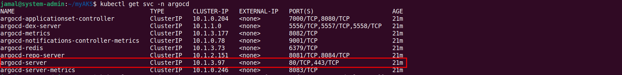

kubectl -n argocd patch svc argocd-server -p '{"spec": {"type": "LoadBalancer"}}'

kubectl get svc argocd-server -n argocd



**Expose the Argo CD Server:**

kubectl get svc -n argocd  
kubectl patch svc argocd-server -n argocd -p '{"spec": {"type": "NodePort"}}'  
kubectl get svc -n argocd

**Expose the Argo CD Server (with AppGw as a Ingress Controller):**

apiVersion: networking.k8s.io/v1

kind: Ingress

metadata:

name: argocd-ingress

namespace: default

annotations:

appgw.ingress.kubernetes.io/ssl-redirect: "true"

spec:

ingressClassName: azure-application-gateway # Specify the Ingress class

tls:

- hosts:

- argocd.wingserp.net

secretName: wingerp.net-tls

rules:

- host: argocd.wingserp.net

http:

paths:

- path: /

pathType: Prefix # Required field

backend:

service:

name: argocd-server

port:

number: 80

* **Access the Argo CD Web UI:**
* **Default Username:** admin

**Retrieve the Initial Password:**

kubectl get secret argocd-initial-admin-secret -n argocd -o jsonpath="{.data.password}" | base64 -d

* **Access URL:** https://<your-node-ip>:<node-port>/

Replace <your-node-ip> with your node's IP address and <node-port> with the port number obtained from the patched service.