

ArgoCD Installation

Ref: <https://argo-cd.readthedocs.io/en/stable/getting_started/>

kubectl create namespace argocd  
kubectl apply -n argocd -f <https://raw.githubusercontent.com/argoproj/argo-cd/stable/manifests/install.yaml>

Verify Instllaiton  
kubectl get pods -n argocd

Expose ArgoCD Server via LoadBalancer

kubectl get svc -n argocd

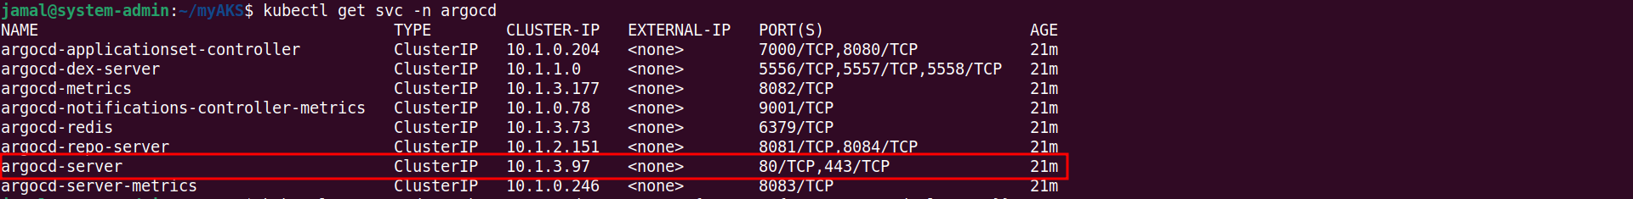

kubectl -n argocd patch svc argocd-server -p '{"spec": {"type": "LoadBalancer"}}'

kubectl get svc argocd-server -n argocd



Access the ArgoCD Web UI

<https://20.255.211.159>

Username: admin

Password: Execute the following command

kubectl -n argocd get secret argocd-initial-admin-secret -o jsonpath="{.data.password}" | base64 -d

Add Private Git Repository in ArgoCD Web UI

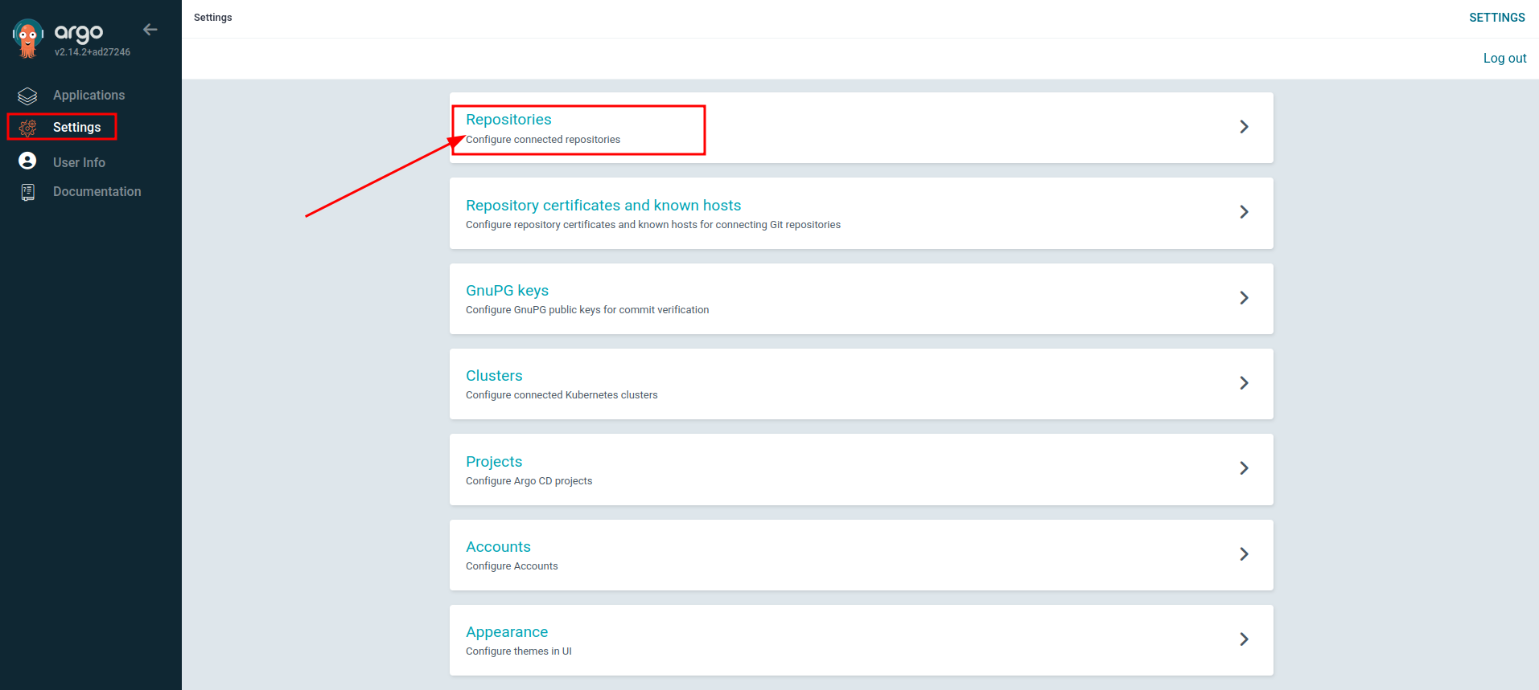

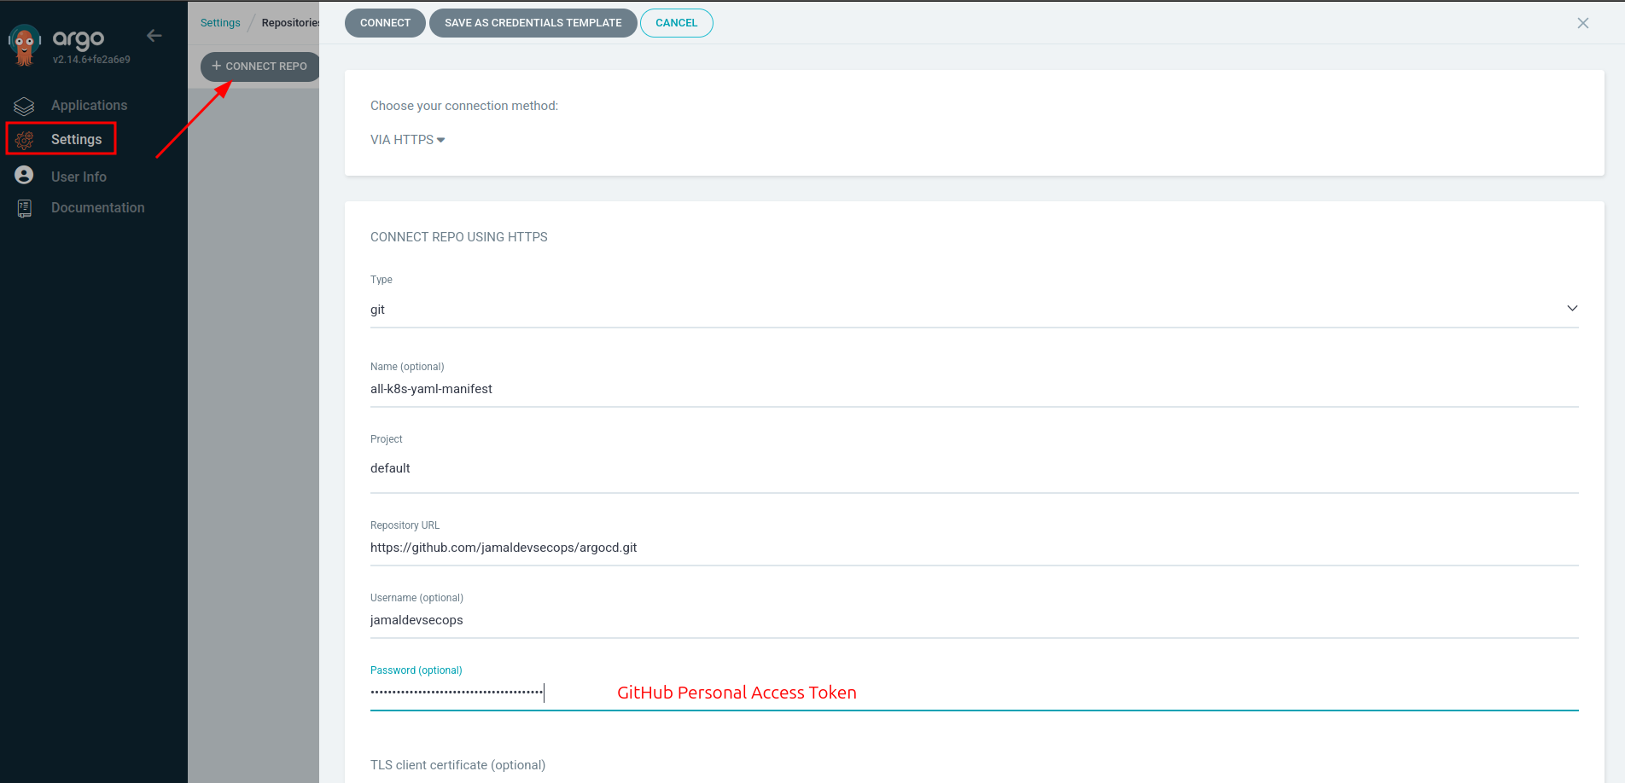

Deploy Application

