The Islamia University of Bahawalpur
Department of Computer Science



System Design Document
(SDD DOCUMENT)
for

MERN Laptop E-commerce Platform
Version 1.0

By
Muhammad Hammad
F22BDOCS1M1094
Session Spring/Fall 2022 – 2026

Supervisor
Mam. Sadiqa Ajmal

Bachelor of Science in Computer Science

Revision History
Date | Description | Author | Comments
09/12/2025 | Initial Draft Created | Muhammad Hammad | First Version

Document Approval
The following Software Requirements Specification has been accepted and approved by the following:
Signature | Printed Name | Title | Date
 | Mam. Sadiqa Ajmal | Supervisor, CSIT 21306 | 09/12/2025

Table of Contents
1 INTRODUCTION 4
1.1 Purpose 4
1.2 Scope 4
1.3 Overview 5
1.4 Reference Material 5
1.5 Definitions and Acronyms 5
2 SYSTEM OVERVIEW 6
3 SYSTEM ARCHITECTURE 6
3.1 Architectural Design 6
3.2 Decomposition Description 7
3.3 Design Rationale 8
3.3.1 Technology Selection Rationale: 8
3.3.2 Architectural Pattern Rationale: 9
3.3.3 Security and Compliance Considerations: 9
4 DATA DESIGN 9
4.1 Data Description 9
4.2 Database Schema 10
5 COMPONENT DESIGN 12
5.1 Algorithm Specifications 12
5.1.1 Authentication Algorithm 12
5.1.2 Shopping Cart Calculation Algorithm 12
5.1.3 Order Processing Algorithm 12
6 HUMAN INTERFACE DESIGN 12
6.1 Overview of User Interface 12
6.2 Wireframe Designs 13
6.3 User Workflow 14
7 REQUIREMENTS MATRIX 14
8 APPENDICES 16
8.1 Appendix A: Deployment Configuration 16
8.2 Appendix B: API Specifications 16
8.2.1 REST API Endpoints: 16
8.3 Appendix C: Maintenance Procedures 17
8.3.1 Update Procedures: 17
8.3.2 Disaster Recovery: 18

INTRODUCTION
The MERN Laptop E-commerce Platform is a comprehensive web application that falls within the category of Web Application based Information System with e-commerce capabilities. The platform provides complete online shopping functionality for laptop products with separate interfaces for customers and administrators.

Purpose
The purpose of the MERN Laptop E-commerce Platform project is to develop a specialized, full-featured online store that addresses the specific needs of customers shopping for laptops and the businesses selling them. It aims to move beyond generic e-commerce solutions by providing detailed technical filtering (RAM, ROM, generation, etc.), a secure and seamless purchasing journey, and robust administrative tools for inventory and order management. The platform leverages the modern MERN stack to deliver a fast, scalable, and maintainable application that builds customer trust through reliable transactions (via PayPal) and a professional user experience, ultimately driving online sales for laptop retailers.

Scope
The MERN Laptop E-commerce Platform is a comprehensive web application that provides complete online shopping functionality for laptop products with separate interfaces for customers and administrators. The system provides user registration and authentication, product browsing with advanced filtering, shopping cart management, order processing, payment integration, and profile management for customers. Administrators receive dashboard interfaces for product management, order processing, user management, and inventory control.
The system will provide:
- Secure user authentication using JWT tokens
- Product browsing with advanced filtering (RAM, ROM, generation, etc.)
- Shopping cart management with real-time calculations
- Order processing with PayPal and cash on delivery options
- Admin dashboard for product and order management
- Responsive design using Tailwind CSS
- Image management using Cloudinary The system will NOT provide:
- Voice search functionality
- Augmented reality features
- Advanced AI recommendations
- Multi-vendor support
- International shipping calculations

Overview
The MERN Laptop E-commerce Platform is a full-stack web application built with MongoDB, Express.js, React.js, and Node.js. It features a responsive React frontend styled with Tailwind CSS and a secure Node.js/Express backend. The system is structured around two core interfaces: a customer-facing store for browsing, filtering, and purchasing laptops, and an admin dashboard for managing products, orders, and users. Key integrations include PayPal for payment processing and Cloudinary for image management. All user authentication is handled via JWT tokens, and data is persisted in a MongoDB database. This document outlines the complete requirements for this dual-role e-commerce system.

Reference Material
- IEEE Standard 1016-2009 - Recommended Practice for Software Design Descriptions
- MERN Laptop E-commerce Platform SRS Document
- React.js Documentation
- Node.js and Express.js Documentation
- MongoDB and Mongoose Documentation
- PayPal Developer Documentation
- Cloudinary API Documentation
- UML 2.5 Specification
- WCAG 2.1 Web Content Accessibility Guidelines

Definitions and Acronyms
- SDD: Software Design Document
- SRS: Software Requirements Specification
- MERN: MongoDB, Express.js, React.js, Node.js
- JWT: JSON Web Token for authentication
- CRUD: Create, Read, Update, Delete operations
- API: Application Programming Interface
- HTTPS: Hypertext Transfer Protocol Secure
- JSON: JavaScript Object Notation
- UI: User Interface

SYSTEM OVERVIEW
The MERN Laptop E-commerce Platform is designed as a full-stack web application using the MERN technology stack with clear separation between presentation layer (React.js frontend), business logic layer (Node.js/Express.js backend), and data layer (MongoDB database). The platform is developed to provide specialized laptop shopping experience with detailed technical specifications and filtering capabilities while ensuring secure transactions and efficient business operations.
The technology stack includes React.js 18+ for frontend, Node.js 18+ with Express.js for backend, MongoDB for database, Tailwind CSS for styling, and cloud services (PayPal, Cloudinary) for payment and image management. The system employs a modular design with components for user management, product catalog, shopping cart, order processing, and admin dashboard, each developed as independent modules that can be tested and maintained separately.

SYSTEM ARCHITECTURE

Architectural Design
The system employs a layered architecture with three main tiers: Presentation Layer, Business Logic Layer, and Data Layer, following the Model-View-Controller (MVC) pattern adapted for the MERN stack. This separation ensures modularity, testability, and maintain- ability while supporting the requirements of e-commerce operations.
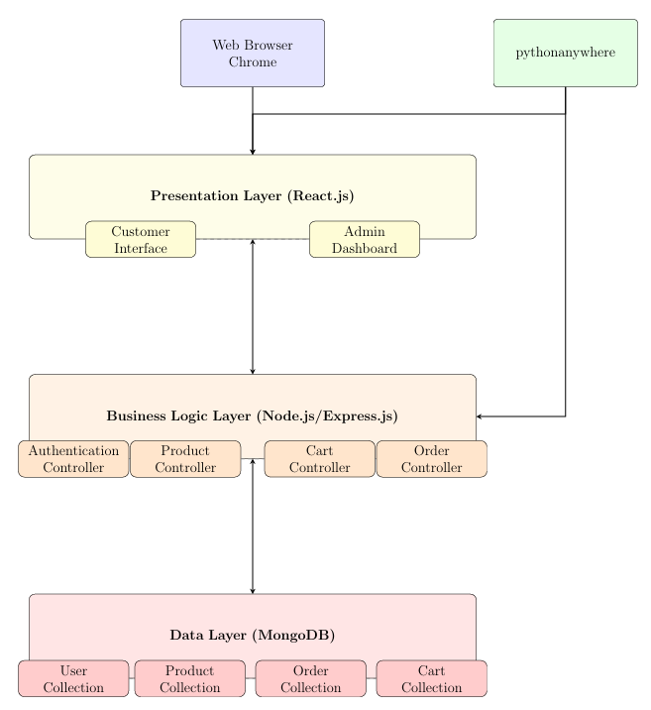
Figure 1: System Architecture Overview

Decomposition Description
The system is decomposed into five main modules following modular design principles to enable parallel development and independent testing:
- Authentication & User Management Module: Handles customer and admin registration, login, session management with JWT tokens, and role-based access control.
- Product Management Module: Manages laptop product catalog with detailed specifications, advanced filtering, image upload to Cloudinary, and inventory tracking.
- Shopping Cart Module: Provides shopping cart functionality with real-time calculations, persistent storage, and stock availability checks.
- Order Processing Module: Handles complete order lifecycle from cart to delivery with PayPal integration, cash on delivery option, and status tracking.
- Admin Dashboard Module: Provides comprehensive administrative controls for product management, order processing, user management, and business insights.
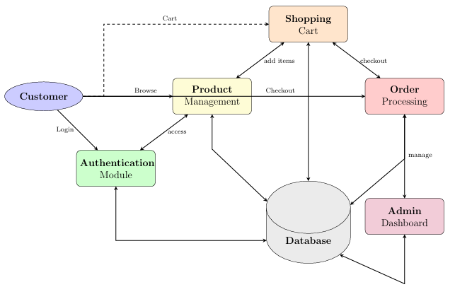
Figure 2: System Module Decomposition

Design Rationale
The architectural decisions were driven by e-commerce requirements, technical constraints, and academic project scope:

Technology Selection Rationale:
- MERN Stack: Selected for full JavaScript development, excellent performance, rich ecosystem, and suitability for modern web applications.
- MongoDB: Chosen for flexible schema, scalability, and JSON-like document structure ideal for product catalog with varying specifications.
- React.js: Selected for component-based architecture, virtual DOM for performance, and rich ecosystem for UI development.
- Tailwind CSS: Chosen for utility-first approach, responsive design capabilities, and rapid UI development.

Architectural Pattern Rationale:
- MVC Pattern: Adapted for MERN stack with clear separation between data models, controllers (Express.js), and views (React.js).
- Layered Architecture: Ensures modularity where each layer has specific responsibilities, making the system easier to understand and maintain.
- Modular Decomposition: Allows parallel development of components by different team members in an academic setting.

Security and Compliance Considerations:
- JWT-based authentication for secure user sessions
- HTTPS for all data transmission
- Password hashing using bcrypt algorithm
- Secure payment processing through PayPal
- Input validation and sanitization
Alternative architectures considered included monolithic Django application (rejected for MERN requirement) and micro services (rejected due to complexity). The chosen MERN stack architecture provides optimal balance of modern development practices, performance, and maintainability.

DATA DESIGN

Data Description
The system transforms e-commerce operations data into a MongoDB document-based structure with consideration of scalability and flexible product specifications. The design emphasizes document collections with proper indexing for query performance while maintaining data relationships through references.
Data storage is organized into six main collections:
- User Data: Customer and admin authentication credentials (hashed), profiles, addresses, and role information.
- Product Data: Laptop product catalog with detailed specifications, images, pricing, and inventory tracking.
- Cart Data: Shopping cart contents with real-time calculations and persistent storage.
- Order Data: Complete order information including items, shipping, payment, and status tracking.
- Category Data: Product categorization and filtering metadata.
- Review Data: Customer product reviews and ratings.
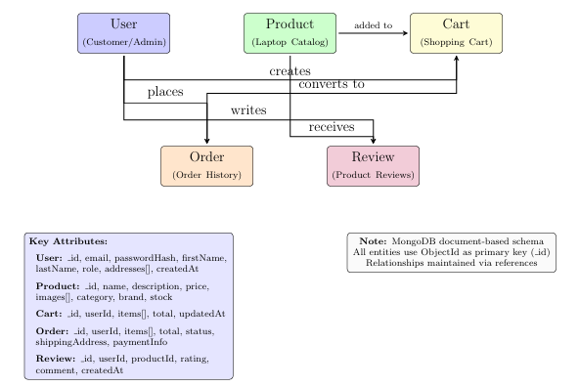
Figure 3: Entity-Relationship Diagram for E-commerce Platform

Database Schema

Collection  Name | Field Name | Data  Type | Description
users |  |  | User authentication and profiles
 | id  email passwordHash firstName lastName  role addresses createdAt  updatedAt | ObjectId  String String String String String Array Date  Date | Primary key, auto-generated  Unique user email address Hashed password using bcrypt User first name  User last name ’customer’ or ’admin’ User shipping addresses  Account creation timestamp Last profile update
products |  |  | Laptop product catalog
 | id  name description  specifications | ObjectId  String String  Object | Primary key, auto-generated  Product name Product description  Technical specs (RAM, ROM, etc.)
Collection  Name | Field Name | Data  Type | Description
 | price  salePrice images category brand stock  isActive createdAt | Number  Number Array String String Number  Boolean Date | Product price  Discounted price Cloudinary image URLs Product category Laptop brand  Inventory quantity Product availability status  Product creation timestamp
carts |  |  | Shopping cart data
 | id  userId items total createdAt  updatedAt | ObjectId  ObjectId Array Number Date  Date | Primary key, auto-generated  Reference to user  Cart items with product details Cart total amount  Cart creation timestamp Last cart update
orders |  |  | Order management data
 | id  userId items  totalAmount status shippingAddress paymentMethod paymentStatus createdAt  updatedAt | ObjectId  ObjectId Array Number String Object String String Date  Date | Primary key, auto-generated  Reference to user Order items Order total Order status Delivery address Payment type Payment status  Order creation timestamp Last status update
reviews |  |  | Product reviews
 | id  productId userId rating comment  createdAt | ObjectId  ObjectId ObjectId Number String  Date | Primary key, auto-generated  Reference to product Reference to user Rating (1-5)  Review text  Review creation timestamp

COMPONENT DESIGN
The system is implemented using component-based architecture with React.js components for UI, Express.js controllers for business logic, and Mongoose models for data operations. Each component follows the Single Responsibility Principle and is designed for testability and maintainability.

Algorithm Specifications

Authentication Algorithm
AuthenticateUseremail, password user ← findOne({email : email}) user = null
error: ’User not found’ isValid ← bcrypt.compare(password, user.passwordHash) not isValid error: ’Invalid credentials’ token ← jwtsign({id : user. id, role : user.role}, SECRET, {expiresIn :′ 7d′}) {success : true, token : token, user : {id : user. id, email: user.email, role : user.role}}

Shopping Cart Calculation Algorithm
CalculateCartTotalcartItems total ← 0 item ∈ cartItems price ← item.product.salePrice OR it subtotal ← price × item.quantity total ← total + subtotal total

Order Processing Algorithm
ProcessOrderuserId, cartItems, shippingAddress, paymentMethod orderItems ←
totalAmount ← 0 item ∈ cartItems item.product.stock < item.quantity error: ’Insufficient stock f orderItems.push({productId : item.product. id, quantity : item.quantity, price : item.product.price} totalAmount ← totalAmount+(item.product.price×item.quantity) order ← create({userId : userId, items : orderItems, totalAmount : totalAmount, ...}) item ∈ cartItems updateProductStoc clearUserCart(userId) order

HUMAN INTERFACE DESIGN

Overview of User Interface
The user interface is designed with e-commerce usability as the primary focus, following principles of modern web design that emphasize clarity, efficiency, and conversion optimization. The interface features two main workflows: (1) customer-facing store interface for product discovery and purchasing, and (2) admin dashboard for business management. The design employs a clean, professional color scheme with high contrast ratios for readability and consistent branding. Interactive elements provide clear visual feedback, and the responsive design ensures optimal viewing across all devices.

Wireframe Designs
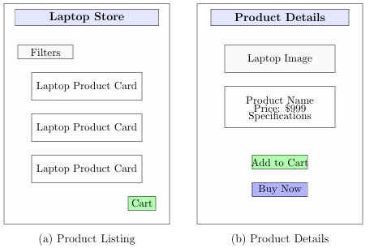
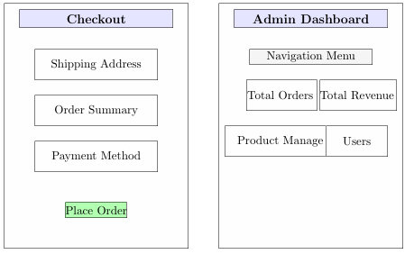
Figure 4: Interface Wireframes: (a) Product Listing, (b) Product Details, (c) Checkout, and (d) Admin Dashboard

User Workflow
Start
Browse Products
Registered?
No
Register/Login
Yes
View Details
Proceed to Checkout
Failed
Payment
Success
Order Confirmation
End
Add to Cart
Figure 5: Customer Shopping Workflow

REQUIREMENTS MATRIX
Req ID | Requirement from SRS | Design Component Handling  Requirement
FR-1 | User Authentication Sys-  tem | Authentication Module, User  Controller, JWT middleware, bcrypt hashing
FR-2 | Product Management Sys-  tem | Product Module, Product Con-  troller, Cloudinary integration, Admin dashboard
FR-3 | Shopping Cart Functionality | Cart Module, Cart Controller,  Real-time calculations, Local storage
FR-4 | Order Management System | Order Module, Order Controller,  Status tracking, Email notifications
FR-5 | Payment Integration | Payment Module, PayPal SDK  integration, Cash on delivery option
Performance-1 | Catalog loading within 3  seconds | Product indexing, MongoDB  query optimization, React lazy loading
Performance-2 | Search results within 2 seconds | Text indexing, Filter optimization, Efficient API endpoints
Reliability-1 | 99.9% uptime | Cloud deployment, Health monitoring, Load balancing
Reliability-2 | Secure transaction processing | PayPal integration, Payment validation, Order rollback
Security-1 | JWT authentication | Auth middleware, Token validation, Secure storage
Security-2 | Password hashing | bcrypt implementation, Salt  rounds, Secure credential handling
Security-3 | Secure payment processing | PayPal SDK, HTTPS, Payment  verification
Maintainability-  1 | Modular code structure | Component-based architecture, API documentation, Code comments
Maintainability-  2 | Easy updates | Configuration management, Version control, Deployment scripts
Usability-1 | Responsive design | Tailwind CSS, Mobile-first approach, Cross-browser testing
Usability-2 | Intuitive navigation | Clear UI hierarchy, Breadcrumb  navigation, Search functionality
Usability-3 | Accessible interface | WCAG compliance, Keyboard  navigation, ARIA labels

APPENDICES

Appendix A: Deployment Configuration

Package Dependencies:
// package.json (Backend)
{
"dependencies": { "express": "^4.18.0",
"mongoose": "^7.0.0",
"bcryptjs": "^2.4.3",
"jsonwebtoken": "^9.0.0",
"cors": "^2.8.5",
"dotenv": "^16.0.0",
"multer": "^1.4.5",
"cloudinary": "^1.37.0", "@paypal/checkout-server-sdk": "^1.0.3", "nodemailer": "^6.9.0"
}
}
// package.json (Frontend)
{
"dependencies": { "react": "^18.0.0",
"react-dom": "^18.0.0",
"react-router-dom": "^6.0.0",
"axios": "^1.3.0",
"react-redux": "^8.0.0", "@reduxjs/toolkit": "^1.9.0", "tailwindcss": "^3.0.0",
"react-hot-toast": "^2.0.0"
}
}

Appendix B: API Specifications

REST API Endpoints:
Endpoint | Method | Auth | Description
/api/auth/register | POST | No | Register new user
/api/auth/login | POST | No | User authentication
api/auth/logout | POST | Yes | User logout
/api/products | GET | No | Get all products
/api/products/:id | GET | No | Get single product
/api/products | POST | Admin | Create new product
/api/products/:id | PUT | Admin | Update product
/api/cart | GET | Yes | Get user cart
/api/cart | POST | Yes | Add to cart
/api/cart/:id | DELETE | Yes | Remove from cart
/api/orders | POST | Yes | Create order
/api/orders | GET | Yes | Get user orders
/api/orders/:id | GET | Yes | Get order details
/api/payment/create | POST | Yes | Create payment session
/api/payment/execute | POST | Yes | Execute payment

Appendix C: Maintenance Procedures

Routine Maintenance Tasks:

Task | Frequency | Procedure
Database backup | Daily | Automated MongoDB backup to  cloud storage
Log file rotation | Weekly | Compress logs, delete older than  30 days
Inventory sync | Daily | Update product stock levels, flag  low inventory
Security updates | Monthly | Update dependencies, apply security patches
Performance monitoring | Continuous | Monitor API response times, error rates
Payment reconciliation | Daily | Verify PayPal transactions, resolve discrepancies

Update Procedures:
Code Updates:
- Test in staging environment
- Update dependencies with version locking
- Deploy during low-traffic periods
- Monitor error rates post-deployment
Database Updates:
- Backup database before migration
- Test migrations on staging
- Use Mongoose migration scripts
- Monitor performance impact
Service Updates:
- Update PayPal SDK versions
- Update Cloudinary integration
- Test payment flow thoroughly
- Maintain rollback capability

Disaster Recovery:
- Regular backup of MongoDB database and product images
- Documentation of recovery procedures
- Alternative payment processing ready
- Contact information for technical support
- Communication plan for service disruptions

