The Islamia University of Bahawalpur
Department of Computer Science



Software Requirement Specification
(SRS DOCUMENT)
for

MERN Laptop E-commerce Platform
Version 1.0

By
Muhammad Hammad
F22BDOCS1M1094
Session Spring/Fall 2022 – 2026

Supervisor
Mam. Sadiqa Ajmal

Bachelor of Science in Computer Science

Revision History
Date | Description | Author | Comments
09/12/2025 | Initial Draft Created | Muhammad Hammad | First Version

Document Approval
The following Software Requirements Specification has been accepted and approved by the following:

Signature | Printed Name | Title | Date
 | Mam. Sadiqa Ajmal | Supervisor, CSIT 21306 | 09/12/2025

Table of Contents
1 Introduction 5
1.1 Purpose 5
1.2 Scope 5
1.3 Definitions, Acronyms, and Abbreviations 5
1.4 References 5
1.5 Overview 7
2 The Overall Description 7
2.1 Product Perspective 7
2.1.1 Operations 7
2.1.2 Site Adaptation Requirements 7
2.2 Product Functions 7
2.3 User Characteristics 8
2.4 General Constraints 8
2.5 Assumptions and Dependencies 8
3 Specific Requirements 8
3.1 External Interface Requirements 8
3.1.1 System Interfaces 8
3.1.2 User Interfaces 9
3.1.3 Hardware Interfaces 9
3.1.4 Software Interfaces 9
3.1.5 Communications Interfaces 9
3.2 Functional Requirements 9
3.2.1 User Authentication System 9
3.2.2 Product Management System 9
3.2.3 Shopping Cart Functionality 10
3.2.4 Order Management System 10
3.2.5 Payment Integration 10
3.3 Use Cases 10
3.3.1 Use Case 1: Customer Registration and Login 10
3.3.2 Use Case 2: Product Browsing and Filtering 11
3.3.3 Use Case 3: Shopping Cart Management 12
3.3.4 Use Case 4: Order Processing and Payment 13
3.4 Classes / Objects 15
3.4.1 User Class 15
3.4.2 Product Class 16
3.4.3 Order Class 16
3.4.4 Cart Class 16
3.5 Non-Functional Requirements 17
3.5.1 Performance 17
3.5.2 Reliability 17
3.5.3 Security 17
3.5.4 Maintainability 17
3.5.5 Usability 17
3.6 Inverse Requirements 17
3.7 Logical Database Requirements 17
3.8 Design Constraints 17

Introduction

Purpose
The purpose of the MERN Laptop E-commerce Platform project is to develop a specialized, full-featured online store that addresses the specific needs of customers shopping for laptops and the businesses selling them. It aims to move beyond generic e-commerce solutions by providing detailed technical filtering (RAM, ROM, generation, etc.), a secure and seamless purchasing journey, and robust administrative tools for inventory and order management. The platform leverages the modern MERN stack to deliver a fast, scalable, and maintainable application that builds customer trust through reliable transactions (via PayPal) and a professional user experience, ultimately driving online sales for laptop retailers.

Scope
The MERN Laptop E-commerce Platform is a comprehensive web application that falls within the category of Web Application based Information System with e-commerce capabilities. The platform provides complete online shopping functionality for laptop products with separate interfaces for customers and administrators.
The system will provide customers with user registration and authentication, product browsing with advanced filtering, shopping cart management, order processing, payment integration, and profile management. Administrators will receive dashboard interfaces for product management, order processing, user management, and inventory control.
The system will include PayPal payment gateway integration, Cloudinary image storage, JWT-based authentication, and responsive design. The platform will not include advanced AI features, voice search, or augmented reality product visualization in the initial version.

Definitions, Acronyms, and Abbreviations
- MERN: MongoDB, Express.js, React.js, Node.js technology stack
- JWT: JSON Web Token for authentication
- CRUD: Create, Read, Update, Delete operations
- SRS: Software Requirements Specification
- UI: User Interface
- API: Application Programming Interface

References
- React.js Documentation
- Node.js and Express.js Documentation
- MongoDB and Mongoose Documentation
- PayPal Developer Documentation
- Cloudinary API Documentation

Overview
The MERN Laptop E-commerce Platform is a full-stack web application built with MongoDB, Express.js, React.js, and Node.js. It features a responsive React frontend styled with Tailwind CSS and a secure Node.js/Express backend. The system is structured around two core interfaces: a customer-facing store for browsing, filtering, and purchasing laptops, and an admin dashboard for managing products, orders, and users. Key integrations include PayPal for payment processing and Cloudinary for image management. All user authentication is handled via JWT tokens, and data is persisted in a MongoDB database. This document outlines the complete requirements for this dual-role e-commerce system.

The Overall Description

Product Perspective
The MERN Laptop E-commerce Platform is an independent web application designed to provide complete online shopping capabilities for laptop products. Unlike generic e-commerce platforms, this product specializes in laptop sales with detailed product specifications and specialized filtering options.
The system will operate as a full-stack MERN application with React.js frontend, Node.js/Express.js backend, and MongoDB database. The product emphasizes user experience, security, and comprehensive administrative controls for efficient business operations.

Operations
The system will support continuous e-commerce operations with real-time inventory management. Normal operations include user registrations, product browsing, shopping cart management, order processing, payment transactions, and administrative controls. The system will maintain 24/7 availability with secure transaction processing.
Data backup operations will preserve customer information, product catalog, and order history. The system will support high concurrent user loads during peak shopping periods with optimized database queries and caching mechanisms.

Site Adaptation Requirements
The system requires a web hosting environment with Node.js runtime and MongoDB database support. Installation will require configuration of PayPal payment gateway, Cloudinary image storage, JWT authentication, and database connections. The deployment environment must provide SSL certification for secure transactions.
Browser compatibility will be ensured for major modern web browsers including Chrome, Firefox, Safari, and Edge. Mobile device access will be supported through responsive design using Tailwind CSS.

Product Functions
The core functionality of the MERN Laptop E-commerce Platform centers around comprehensive online shopping operations. The system enables customer registration and authentication with secure JWT-based sessions. Product management provides detailed laptop specifications with advanced filtering by RAM, ROM, generation, and other technical parameters.
Shopping cart functionality includes add, update, and remove operations with real-time calculations. Order management handles complete order lifecycle from cart to delivery with status tracking. Payment integration supports both PayPal and cash on delivery options. Administrative controls provide comprehensive business management capabilities.

User Characteristics
The primary user groups for the platform are customers and administrators. Customers are laptop shoppers with varying technical proficiency who need intuitive product discovery, easy ordering, and secure payment options. They require responsive interfaces and reliable order tracking.
Administrators are business staff with moderate technical skills who need comprehensive product management, order processing, and user management capabilities. They require efficient dashboard interfaces and real-time business insights.

General Constraints
The system development and operation are constrained by the MERN technology stack requirements and e-commerce security standards. The application requires secure payment gateway integration and data protection compliance. Performance must support high product catalog volumes and concurrent user transactions.
The system depends on external services including PayPal for payments and Cloudinary for image storage. Inventory management requires real-time stock tracking to prevent overselling.

Assumptions and Dependencies
The platform development assumes the availability of MERN stack technologies and third- party service integrations. The system depends on stable internet connectivity for payment processing and image management. External service availability and API rate limits may impact functionality.

Specific Requirements

External Interface Requirements

System Interfaces
The platform interfaces with PayPal payment gateway for payment processing and Cloudinary API for image storage and management. Secure API communications handle payment transactions and image uploads.

User Interfaces
The user interface will be implemented as a responsive React.js application with Tailwind CSS. Customer interfaces will feature intuitive product browsing, easy cart management, and streamlined checkout. Admin interfaces will provide comprehensive dashboard controls with efficient data management.

Hardware Interfaces
The system requires standard web server infrastructure. Client-side requirements include modern web browsers with JavaScript support. No specialized hardware is required.

Software Interfaces
The application uses React.js 18 for frontend, Node.js with Express.js for backend, MongoDB with Mongoose for database, JWT for authentication, Multer for file uploads, and Tailwind CSS for styling.

Communications Interfaces
Client-server communication uses HTTPS with RESTful APIs. Payment gateway integration uses secure PayPal SDK. Image uploads use Cloudinary API with secure authentication.

Functional Requirements

User Authentication System
Introduction The system shall provide secure user registration and authentication using JWT tokens with session management.
Inputs User registration details, login credentials, password reset requests, profile update information.
Processing Password hashing with bcrypt, JWT token generation and validation, session management, role-based access control.
Outputs User accounts, authentication tokens, profile data, session states.
Error Handling Duplicate email prevention, invalid credential handling, token expiration management.

Product Management System
Introduction The system shall manage comprehensive laptop product catalog with de- tailed specifications and inventory tracking.
Inputs Product details, specifications, images, pricing, inventory levels, category information.
Processing Product CRUD operations, image upload and processing, inventory tracking, category management.
Outputs Product catalog, detailed product pages, inventory status, category listings.
Error Handling Image upload validation, inventory conflict prevention, data integrity maintenance.

Shopping Cart Functionality
Introduction The system shall provide complete shopping cart management with real- time calculations and persistent storage.
Inputs Product selections, quantity changes, cart updates, user sessions.
Processing Cart item management, quantity validation, price calculations, stock avail- ability checks.
Outputs Cart contents, subtotal calculations, item summaries, persistent cart storage.
Error Handling Out-of-stock items, price changes, cart persistence errors.

Order Management System
Introduction The system shall handle complete order lifecycle from cart to delivery with status tracking.

Inputs Order details, shipping addresses, payment information, status updates.
Processing Order creation, status transitions, email notifications, inventory updates.
Outputs Order confirmations, status updates, shipping details, order history.
Error Handling Payment failures, inventory conflicts, invalid status transitions.

Payment Integration
Introduction The system shall process secure payments through PayPal gateway with cash on delivery alternative.
Inputs Payment method selection, transaction details, order amounts.
Processing Payment gateway communication, transaction processing, order confirmation.
Outputs Payment confirmations, transaction records, order status updates.
Error Handling Payment failures, gateway timeouts, transaction rollbacks.

Use Cases

Use Case 1: Customer Registration and Login
Actor: Customer
Precondition: Customer accesses the platform for shopping
Main Flow:
- Customer accesses registration page
- Enters personal details and credentials
- System validates and creates user account
- Customer receives confirmation
- Customer logs in with credentials
- System authenticates and creates session
Postcondition: Customer account created and authenticated

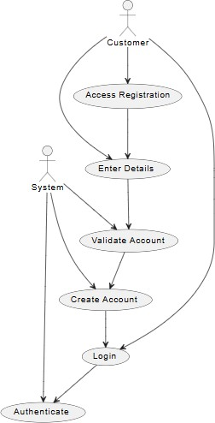

Figure 1: Customer Registration and Login

Use Case 2: Product Browsing and Filtering
Actor: Customer
Precondition: Customer is logged in and browsing products
Main Flow:
- Customer accesses product catalog
- Applies filters (RAM, ROM, brand, price)
- Views filtered results
- Sorts products by various criteria
- Views product details and specifications
- Checks product availability and reviews
Postcondition: Customer finds desired laptop products

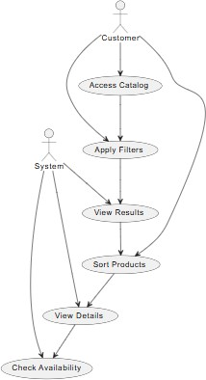

Figure 2: Product Browsing and Filtering

Use Case 3: Shopping Cart Management
Actor: Customer
Precondition: Customer has selected products for purchase
Main Flow:
- Customer adds products to cart
- System updates cart contents
- Customer reviews cart items
- Updates quantities or removes items
- System recalculates totals
- Customer proceeds to checkout
Postcondition: Cart prepared for checkout

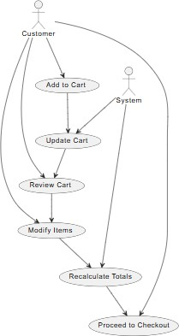

Figure 3: Shopping Cart Management

Use Case 4: Order Processing and Payment
Actor: Customer
Precondition: Customer has items in cart ready for purchase
Main Flow:
- Customer initiates checkout process
- Selects shipping address and method
- Chooses payment method (PayPal/COD)
- Completes payment transaction
- System confirms order and updates inventory
- Customer receives order confirmation
Postcondition: Order successfully placed and confirmed

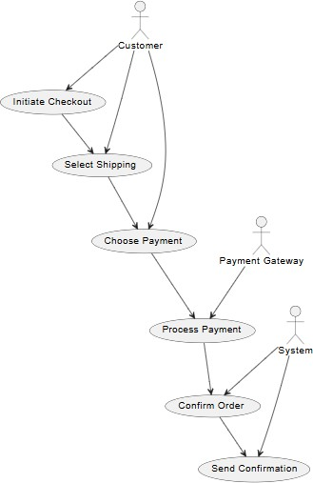

Figure 4: Order Processing and Payment
    - Use Case 5: Admin Product Management
Actor: Administrator
Precondition: Admin is logged into dashboard
Main Flow:
- Admin accesses product management
- Adds new laptop products with specifications
- Uploads product images to Cloudinary
- Sets pricing and inventory levels
- Manages product categories and filters
- Updates product information as needed
Postcondition: Product catalog updated and managed
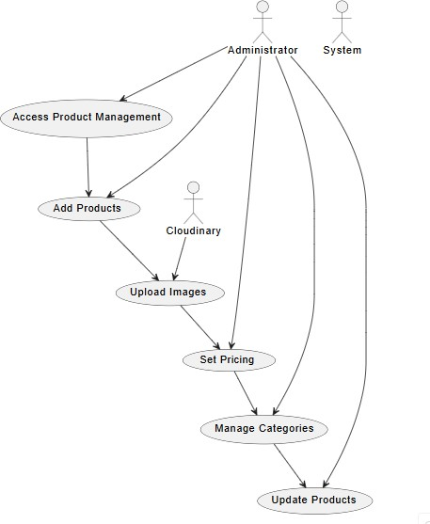
Figure 5: Admin Product Management

Classes / Objects

User Class
Attributes
- userId: ObjectId uniquely identifying users email: String storing user email
- passwordHash: String storing hashed password
- firstName: String storing user first name
- lastName: String storing user last name
- role: Enum defining user role (customer, admin) addresses: Array storing user addresses orders: Array referencing user orders
- createdAt: Date tracking account creation
- lastLogin: Date tracking recent activity

Functions
authenticate(), updateProfile(), manageAddresses(), viewOrderHistory()

Product Class
Attributes
- productId: ObjectId uniquely identifying products name: String storing product name description: String storing product description specifications: Object storing technical specs price: Number storing product price
- salePrice: Number storing discounted price images: Array storing product images category: String storing product category brand: String storing laptop brand stock: Number tracking inventory reviews: Array storing product reviews

Functions
updateStock(), addReview(), calculateRating(), manageImages()

Order Class
Attributes
- orderId: ObjectId uniquely identifying orders
- userId: ObjectId referencing ordering user items: Array storing order items
- totalAmount: Number storing order total
- status: Enum tracking order state
- shippingAddress: Object storing delivery address pay- mentMethod: String storing payment type
- paymentStatus: Enum tracking payment state
- createdAt: Date tracking order creation
- updatedAt: Date tracking last update

Functions
calculateTotal(), updateStatus(), generateInvoice(), trackShipping()

Cart Class
Attributes
- cartId: ObjectId uniquely identifying carts
- userId: ObjectId referencing cart owner items: Array storing cart items total: Number storing cart total
- createdAt: Date tracking cart creation
- updatedAt: Date tracking last update

Functions
addItem(), removeItem(), updateQuantity(), calculateTotal()

Non-Functional Requirements

Performance
Product catalog loading within 3 seconds, search results within 2 seconds, payment processing within 10 seconds, support for 1000+ concurrent users, database queries optimized with indexing.

Reliability
99.9% uptime, secure transaction processing, data backup and recovery, error handling and logging.

Security
JWT authentication, password hashing, secure payment processing, data encryption, role- based access control.

Maintainability
Modular code structure, comprehensive documentation, version control, automated testing.

Usability
Responsive design, intuitive navigation, mobile compatibility, accessible interfaces.

Inverse Requirements
No voice search functionality, no augmented reality features, no advanced AI recommendations, no multi-vendor support, no international shipping calculations.

Logical Database Requirements
The platform will use MongoDB with collections for users, products, orders, carts, categories, and reviews. Relationships between data entities will be maintained through referenced ObjectIds. Indexing will be applied to frequently queried fields such as email, product category, and order status to ensure efficient query performance. Data validation will be enforced via Mongoose schemas, ensuring data integrity across user interactions and transactions.fields.

Design Constraints
Development must adhere strictly to the MERN technology stack (MongoDB, Express.js, React.js, Node.js). The frontend must implement responsive design using Tailwind CSS for full mobile compatibility. Integration with PayPal for payments and Cloudinary for image storage is mandatory. Security standards including JWT authentication and data encryption must be followed throughout the application.

