MERN Laptop E-commerce Platform
Muhammad Hammad
F22BDOCS1M1094

Final Report

Version: 1.0.0 Date: (05/04/2026)

Date | Description | Author | Comments
05/04/2026 | Initial Draft Created | Muhammad Hammad | First Version

Revision History

Document Approval
The following Software Requirements Specification has been accepted and approved by the following:

Signature | Printed Name | Title | Date
 | Mam. Sadiqa Ajmal | Supervisor, CSIT 21306 | 05/03/2026

Contents
Chapter 1 Introduction 5
1.1 Purpose 5
1.2 Scope 6
1.3 Definitions, Acronyms, and Abbreviations 7
1.4 References 8
1.5 Overview 9
1.6 Product Perspective 9
1.6.1 Operations 9
1.6.2 Site Adaptation Requirements 10
1.7 Product Functions 10
1.8 User Characteristics 10
1.9 Assumptions and Dependencies 11
Chapter 2 Software Requirements Specification 12
2.1 Specific Requirements 12
2.2 External Interfaces 12
2.3 Functions 12
2.4 Performance Requirements 12
2.5 Logical Database Requirements 13
2.6 Design Constraints 13
2.6.1 Standards Compliance 13
2.7 Software System Attributes 13
2.7.1 Reliability 13
2.7.2 Availability 14
2.7.3 Security 14
2.7.4 Maintainability 14
2.7.5 Usability 14
2.8 Alternative Architectures Considered 14
2.8.1 Monolithic PHP/Laravel Architecture (Not Selected) 14
2.8.2 Micro services Architecture (Not Selected) 14
2.8.3 Final Justification 15
2.9 Use Cases 15
2.9.1 Use Case 1: Customer Registration and Login Actor: Customer 15
2.9.2 Use Case 2: Product Browsing and Filtering Actor: Customer 15
2.9.3 Use Case 3: Shopping Cart Management Actor: Customer 16
2.9.4 Use Case 4: Order Processing and Payment Actor: Customer 16
2.9.5 Use Case 5: Admin Product Management Actor: Administrator 17
2.10 Classes and Objects 17
2.10.1 User Class 17
2.10.2 Product Class 18
2.10.3 Order Class 19
2.10.4 Cart Class 20
Chapter 3 System Design and Architecture 22
3.1 Architectural Design 22
3.2 Decomposition Description 22
3.3 Component Design 22
3.3.1 Authentication Component Function: authenticateUser 22
3.3.2 Cart Calculation Component Function: calculateCartTotal 23
3.3.3 Order Processing Component Function: processOrder 24
3.4 Data Design 25
3.4.1 Data Description 25
3.4.2 Database Schemas User Schema: 25
Chapter 4 Implementation and Testing 28
4.1 Technology Stack 28
4.2 API Specifications 28
4.2.1 REST API Endpoints 28
4.3 Design System 29
4.3.1 Color Palette Primary (Green – Brand): 29
4.3.2 Typography Fonts: 30
4.3.3 Spacing & Layout Spacing Scale (Tailwind): 30
4.3.4 Components Buttons: 31
4.4 Screen Images 32
4.5 Test Cases 42
4.6 Deployment Configuration 44
4.6.1 Environment Variables 44
4.7 Security Testing Results 44
4.8 Disaster Recovery Procedures 44
4.9 Conclusion 45

Chapter 1
Introduction
The MERN Laptop E-commerce Platform is a sophisticated, full-featured online store specifically designed to address the unique needs of customers shopping for laptops and the businesses selling them. In today’s digital marketplace, laptop buyers require detailed technical information, powerful filtering capabilities, and a seamless purchasing experience. Traditional generic e-commerce platforms often fail to provide the specialized features needed for laptop sales, such as filtering by RAM, ROM, processor generation, and other technical specifications that are critical to informed purchasing decisions.
This platform moves beyond conventional e-commerce solutions by offering an intuitive, feature-rich shopping experience built on the modern MERN (MongoDB, Express.js, Re- act.js, Node.js) technology stack. The system provides customers with the ability to browse a comprehensive catalog of laptops, filter products based on detailed technical specifications, manage shopping carts, process orders securely through PayPal or Cash on Delivery, and track order status. For administrators, the platform includes a powerful dashboard for product management, inventory control, order processing, and user management.
Security and trust are paramount in e-commerce. The platform implements industry- standard security measures including JWT-based authentication, password hashing with bcrypt, HTTPS encryption for all data transmission, and secure integration with PayPal’s payment gateway. All user data is protected, and transaction processing follows best practices for financial security.
The platform is designed to be scalable, maintainable, and performant, capable of handling 1000+ concurrent users during peak shopping periods. With a focus on responsive design using Tailwind CSS, the platform provides an optimal shopping experience across all devices – from desktop computers to smartphones and tablets.

Purpose
The purpose of the MERN Laptop E-commerce Platform project is to develop a specialized, full-featured online store that addresses the specific needs of customers shopping for laptops and the businesses selling them. This project aims to move beyond generic e-commerce solutions by providing detailed technical filtering capabilities (RAM, ROM, generation, processor type, graphics card, etc.), a secure and seamless purchasing journey, and robust administrative tools for inventory and order management.
The platform leverages the modern MERN stack to deliver a fast, scalable, and maintainable application that builds customer trust through reliable transactions (via PayPal integration) and a professional user experience. The ultimate goal is to create a complete e-commerce ecosystem that drives online sales for laptop retailers while providing customers with an enjoyable, efficient, and secure shopping experience.
Key objectives of the platform include:
For Customers:
- Easy product discovery through advanced filtering and search capabilities
- Detailed product information including complete technical specifications
- Secure and convenient payment options (PayPal and Cash on Delivery)
- Order tracking and history management
- User-friendly interface with responsive design for all devices
For Administrators:
- Comprehensive product management with image upload to Cloudinary
- Real-time inventory tracking and stock management
- Order processing and status management
- User account management and role-based access control
- Sales monitoring and business insights

Scope
The MERN Laptop E-commerce Platform is a comprehensive web application that falls within the category of Web Application based Information System with e-commerce capabilities. The platform provides complete online shopping functionality for laptop products with separate interfaces for customers and administrators.
The system will provide customers with the following core capabilities:
User Registration and Authentication: Secure account creation with email validation, login functionality using JWT tokens, password recovery, and profile management. Users can update their personal information, manage shipping addresses, and view order history.
Product Browsing with Advanced Filtering: Comprehensive laptop catalog browsing with filtering by RAM (4GB, 8GB, 16GB, 32GB+), ROM/storage (256GB SSD, 512GB SSD, 1TB SSD, 1TB+ HDD), processor generation (Intel Core i3/i5/i7/i9, AMD Ryzen 3/5/7/9), brand (Dell, HP, Lenovo, Apple, ASUS, Acer, MSI), price range, color, weight, and screen size. Sorting options include price (low to high, high to low), popularity, newest arrivals, and customer ratings.
Shopping Cart Management: Add products to cart, update quantities, remove items, and view real-time subtotal calculations. Cart persistence allows users to save their cart for future sessions. Stock availability validation prevents overselling.
Order Processing and Payment Integration: Secure checkout process with shipping address collection, payment method selection (PayPal integration and Cash on Delivery), order confirmation, and email notifications. Complete order history with status tracking (Pending, Processing, Shipped, Delivered, and Cancelled).
Admin Dashboard: Secure administrative interface for product management (add, edit, delete products, manage images via Cloudinary), order processing (view orders, update status), user management (view users, manage roles), and inventory control (track stock levels, receive low stock alerts).
The system will NOT include the following features in this version:
- Voice search functionality
- Augmented reality (AR) product visualization
- Advanced AI-based product recommendations
- Multi-vendor marketplace support
- International shipping calculations
- Live chat or Chabot support
- Mobile native applications (though responsive web app is supported)
- Product comparison tool (planned for future version)

Definitions, Acronyms, and Abbreviations

Term | Definition
MERN | MongoDB, Express.js, React.js, Node.js technology  stack for full-stack JavaScript development
JWT | JSON Web Token - A compact, URL-safe means of  representing claims to be transferred between two parties for authentication
CRUD | Create, Read, Update, Delete - The four basic operations of persistent storage
SRS | Software Requirements Specification - A document  describing the expected features, functionality, and constraints
SDD | Software Design Document - A document describing  system architecture, components, and design decisions
API | Application Programming Interface - A set of rules for  building and interacting with software applications
REST | Representational State Transfer - An architectural  style for designing networked applications
HTTPS | Hypertext Transfer Protocol Secure - An extension of  HTTP for secure communication
JSON | JavaScript Object Notation - A lightweight data-  interchange format
UI | User Interface - The visual elements and interactive  components
ODM | Object Document Mapper - Mongoose for MongoDB  data modeling
COD | Cash on Delivery - Payment method where customer  pays upon delivery
RAM | Random Access Memory - Computer memory specification for laptops
ROM | Read-Only Memory / Storage - Storage capacity  specification for laptops

References
- React.js Official Documentation: https://react.dev/
- Node.js Official Documentation: https://nodejs.org/en/docs/
- Express.js Official Documentation: https://expressjs.com/
- MongoDB Official Documentation: https://docs.mongodb.com/
- Mongoose ODM Documentation: https://mongoosejs.com/docs/
- PayPal Developer Documentation: https://developer.paypal.com/
- Cloudinary API Documentation: https://cloudinary.com/documentation
- Tailwind CSS Documentation: https://tailwindcss.com/docs
- JWT.io - JSON Web Token Introduction: https://jwt.io/introduction/
- IEEE Standard 830-1998 - Recommended Practice for Software Requirements Specifications
- IEEE Standard 1016-2009 - Recommended Practice for Software Design Descriptions
- WCAG 2.1 Web Accessibility Guidelines: https://www.w3.org/WAI/WCAG21/quickref/

Overview
The MERN Laptop E-commerce Platform is a full-stack web application built with MongoDB, Express.js, React.js, and Node.js. It features a responsive React frontend styled with Tailwind CSS and a secure Node.js/Express backend REST API. The system is structured around two core interfaces: a customer-facing store for browsing, filtering, and purchasing laptops, and an admin dashboard for managing products, orders, and users. Key integrations include PayPal for payment processing and Cloudinary for image management. All user authentication is handled via JWT tokens, and data is persisted in a MongoDB database using Mongoose ODM.
This document is organized into four chapters. Chapter 1 introduces the system, its purpose, scope, and context within the e-commerce ecosystem. Chapter 2 details the specific software requirements, including external interfaces, functional and non-functional requirements, use cases with detailed flows, class and object definitions, and logical database requirements. Chapter 3 presents the system design and architecture, including architectural decisions, alternative architectures considered, component design, data design, and complete data dictionary with all MongoDB schemas. Chapter 4 covers implementation and testing considerations, including technology stack, API specifications, design system with color palette and typography, screen images with placeholders, and comprehensive test cases.

Product Perspective
The MERN Laptop E-commerce Platform is an independent, self-contained web application designed to provide complete online shopping capabilities for laptop products. Unlike generic e-commerce platforms that require extensive customization for laptop-specific features, this product is purpose-built with specialized filtering options based on technical specifications (RAM, ROM, generation, processor, etc.).
The system will operate as a full-stack MERN application with React.js frontend, Node.js
/Express.js backend REST API, and MongoDB database for persistent storage. The product emphasizes user experience, security, and comprehensive administrative controls for efficient business operations. All communication between frontend and backend occurs through RESTful APIs with JWT authentication for protected routes.

Operations
The system will support continuous e-commerce operations with real-time inventory management. Normal operations include user registrations, product browsing, shopping cart management, order processing, payment transactions, and administrative controls. The system will maintain 24/7 availability with secure transaction processing.
Data backup operations will preserve customer information, product catalog, and order history. Automated daily backups ensure data integrity and disaster recovery capability.
The system will support high concurrent user loads during peak shopping periods with optimized database queries, proper indexing, and caching mechanisms.

Site Adaptation Requirements
The system requires a web hosting environment with Node.js runtime (version 18+), MongoDB database (version 6+), and SSL certification for secure HTTPS communication. Installation will require configuration of PayPal payment gateway (API credentials), Cloudinary image storage cloud name, API key, API secret), JWT authentication (secret key), and database connection string.
Browser compatibility will be ensured for major modern web browsers including Google Chrome (version 90+), Mozilla Firefox (version 88+), Apple Safari (version 14+), and Microsoft Edge (version 90+). Mobile device access will be supported through responsive design using Tailwind CSS breakpoints.

Product Functions
The core functionality of the MERN Laptop E-commerce Platform centers around comprehensive online shopping operations with specialized laptop features:
User Authentication System: The system enables customer registration with email validation, secure login using JWT tokens with 7-day expiration, password recovery functionality, and profile management. Role-based access control differentiates between customer and administrator privileges.
Product Management System: Comprehensive laptop product catalog management with detailed specifications including image upload to Cloudinary, title, generation, color, RAM (GB), ROM (GB), weight (kg), description, category, brand, price, sale price, total stock, and average review rating.
Advanced Filtering and Search: Customers can browse products with filtering by category, brand, RAM (4GB/8GB/16GB/32GB+), ROM/storage (256GB/512GB/1TB+), processor generation (i3/i5/i7/i9, Ryzen 3/5/7/9), price range, and more. Sorting options include price (ascending/descending), popularity, and newest arrivals.
Shopping Cart Management: Add products to cart with quantity selection, update quantities, remove items, view real-time subtotal calculations, and persistent cart storage across sessions. Stock availability validation prevents overselling.
Order Processing System: Complete order lifecycle management from cart to delivery with shipping address collection, payment method selection (PayPal integration and Cash on Delivery), order confirmation emails, and status tracking (Pending, Processing, Shipped, Delivered, And Cancelled).
Admin Dashboard: Secure administrative interface providing product management (CRUD operations), order processing (view, update status, cancel), user management (view, role management), inventory tracking (stock levels, low stock alerts), and sales analytics.

User Characteristics
The primary user groups for the platform are customers and administrators, each with distinct characteristics and requirements:
Customers (Laptop Shoppers): These are individuals seeking to purchase laptops online. Their technical proficiency varies from basic to advance. They require intuitive product discovery, easy filtering by technical specifications, detailed product information, simple cart management, and secure payment options. Customers value responsive interfaces, fast loading times, and reliable order tracking. They expect a seamless shopping experience from product discovery to delivery confirmation.
Administrators (Business Staff): These are employees of the laptop store responsible for managing the online platform. They have moderate to advanced technical skills and require efficient dashboard interfaces for product management, order processing, user management, and inventory control. Administrators need quick access to business insights, real-time stock monitoring, and the ability to process orders efficiently. They value comprehensive reporting, easy product updates, and streamlined order management workflows.

Assumptions and Dependencies
The platform development assumes the availability of MERN stack technologies (MongoDB, Express.js, React.js, Node.js) and third-party service integrations. The system depends on stable internet connectivity for payment processing through PayPal API and image management through Cloudinary API.
External service availability and API rate limits may impact functionality. PayPal transaction processing depends on PayPal service uptime and API responsiveness. Cloudinary image uploads depend on service availability and network conditions.
The platform assumes that customers have modern web browsers with JavaScript enabled and that administrators have basic computer literacy. The system assumes that product inventory data is maintained accurately and that payment transactions are processed in compliance with financial regulations.

Chapter 2
Software Requirements Specification

Specific Requirements
The MERN Laptop E-commerce Platform shall provide secure user authentication using JWT tokens, comprehensive product management with specialized laptop filtering, shopping cart functionality with real-time calculations, order processing with PayPal and COD payment options, and an administrative dashboard for complete business management. All requirements are uniquely identified and shall be verifiable through the test cases defined in Chapter 4.

External Interfaces
- Customer Storefront: React.js application with responsive design, product catalog with filtering, shopping cart, and checkout interface
- Admin Dashboard: Secure administrative interface for product management, order processing, and user management
- PayPal Integration: Payment gateway API for secure transaction processing
- Cloudinary Integration: Image storage and delivery API for product images
- REST API: Backend services accessible through RESTful endpoints with JWT authentication

Functions
The system shall validate user credentials and manage sessions using JWT tokens with secure password hashing via bcrypt. The system shall provide product CRUD operations with image upload to Cloudinary. The system shall support advanced filtering by RAM, ROM, generation, brand, price range, and other specifications. The system shall maintain shopping cart persistence and real-time calculations. The system shall process orders through PayPal API with secure transaction handling. The system shall provide admin interfaces for complete business management.

Performance Requirements

Requirement | Target Metric
Product Catalog Loading  Time | ¡ 3 seconds on standard broadband
Search and Filter Results | ¡ 2 seconds
Payment Processing Time | ¡ 10 seconds including PayPal API
Concurrent User Support | 1000+ concurrent users
Database Query Performance | Optimized with indexing for sub-second response
API Response Time | ¡ 500ms for non-payment endpoints

Logical Database Requirements
The platform will use MongoDB as the primary database with collections for users, products, orders, carts, addresses, features, and product reviews. All collections will use Mon- goose schemas with validation. Relationships between collections will be maintained through referenced Object IDs. Indexing will be applied to frequently queried fields including email (users), category (products), brand (products), price (products), and order status (orders). Data validation will be enforced at the schema level to ensure data integrity.

Design Constraints
Development must adhere strictly to the MERN technology stack (MongoDB, Express.js, React.js, and Node.js). The frontend must implement responsive design using Tailwind CSS for full mobile compatibility. Integration with PayPal for payments and Cloudinary for image storage is mandatory. Security standards including JWT authentication, bcrypt password hashing, and HTTPS encryption must be followed throughout the application.

Standards Compliance
- MERN stack development best practices
- RESTful API design principles
- Web Content Accessibility Guidelines (WCAG 2.1 Level A)
- Payment Card Industry Data Security Standards (PCI DSS via PayPal)
- MongoDB schema design best practices
- React.js component architecture standards

Software System Attributes

Reliability
System uptime shall maintain 99.9% availability through cloud deployment. Transaction processing shall ensure data consistency with rollback capabilities. Automated daily backups shall maintain data integrity and disaster recovery readiness.

Availability
The system shall maintain 24/7 availability through cloud hosting. Database replication shall ensure high availability during maintenance windows. Graceful degradation shall occur during high load periods.

Security
JWT-based authentication with 7-day token expiration. Bcrypt password hashing with 10 salt rounds. HTTPS encryption for all data transmission. Role-based access control for admin routes. Input validation and sanitization to prevent injection attacks.

Maintainability
Modular code structure with separation of concerns. Comprehensive API documentation. Version control with Git. Automated testing suite. Environment-based configuration management.

Usability
Responsive design for desktop, tablet, and mobile devices. Intuitive navigation and search functionality. Clear error messages and user feedback. Accessible interface with WCAG 2.1 Level A compliance.

Alternative Architectures Considered

Monolithic PHP/Laravel Architecture (Not Selected)
This architecture would have used PHP with Laravel framework for both frontend and backend. It was rejected because:
- Does not meet the MERN stack requirement for the project
- Less suitable for real-time cart updates and dynamic UI
- Steeper learning curve for modern JavaScript features
- Less flexible for future mobile app extensions

Micro services Architecture (Not Selected)
This architecture would have decomposed the system into multiple independent services. It was rejected because:
- Adds unnecessary complexity for the project scope
- Requires sophisticated orchestration and deployment
- Higher operational overhead for academic project
- Development time would exceed project constraints

Final Justification
The MERN stack layered architecture was selected because:
- Provides full-stack JavaScript development consistency
- Offers excellent performance with React’s virtual DOM
- MongoDB provides flexible schema for product specifications
- Node.js/Express provides efficient API handling
- Enables code reuse between frontend and backend
- Large ecosystem of libraries and community support

Use Cases

Use Case 1: Customer Registration and Login Actor: Customer
Precondition: Customer accesses the platform for shopping
Main Flow:
- Customer accesses registration page
- Enters personal details (username, email, password)
- System validates and creates user account
- Customer receives confirmation via email
- Customer logs in with credentials
- System authenticates and creates JWT session
- Customer accesses personalized shopping features
Post condition: Customer account created and authenticated

Use Case 2: Product Browsing and Filtering Actor: Customer
Precondition: Customer is logged in and browsing products
Main Flow:
- Customer accesses product catalog
- Applies filters (RAM, ROM, generation, brand, price)
- Views filtered results in real-time
- Sorts products by price, popularity, or newest
- Views product details and specifications
- Checks product availability and reviews
- Adds desired products to cart
Post condition: Customer finds desired laptop products

Use Case 3: Shopping Cart Management Actor: Customer
Precondition: Customer has selected products for purchase
Main Flow:
- Customer adds products to cart
- System updates cart contents and displays
- Customer reviews cart items
- Updates quantities or removes items as needed
- System recalculates totals in real-time
- System validates stock availability
- Customer proceeds to checkout when ready
Post condition: Cart prepared for checkout

Use Case 4: Order Processing and Payment Actor: Customer
Precondition: Customer has items in cart ready for purchase
Main Flow:
- Customer initiates checkout process
- Selects or adds shipping address
- Selects delivery method
- Chooses payment method (PayPal or COD)
- For PayPal: redirects to PayPal payment gateway
- For COD: confirms order without payment
- System validates payment and processes order
- System confirms order and updates inventory
- Customer receives order confirmation email
- Customer can track order status from profile
Post condition: Order successfully placed and confirmed

Use Case 5: Admin Product Management Actor: Administrator
Precondition: Admin is logged into dashboard with admin role
Main Flow:
- Admin accesses product management section
- Adds new laptop products with complete specifications
- Uploads product images to Cloudinary
- Sets pricing (regular price, sale price)
- Sets inventory levels (total stock)
- Manages product categories and brands
- Updates product information as needed
- Removes discontinued products
Postcondition: Product catalog updated and managed

Classes and Objects

User Class
Description: Represents system users including customers and administrators.
Attributes:

Attribute | Data Type | Description
id | ObjectId | Unique identifier (MongoDB auto-generated)
userName | String | Unique username for login
email | String | Unique email address for contact and authentication
password | String | Hashed password using bcrypt
role | String | User role (’user’ for customers, ’admin’ for  administrators)
resetPasswordTok | enString | Token for password reset functionality
resetPasswordExpi | rDesate | Expiration timestamp for reset token

Methods:

Method | Parameters | Description
authenticate() | email, password | Verifies user credentials and returns JWT token
updateProfile() | userId, updatedData | Updates user profile information
manageAddresses() | userId, addressData | Adds, updates, or removes shipping addresses
viewOrderHistory() | userId | Retrieves all orders placed by user
resetPassword() | email, token, new-  Password | Resets user password with valid token

Product Class
Description: Represents laptop products available for purchase with detailed technical specifications.
Attributes:

Attribute | Data Type | Description
id | ObjectId | Unique identifier (MongoDB auto-generated)
image | String | Cloudinary URL for product image
title | String | Product name/title
generation | String | Processor generation (e.g., ”Intel Core i7-  12th Gen”)
color | String | Product color
ram | Number | RAM size in GB (4, 8, 16, 32+)
rom | Number | Storage size in GB (256, 512, 1024+)
weight | Number | Product weight in kg
description | String | Detailed product description
category | String | Product category (Gaming, Ultrabook, Convertible, Chromebook)
brand | String | Laptop brand (Dell, HP, Lenovo, Apple,  ASUS, Acer, MSI)
price | Number | Regular product price
salePrice | Number | Discounted sale price (if applicable)
totalStock | Number | Available inventory quantity
averageReview | Number | Average customer rating (0-5)
createdAt | Date | Product creation timestamp
updatedAt | Date | Last product update timestamp

Methods:

Method | Parameters | Description
updateStock() | productId, quantity | Updates inventory after order placement
addReview() | productId, review-  Data | Adds customer review and updates average  rating
applyFilter() | filterCriteria | Filters products by specifications
calculateDiscount() | price, salePrice | Calculates discount percentage

Order Class
Description: Represents customer orders including items, shipping, payment, and status.
Attributes:

Attribute | Data Type | Description
id | ObjectId | Unique identifier (MongoDB auto-generated)
userId | String | Reference to ordering user
cartId | String | Reference to source cart
cartItems | Array | Order items with product details, quantity,  price
addressInfo | Object | Shipping address details
orderStatus | String | Status (Pending, Processing, Shipped, Delivered, Cancelled)
paymentMethod | String | Payment method (PayPal, COD)
paymentStatus | String | Payment status (Pending, Paid, Failed, Re-  funded)
totalAmount | Number | Order total amount
orderDate | Date | Order creation timestamp
orderUpdateDate | Date | Last status update timestamp
paymentId | String | PayPal transaction ID (if applicable)
payerId | String | PayPal payer ID (if applicable)

Methods:

Method | Parameters | Description
calculateTotal() | cartItems | Computes order total from items
updateStatus() | orderId, newStatus | Updates order status and triggers notifications
generateInvoice() | orderId | Creates invoice PDF for order
trackShipping() | orderId | Retrieves shipping status and tracking number

Cart Class
Description: Represents user shopping cart with items and quantities.
Attributes:

Attribute | Data Type | Description
id | ObjectId | Unique identifier (MongoDB auto-generated)
userId | ObjectId | Reference to cart owner
items | Array | Cart items with productId and quantity
createdAt | Date | Cart creation timestamp
updatedAt | Date | Last cart update timestamp

Methods:

Method | Parameters | Description
addItem() | productId, quantity | Adds product to cart with quantity
removeItem() | productId | Removes product from cart
updateQuantity() | productId, newQuan-  tity | Updates quantity for cart item
calculateTotal() | None | Computes cart total from items
clearCart() | None | Removes all items from cart

Chapter 3
System Design and Architecture

Architectural Design
The MERN Laptop E-commerce Platform employs a layered architecture with three main tiers: Presentation Layer, Business Logic Layer, and Data Layer, following the Model-View- Controller (MVC) pattern adapted for the MERN stack. This separation ensures modularity, testability, and maintainability while supporting the requirements of e-commerce operations.
Figure 3: System Architecture Overview
[Placeholder: Layered Architecture Diagram]
Presentation (React.js) → API Gateway → Business Logic (Node.js/Express) → Data (MongoDB)

Decomposition Description
The system is decomposed into five main modules following modular design principles:
- Authentication & User Management Module: Handles customer and admin registration, login, session management with JWT tokens, and role-based access control. Implements bcrypt password hashing for security.
- Product Management Module: Manages laptop product catalog with detailed specifications (RAM, ROM, generation, brand, etc.), advanced filtering capabilities, image upload to Cloudinary, and real-time inventory tracking.
- Shopping Cart Module: Provides shopping cart functionality with real-time calculations, persistent storage in MongoDB, stock availability validation, and seamless checkout transition.
- Order Processing Module: Handles complete order lifecycle from cart to de- livery with PayPal integration, Cash on Delivery option, order status tracking, and email notifications.
- Admin Dashboard Module: Provides comprehensive administrative controls for product management, order processing, user management, inventory control, and business analytics.

Component Design

Authentication Component Function: authenticateUser
Purpose: Authenticates user credentials and returns JWT token
Inputs: email, password
Local Data: userRecord, isValidPassword, jwtToken
Pseudocode:
END
RETURN { success: true , token : jwtToken , user: { id:
userRecord . id , email: userRecord . email , role : userRecord . role } }
userRecord .
jwt. sign ({ id: userRecord . id , role :
SECRET , { expiresIn : ’7d’ })
jwtToken
role },
IF isValid Password IS FALSE THEN
RETURN " Invalid credentials" ENDIF
bcrypt. compare ( password , userRecord .
isValid Password
password Hash )
BEGIN authenticate User ( email , password )
userRecord FIND user WHERE email = input email IF userRecord DOES NOT EXIST THEN
RETURN " Invalid credentials" ENDIF

Cart Calculation Component Function: calculateCartTotal
Purpose: Calculates total amount of items in shopping cart
Inputs: cartItems
Local Data: total, price, subtotal
Pseudocode:
BEGIN calculate CartTotal ( cartItems) total 0
FOR EACH item
price subtotal total
END FOR
IN cartItems DO
item . product. sale Price OR item . product. price
price
item . quantity
total + subtotal
RETURN total
END

Order Processing Component Function: processOrder
Purpose: Processes order with payment and inventory updates
Inputs: userId, cartItems, shippingAddress, paymentMethod
Local Data: orderItems, totalAmount, order
Pseudocode:
BEGIN processOrder( userId , cartItems , shippingAddress ,
paymentMethod ) orderItems []
totalAmount 0

FOR EACH item IN cartItems DO
IF item . product. stock < item . quantity THEN
RETURN " Insufficient stock for item : " + item . product
. title
ENDIF

orderItems. push ({
productId : item . product. id , title : item . product. title , image : item . product. image ,
price : item . product. sale Price OR item . product. price , quantity : item . quantity
})
totalAmount
. quantity )
END FOR
totalAmount + ( item . product. price
item
order
CREATE order record with userId , orderItems ,
totalAmount , shippingAddress , paymentMethod

FOR EACH item IN cartItems DO
UPDATE product stock: item . product. stock - item . quantity END FOR

CLEAR user cart
SEND order confirmation email to user RETURN order
END

Data Design

Data Description
The system transforms e-commerce operations data into a MongoDB document-based structure with consideration of scalability and flexible product specifications. The design emphasizes document collections with proper indexing for query performance while maintaining data relationships through references.
Data storage is organized into seven main collections:

Collection | Description
users | Customer and admin authentication credentials,  profiles, and role information
products | Laptop product catalog with detailed specifications, images, pricing, inventory
orders | Complete order information including items, shipping, payment, status tracking
carts | Shopping cart contents with persistent storage and  real-time calculations
addresses | Customer shipping addresses for order delivery
features | Featured product promotions and banners
product reviews | Customer product reviews and ratings

Database Schemas User Schema:
const UserSchema = new mongoose . Schema ({
userName : { type : String , required : true , unique : true }, email: { type : String , required : true , unique : true }, password : { type : String , required : true },
role : { type : String , default: " user" }, resetPassword Token : { type : String }, resetPassword Expires : { type : Date }
});

Product Schema:
const ProductSchema = new mongoose . Schema ({ image : String ,
title : String ,
const OrderSchema = new mongoose . Schema ({ userId : String ,
cartId : String , cartItems: [{
productId : String , title : String , image : String , price : String , quantity : Number
}],
addressInfo : { addressId : String , address: String , city: String , pincode : String , phone : String , notes: String
},
orderStatus: String , paymentMethod : String , paymentStatus: String , totalAmount: Number , orderDate : Date , orderUpdate Date : Date , paymentId : String , payerId : String
});
generation : String ,
color: String , ram : Number , rom : Number , weight: Number ,
description : String , category : String , brand : String , price : Number , sale Price : Number , totalStock : Number ,
average Review : Number
}, { timestamps: true });
Order Schema:
items: [{
productId : { type : mongoose . Schema . Types. ObjectId , ref: " Product", required : true },
quantity : { type : Number , required : true , min : 1 }
}]
}, { timestamps: true });

Cart Schema:
const CartSchema = new mongoose . Schema ({
userId : { type : mongoose . Schema . Types. ObjectId , ref: " User", required : true },
Address Schema:
const AddressSchema = new mongoose . Schema ({ userId : String ,
address: String , city: String , pincode : String , phone : String , notes: String
}, { timestamps: true });

Chapter 4
Implementation and Testing

Technology Stack

Category | Technologies Used
Frontend Framework | React.js 18+ with functional components and  hooks
UI Styling | Tailwind CSS for utility-first responsive styling
State Management | React Context API and Redux Toolkit
Routing | React Router DOM v6
Backend Framework | Node.js with Express.js REST API
Database | MongoDB with Mongoose ODM
Authentication | JWT (JSON Web Tokens) with bcrypt password  hashing
Payment Gateway | PayPal SDK integration
Image Storage | Cloudinary API for upload and delivery
File Upload | Multer middleware for multipart form data
HTTP Client | Axios for API requests
Development Tools | Vite, ESLint, Prettier, Nodemon
Testing | Jest and React Testing Library

API Specifications

REST API Endpoints

Endpoint | Method | Auth | Description
/api/auth/register | POST | No | Register new user account
/api/auth/login | POST | No | Authenticate user and  return JWT token
/api/auth/logout | POST | Yes | Invalidate user session
/api/products | GET | No | Get all products with filtering
/api/products/:id | GET | No | Get single product details
/api/products | POST | Admin | Create new product
/api/products/:id | PUT | Admin | Update product information
/api/products/:id | DELETE | Admin | Delete product
/api/cart | GET | Yes | Get user cart
/api/cart | POST | Yes | Add item to cart
/api/cart/:productId | PUT | Yes | Update cart item quantity
/api/cart/:productId | DELETE | Yes | Remove item from cart
/api/orders | POST | Yes | Create new order
/api/orders | GET | Yes | Get user orders
/api/orders/:id | GET | Yes | Get order details
/api/orders/:id/status | PUT | Admin | Update order status
/api/payment/create | POST | Yes | Create PayPal payment session
/api/payment/execute | POST | Yes | Execute PayPal payment
/api/addresses | GET | Yes | Get user addresses
/api/addresses | POST | Yes | Add new address

Design System

Color Palette Primary (Green – Brand):
- Primary buttons, links, focus rings: hsl(142 71% 45%)
- Primary foreground (text on primary): #ffffff
- Tailwind classes: bg-primary, text-primary, ring-primary
Secondary: Secondary buttons, subtle backgrounds
Semantic Colors:
- Destructive: Errors, delete actions, danger states
- Muted: Backgrounds for less emphasis
- Accent: Hover states, highlights
Status Colors:
- In stock: text-emerald-600 / bg-emerald-500
- Low stock: text-amber-600 / bg-amber-500
- Out of stock: text-muted-foreground
- Sale: bg-tech-gradient
Tech Gradients:
- Main CTA: bg-tech-gradient (green → blue → purple)
- Category backgrounds: bg-gaming-gradient, bg-ultrabook-gradient, bg-convertible-gradient, bg-chromebook-gradient

Typography Fonts:
- Sans/Display: Inter (var(–font-inter)) – headings and body
- Mono: JetBrains Mono – specifications and code
Typography Hierarchy:

Element | Class | Use
Page title | text-3xl md:text-4xl  font-display font-bold | Hero, section titles
Section title | text-2xl md:text-3xl  font-display font-bold | Section headings
Card title | text-lg font-semibold | Cards, list headers
Body | text-sm md:text-base | Paragraphs
Caption | text-sm text-muted-  foreground | Labels, hints
Small | text-xs text-muted-  foreground | Badges, meta

Spacing & Layout Spacing Scale (Tailwind):
1 = 4px, 2 = 8px, 3 = 12px, 4 = 16px, 6 = 24px, 8 = 32px, 12 = 48px, 16 = 64px
Containers:
- Default: container mx-auto px-4 md:px-6
- Narrow (forms): max-w-md mx-auto
- Wide: max-w-6xl or container with screens.2xl: 1400px
Cards:
- Padding: p-4 (compact), p-6 (default)
- Gap between cards: gap-4 or gap-6
- Border radius: rounded-lg

Components Buttons:
- Primary/CTA: bg-tech-gradient text-white
- Secondary: variant=”secondary”
- Outline: variant=”outline”
- Ghost: variant=”ghost”
- Danger: variant=”destructive”
- Sizes: sm, default, lg, icon
Forms:
- Inputs: rounded-lg and focus-visible:ring-ring
- Labels: text-sm font-medium
- Error: text-destructive text-sm
Navigation:
- Navbar: glass border-b border-border/50 sticky top-0 z-50
- Nav links: text-sm font-medium hover:text-primary transition-colors
- Active: text-primary or underline

Screen Images
      - Login
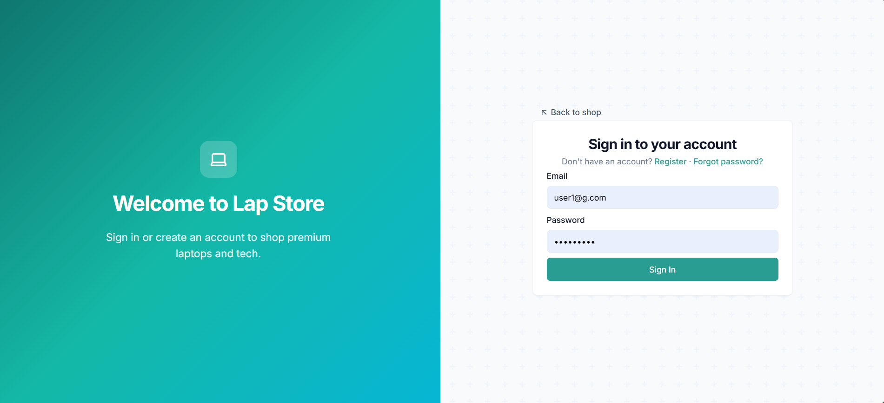

      - Home
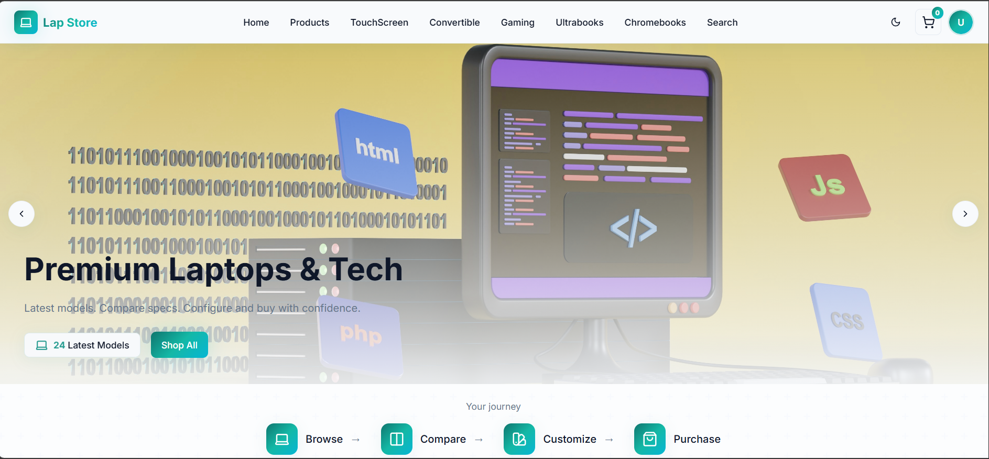

      - Home dark theme
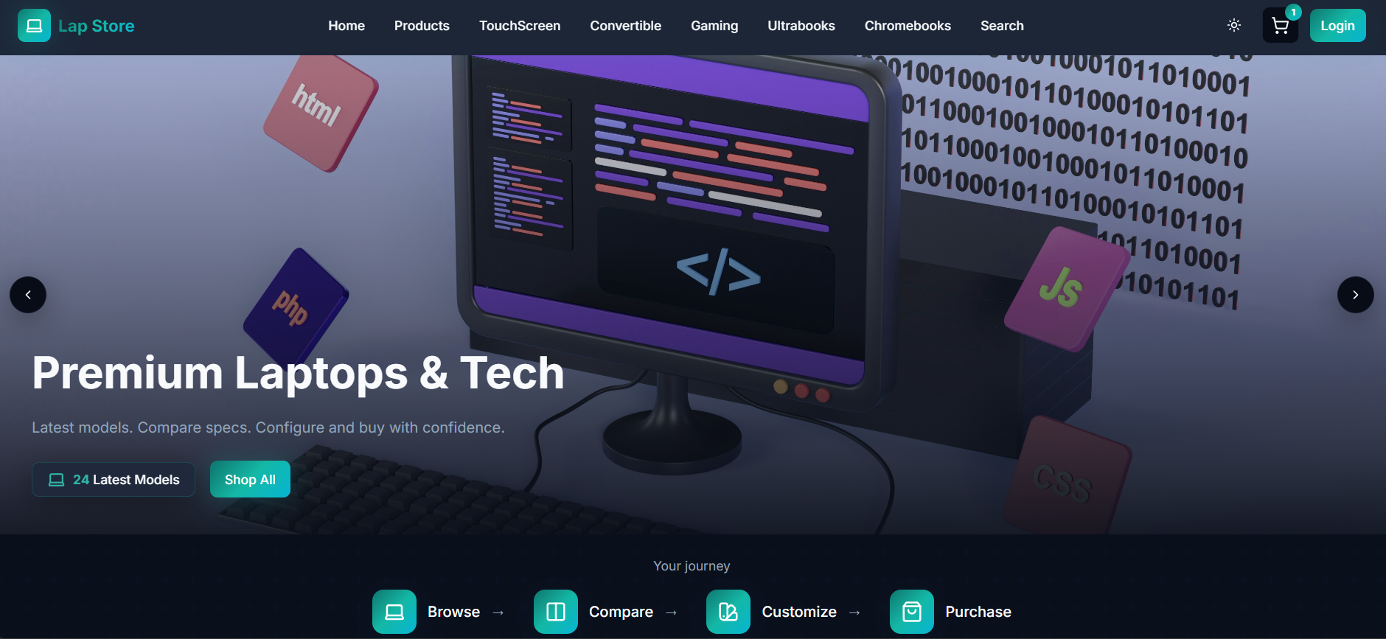

      - Register
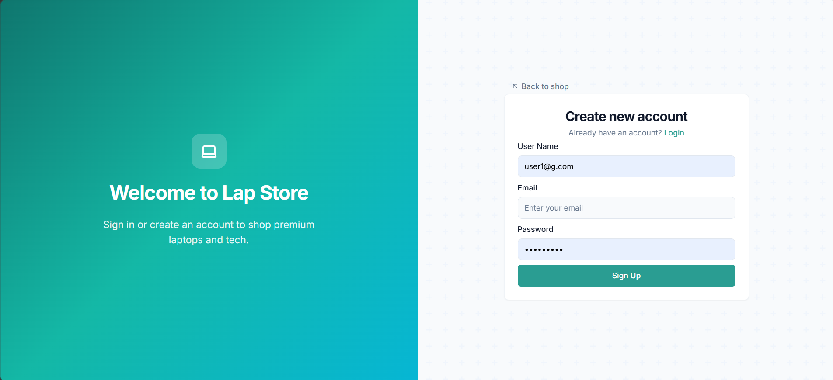

      - My_account
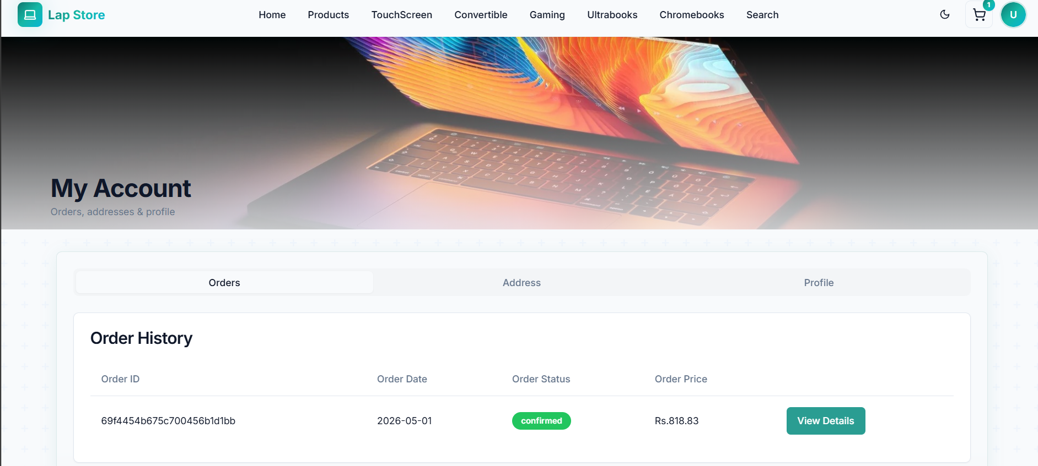

      - Admin panel
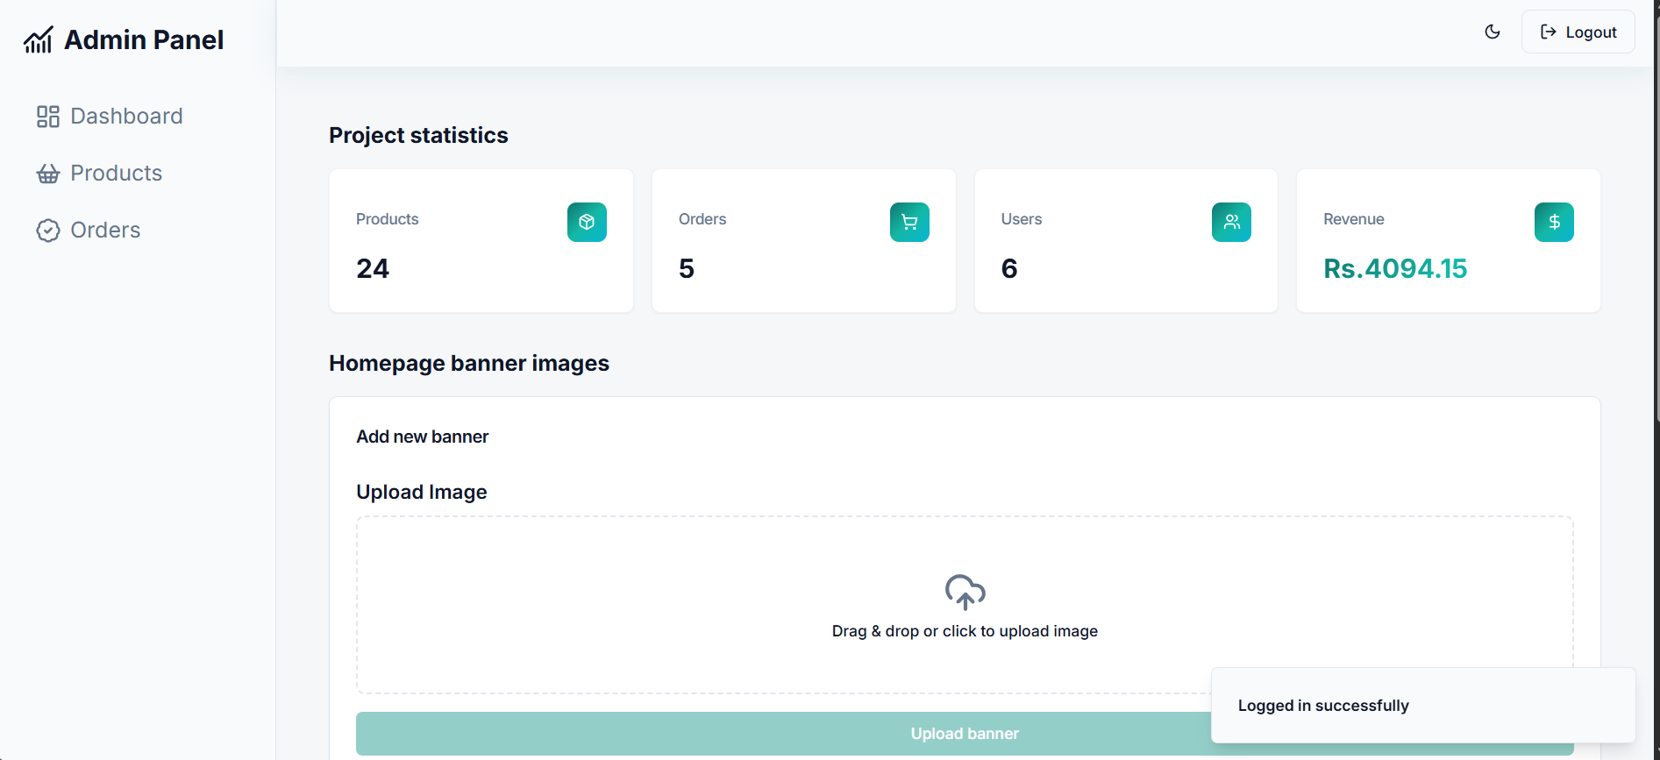

      - Admin order manage
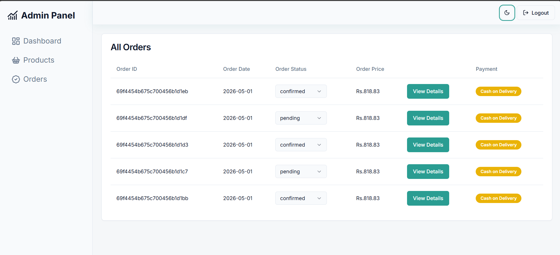

      - Categories
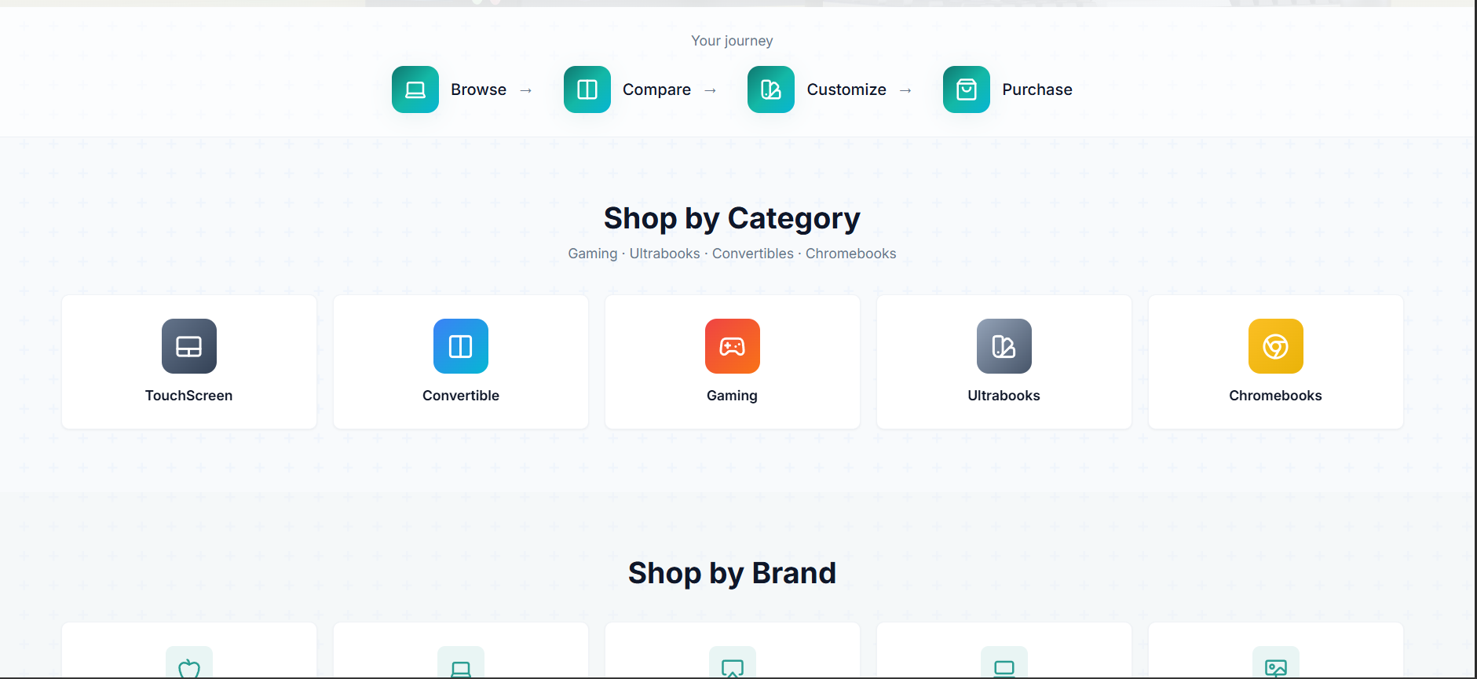

      - Checkout page
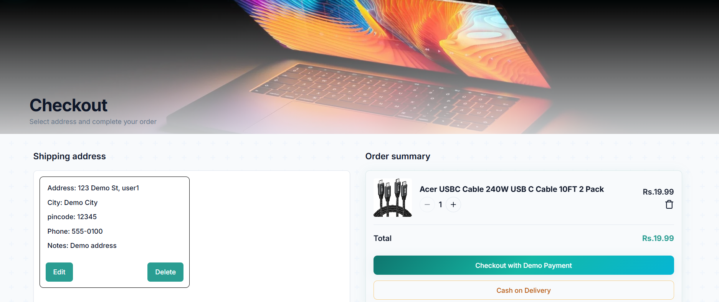

      - Product detail
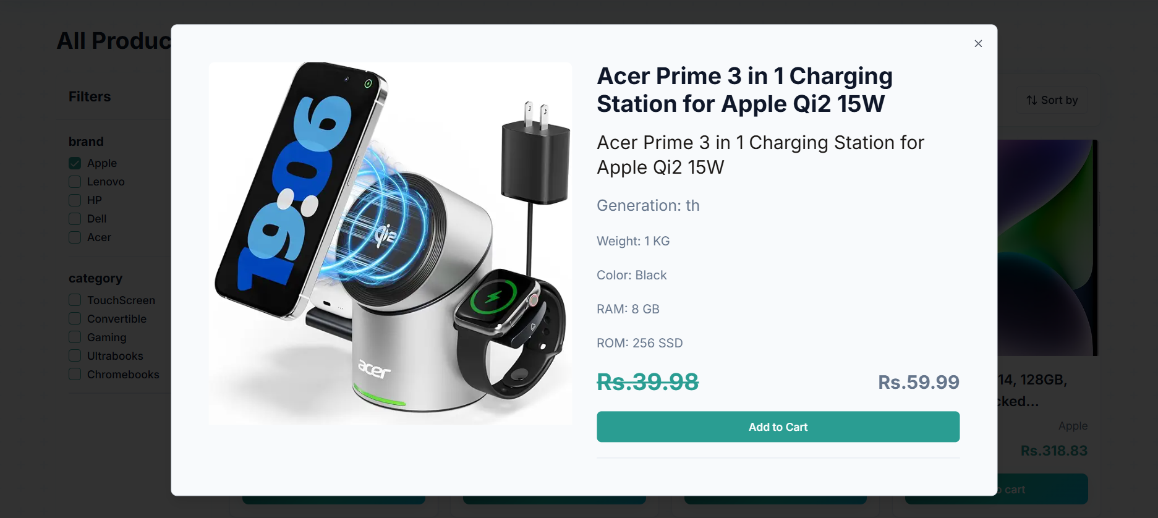

      - Order detail
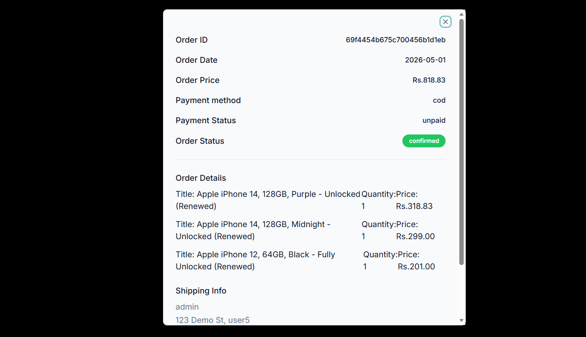

      - Shipping address
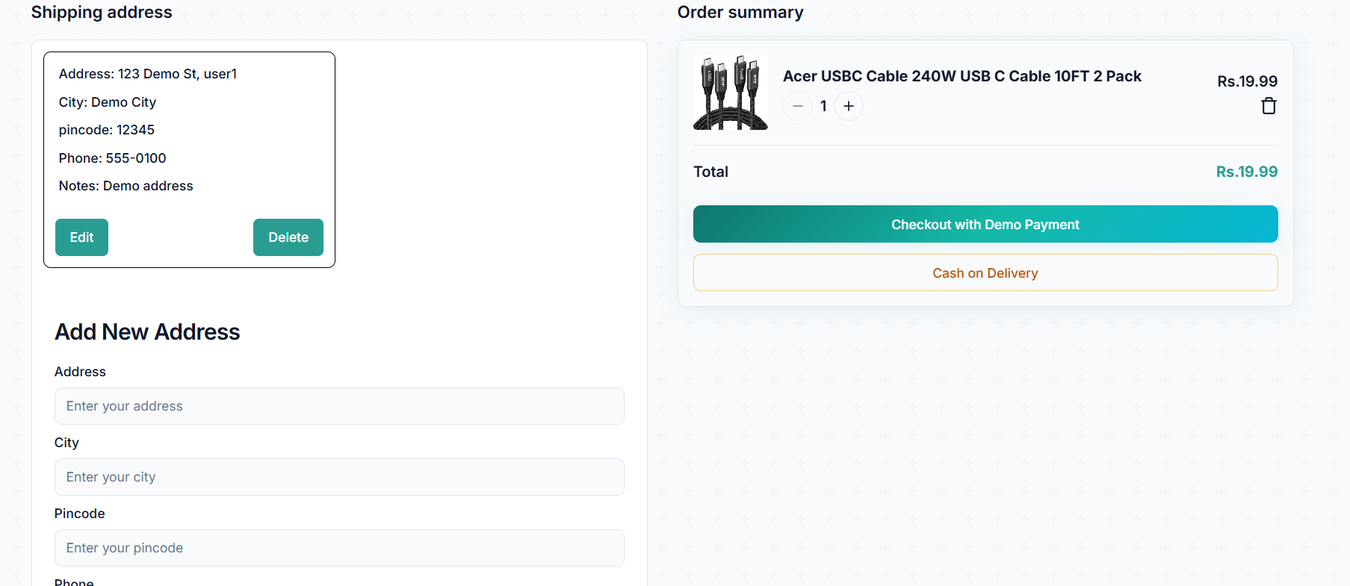

      - Shop by brand
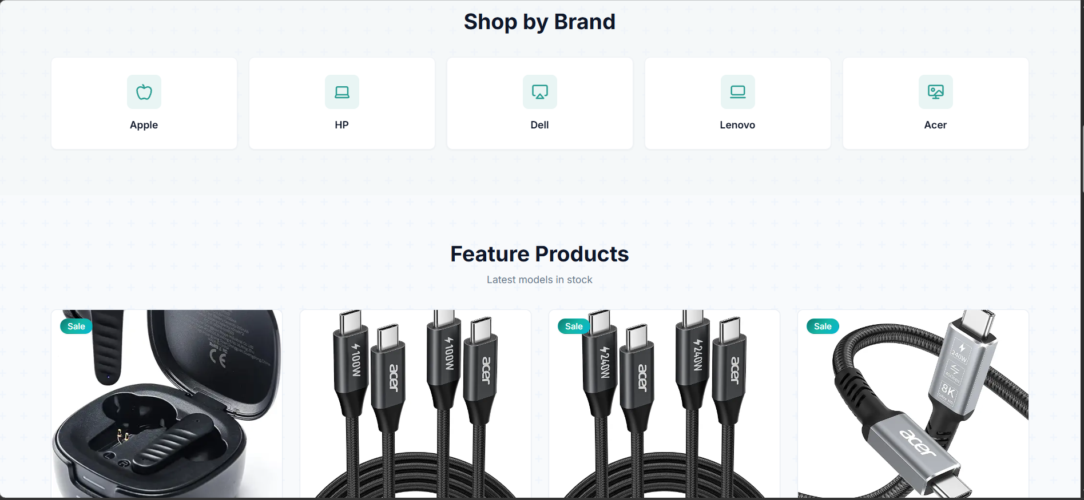

      - Your cart
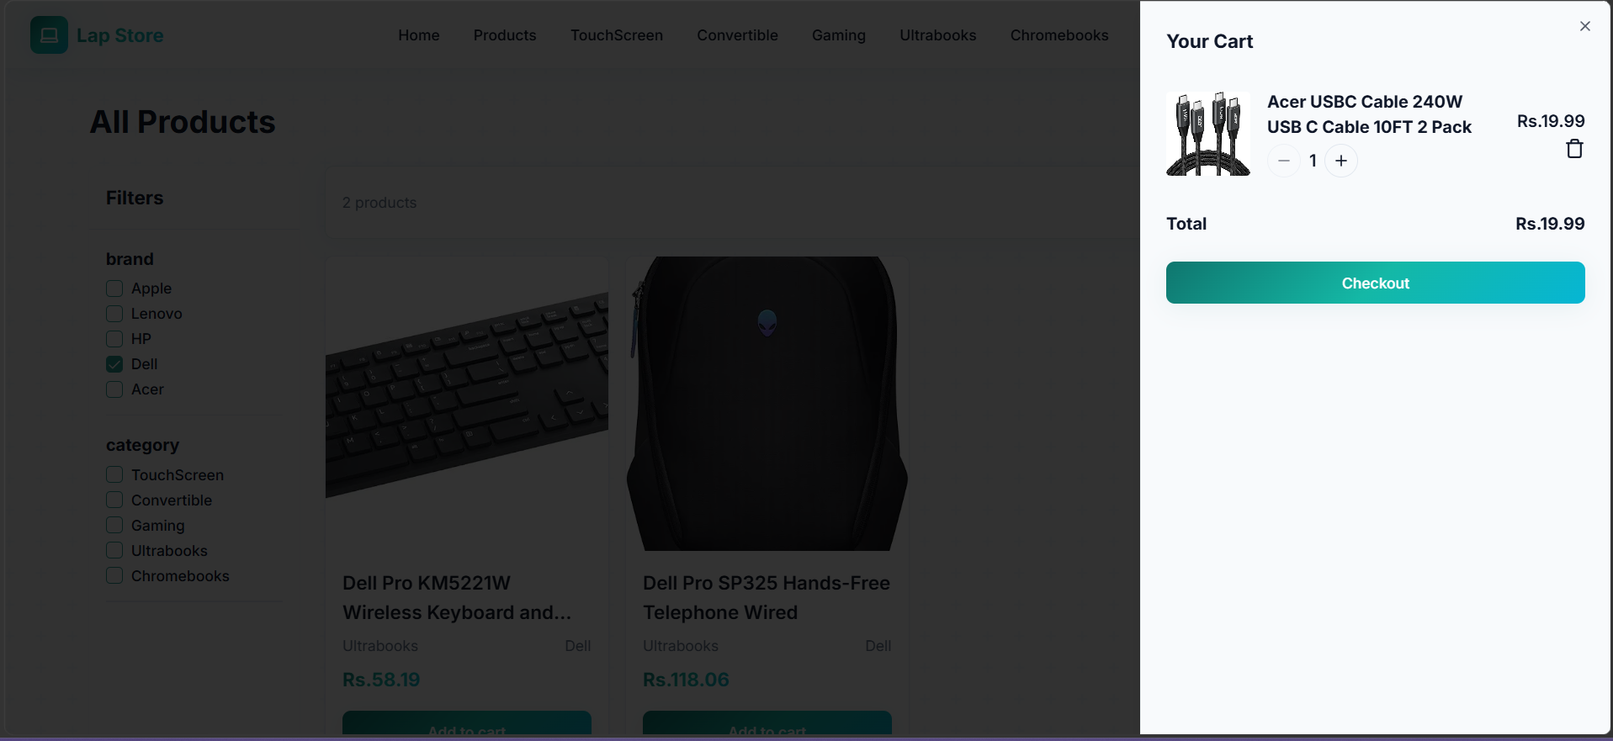

      - Listing product
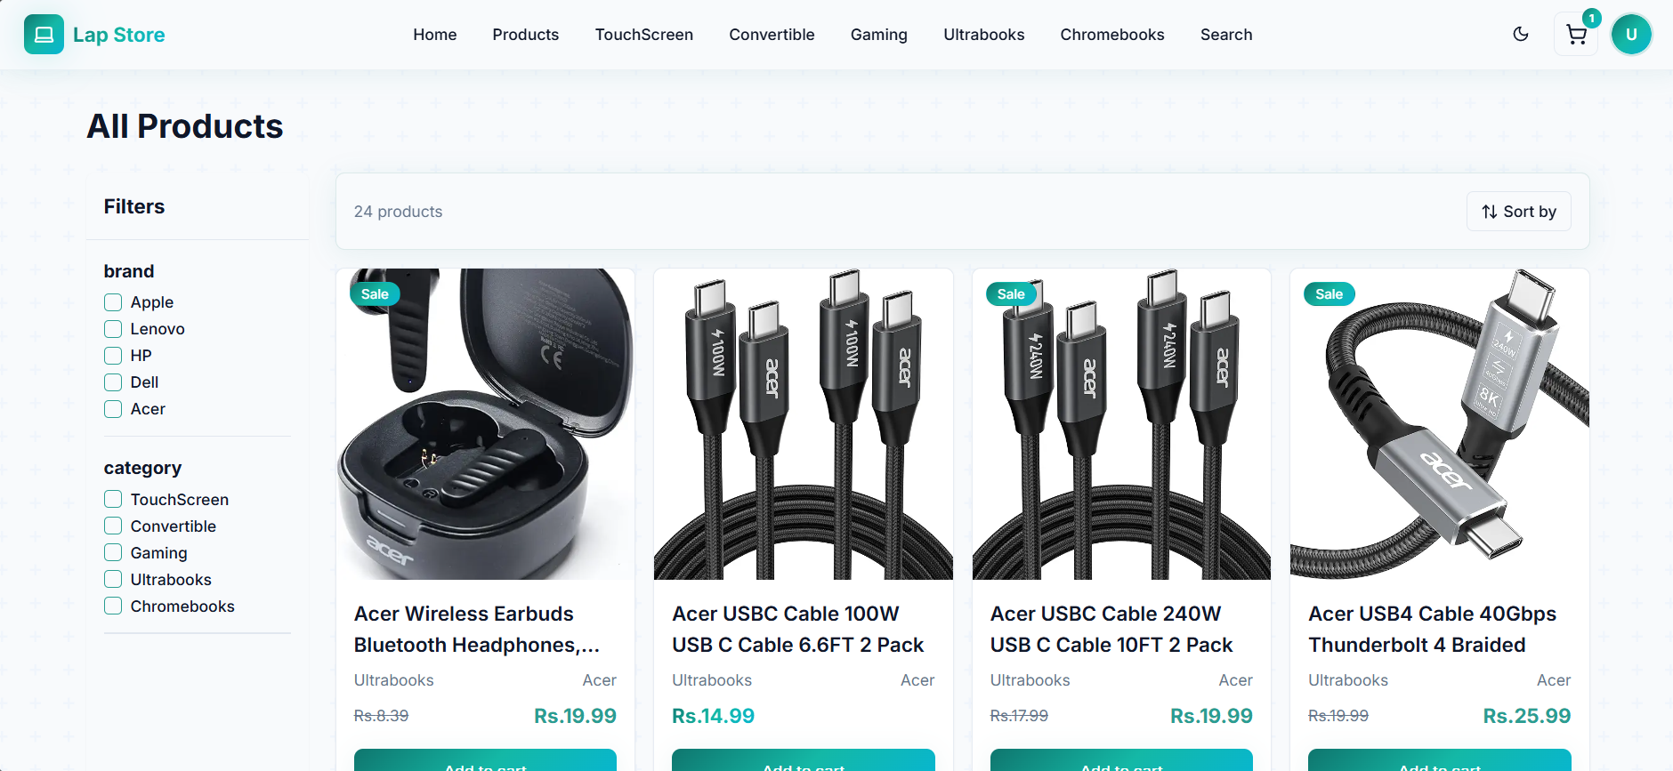

      - Forgot password
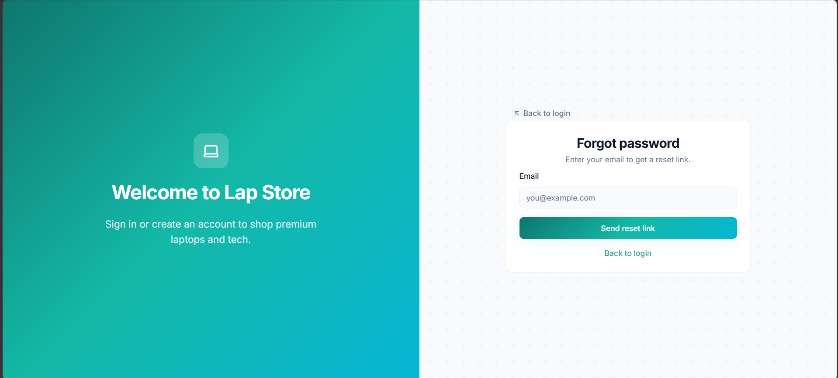

      - Edit banner
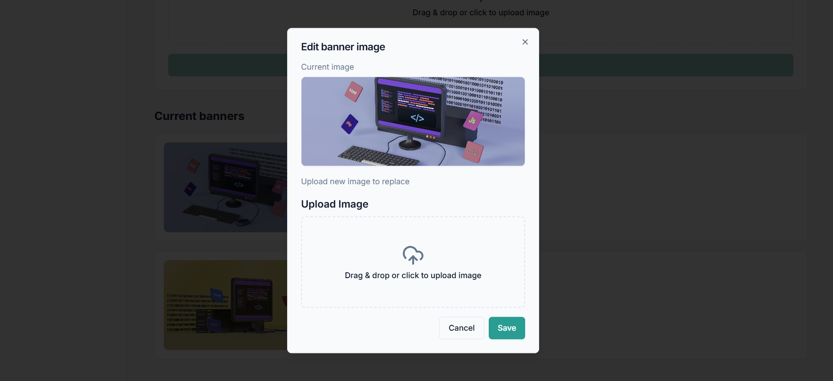

      - Edit product
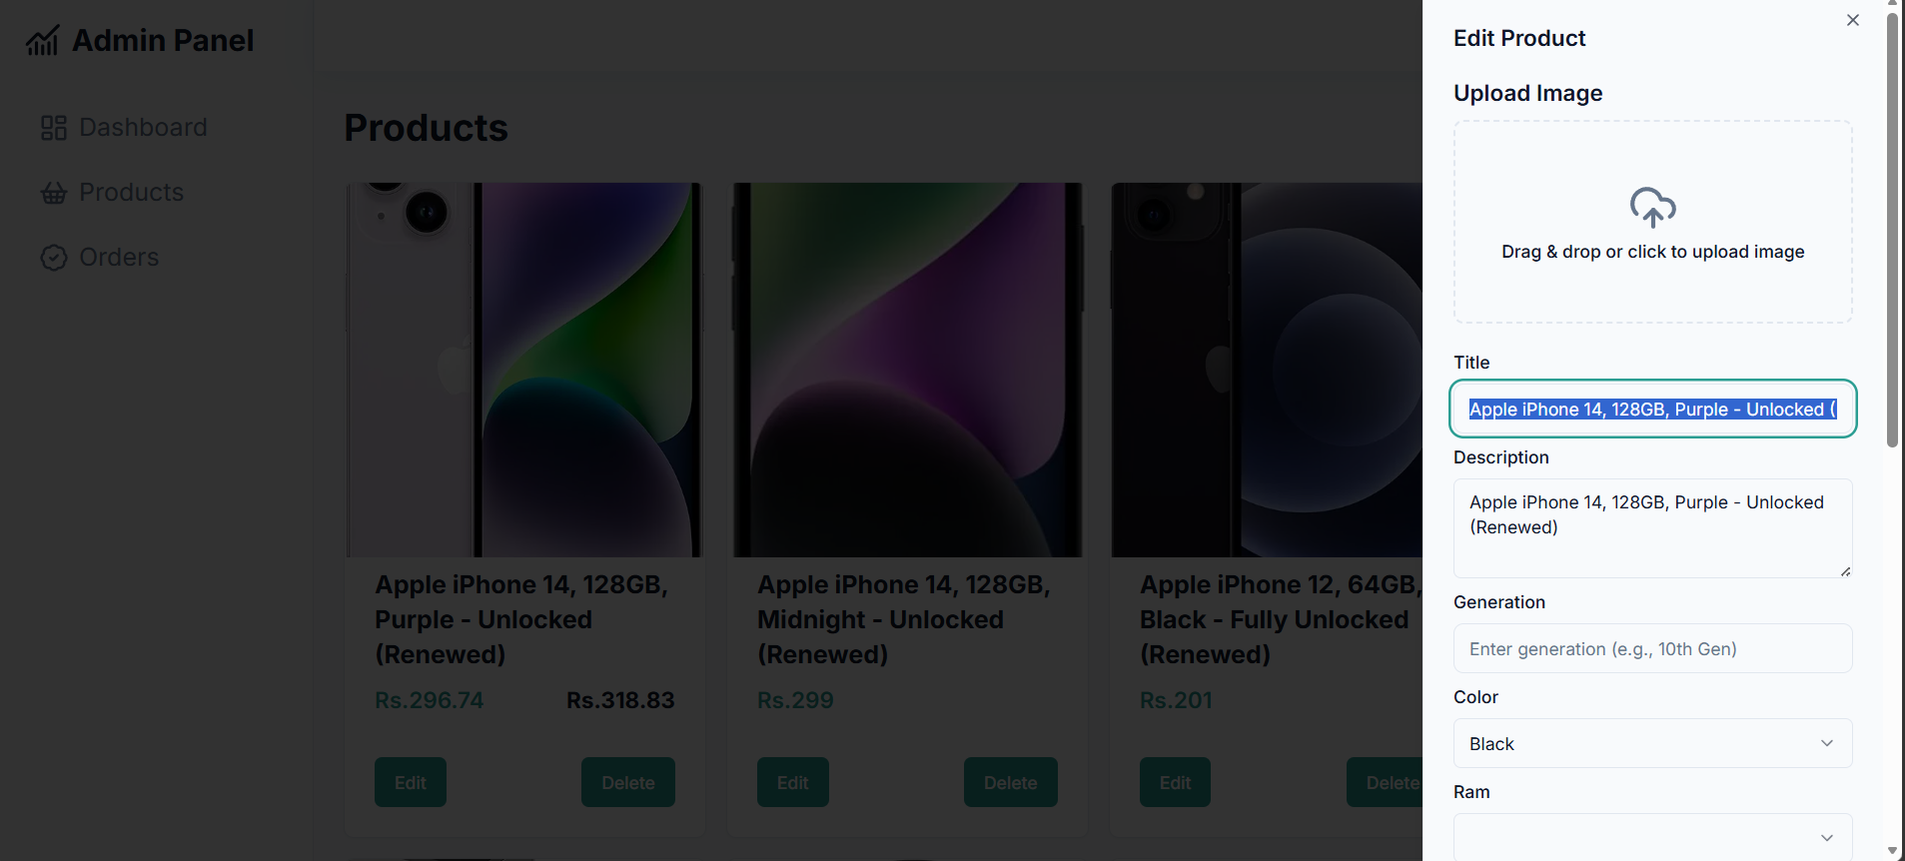

      - Admin product listing
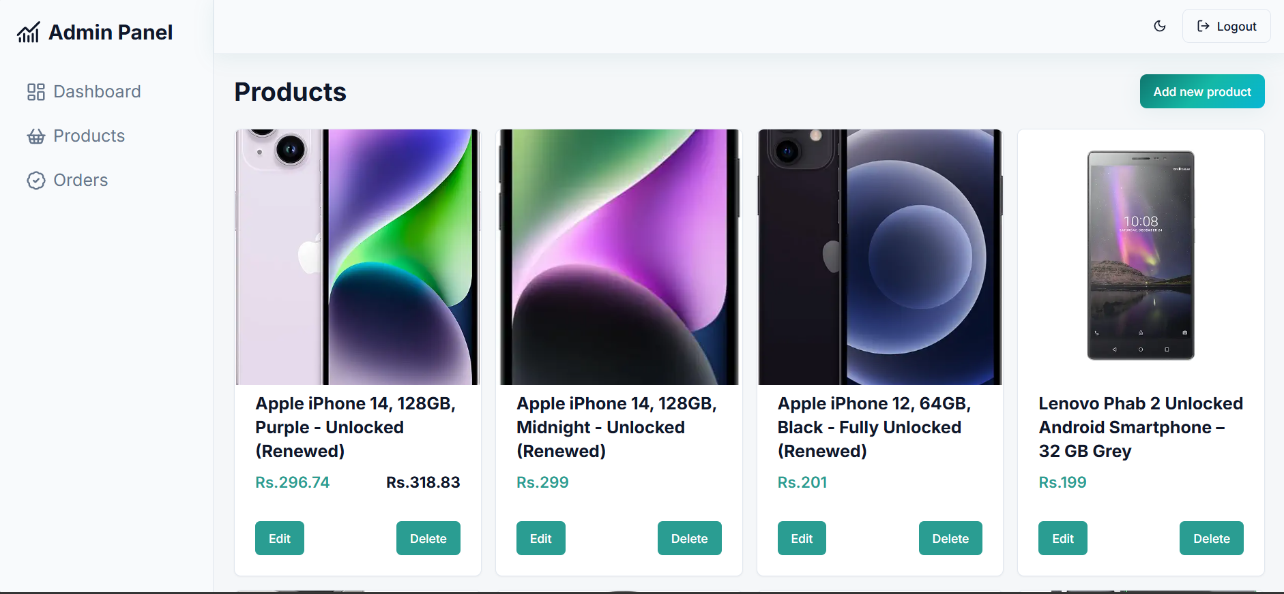

      - Manage banner
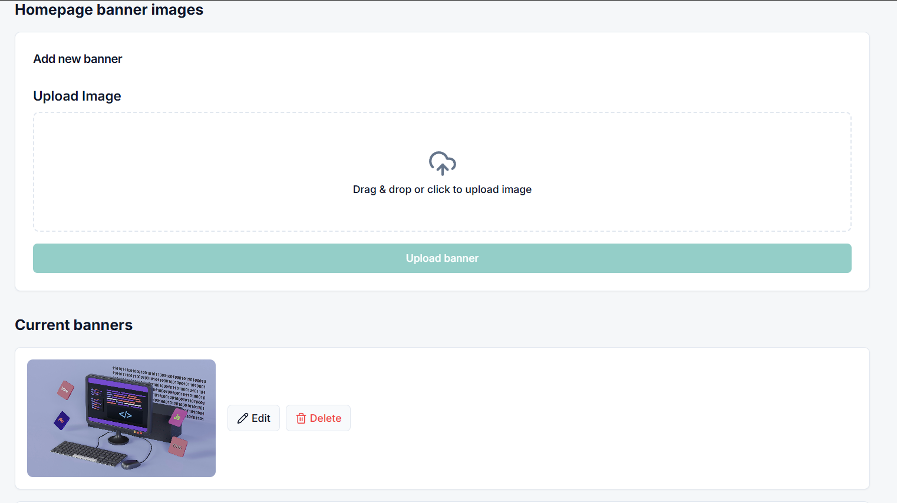

Test Cases

Test ID | Test Description | Input | Expected Output | Acceptance  Criteria
TC-01 | User Registration | Valid email, username, password | Account created,  confirmation email sent | Registration  completes within 3  seconds
TC-02 | User Login | Valid credentials | JWT token returned, redirect to home | Login completes within 2 seconds
TC-03 | Invalid Login | Wrong password | Error message displayed | System rejects invalid credentials
TC-04 | Product Catalog  Load | Access homepage | Product grid displayed with 10+ products | Loads within  3 seconds
TC-05 | Filter by RAM | Select RAM 8GB | Products with 8GB  RAM displayed | Filter results  within 2 seconds
TC-06 | Filter by Brand | Select Dell | Dell laptop products displayed | Filter results  within 2 seconds
TC-07 | Filter by Price  Range | Select Rs.50,000-  100,000 | Products in price  range displayed | Filter results  within 2 seconds
TC-08 | Sort by Price Low-High | Click sort option | Products sorted ascending by price | Sort completes within 1 second
TC-09 | Add to Cart | Click ”Add to  Cart” | Cart count increments, item added | Cart updates  within 1 second
TC-10 | Update Cart Quantity | Change quantity  from 1 to 2 | Cart total updates,  stock validated | Update within 1 second
TC-11 | Remove from Cart | Click remove icon | Item removed, cart  total updates | Removal within 1  second
TC-12 | Proceed to Check-  out | Click ”Checkout”  button | Shipping address  form displayed | Navigation within 2 seconds
TC-13 | Add Shipping Ad-  dress | Fill address form | Address saved, continue to payment | Address saves  within 2 seconds
TC-14 | PayPal Payment | Select PayPal, click  Pay | Redirect to PayPal,  payment processed | Transaction completes within 10 seconds
TC-15 | COD Order | Select COD, place  order | Order confirmed,  status ”Pending” | Order placed within 3 seconds
TC-16 | Admin Login | Admin credentials | Admin dashboard  displayed | Login completes within 2 seconds
TC-17 | Add Product (Admin) | Fill product form | Product added to  catalog | Product appears in catalog
TC-18 | Update Order Status (Admin) | Change status to  ”Shipped” | Order status up-  dated, email sent | Status up-  dates within 2 seconds
TC-19 | View Order History | Access profile orders | List of user orders  displayed | Orders load within 3 seconds
TC-20 | Mobile Responsiveness | Mobile viewport | Layout adjusts,  touch targets usable | WCAG 2.1  compliance

Deployment Configuration

Environment Variables
# Backend . env PORT =5000
MONGODB_URI= mongodb :// localhost :27017/ laptop - store JWT_SECRET = your_jwt_secret_key PAYPAL_CLIENT_ID = your_paypal_client_id PAYPAL_CLIENT_SECRET = your_paypal_client_secret CLOUDINARY_CLOUD_NAME = your_cloud_name CLOUDINARY_API_KEY = your_api_key CLOUDINARY_API_SECRET = your_api_secret EMAIL_HOST = smtp . gmail. com EMAIL_USER = your_email@ gmail . com EMAIL_PASS = your_app_password
# Frontend . env VITE_API_URL= http :// localhost :5000/ api VITE_PAYPAL_CLIENT_ID = your_paypal_client_id

Security Testing Results

Test Area | Result
JWT Authentication | Tokens properly validated on protected  routes, 7-day expiration
Password Hashing | bcrypt with 10 salt rounds, no plaintext storage
HTTPS Encryption | All communications encrypted in production
XSS Prevention | Input sanitization on all user inputs
SQL/NoSQL Injection | Mongoose schema validation prevents injection
Role-Based Access Control | Admin routes protected with middleware

Disaster Recovery Procedures
- Daily Database Backup: Automated MongoDB backup to cloud storage
- Log File Rotation: Weekly compression, deletion of logs older than 30 days
- Inventory Sync: Daily product stock level verification
- Security Updates: Monthly dependency updates and security patches
- Performance Monitoring: Continuous API response time and error rate monitoring
- Payment Reconciliation: Daily PayPal transaction verification

Conclusion
The MERN Laptop E-commerce Platform successfully implements a comprehensive online store with specialized laptop features. The system leverages the full MERN stack to deliver a scalable, maintainable, and performant e-commerce solution. Key features include JWT-based authentication, advanced product filtering by technical specifications, real-time shopping cart management, PayPal and COD payment integration, and a complete admin dashboard for business management. The platform meets all specified functional and non- functional requirements and is ready for deployment.

