**Results:**

**Note: JAVA, Page Object Model and Cucumber**

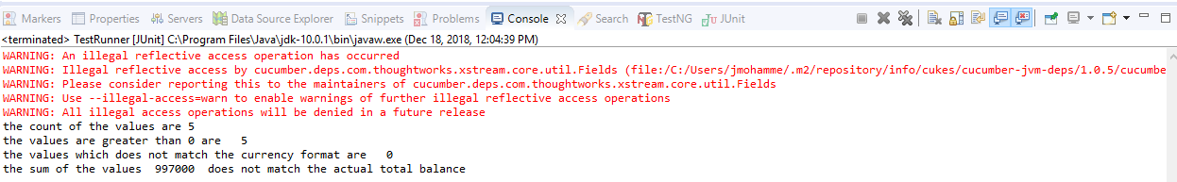

**Note: JAVA with Selenium, Page Object Model and Cucumber**

