**Basic Network Troubleshooting**

There is HSRP configuration on R1 and R2 routers. Left side HSRP VIP is 192.168.1.1 and right side VIP is 172.16.1.10. Dynamic routing protocol (OSPF) is used all routers in topology. Web server secured by ACL on R3 router. Only web (TCP port: 80) access granted to Web server IP (10.10.10.2) address from ClientA IP address (192.168.1.4).

ClientA (192.168.1.4) cannot open web site on Web Server (10.10.10.2).

Our purpose show troubleshooting steps to resolve this problem.

Network topology below:

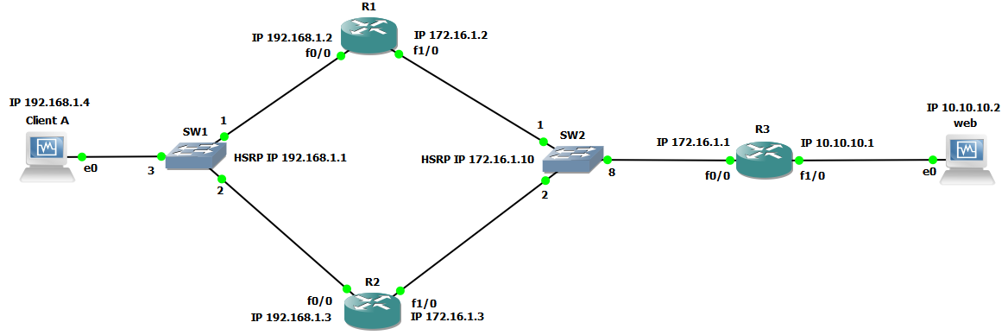

Firstly we will use **ping,** **traceroute** and **telnet** command.

root@ClientA ~# **ping -c 4 10.10.10.2**

PING 10.10.10.2 (10.10.10.2) 56(84) bytes of data.

From 172.16.1.1 icmp_seq=1 Packet filtered

From 172.16.1.1 icmp_seq=2 Packet filtered

From 172.16.1.1 icmp_seq=3 Packet filtered

From 172.16.1.1 icmp_seq=4 Packet filtered

--- 10.10.10.2 ping statistics ---

4 packets transmitted, 0 received, +4 errors, 100% packet loss, time 4010ms

root@ClientA ~# **traceroute 10.10.10.2**

traceroute to 10.10.10.2 (10.10.10.2), 30 hops max, 60 byte packets

1 192.168.1.3 (192.168.1.3) 2.768 ms 1.895 ms 1.875 ms

2 172.16.1.1 (172.16.1.1) 11.986 ms 11.972 ms 12.038 ms

3 172.16.1.1 (172.16.1.1) 11.991 ms **!X** 11.968 ms **!X** 12.006 ms **!X**

**Note**: **traceroute** command output shows us problem exist after closest router (R3). But we will continue troubleshooting. Because our purpose is to show troubleshooting methods.

root@ClientA ~# **telnet 10.10.10.2 80**

Trying 10.10.10.2...

telnet: connect to address 10.10.10.2: Connection refused

Second step is to check routing and CEF (Cisco Express Forwarding) table HSRP Active member.

Determines active or standby member of HSRP

R2#**sh standby**

**FastEthernet0/0** - Group 0

State is **Active**

2 state changes, last state change 00:21:54

Virtual IP address is **192.168.1.1**

Active virtual MAC address is 0000.0c07.ac00

Local virtual MAC address is 0000.0c07.ac00 (v1 default)

Hello time 3 sec, hold time 10 sec

Next hello sent in 0.624 secs

Preemption disabled

Active router is local

**Standby router is 192.168.1.2**, priority 100 (expires in 10.128 sec)

Priority 200 (configured 200)

Group name is "hsrp-Fa0/0-0" (default)

**FastEthernet1/0** - Group 1

State is **Active**

2 state changes, last state change 00:21:56

Virtual IP address is **172.16.1.10**

Active virtual MAC address is 0000.0c07.ac01

Local virtual MAC address is 0000.0c07.ac01 (v1 default)

Hello time 3 sec, hold time 10 sec

Next hello sent in 1.472 secs

Preemption disabled

Active router is local

**Standby router is 172.16.1.2**, priority 100 (expires in 10.944 sec)

Priority 100 (default 100)

Group name is "hsrp-Fa1/0-1" (default)

Checks OSPF configuration on R2

R2#**show running-config | section ospf**

router ospf 100

router-id 2.2.2.2

network 172.16.1.0 0.0.0.255 area 0

network 192.168.1.0 0.0.0.255 area 0

Checks routing table of specific network or host address.

R2#**sh ip route** **10.10.10.2**

**Routing entry for 10.10.10.0/24**

Known via "ospf 100", distance 110, metric 2, type intra area

Last update from 172.16.1.1 on FastEthernet1/0, 00:21:43 ago

Routing Descriptor Blocks:

* **172.16.1.1, from 3.3.3.3, 00:21:43 ago, via FastEthernet1/0**

Route metric is 2, traffic share count is 1

Checks CEF (Cisco Express Forwarding) table of specific network or host address.

R2#**sh ip cef 10.10.10.2**

**10.10.10.0/24**

**nexthop 172.16.1.1 FastEthernet1/0**

Continuing troubleshooting on R3 router.

Shows ARP (Address Resolution Protocol) table of router

R3#**sh arp**

Protocol Address Age (min) Hardware Addr Type Interface

Internet 10.10.10.1 - ca03.0c94.001c ARPA FastEthernet1/0

**Internet 10.10.10.2 10 0800.27f0.75f2 ARPA FastEthernet1/0**

Internet 172.16.1.1 - ca03.0c94.0000 ARPA FastEthernet0/0

Internet 172.16.1.2 33 ca01.14fc.001c ARPA FastEthernet0/0

Internet 172.16.1.3 33 ca02.13b8.001c ARPA FastEthernet0/0

R3#

Shows mac address table of switch. If there is switch between R3 router and Web server.

SW#**show mac address-table dynamic interface GigabitEthernet 0/10**

Mac Address Table

-------------------------------------------

Vlan Mac Address Type Ports

---- ----------- -------- -----

1 **0800.27f0.75f2** DYNAMIC Gi0/10

Total Mac Addresses for this criterion: 1

If the destination address exists in the ARP table, then better way to check ACL.

Shows name and direction of access-list applied to interface

R3#**sh run in fa 1/0**

interface FastEthernet1/0

ip address 10.10.10.1 255.255.255.0

**ip access-group web-srv out**

duplex auto

speed auto

end

Shows defined access-lists

R3#**sh ip access-lists web-srv**

Extended IP access list **web-srv**

**10 permit tcp host 192.168.1.4 host 10.10.10.2 eq www (5 matches)**

ACL match count exactly shows us the problem is in Server side. But anyway we are going to show a few troubleshooting steps on R3.

Firstly ping to the to the Web Server using source IP address of R3 router.

R3#**ping 10.10.10.2 source 10.10.10.1**

Type escape sequence to abort.

Sending 5, 100-byte ICMP Echos to 10.10.10.2, timeout is 2 seconds:

Packet sent with a source address of 10.10.10.1

**!!!!!**

Success rate is 100 percent (5/5), round-trip min/avg/max = 4/8/12 ms

Secondly telnet to Web Server tcp port 80 using source interface of R3 router.

R3#**telnet 10.10.10.2 80 /source-interface fa1/0**

Trying 10.10.10.2, 80 ...

% Connection refused by remote host

We found out that problem is in the Web Server.

[root@Web ~]# **service httpd status**

httpd is **stopped**

[root@web ~]# **service httpd start**

Starting httpd: [ OK ]

At the end telnet to Web Server again from ClientA.

[root@ClientA ~]# **telnet 10.10.10.2 80**

Trying 10.10.10.2...

Connected to 10.10.10.2.

Escape character is '^]'.