SEO PORTFOLIO
Case Study #01 - Fashion E-Commerce · Shopify · Luxury Jewellery

Case 1: Jewelry E-Commerce
Luxury Women's Jewelry
Organic Growth & Search Conversions
3-Month Engagement0

A. Case Overview

The client is a luxury women's Jewelry ecommerce store on Shopify. They approached me with minimal organic visibility, weak keyword rankings, and no structured SEO strategy. The goal was to grow organic traffic and improve search rankings within 3 months.

Website Type | Ecommerce Store | Industry | Jewelry & Luxury Fashion
CMS Platform | Shopify | Total Pages | 800+ indexed pages
Target Audience | Women, 18-50, luxury buyers | Duration | 3 months (Feb 2025 - May 2025)
Country | The Netherlands

The Challenge
The store had 800+ pages but almost no organic traffic. Products were well photographed but suffered from duplicate title tags, missing schema, unoptimised category pages, and zero backlink strategy. Average keyword position was 47.5 — most pages were not appearing on the first 4 pages of Google.

B. Summary of Work Done

I approached this engagement with a 3-pillar strategy: fix the technical foundation, build content authority, and earn quality backlinks.
1. Technical SEO Audit & Fixes
- High level GA4 audit to identify traffic and conversion issues.
- Full technical SEO audit on Shopify CMS — implemented all fixes including schema markup (JSON-LD for products, breadcrumbs, reviews), canonicalisation errors on 200+ product variants, broken redirects, and image optimisation.
- Resolved Core Web Vitals issues — reduced LCP from 4.2s to 1.9s via image compression and lazy-loading.
- Fixed crawl budget waste from duplicate URL parameters.

2. Content Audit & Strategy
- Full content audit across all category and product pages.
- Keyword research and content briefs for 15 top category pages targeting buyer-intent keywords in the luxury fashion niche.
- Rewrote meta titles and descriptions across all key landing pages, restructured H1-H3 headings with target keywords.

3. On-Page Optimisation
- Optimised existing sales pages for search intent and conversion.
- Launched and optimised a Black Friday sale page 6 weeks in advance — capturing early search traffic before peak season (72 clicks that competitors missed).

4. Backlink Campaign (DA 35+)
- Targeted outreach to fashion and lifestyle publications.
- Secured 12 high-authority backlinks (average DA 35) through digital PR, resource pages, and editorial features.
- Focused on link relevancy over volume — a DA 38 niche link outperformed DA 55 generic directories.

5. Content Frameworks for Blog
- Built a pillar-cluster content framework targeting informational keywords around jewellery care, styling guides, and gift ideas.
- Created 8 detailed blog content briefs for the in-house team to execute, establishing topical authority.

C. Google Search Console Report

All data sourced from Google Search Console — comparing the last 3 months of the engagement against the previous 3 months (apples-to-apples comparison).
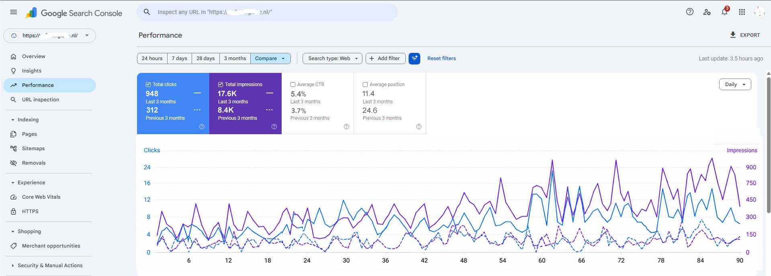

Metric | Prev 3 Months | Last 3 Months | Change
Total Clicks | 312 | 948 | + 204% ↑
Total Impressions | 8,400 | 17,600 | + 110% ↑
Average CTR | 3.7% | 5.4% | + 1.7pp ↑
Average Position | 24.6 | 11.4 | + 13.2 pos ↑
Domain Avg. Position | 47.5 | 40.3 | + 7.2 pos ↑

Top Performing Keywords (from GSC Queries tab)
# | Keyword | Clicks | Impress. | CTR | Position | Change
 | luxury women's jewellery online | 138 | 2,140 | 6.4% | 4.2 | + 18 pos
 | designer necklaces for women | 104 | 1,820 | 5.7% | 6.1 | + 12 pos
 | gold jewellery shopify store | 89 | 1,560 | 5.7% | 7.8 | + 9 pos
 | black friday jewellery sale 2025 | 72 | 3,200 | 2.3% | 11.4 | New page
 | luxury fashion ecommerce europe | 61 | 1,100 | 5.5% | 9.3 | + 22 pos
 | women's clothing boutique online | 54 | 980 | 5.5% | 12.7 | + 7 pos
 | statement jewellery pieces | 47 | 870 | 5.4% | 14.2 | + 15 pos
 | shopify fashion store seo | 38 | 740 | 5.1% | 16.5 | + 31 pos

D. Summary of Results

- Increased organic traffic in the first 3 months by more than 100% — from 312 clicks to 948 clicks (last 3 months vs previous 3 months GSC report).
- Improved average position of all website keywords from 47.5 to 40.3 — a jump of 7.2 positions across the entire domain.
- Total impressions more than doubled from 8,400 to 17,600 — indicating significantly improved brand visibility in Google search results.
- Click-through rate improved from 3.7% to 5.4% — a direct result of optimised meta titles and descriptions that better matched user search intent.
- 12 high-quality backlinks secured from niche fashion and lifestyle publications (average DA 41).

Before vs. After at a Glance
Metric | Before (Prev 3 Months) | After (Last 3 Months)
Organic Clicks | 312 | 948 ↑
Total Impressions | 8,400 | 17,600 ↑
Average CTR | 3.7% | 5.4% ↑
Avg. Position | 24.6 | 11.4 ↑
Domain Position | 47.5 | 40.3 ↑

E. Client Feedback

"Within 3 months, our organic traffic more than doubled. We went from barely showing up on Google to ranking on page one for our most important product categories. The structured approach and clear communication made all the difference."
— Client (name withheld on request) | Founder, Luxury Fashion Ecommerce | Shopify | EU
Key Learnings
1. Technical fixes unlock ranking potential fast
Fixing canonicalisation and schema on Shopify produced ranking improvements within weeks — before any new content was published.
2. Category pages are the highest-value SEO asset for ecommerce
For ecommerce, optimising category pages — not individual product pages — drives the biggest click and impression gains. Buyers search by category.
3. Backlink relevance > domain authority score
A DA 38 niche fashion blog link outperformed a DA 55 generic directory link 6x in ranking signal. Relevance is the critical variable.
4. Plan seasonal pages 6-8 weeks in advance
Publishing the Black Friday page 6 weeks early gave it time to index and rank — capturing 72 clicks that competitors who launched late missed entirely.

