Jamare Noah McCallum
Module 1 – GitHub Repository Setup
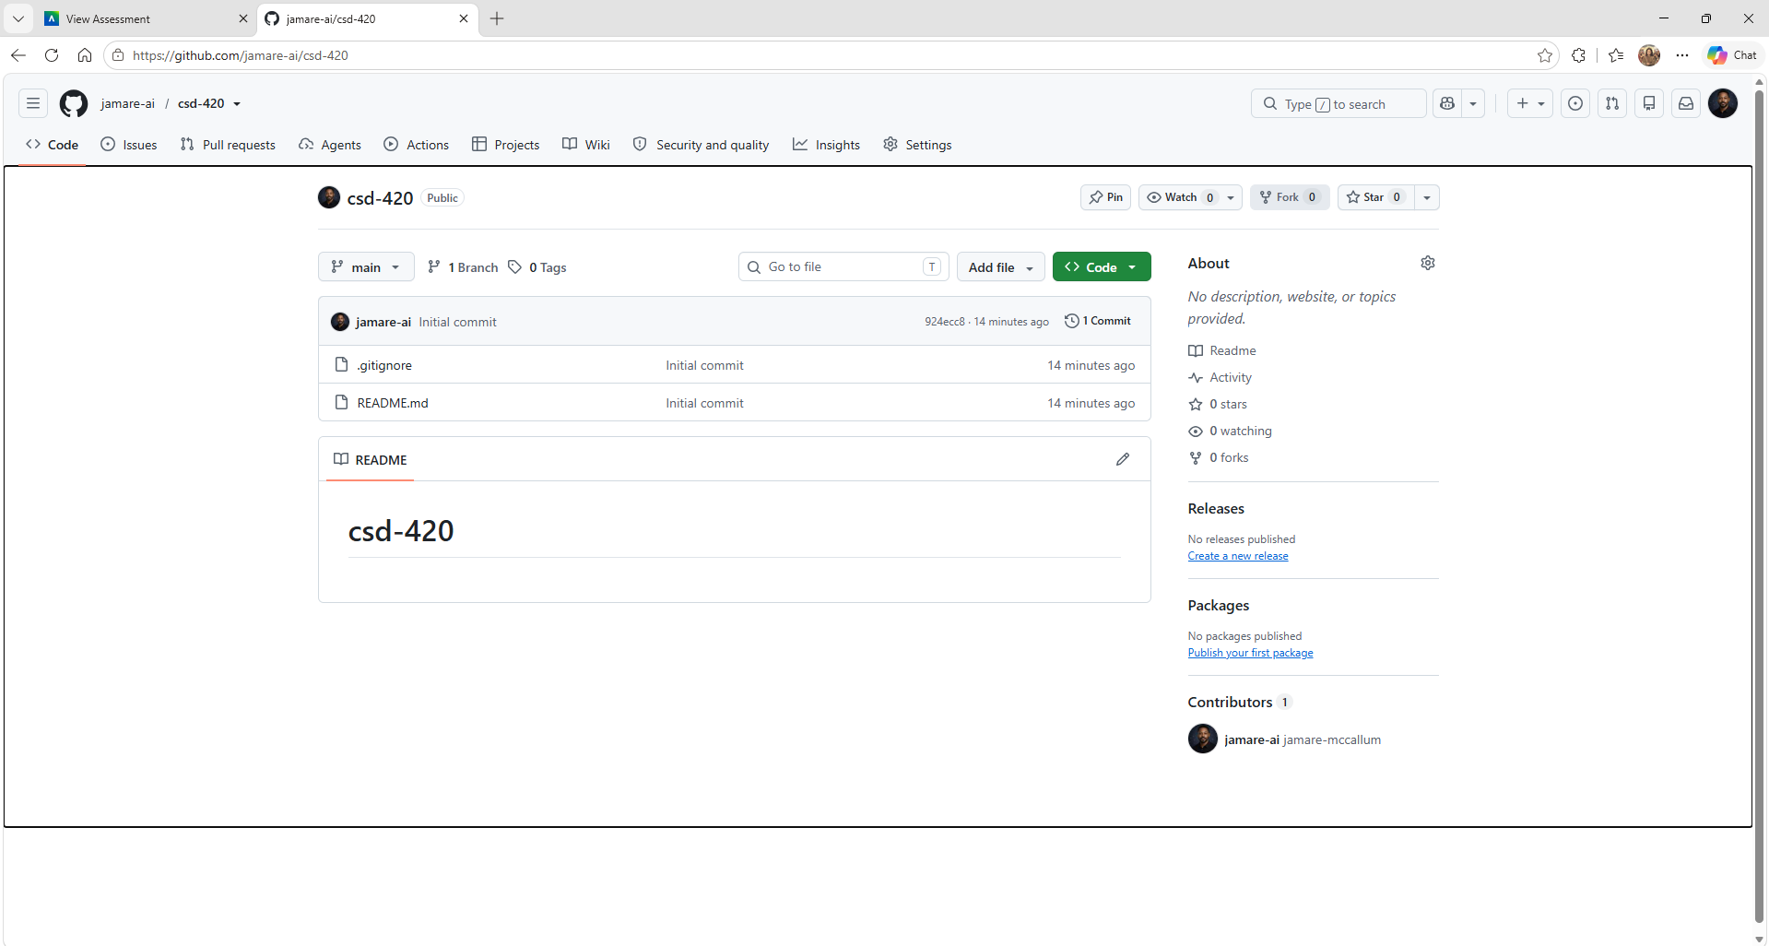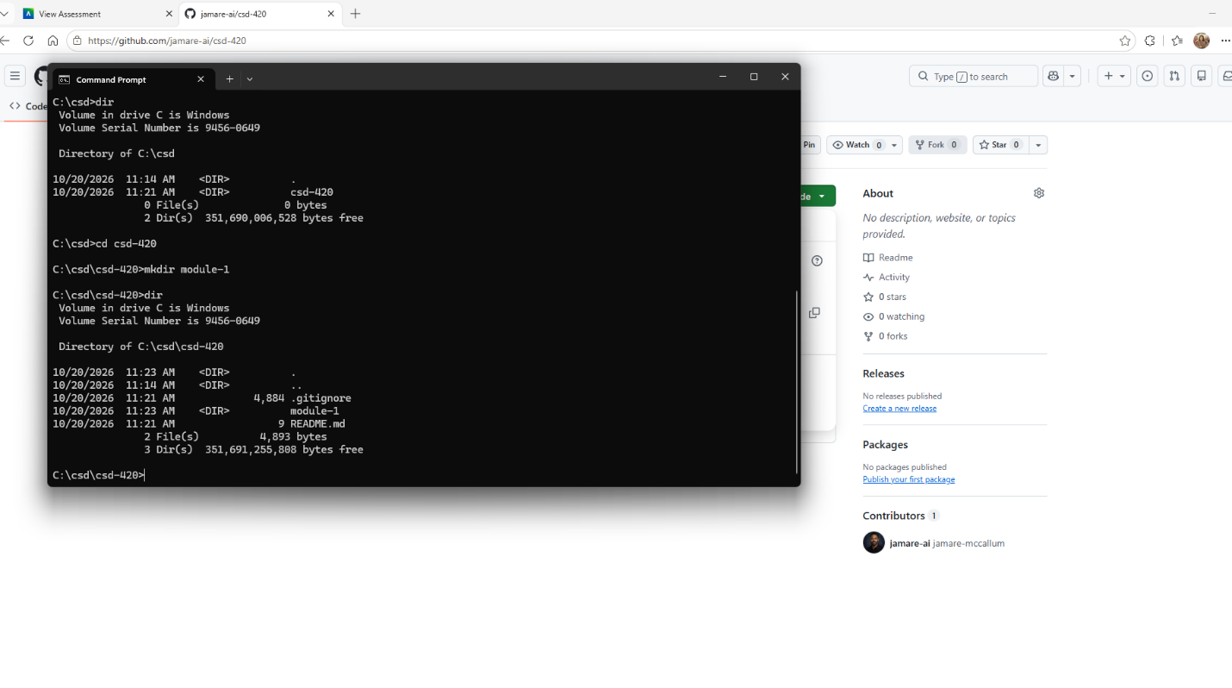

https://github.com/jamare-ai/csd-420
