Jamare McCallum
CSD 420
Module 3 Assignment
November 4, 2026

This program creates an ArrayList with 50 random values between 1 and 20. The program uses a generic method called removeDuplicates() to create a new ArrayList that contains only unique values. The original list and the list without duplicates are displayed in the output. This assignment demonstrates the use of generics, ArrayLists, methods, and loops from Chapter 19.

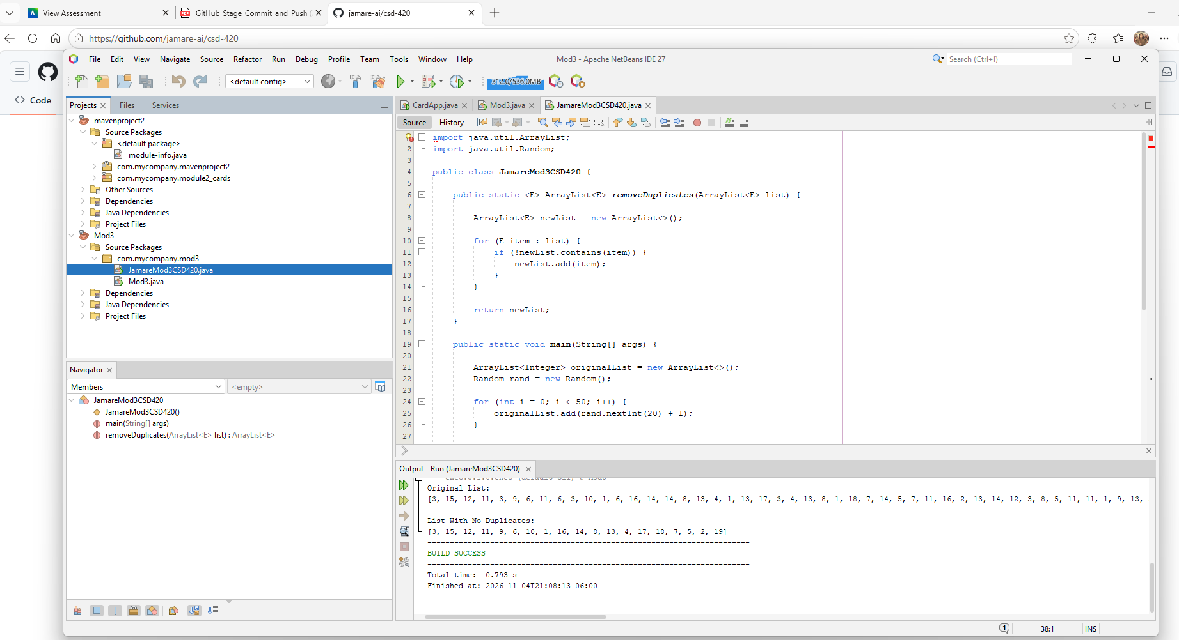
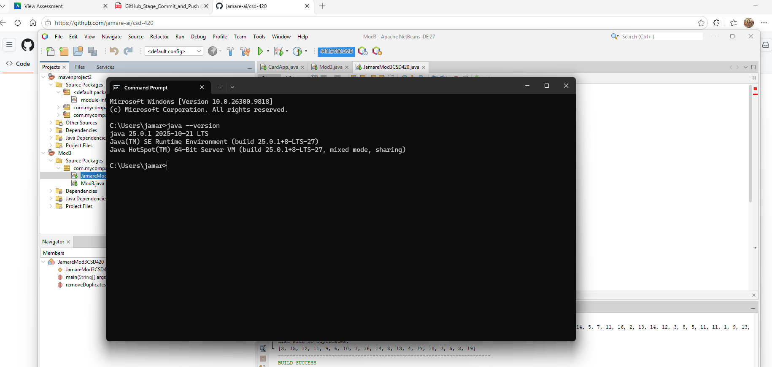
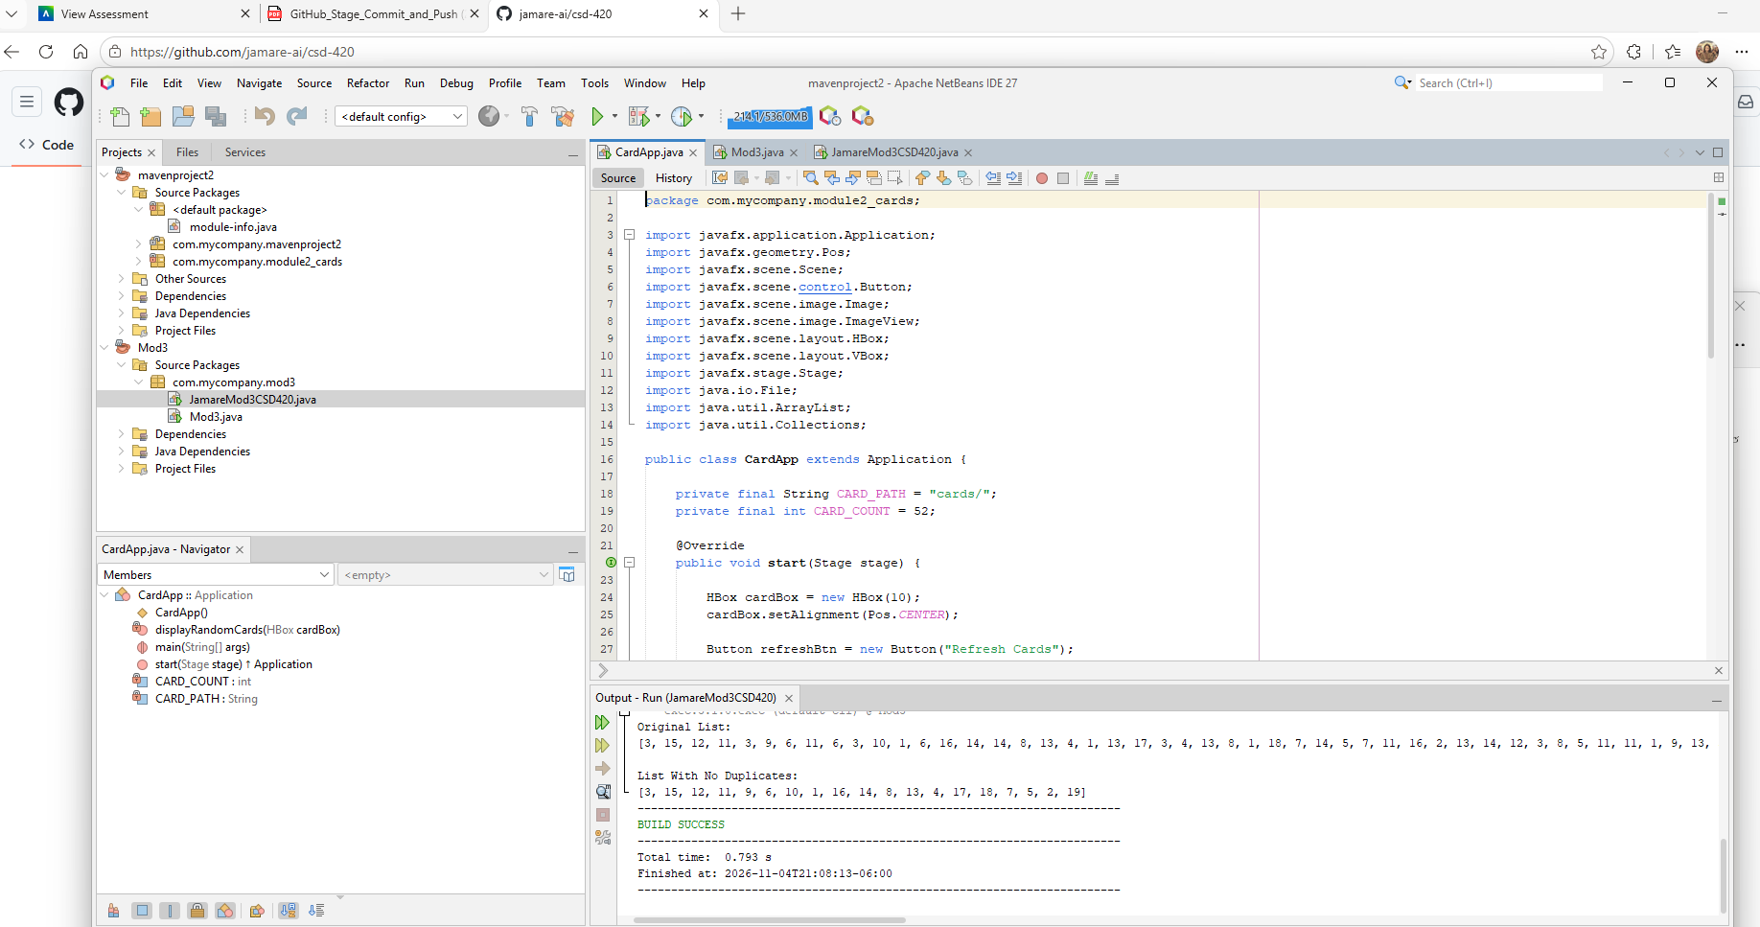
GitHub Repository URL:
https://github.com/jamare-ai/csd-420
GitHub Folder URL:
https://github.com/jamare-ai/csd-420/tree/main/Mod3

