Session15 Assignment

1.Write a Python function called get_song_duration_per_minute that divides the total duration of a Spotify playlist (in minutes) by the number of songs, and handles the case where the number of songs is zero using try, except, and finally blocks.

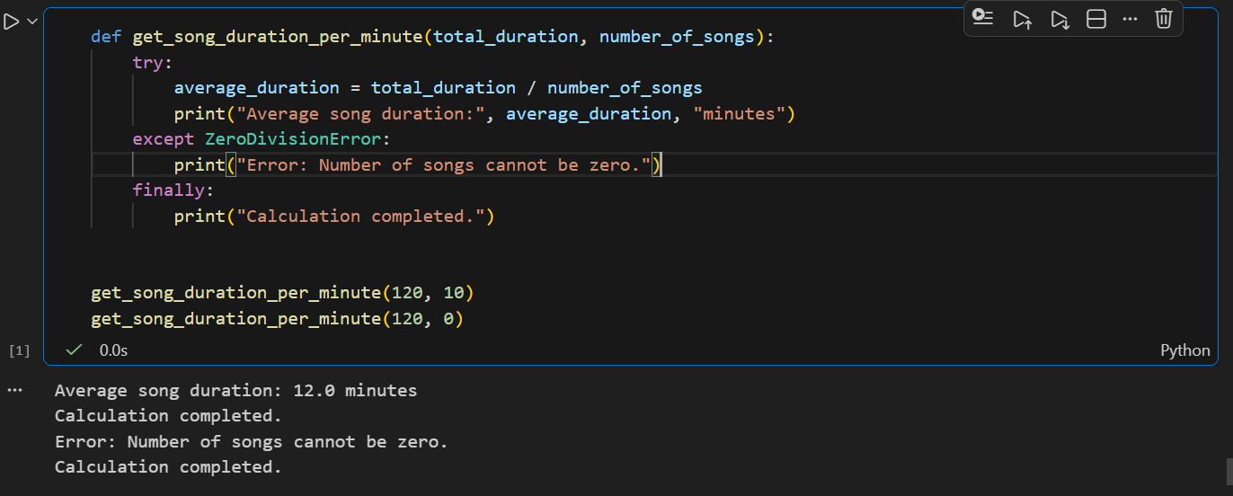

2.Build a Flipkart-style price-per-item calculator: take total cart amount and item count as input, perform division, and use try-except to catch and display a user-friendly message if the item count is zero.

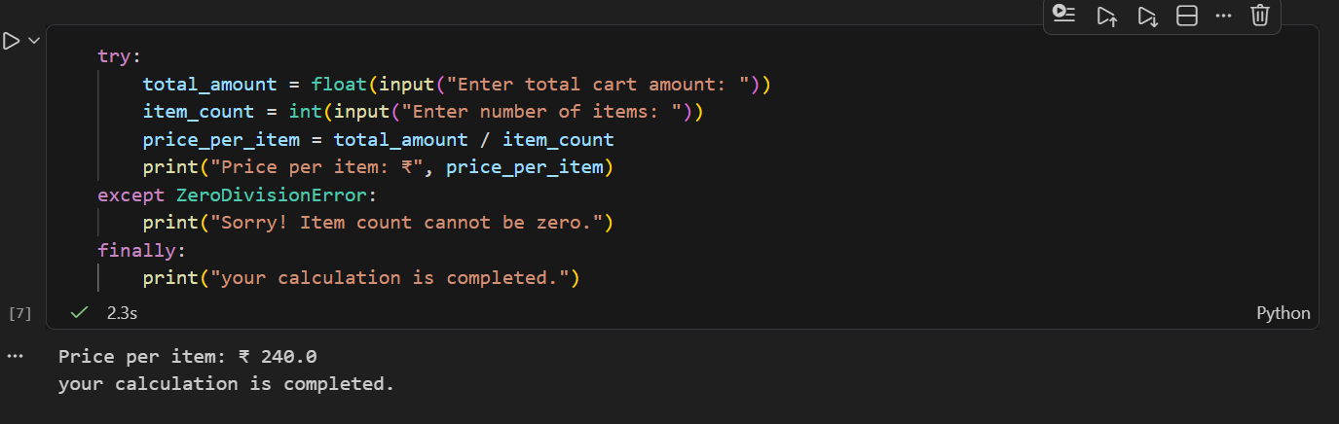

3.Create a Paytm cashback calculator that asks for total spend and number of offers applied, then divides spend by offers to show average cashback per offer. If the number of offers is zero, raise a custom exception called NoOffersApplied and display a custom error message.<br><br><em><strong>Hint:</strong> Define your own exception class by subclassing Exception.</em>

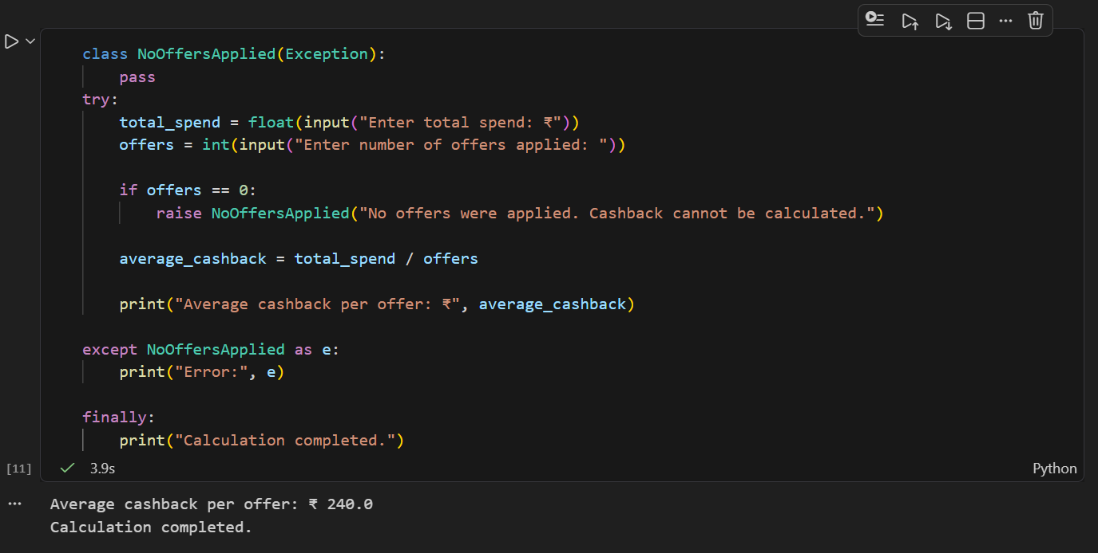

4.Refactor the following buggy code to handle exceptions correctly so it never crashes and always prints 'Thank you for using the calculator' at the end, even if an exception occurs:<br><br>def calculate_average_rating(total_rating, num_reviews):<br> return total_rating / num_reviews<br>print(calculate_average_rating(500, 0))

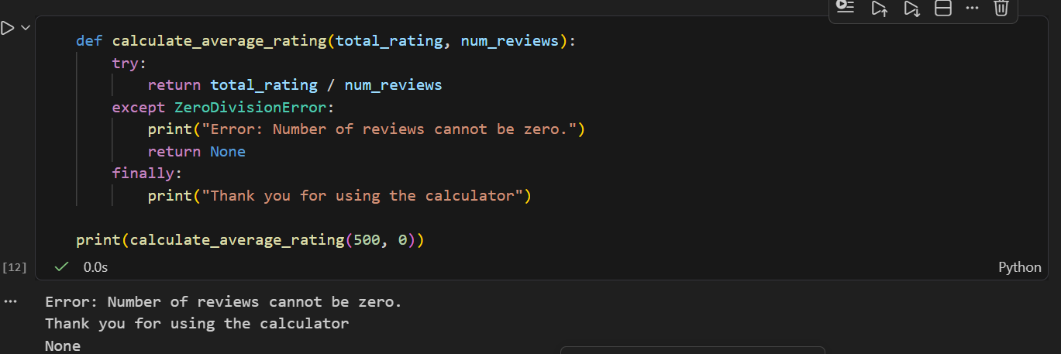
5.Write a function called safe_divide_for_zomato that takes two numbers (bill amount and number of people), uses try, except, else, and finally to divide the bill and print the result, print a custom error if division by zero, and always print 'Split calculation done' at the end.

