Session14 Assignment

1.Create a text file named playlist.txt and write the names of 5 songs you listened to this week, each on a new line using Python's open() function in write mode.

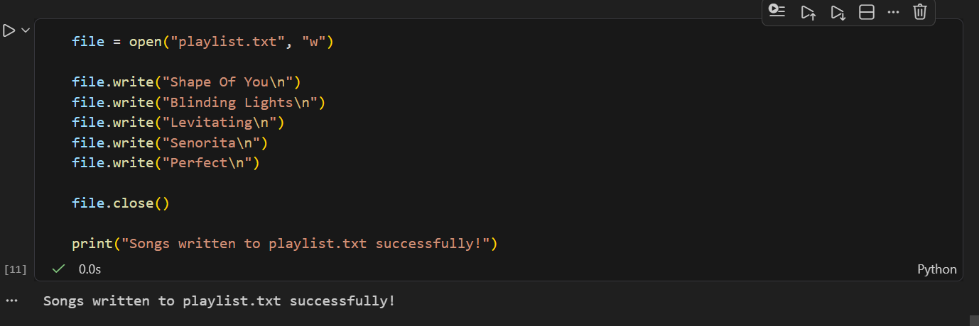

2.Read the playlist.txt file you created and display each song name in uppercase letters using Python.

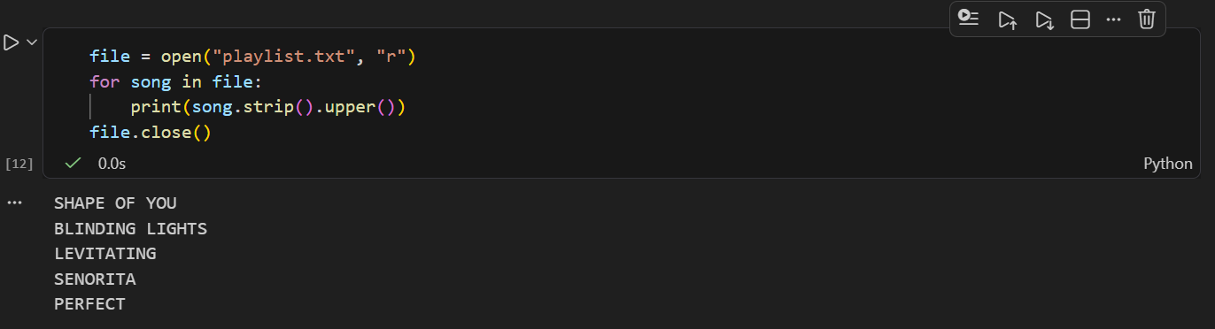

3.Download a sample CSV file of IPL match scores (you can create your own with columns: match_id, team1, team2, winner) and write a Python script to read the file and print the winner of each match using the csv module.

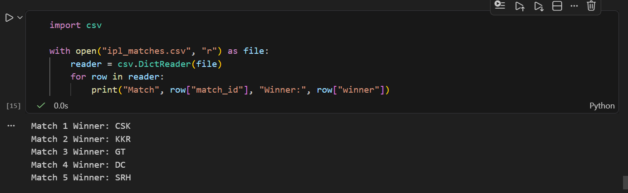

4.Find a public JSON file of trending movies (or create your own movies.json with at least 3 movie objects containing title, year, and rating), then use the json module in Python to load the file and print the title and rating of each movie.

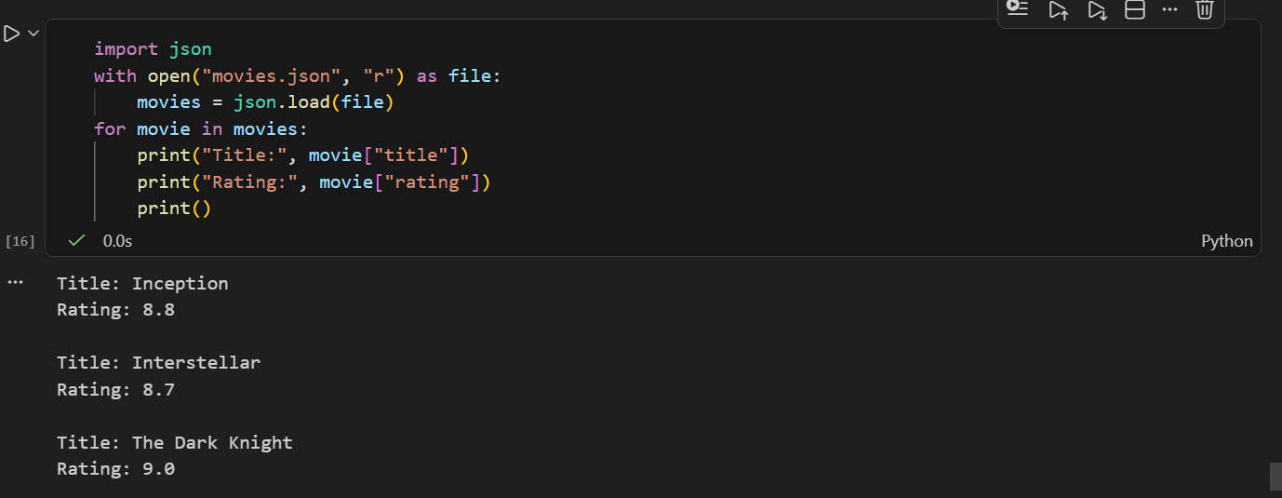

5.Use the pathlib module to check if a file called 'my_fav_apps.json' exists in your current directory, and if not, create it and write a JSON array of your top 3 mobile apps (e.g., Instagram, Zomato, Paytm) with their names and categories.<br><br><em><strong>Hint:</strong> Use Path('my_fav_apps.json').exists() to check for the file, and json.dump() to write the data.</em>

