Session19-oops Assignment

1.Define a Python class called Song with attributes title, artist, and duration (in seconds). Create an object for your favorite song and print its details.

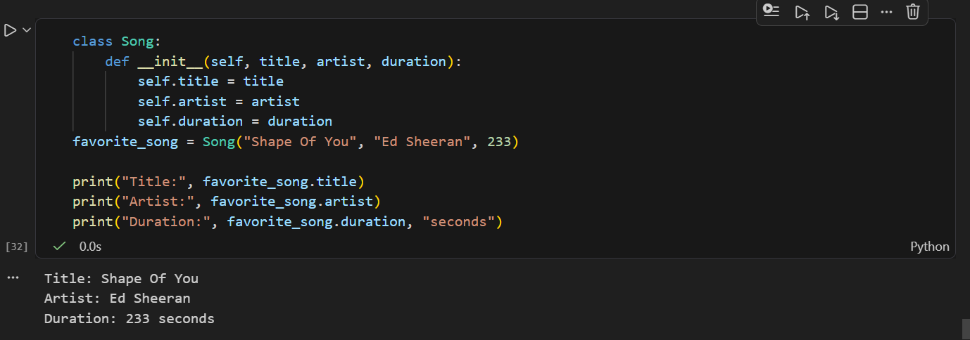

2.Add a method play_preview(self) to the Song class that prints 'Playing 30-second preview of [title] by [artist]'. Call this method using the object you created.

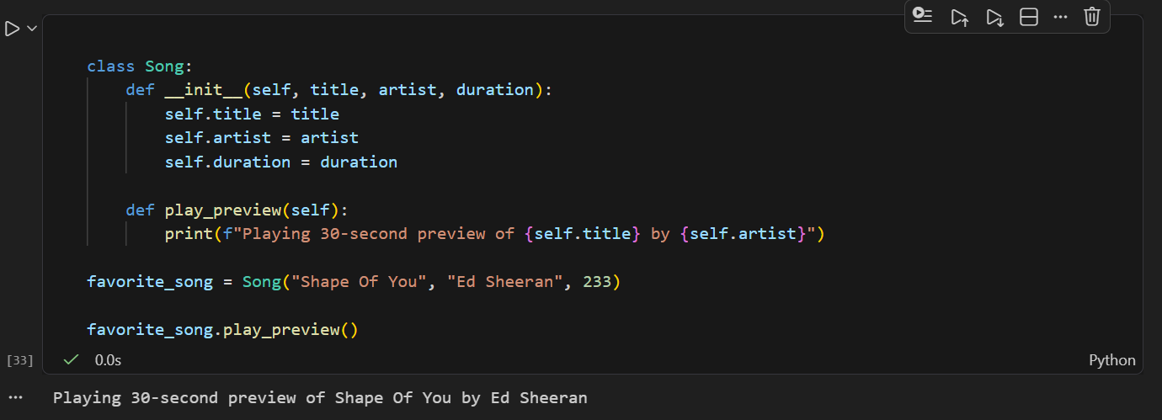

3.Create a class called FoodOrder with attributes: restaurant_name, items (list), and total_price. Write an __init__() constructor to initialize these, then create an object representing your last Zomato or Swiggy order and print its details.

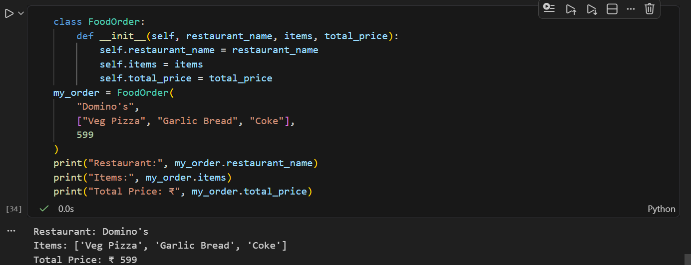

4.Extend the FoodOrder class by adding a method add_item(self, item_name, item_price) that adds the item to the items list and updates total_price. Demonstrate by adding two items to your order and printing the updated total.

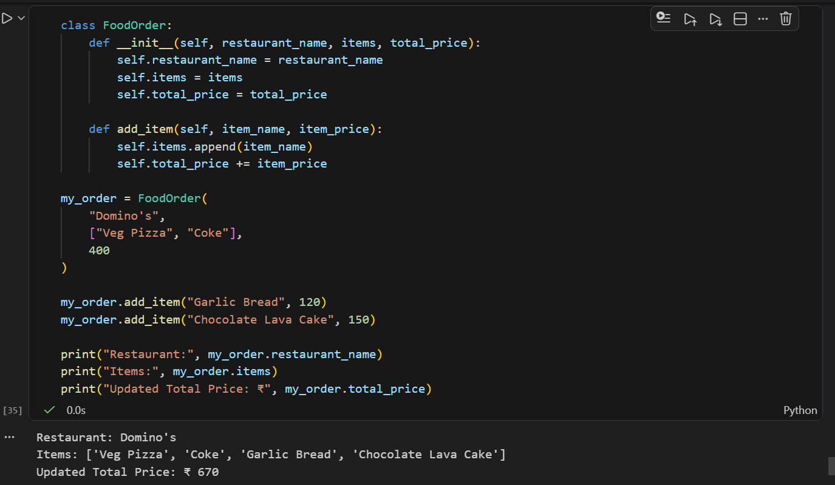
5.Refactor your Song class so that the duration attribute is optional in the constructor (default to 0 if not provided).<br><br><em><strong>Hint:</strong> Use a default argument for duration in the __init__() method.</em>

