Session20 Assignment

1.Create a Python class called Playlist with a private attribute _songs (a list) and a public method add_song(song) to add a song title to the playlist. Print the playlist after adding 3 songs.

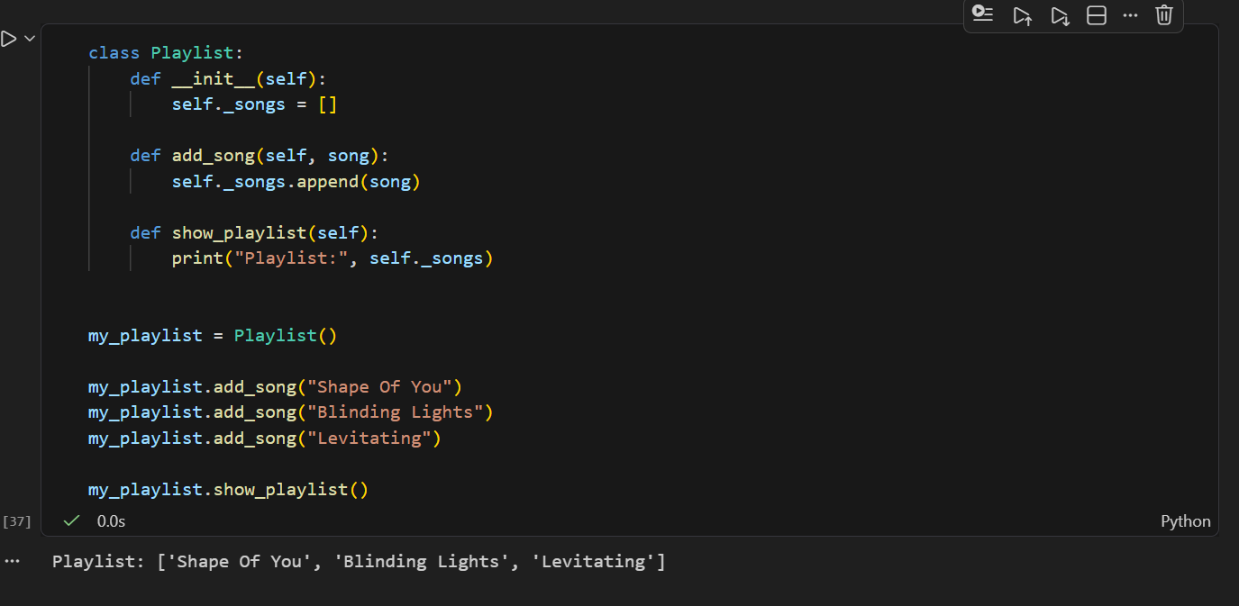

2.Build a Product class for a Flipkart-style app with a private attribute _price. Implement get_price() and set_price() methods to access and update the price. Demonstrate setting and getting the price for a product object.

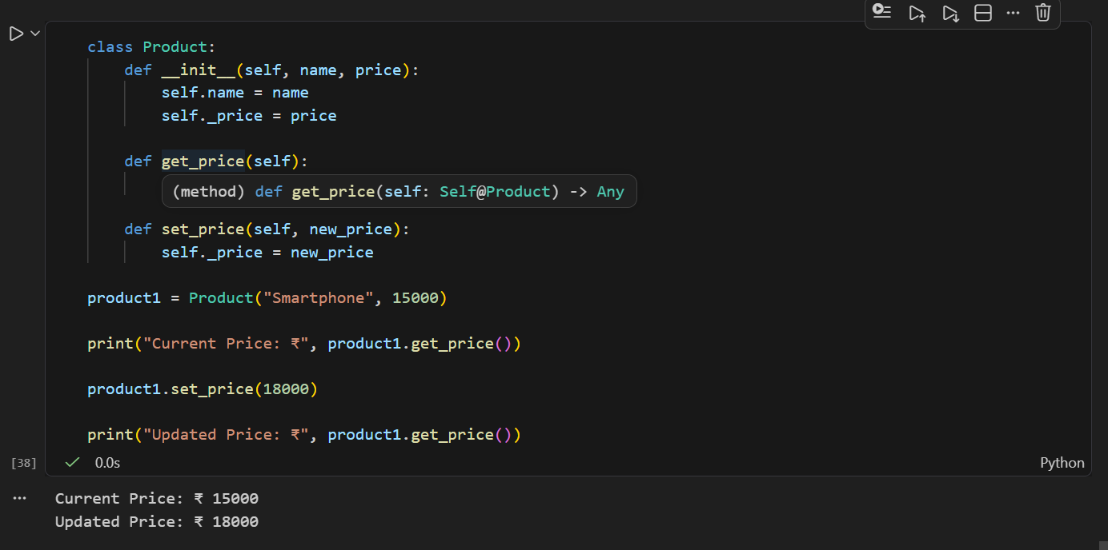
3.Create a Movie class with a private attribute _rating (float between 0 and 10). Write getter and setter methods for _rating. The setter should only allow values between 0 and 10; if an invalid value is given, print an error message.<br><br><em><strong>Constraint:</strong> Do not allow direct access to _rating outside the class.</em>

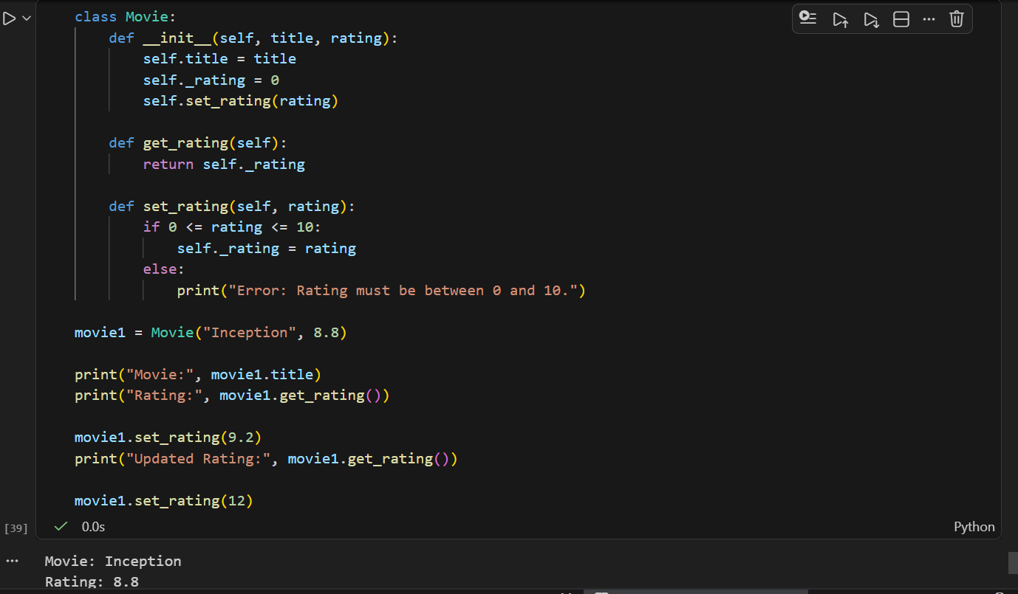

4.Design a simple abstract class PaymentMethod with an abstract method pay(amount). Then, create two subclasses: Paytm and PhonePe, each implementing pay(amount) to print a different message. Instantiate both and call their pay methods with any amount.

