Session12 Assignment

1.Write a lambda function to convert a list of song titles from Spotify to all lowercase letters and use map() to apply it to ['Shape Of You', 'Blinding Lights', 'Levitating', 'Senorita'], printing the cleaned list.

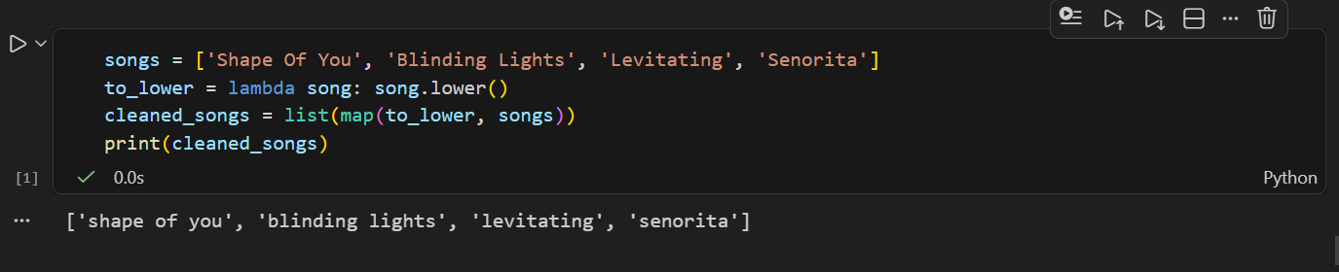

2.Given a list of Zomato restaurant ratings [4.2, 3.8, 4.5, 2.9, 3.5], use filter() with a lambda to find and print only the restaurants with ratings above 4.0.

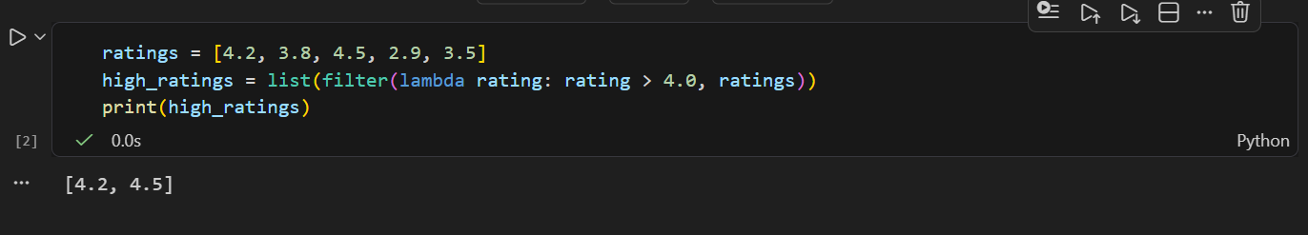

3.Use reduce() from functools to calculate the total price of items in a Flipkart shopping cart: [499, 1299, 299, 799]. Print the final total.<br><br><em><strong>Hint:</strong> Import reduce from functools and use a lambda to sum two numbers.</em>

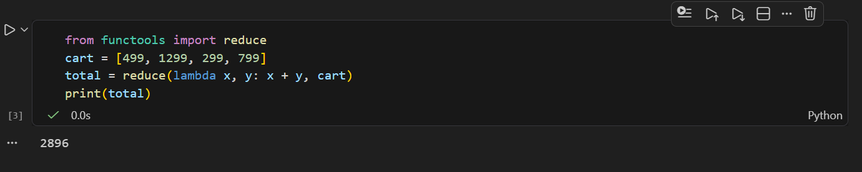
4.Create a function format_followers that takes a number and returns it in 'K' or 'M' format (e.g., 1500 → '1.5K', 1200000 → '1.2M'), then use map() to apply it to a list of follower counts: [950, 1500, 25000, 1200000].

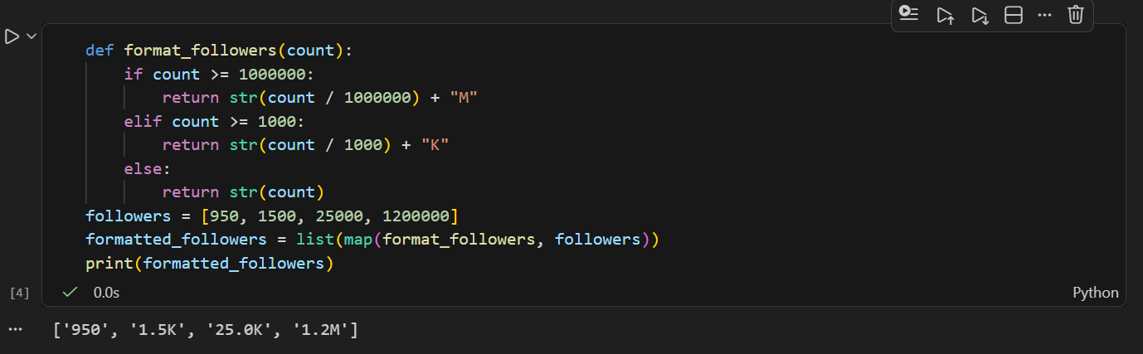

5.Use an AI tool like ChatGPT or Copilot to generate a lambda function that filters out all odd numbers from a list of IPL scores [101, 98, 120, 77, 88], then test the code in your Python environment and paste the working code here.

