Session23 Assignment

1.Fetch the current temperature and weather description for your city using the OpenWeatherMap API and print the results in a readable format.

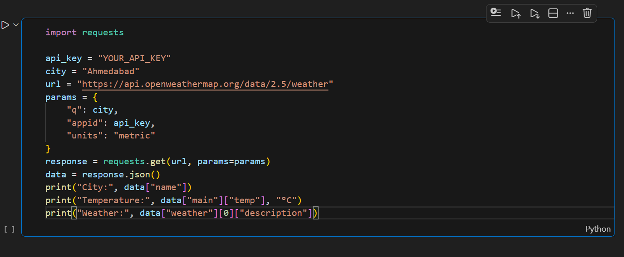

2.Build a small Python script that fetches the latest price of Bitcoin and Ethereum from the CoinGecko API and displays them with the current date and time.

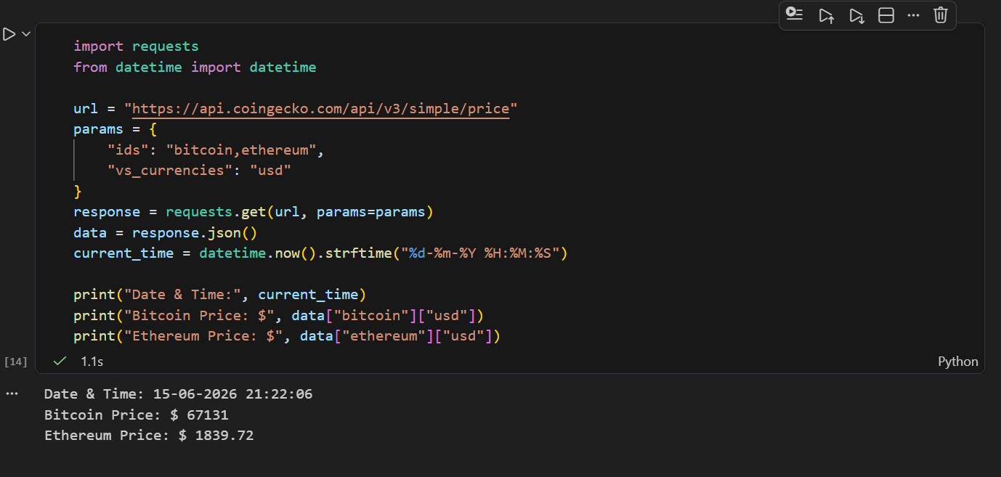

3.Use the NASA Astronomy Picture of the Day (APOD) API to get today's image title and explanation, and save the image to your local system.<br><br><em><strong>Hint:</strong> The API returns a URL for the image — use requests to download it.</em>

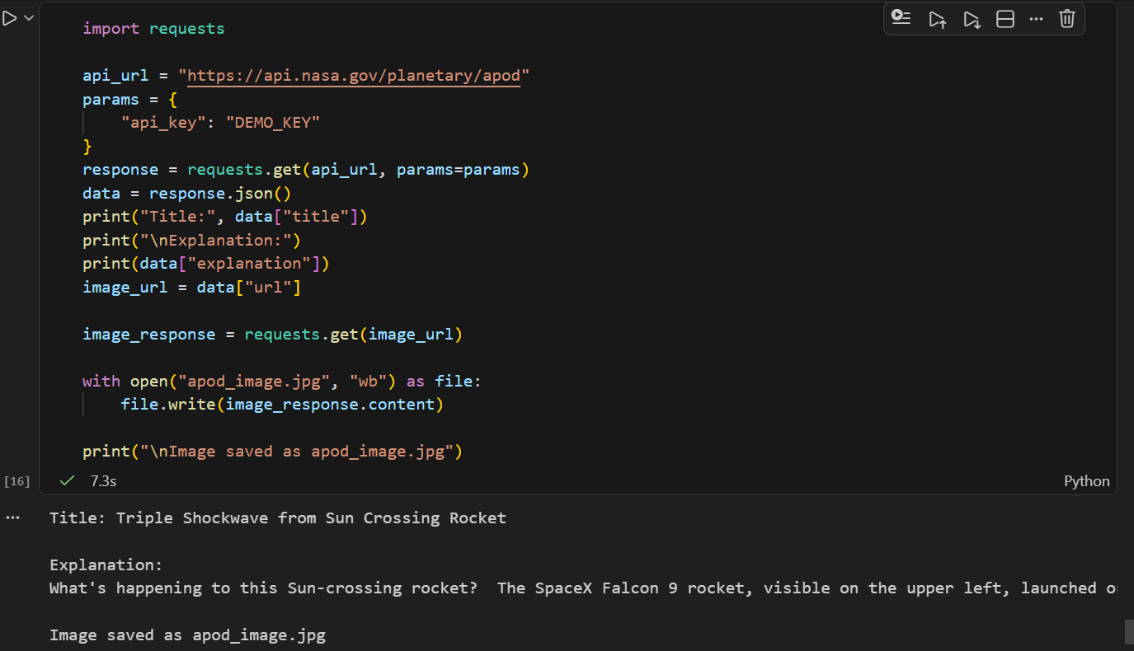

4.Create a Python program that fetches the latest COVID-19 case numbers for India from a public COVID API and displays total cases, recovered, and deaths in a table format.
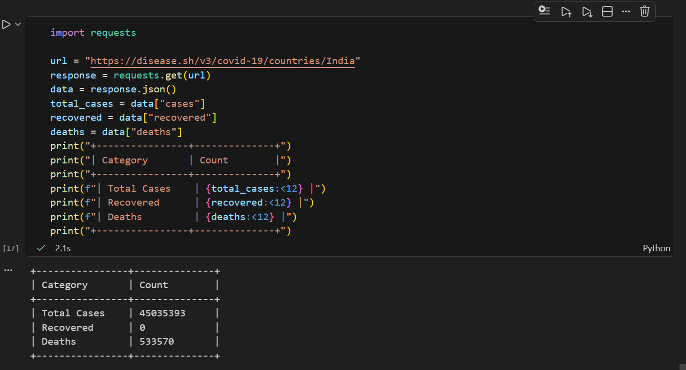
5.Combine data from two APIs: fetch the current temperature in Mumbai from OpenWeatherMap and the latest Bitcoin price from CoinGecko, then display both results together in a single output.<br><br><em><strong>Constraint:</strong> Handle errors gracefully if either API call fails and show an appropriate message.</em>

