Session25 Assignment

1.Fetch the latest 24-hour price and volume data for at least 10 popular cryptocurrencies using the Binance API and save the raw JSON response to a file named crypto_data.json.

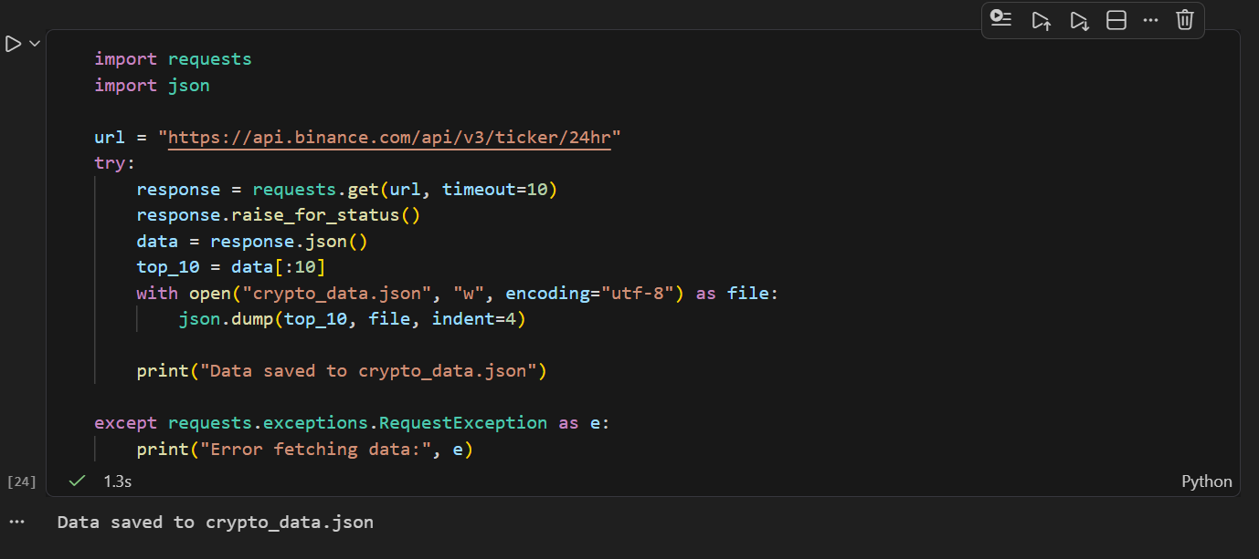

2.Write a Python function find_most_volatile_coin(data) that takes the loaded Binance coin data and returns the symbol of the coin with the highest percentage price change in the last 24 hours.
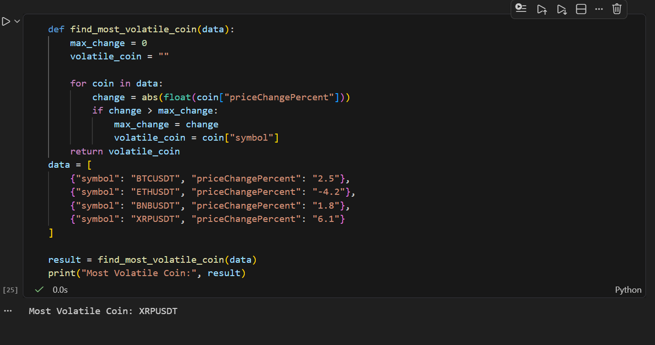
3.Create a script that calculates the average price of all coins in your crypto_data.json, then prints a list of all coins currently trading below this average price.

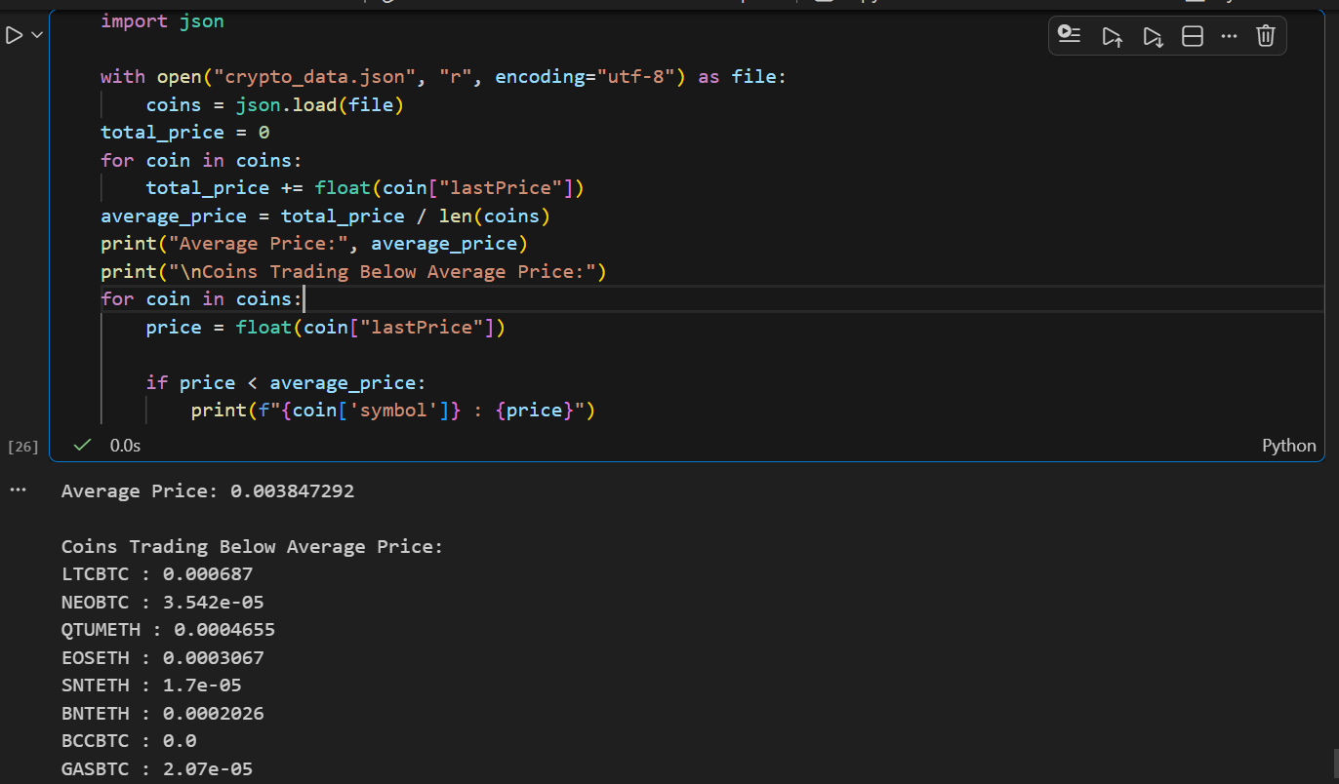

4.Build a function rank_coins_by_volume(data) that sorts all coins by their total traded volume in descending order and prints the top 5 coins with their rank and volume.
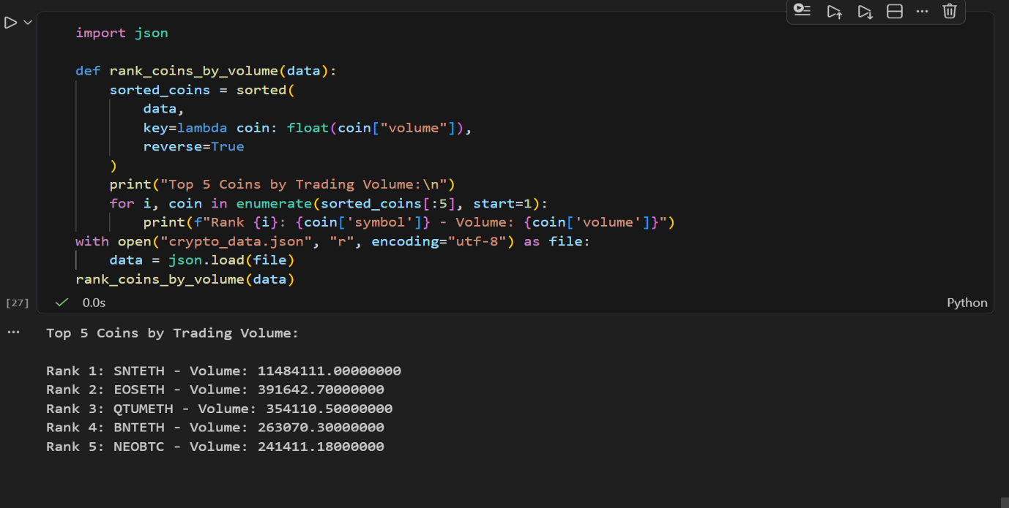
5.Automate your data fetch and analysis by scheduling your script to run every hour using the schedule Python library, and add error handling to gracefully manage Binance API rate limits.<br><br><em><strong>Hint:</strong> Catch HTTP 429 errors and implement a retry with exponential backoff.</em>

