Session17 Assignment

1.Create a Python script that imports the math module and uses math.sqrt() to calculate and print the square root of 225.

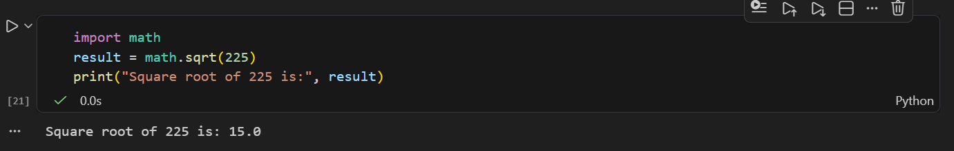

2.Write a script that uses the os module to create a new folder named 'MyDownloads' in your current working directory, then print the absolute path of the new folder.

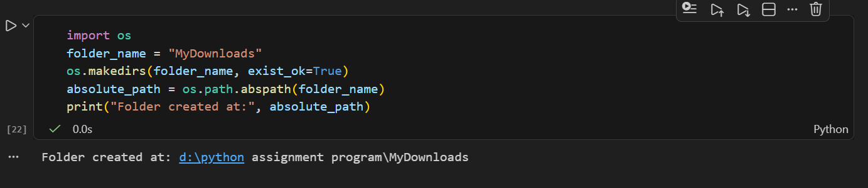

3.Use the datetime module to get the current date and time, then format and print it as 'DD-MM-YYYY HH:MM:SS', similar to how WhatsApp shows message timestamps.<br><br><em><strong>Hint:</strong> Use strftime() to format the output.</em>

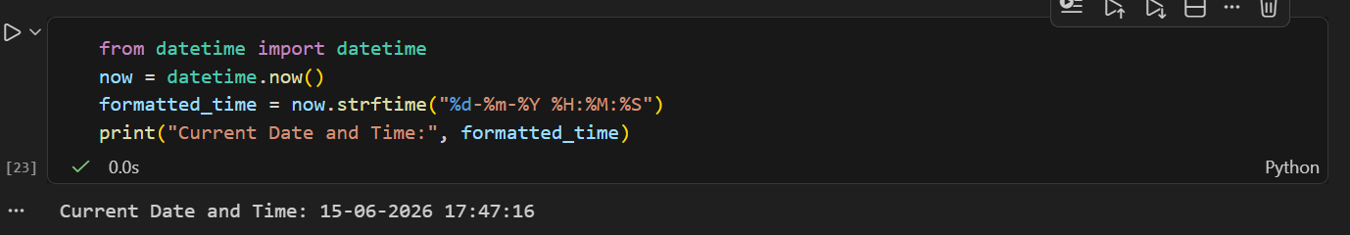

4.Create a custom Python module called playlist_utils.py with a function add_song(playlist, song) that adds a song to a list. Import this module in another script and use it to add three songs to a playlist, then print the final playlist.

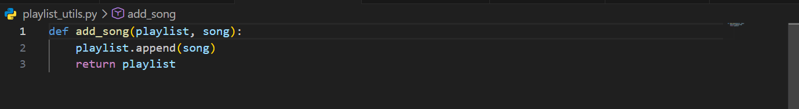

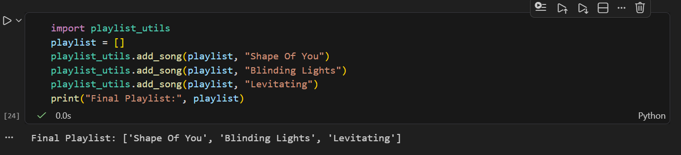

5.Set up a new virtual environment using venv, activate it, and install the 'requests' package using pip. Write a short script that imports requests and prints the version installed.<br><br><em><strong>Hint:</strong> Use 'python -m venv venv_folder', then 'pip install requests'.</em>

