SESSION 8 ASSIGNMENT

1. Create a table called Orders with columns: order_id, user_id, payment_method, and amount. Insert at least 8 sample records representing different users and payment methods (like UPI, Card, Wallet, COD).

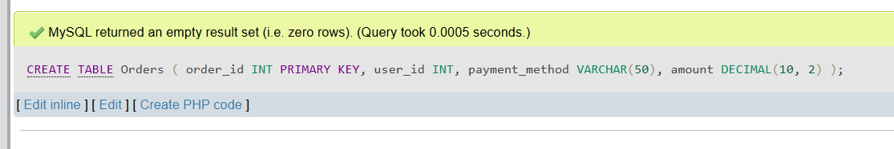

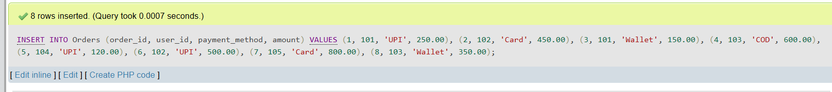

2. Write an SQL query to count how many orders were placed using each payment_method in the Orders table, similar to how Zomato shows payment breakdown in analytics.

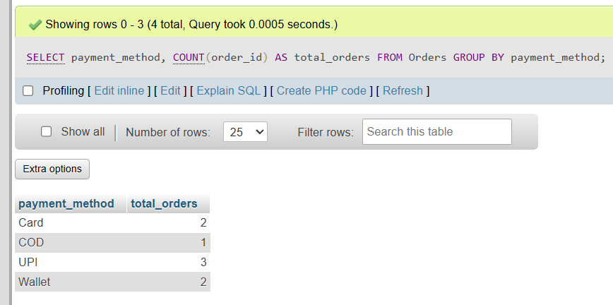

3. Write an SQL query to find the total amount spent by each user_id in the Orders table. Display user_id and their total spend.

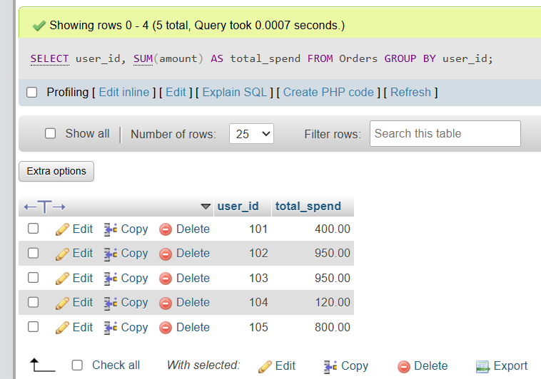

4. Write an SQL query to show only those payment methods where the average order amount is greater than 300, using GROUP BY and HAVING.<br><br><em><strong>Hint:</strong> Use AVG(amount) in your HAVING clause.</em>

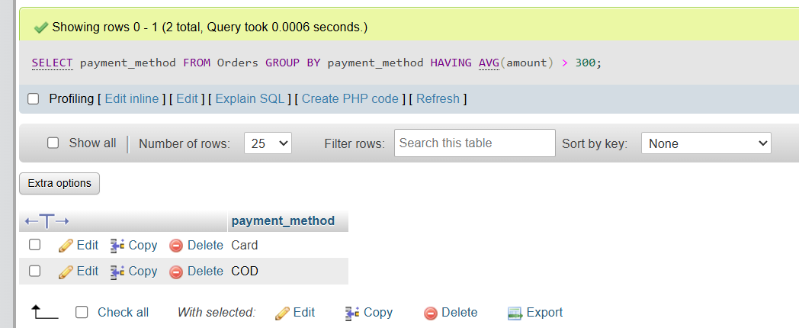

5. Explain the difference between WHERE and HAVING by giving one example query for each, using the Orders table. Your examples should show a scenario where WHERE and HAVING filter different things.

Basically dono data ko filter karne ke liye use hote hain, par farq bas is baat ka hai ki filter kab aur kahan lag raha hai.
WHERE: Ye grouping (GROUP BY) hone se pehle data ko filter karta hai. Isme hum seedha table ke columns pe condition lagate hain. Iske andar hum SUM(), AVG() ya COUNT() jaise aggregate functions use nahi kar sakte.
HAVING: Ye grouping hone ke baad data ko filter karta hai. Jab hume groups ke result par condition lagani hoti hai (jaise total sum ya average nikalne ke baad kisi cheez ko filter karna), tab hum HAVING use karte hain.

Example Queries (Orders table se):
WHERE ka example: Agar mujhe table me se seedha wo orders nikalne hain jahan amount 400 se upar hai:

SQL
SELECT * FROM Orders
WHERE amount > 400;
(Ye ek simple filter hai jo table ki har ek row ko directly check karega)

HAVING ka example: Ab maan lo mujhe aise users nikalne hain jinhone total milakar 500 se zyada ki shopping ki hai:

SQL
SELECT user_id, SUM(amount) AS total_spent
FROM Orders
GROUP BY user_id
HAVING SUM(amount) > 500;

