SESSION 13 ASSIGNMENT

1. Create a table named Playlists with columns: id, user_id, playlist_name, and total_likes. Insert at least 8 sample rows with different users and playlists, making sure some playlists have the same user_id.

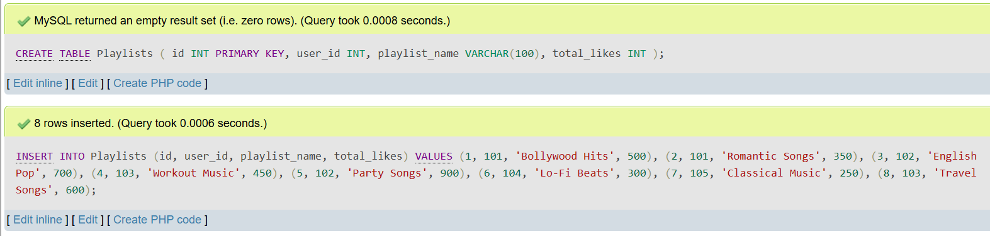

2. Write a SQL query using ROW_NUMBER() and the OVER() clause to assign a unique row number to each playlist, ordered by total_likes in descending order.

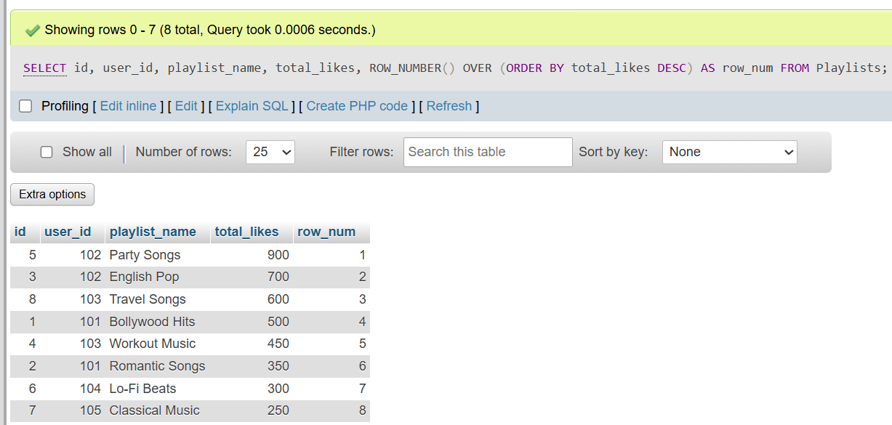

3. Use the RANK() function with the OVER() clause to rank all playlists by total_likes, and display the playlist_name, user_id, total_likes, and their rank.

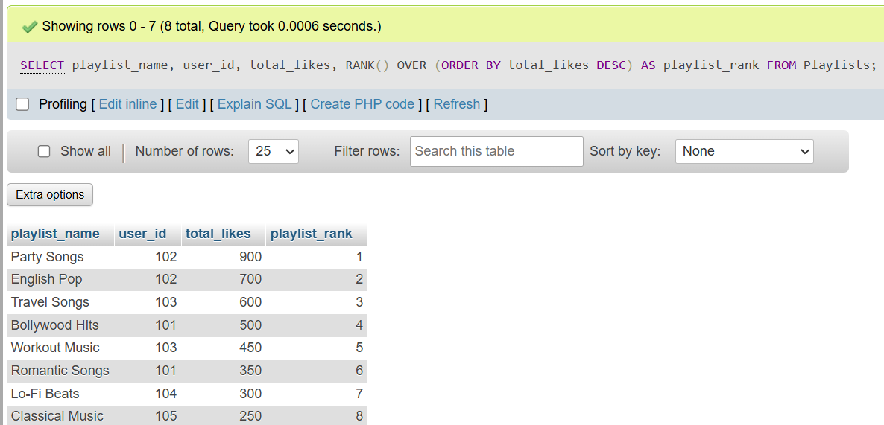

4. Write a SQL query using DENSE_RANK() and PARTITION BY user_id to rank each user's playlists by total_likes, showing playlist_name, user_id, total_likes, and dense rank.<br><br><em><strong>Hint:</strong> This will show how popular each playlist is within each user's account, similar to how Spotify might rank your top playlists.</em>

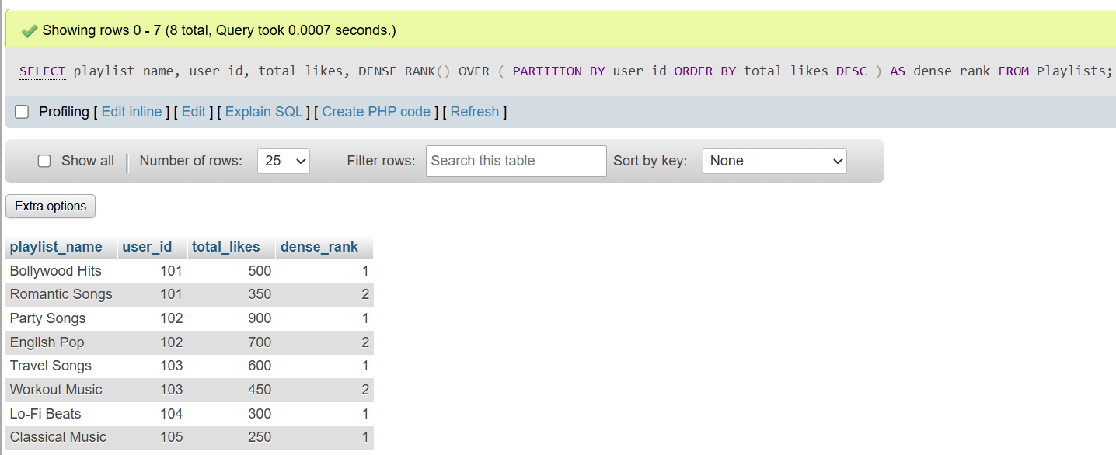

5. Imagine you want to show the top 2 playlists per user based on total_likes, like Spotify's 'Your Top Playlists' feature. Write a query using a window function to select only the top 2 playlists for each user.

