SkatePros – Jamar Plummer
https://github.com/jamarpl/web-programming-assigments/tree/main/IA2
https://cosmic-biscotti-826b05.netlify.app/
Website/Business Idea: I decided to use something I’m interested in as the inspiration for this project, so I decided to make a skateboarding item retailer
Mission Statement: To provide high-quality skateboarding gear and components that empower riders of all levels to express themselves and push their limits.
Vision Statement: To be the go-to destination for skateboarders seeking authentic, premium equipment and community in Jamaica
Colour Theme: I wanted to use a unique colour palette from regular skate websites (red and black, blue and black). I decided to use brown to evoke a grounded, reliable feeling (like a tree trunk) and a yellow background (like sunshine) to contrast it. Red evokes a heightened sensitivity in humans, so I used it to highlight the important buttons. I believe these colours fit with the website’s vision & purpose.
Intended Audience: The website targets skaters, who’s demographic is mainly young adults. In Jamaica, there is a growing skate community in universities (Kingston Skate Culture, UTech), so it aims to meet the budget requirements of students (around minimum wage).
Wireframes: Next Page (Black border is used to illustrate a div)
References: See last page

Mobile Design: Navigation bar is replaced by menu, Products are arranged vertically
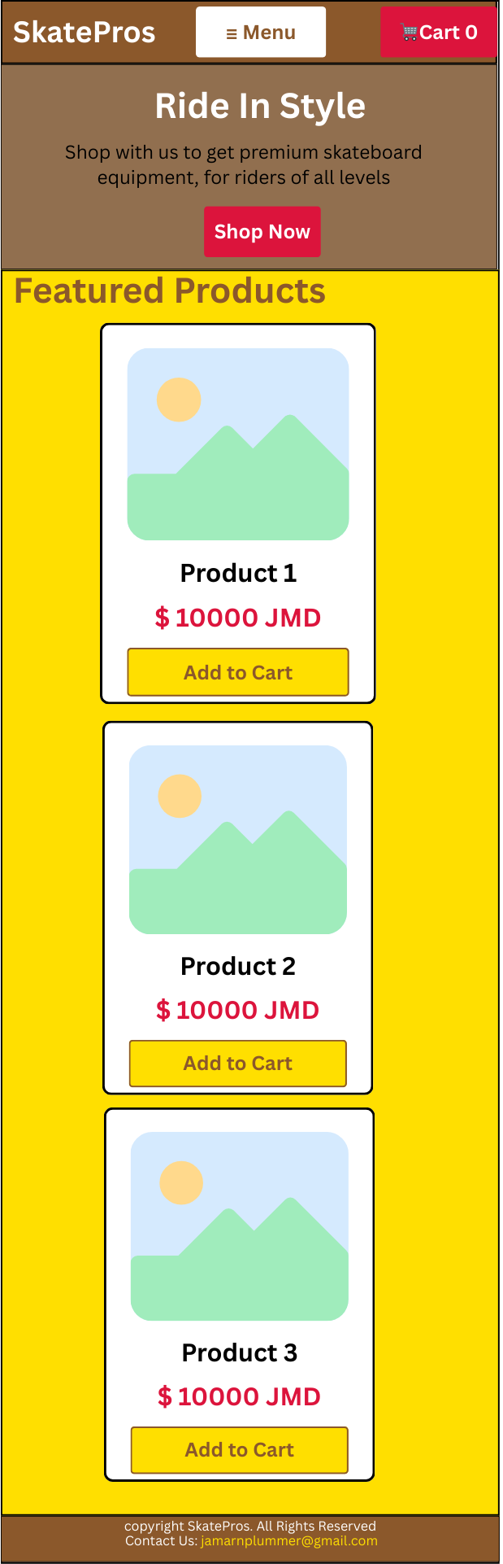
Web Design: Navigation bar is expanded, products are arranged horizontally
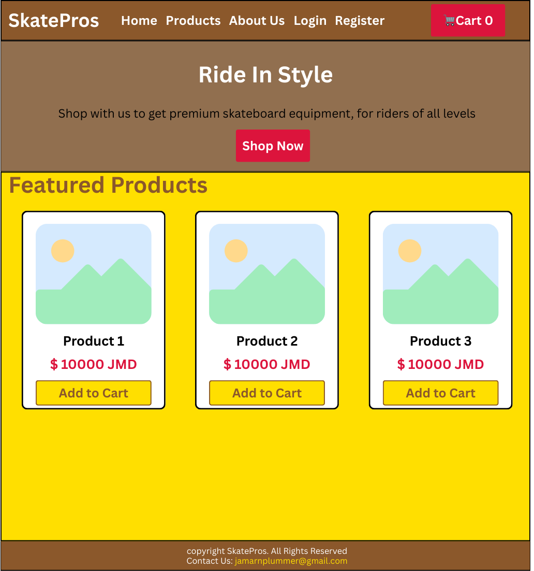

References
Skate Warehouse (2025), https://www.skatewarehouse.com/
W3 Schools (2025), JavaScript Array reduce(), https://www.w3schools.com/jsref/jsref_reduce.asp

