SkatePros
Jamar Plummer – 2405323 - IA2
CIT2011 Friday 12pm to 2pm Badhika
https://github.com/jamarpl/web-programming-assigments/tree/main/IA2
https://cosmic-biscotti-826b05.netlify.app/
Website/Business Idea: I decided to use something I’m interested in as the inspiration for this project, so I decided to make a skateboarding item retailer. This retailer will sell skateboard decks, wheels, and other hardware.
Mission Statement: To provide high-quality skateboarding gear and components that empower riders of all levels to express themselves and push their limits.
Vision Statement: To be the go-to destination for skateboarders seeking authentic, premium equipment and community in Jamaica
Colour Theme: Initially, I wanted to use a unique colour palette to make the website stand out, but it ended up looking garish. Instead, I decided to follow a simpler colour theme. Simpler palettes are less exhausting on the eyes, so I decided to use red highlights with amber complements, and off-white backgrounds. The red draws a lot of visual attention, and amber was the ideal colour to use for the hero element because it complements the red, while keeping a cohesive hierarchy. The off-white was used because using straight white as a background can cause eye strain.
Intended Audience: The website targets skaters, who’s demographic is mainly young adults. In Jamaica, there is a growing skate community in universities (Kingston Skate Culture, UTech), so it aims to meet the budget requirements of students (around minimum wage).
Wireframes: Next Page (Black border is used to illustrate a div)
References: See last page

Mobile Design: Navigation bar is replaced by menu, Products are arranged vertically
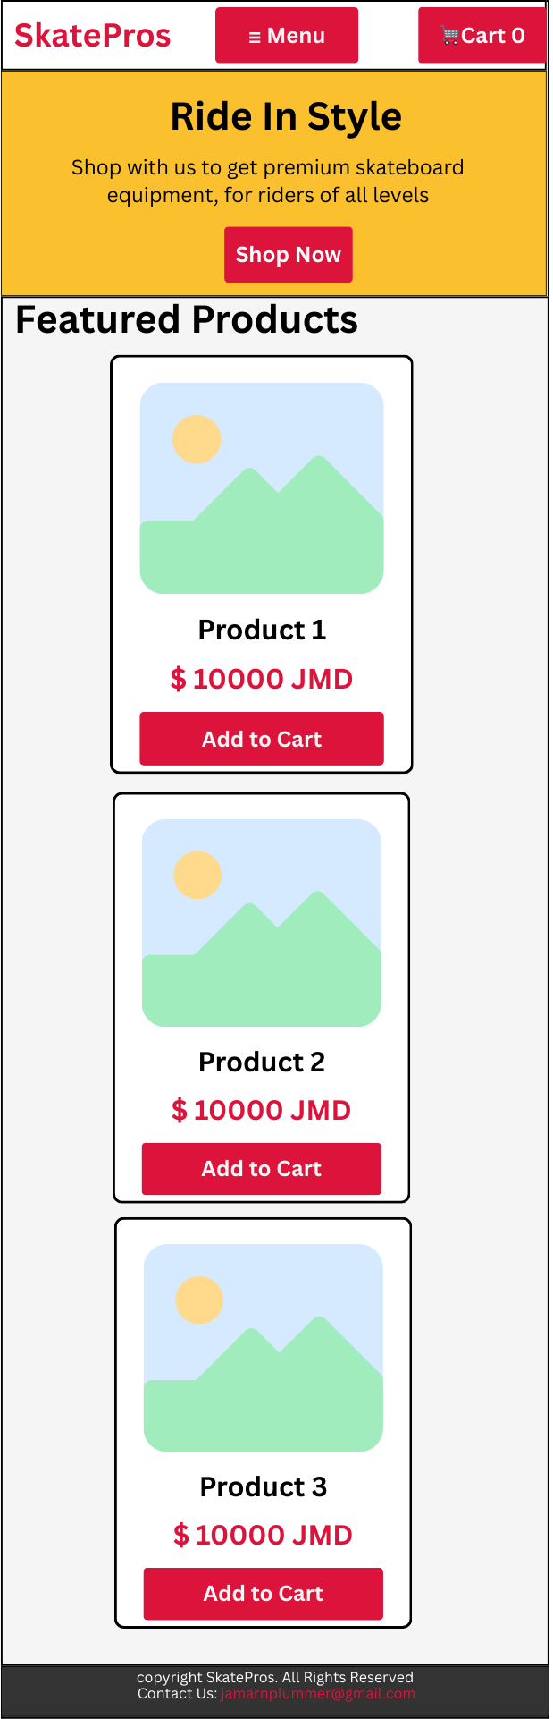
Web Design: Navigation bar is expanded, products are arranged horizontally
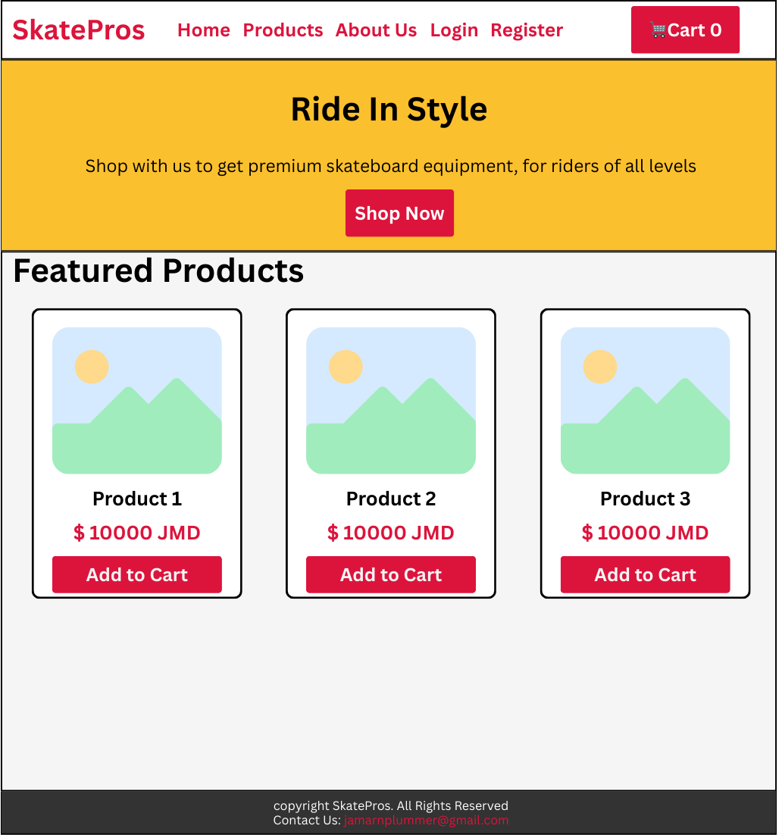

References
Skate Warehouse (2025), https://www.skatewarehouse.com/
W3 Schools (2025), JavaScript Array reduce(), https://www.w3schools.com/jsref/jsref_reduce.asp

