LABORATORY WORK REPORT
Lab 8 — Advanced Queries on the University Database
Database Management Systems
Laboratory work: | Lab 8 — Advanced queries (University database, individual work)
Student full name: | Doe John
Group: | SISCCO-2502NS
Course: | Database Management Systems

Preparation
DBMS: PostgreSQL 16. A new database was created with the code from the handout file “Lab work 8.sql”: 11 tables (Credits, Subjects, Students, Groups, Ed_process, Progress, Teachers, Departments, Majors, Classes, Schedule) with the handout data.
Note. Task 7 asks to add rows with different values to the Progress and Ed_process tables. The handout has only 3 Progress records, all with the same grade 90, so these rows (5 Ed_process rows and 8 Progress rows, see Task 7) were added right after the database was created, and all ten tasks work on the same data. In the new rows the RK average is (RK1 + RK2) / 2 and the final grade is 0.6 · RK average + 0.4 · Exam.
Every result below is the real output of the query, with column names and types as returned by PostgreSQL.

Tasks

Task 1
Write a query with count() aggregation function. Explain the query result.
COUNT(*) counts all rows of the Progress table: there are 11 grade records. COUNT(DISTINCT stud_id) counts each student only once, so only 6 different students have grades; students 7 and 8 have no records in Progress yet.
SELECT COUNT(*) AS progress_records,
COUNT(DISTINCT stud_id) AS students_with_grades
FROM progress;
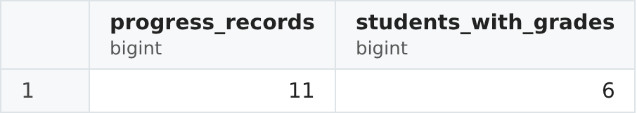
Figure 1. Result of Task 1.

Task 2
Write a query with max(), min(), avg() or sum() aggregation function. Explain the query result.
The aggregate functions are calculated over all 11 final grades. The lowest final grade is 61, the highest is 97, and the average final grade is 84.91 (934 / 11). ROUND(…, 2) leaves two digits after the decimal point.
SELECT MIN(final) AS min_final,
MAX(final) AS max_final,
ROUND(AVG(final), 2) AS avg_final
FROM progress;
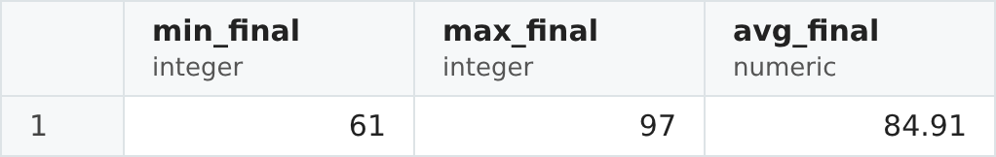
Figure 2. Result of Task 2.

Task 3
Add to the previous query (from #1 or #2) GROUP BY condition. Explain the query result.
GROUP BY stud_id splits the rows of Progress into groups, one group per student, and the aggregate functions are calculated separately for every group. The result has one row for each of the 6 students who have grades: the number of subjects, the lowest, the highest and the average final grade of that student. Without ORDER BY the groups come out in no particular order.
SELECT stud_id,
COUNT(*) AS subjects,
MIN(final) AS min_final,
MAX(final) AS max_final,
ROUND(AVG(final), 2) AS avg_final
FROM progress
GROUP BY stud_id;
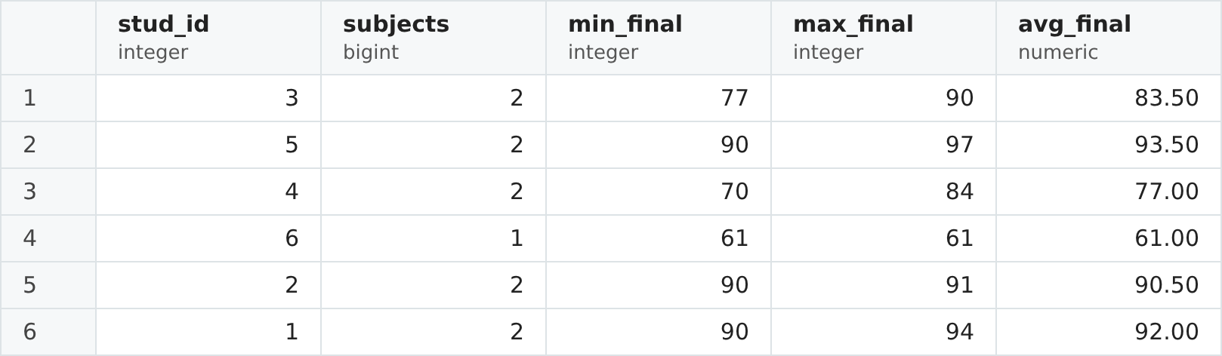
Figure 3. Result of Task 3.

Task 4
Add to the previous query from #4 a condition with HAVING. Explain the query result.
HAVING filters the groups after GROUP BY, so it can use an aggregate function, which WHERE cannot do. Only the students whose lowest final grade is at least 75 (no grade below B-) remain. Students 4 (lowest grade 70) and 6 (61) are removed, so 4 of the 6 groups are left.
SELECT stud_id,
COUNT(*) AS subjects,
MIN(final) AS min_final,
MAX(final) AS max_final,
ROUND(AVG(final), 2) AS avg_final
FROM progress
GROUP BY stud_id
HAVING MIN(final) >= 75;
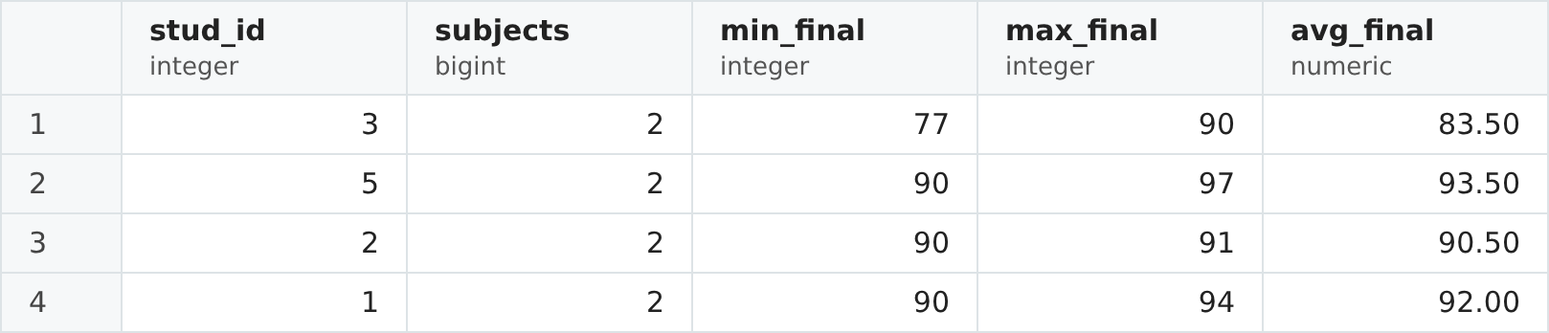
Figure 4. Result of Task 4.

Task 5
Add to the previous query from #4 ORDER BY condition. Explain the query result.
ORDER BY is applied last, after GROUP BY and HAVING. The same 4 students are sorted by their average final grade from the highest to the lowest (DESC): student 5 is first with 93.50 and student 3 is last with 83.50. ORDER BY can use the column alias avg_final from the SELECT list.
SELECT stud_id,
COUNT(*) AS subjects,
MIN(final) AS min_final,
MAX(final) AS max_final,
ROUND(AVG(final), 2) AS avg_final
FROM progress
GROUP BY stud_id
HAVING MIN(final) >= 75
ORDER BY avg_final DESC;
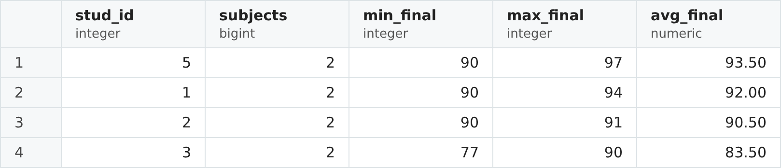
Figure 5. Result of Task 5.

Task 6
Show the Schedule in the following way: Group name, Subject name, Room, Time, Day of week, Type of class, Teacher lname.
Schedule stores only keys, so five joins are needed: through Ed_process to Groups and Subjects, and directly to Classes and Teachers. The database has two classes: CSSE-132 has a Database Design lab at 08:00 in room 303 and CSSE-131 has a Database Design lecture at 10:00 in room 901, both on Monday with teacher Kozina.
SELECT g.group_name AS "Group name",
s.subj_name AS "Subject name",
sc.room AS "Room",
sc.sch_time AS "Time",
sc.day_of_week AS "Day of week",
c.class_type AS "Type of class",
t.lname AS "Teacher lname"
FROM schedule sc
JOIN ed_process e ON sc.proc_id = e.proc_id
JOIN groups g ON e.group_id = g.group_id
JOIN subjects s ON e.subj_id = s.subj_id
JOIN classes c ON sc.class_id = c.class_id
JOIN teachers t ON sc.teach_id = t.teach_id
ORDER BY sc.day_of_week, sc.sch_time;
Figure 6. Result of Task 6.

Task 7
In this task before the SELECT statement add a few rows with different values in the Progress and Ed_process tables. Show the Progress table in the following way: Student fname and lname in one column with "Full name" title, Subject name, RK1, RK2, RK average, Exam, Final.
First, 5 rows are added to Ed_process (Physics for groups CSSE-131 to CSSE-135) and 8 rows with different grades are added to Progress. Then the SELECT joins the first and the last name of the student into one column with the title "Full name" (|| concatenation, double quotes keep the space and capital letters) and takes the subject name through Ed_process. The result shows all 11 grade records.
Step 1. Add new rows:
-- New courses: Physics (subj_id 2) for groups 1-5 in term 3
INSERT INTO Ed_process VALUES (7,1,2,3),
(8,2,2,3),
(9,3,2,3),
(10,4,2,3),
(11,5,2,3);

-- New grades (rk_avg = (rk1+rk2)/2, final = 0.6*rk_avg + 0.4*exam)
INSERT INTO Progress VALUES (4,7,1,95,93,94,94,94),
(5,8,2,88,94,91,92,91),
(6,9,3,80,84,82,70,77),
(7,4,4,85,89,87,80,84),
(8,10,4,70,76,73,65,70),
(9,5,5,98,96,97,96,97),
(10,11,5,92,90,91,89,90),
(11,6,6,60,66,63,58,61);
Step 2. Query:
SELECT st.fname || ' ' || st.lname AS "Full name",
s.subj_name AS "Subject name",
p.rk1 AS "RK1",
p.rk2 AS "RK2",
p.rk_avg AS "RK average",
p.exam AS "Exam",
p.final AS "Final"
FROM progress p
JOIN students st ON p.stud_id = st.stud_id
JOIN ed_process e ON p.proc_id = e.proc_id
JOIN subjects s ON e.subj_id = s.subj_id
ORDER BY p.progress_id;
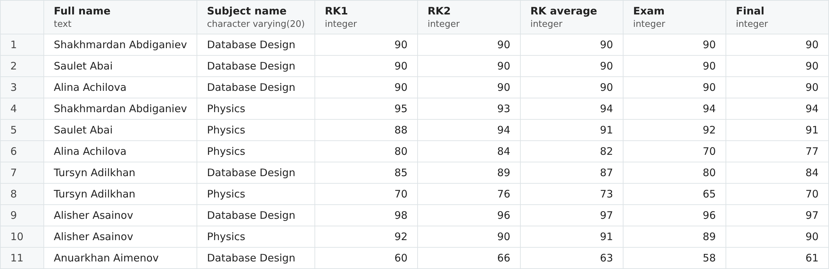
Figure 7. Result of Task 7.

Task 8
Edit the previous query to get only students with good (but not excellent) final grades (in other words, from 75 to 90). Final column contains grades in 100% scoring system.
A WHERE condition is added to the previous query. In the 100-point system 75–89 is "good" (B-, B, B+) and 90 is already "excellent" (A-), so the upper limit is excluded: final >= 75 AND final < 90. Two records remain: Achilova Physics 77 and Adilkhan Database Design 84. The grades of exactly 90 are not included, because they are excellent.
SELECT st.fname || ' ' || st.lname AS "Full name",
s.subj_name AS "Subject name",
p.rk1 AS "RK1",
p.rk2 AS "RK2",
p.rk_avg AS "RK average",
p.exam AS "Exam",
p.final AS "Final"
FROM progress p
JOIN students st ON p.stud_id = st.stud_id
JOIN ed_process e ON p.proc_id = e.proc_id
JOIN subjects s ON e.subj_id = s.subj_id
WHERE p.final >= 75 AND p.final < 90
ORDER BY p.progress_id;
Figure 8. Result of Task 8.

Task 9
Show the following information with the Ed_process table: Group name, Subject name, average value of final (for every subject for every group).
Every row of Ed_process is one subject studied by one group, so the grades are grouped by two columns, group name and subject name, and AVG(final) is calculated for every pair. For example, CSSE-132 has two Database Design grades (90 and 90), so its average is 90.00. CSSE-133 has no Database Design grades, so that pair does not appear: the inner join keeps only courses that have grades.
SELECT g.group_name AS "Group name",
s.subj_name AS "Subject name",
ROUND(AVG(p.final), 2) AS "Average final"
FROM ed_process e
JOIN groups g ON e.group_id = g.group_id
JOIN subjects s ON e.subj_id = s.subj_id
JOIN progress p ON p.proc_id = e.proc_id
GROUP BY g.group_name, s.subj_name
ORDER BY g.group_name, s.subj_name;
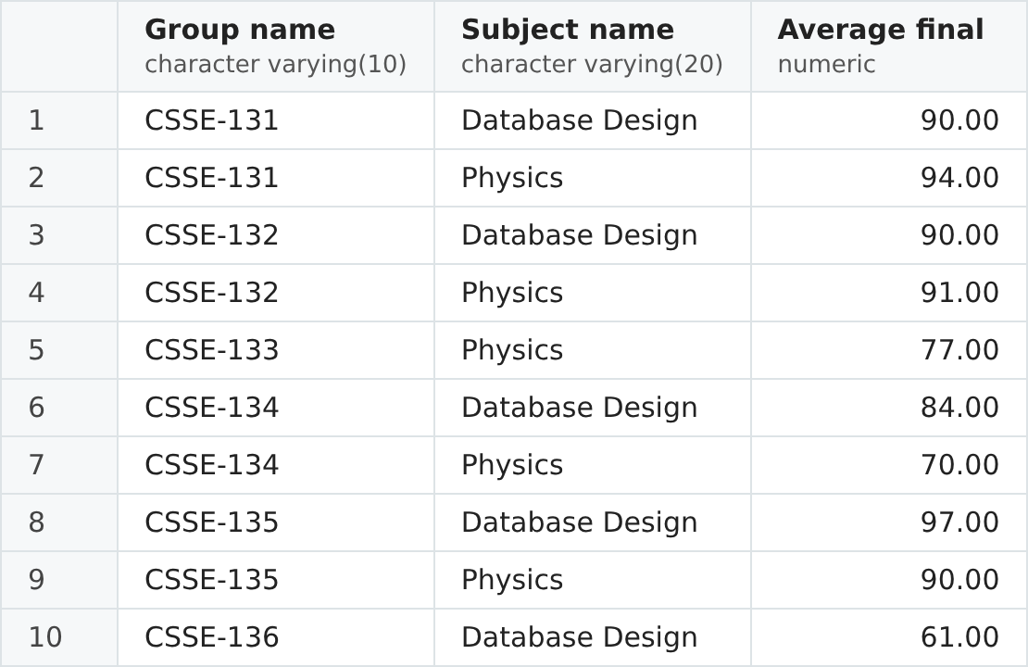
Figure 9. Result of Task 9.

Task 10
Show the following information with the Students and Progress tables: Student fname and lname in one column with "Full name" title, average value of final for all subjects for every student (like gpa). Show only students with average final grade more or equal 90. Sort students alphabetically.
The grades are grouped by student and AVG(final) gives the average final grade of every student over all subjects, like a GPA. HAVING keeps only the students whose average is at least 90: Abai (90.50), Abdiganiev (92.00) and Asainov (93.50). The students are sorted alphabetically by last name, then by first name.
SELECT st.fname || ' ' || st.lname AS "Full name",
ROUND(AVG(p.final), 2) AS "Average final"
FROM students st
JOIN progress p ON p.stud_id = st.stud_id
GROUP BY st.stud_id, st.fname, st.lname
HAVING AVG(p.final) >= 90
ORDER BY st.lname, st.fname;
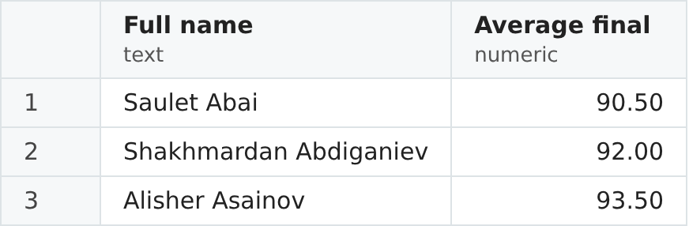
Figure 10. Result of Task 10.

